Problems of the 9th International Physics Olympiads
(Budapest, Hungary, 1976)

Theoretical problems

Problem 1

A hollow sphere of radius R = 0.5 m rotates about a vertical axis through its centre with an angular velocity of ω = 5 s⁻¹. Inside the sphere a small block is moving together with the sphere at the height of R/2 (Fig. 6). (g = 10 m/s².)
a) What should be at least the coefficient of friction to fulfill this condition?
b) Find the minimal coefficient of friction also for the case of ω = 8 s⁻¹.
c) Investigate the problem of stability in both cases,
α) for a small change of the position of the block,
β) for a small change of the angular velocity of the sphere.

R/2
Figure 6
Figure 7
S
α
mω²Rsinα
mg
N
R

Solution

a) The block moves along a horizontal circle of radius 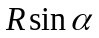. The net force acting on the block is pointed to the centre of this circle (Fig. 7). The vector sum of the normal force exerted by the wall N, the frictional force S and the weight mg is equal to the resultant: 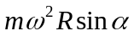.

The connections between the horizontal and vertical components:

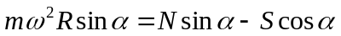,

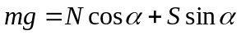.

The solution of the system of equations:

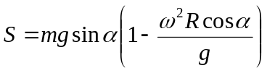,

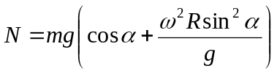.
The block does not slip down if

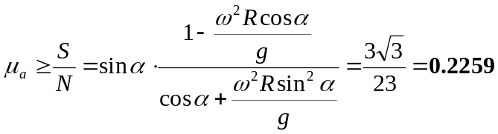.

In this case there must be at least this friction to prevent slipping, i.e. sliding down.

b) If on the other hand 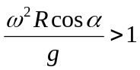 some friction is necessary to prevent the block to slip upwards. must be equal to the resultant of forces S, N and mg. Condition for the minimal coefficient of friction is (Fig. 8):

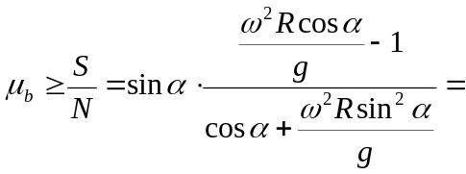
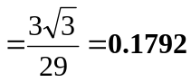.
S
α
mω²Rsinα
mg
N
Figure 8

c) We have to investigate μ_{a} and μ_{b} as functions of α and ω in the cases a) and b) (see Fig. 9/a and 9/b):

α
90°
μ _{a}
0.5
90°
μ _{b}
0.5
ω = 5/s
ω < 5/s
ω > 5/s
α
ω > 8/s
ω = 8/s
ω < 8/s
Figure 9/a
Figure 9/b

In case a): if the block slips upwards, it comes back; if it slips down it does not return. If ω increases, the block remains in equilibrium, if ω decreases it slips downwards.
In case b): if the block slips upwards it stays there; if the block slips downwards it returns. If ω increases the block climbs upwards⁻, if ω decreases the block remains in equilibrium.

Problem 2

The walls of a cylinder of base 1 dm², the piston and the inner dividing wall are perfect heat insulators (Fig. 10). The valve in the dividing wall opens if the pressure on the right side is greater than on the left side. Initially there is 12 g helium in the left side and 2 g helium in the right side. The lengths of both sides are 11.2 dm each and the temperature is

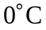. Outside we have a pressure of 100 kPa. The specific heat at constant volume is c_{v} = 3.15 J/gK, at constant pressure it is c_{p} = 5.25 J/gK. The piston is pushed slowly towards the dividing wall. When the valve opens we stop then continue pushing slowly until the wall is reached. Find the work done on the piston by us.
11.2 dm
11.2 dm
1 dm²
Figure 10

Solution

The volume of 4 g helium at temperature and a pressure of 100 kPa is 22.4 dm³ (molar volume). It follows that initially the pressure on the left hand side is 600 kPa, on the right hand side 100 kPa. Therefore the valve is closed.
An adiabatic compression happens until the pressure in the right side reaches 600 kPa (κ = 5/3).

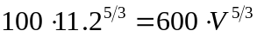,

hence the volume on the right side (when the valve opens):

V = 3.82 dm³.

From the ideal gas equation the temperature is on the right side at this point

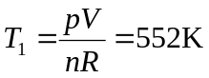.

During this phase the whole work performed increases the internal energy of the gas:

W₁ = (3.15 J/gK) ⋅ (2 g) ⋅ (552 K – 273 K) = 1760 J.

Next the valve opens, the piston is arrested. The temperature after the mixing has been completed:

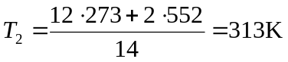.

During this phase there is no change in the energy, no work done on the piston.
An adiabatic compression follows from 11.2 + 3.82 = 15.02 dm³ to 11.2 dm³:

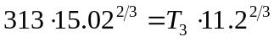,

hence

T₃ = 381 K.
The whole work done increases the energy of the gas:

W₃ = (3.15 J/gK) ⋅ (14 g) ⋅ (381 K – 313 K) = 3000 J.

The total work done:

W_{total} = W₁ + W₃ = 4760 J.

The work done by the outside atmospheric pressure should be subtracted:

W_{atm} = 100 kPa ⋅ 11.2 dm³ = 1120 J.

The work done on the piston by us:

W = W_{total} – W_{atm} = 3640 J.

Problem 3

Somewhere in a glass sphere there is an air bubble. Describe methods how to determine the diameter of the bubble without damaging the sphere.

Solution

We can not rely on any value about the density of the glass. It is quite uncertain. The index of refraction can be determined using a light beam which does not touch the bubble. Another method consists of immersing the sphere into a liquid of same refraction index: its surface becomes invisible.
A great number of methods can be found.
We can start by determining the axis, the line which joins the centers of the sphere and the bubble. The easiest way is to use the “tumbler-over” method. If the sphere is placed on a horizontal plane the axis takes up a vertical position. The image of the bubble, seen from both directions along the axis, is a circle.

If the sphere is immersed in a liquid of same index of refraction the spherical bubble is practically inside a parallel plate (Fig. 11). Its boundaries can be determined either by a micrometer or using parallel light beams.
Along the axis we have a lens system consisting, of two thick negative lenses. The diameter of the bubble can be determined by several measurements and complicated calculations.
Figure11

If the index of refraction of the glass is known we can fit a plano-concave lens of same index of refraction to the sphere at the end of the axis (Fig. 12). As ABCD forms a parallel plate the diameter of the bubble can be measured using parallel light beams.

Figure12
A B
C D
A
r
d
ψ
ϕ
R
B
Figure13

Focusing a light beam on point A of the surface of the sphere (Fig. 13) we get a diverging beam from point A inside the sphere. The rays strike the surface at the other side and illuminate a cap. Measuring the spherical cap we get angle ϕ. Angle ψ can be obtained in a similar way at point B. From

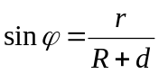 and 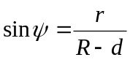

we have

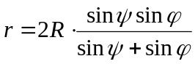, 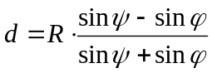.
The diameter of the bubble can be determined also by the help of X-rays. X-rays are not refracted by glass. They will cast shadows indicating the structure of the body, in our case the position and diameter of the bubble.
We can also determine the moment of inertia with respect to the axis and thus the diameter of the bubble.

Experimental problem

The whole text given to the students:

At the workplace there are beyond other devices a test tube with 12 V electrical heating, a liquid with known specific heat (c₀ = 2.1 J/g°C) and an X material with unknown thermal properties. The X material is insoluble in the liquid.
Examine the thermal properties of the X crystal material between room temperature and 70 °C. Determine the thermal data of the X material. Tabulate and plot the measured data.
(You can use only the devices and materials prepared on the table. The damaged devices and the used up materials are not replaceable.)

Solution

Heating first the liquid then the liquid and the crystalline substance together two time-temperature graphs can be plotted. From the graphs specific heat, melting point and heat of fusion can be easily obtained.

Literature

[1] W. Gorzkowski: Problems of the 1st International Physics Olympiad
Physics Competitions 5, no2 pp6-17, 2003

[2] R. Kunfalvi: Collection of Competition Tasks from the Ist through XVth International Physics Olympiads 1967-1984
Roland Eötvös Physical Society in cooperation with UNESCO, Budapest, 1985

[3] A Nemzetközi Fizikai Diákolimpiák feladatai I.-XV.
Eötvös Loránd Fizikai Társulat, Középiskolai Matematikai Lapok, 1985

