Problems of the XI International Olympiad, Moscow, 1979
The publication has been prepared by Prof. S. Kozel and Prof. V.Orlov
(Moscow Institute of Physics and Technology)
The XI International Olympiad in Physics for students took place in Moscow, USSR, in July 1979 on the basis of Moscow Institute of Physics and Technology (MIPT). Teams from 11 countries participated in the competition, namely Bulgaria, Finland, Germany, Hungary, Poland, Romania, Sweden, Czechoslovakia, the DDR, the SFR Yugoslavia, the USSR. The problems for the theoretical competition have been prepared by professors of MIPT (V.Belonuchkin, I.Slobodetsky, S.Kozel). The problem for the experimental competition has been worked out by O.Kabardin from the Academy of Pedagogical Sciences.
It is pity that marking schemes were not preserved.
Theoretical Problems

Problem 1.
A space rocket with mass M=12t is moving around the Moon along the circular orbit at the height of h =100 km. The engine is activated for a short time to pass at the lunar landing orbit. The velocity of the ejected gases u = 10⁴ m/s. The Moon radius R_{M} = 1,7·10³ km, the acceleration of gravity near the Moon surface g_{M} = 1.7 m/s²
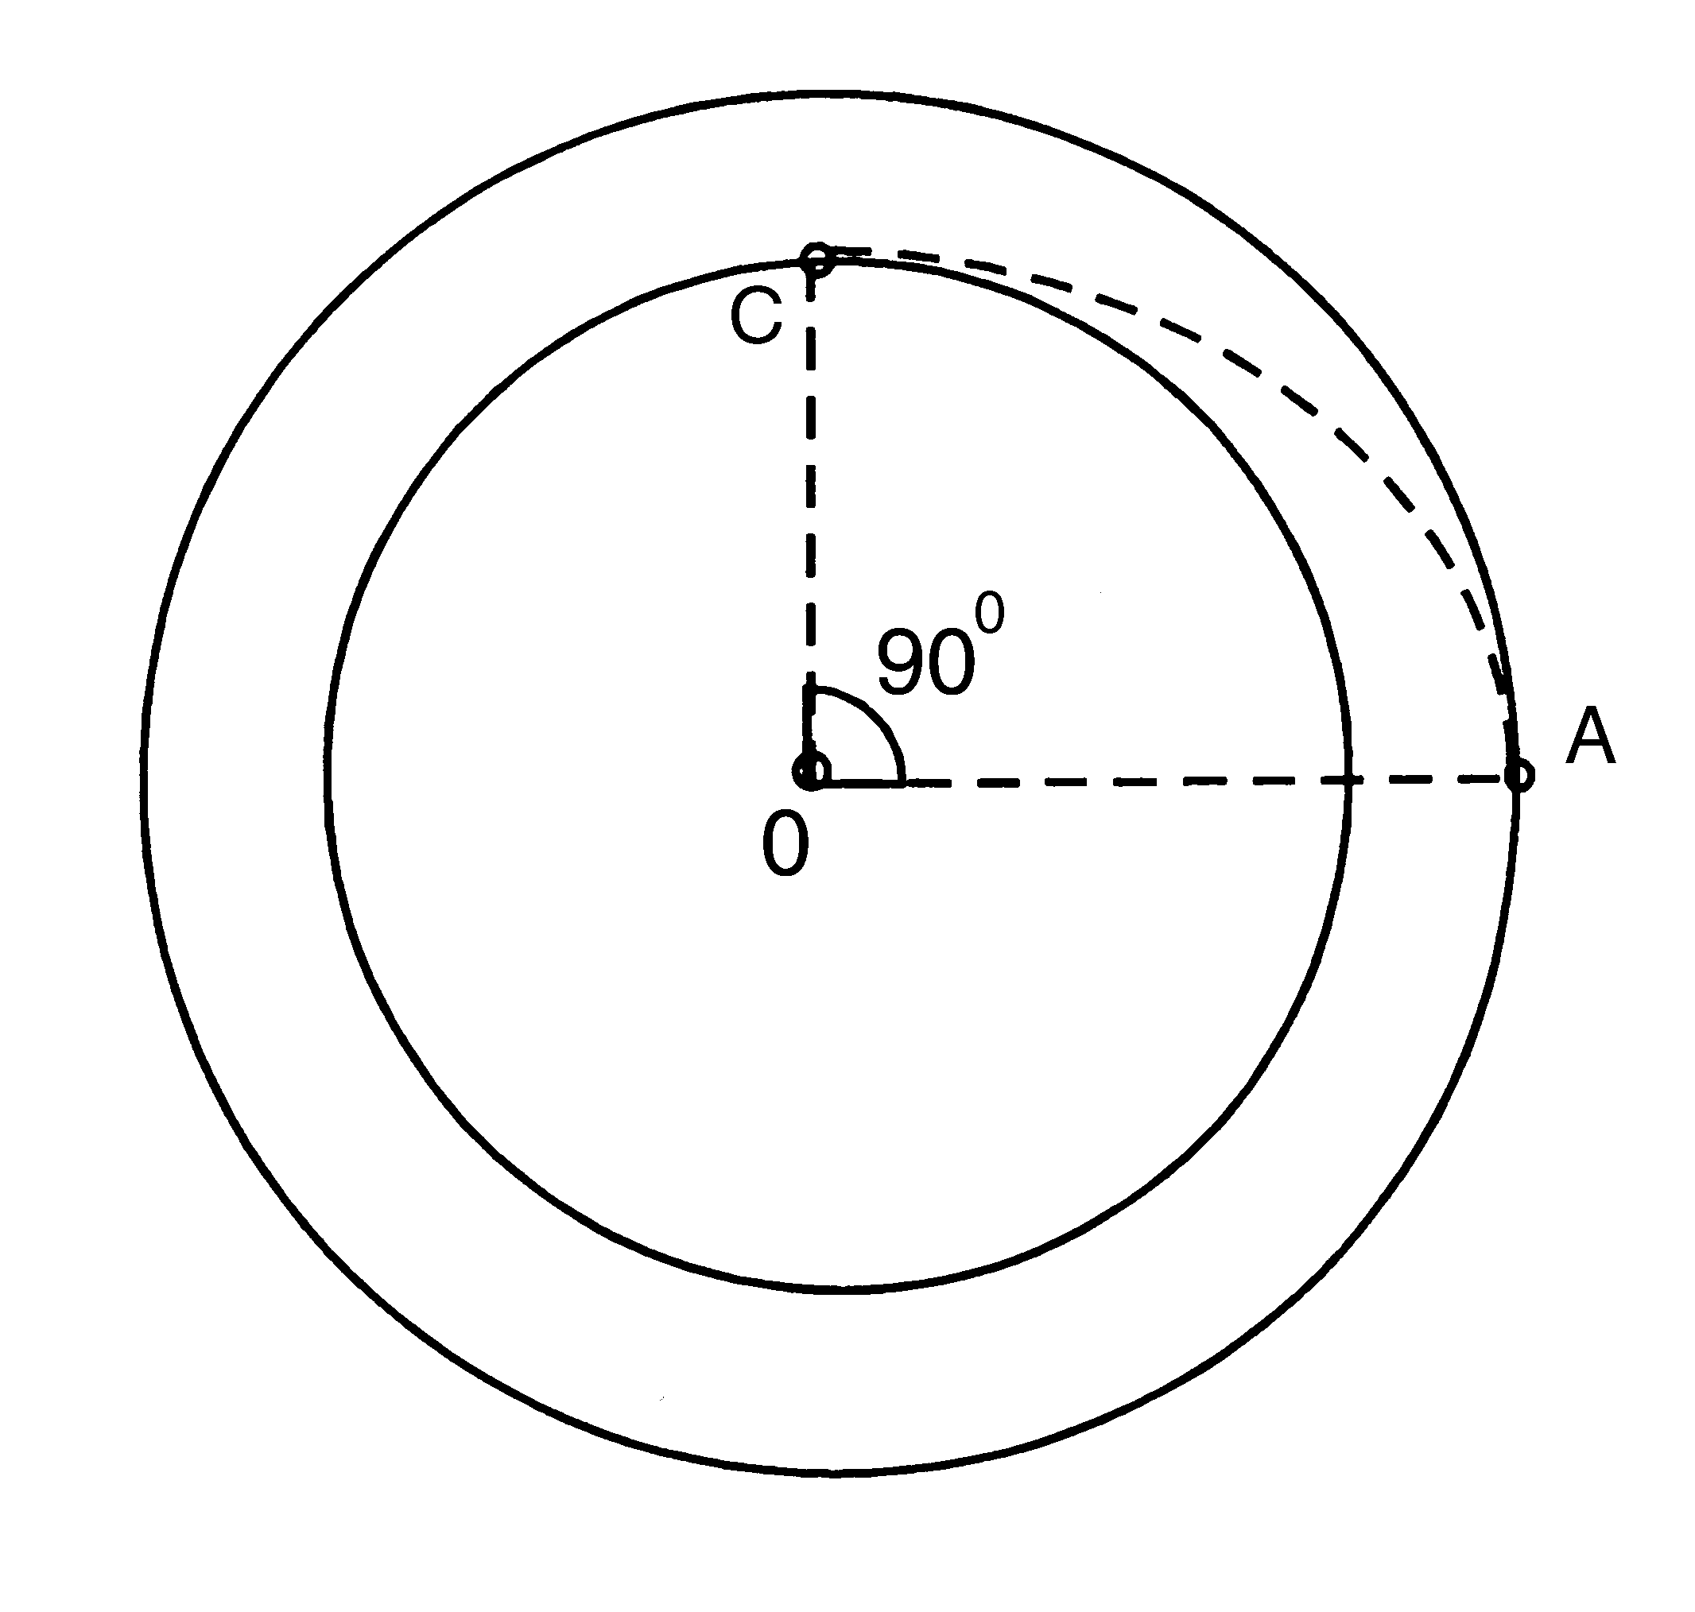
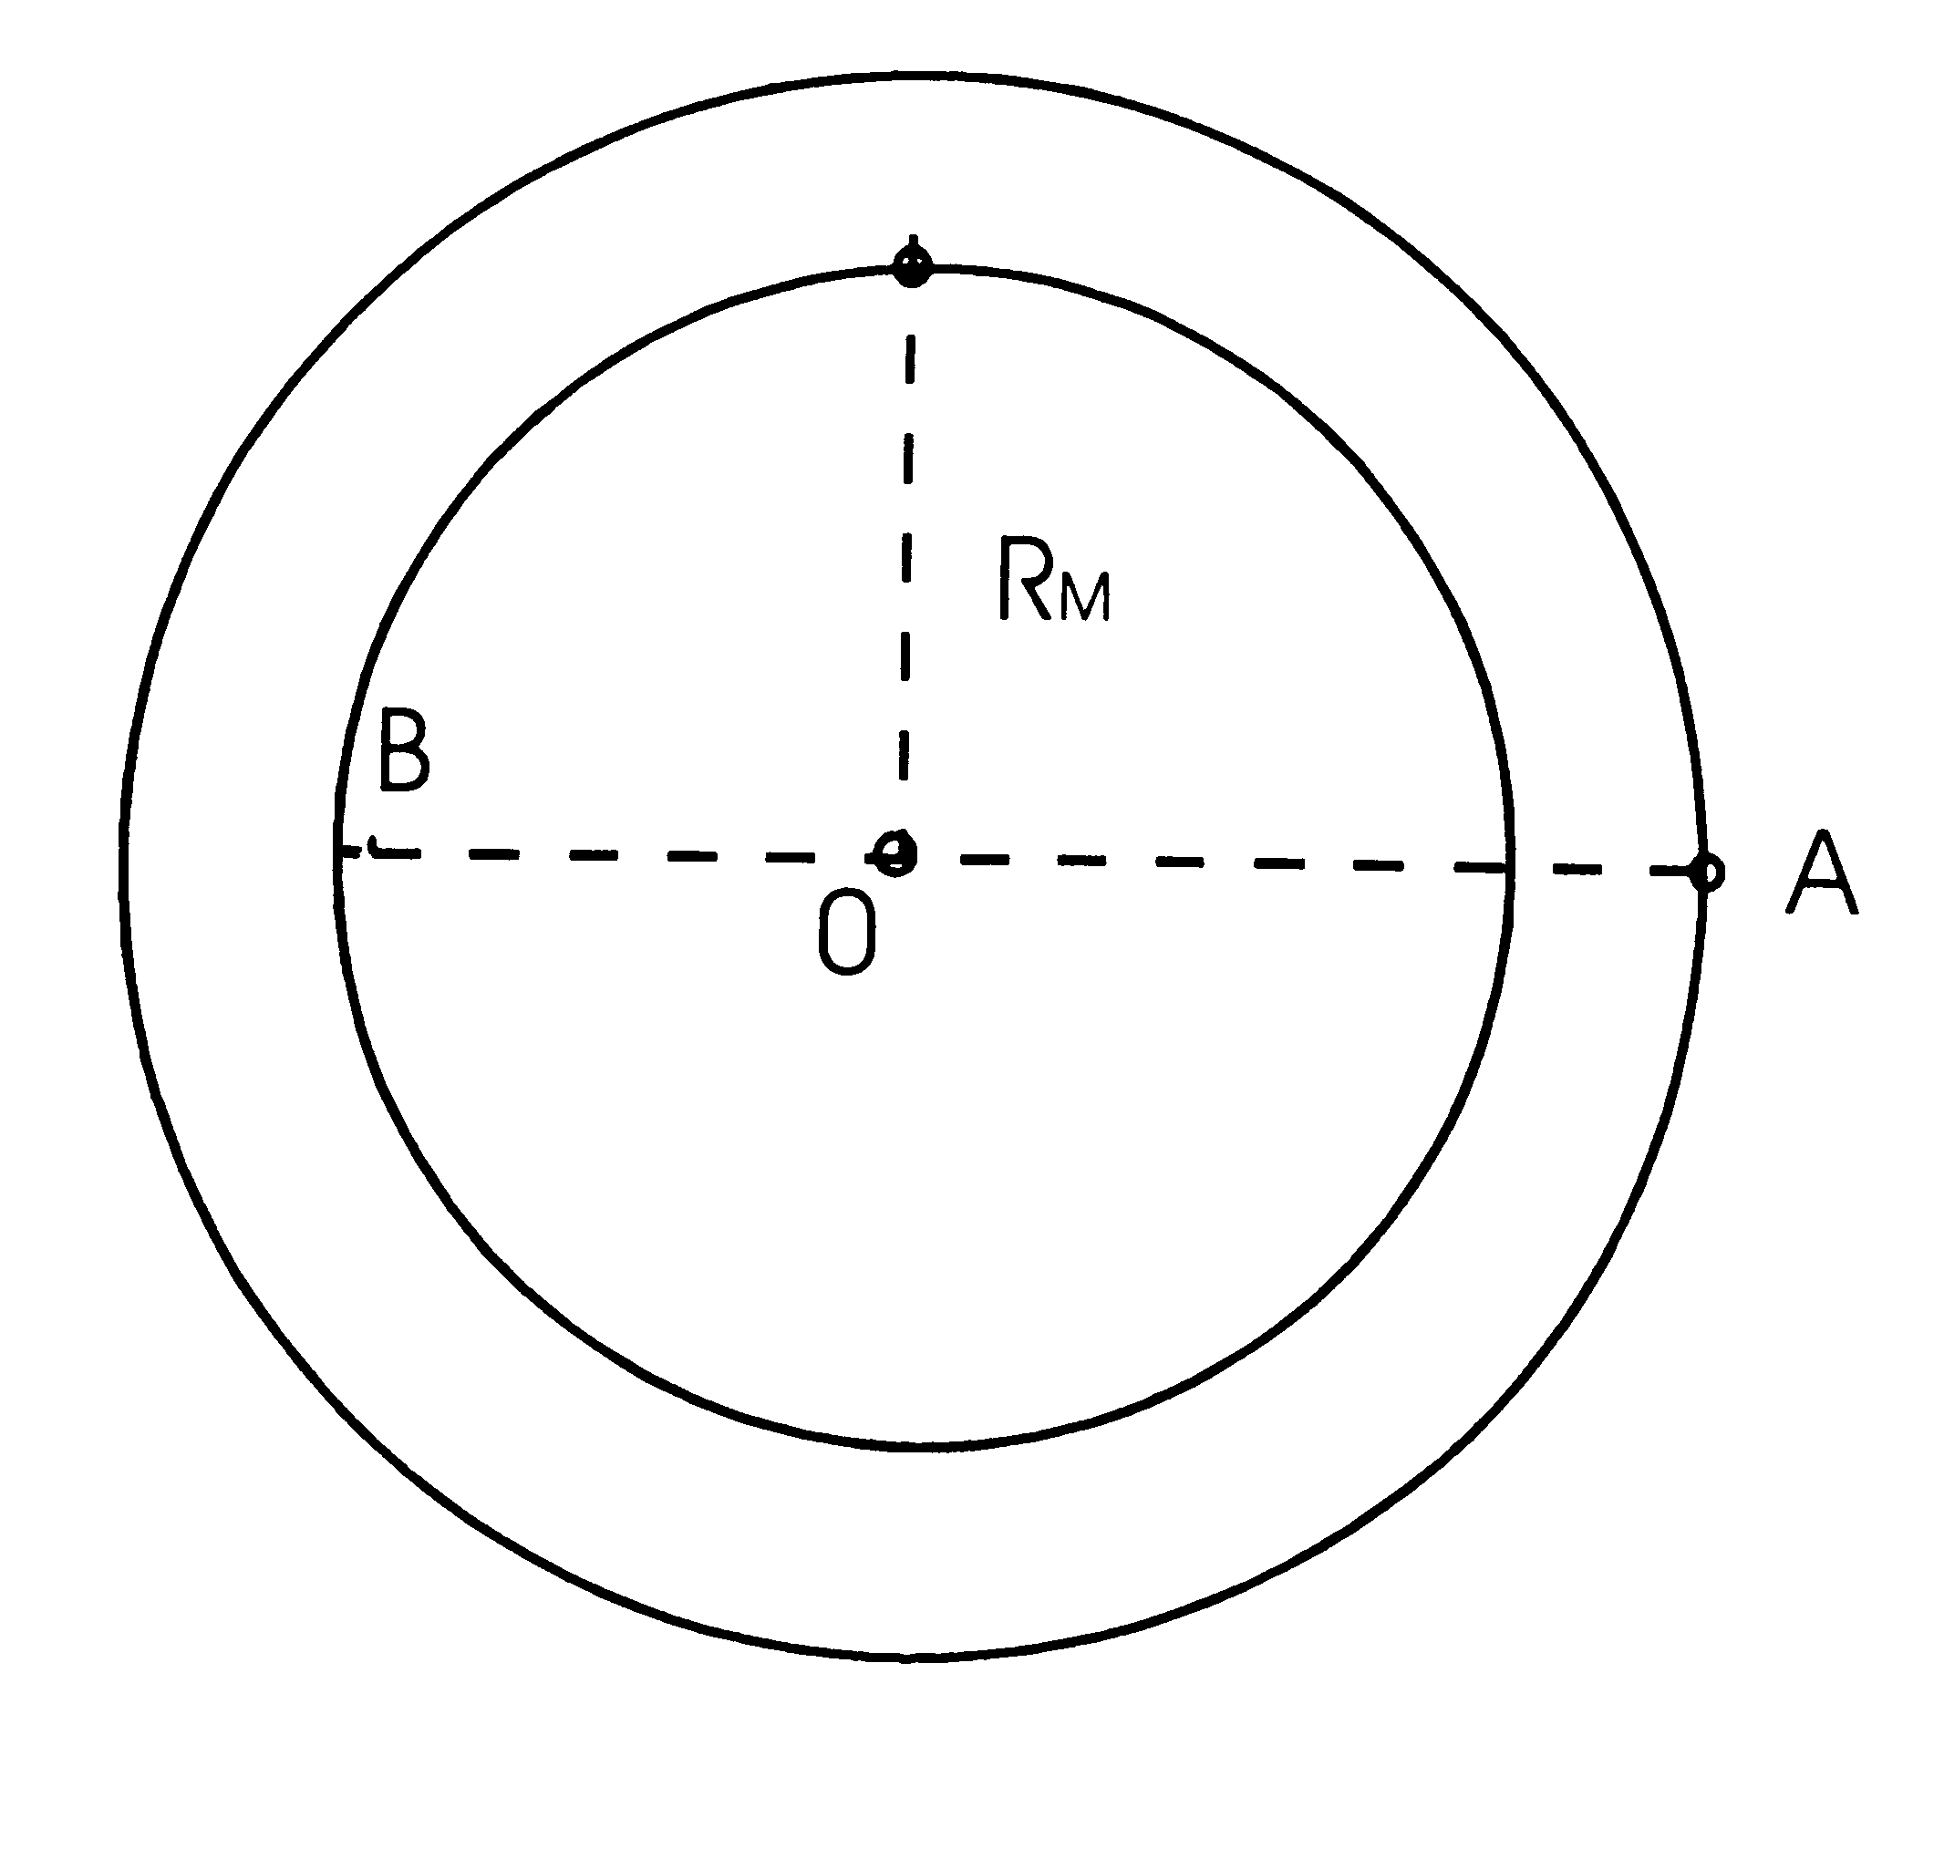

Fig.1 Fig.2

1). What amount of fuel should be spent so that when activating the braking engine at point A of the trajectory, the rocket would land on the Moon at point B (Fig.1)?
2). In the second scenario of landing, at point A the rocket is given an impulse directed towards the center of the Moon, to put the rocket to the orbit meeting the Moon surface at point C (Fig.2). What amount of fuel is needed in this case?

Problem 2.
Brass weights are used to weigh an aluminum-made sample on an analytical balance. The weighing is ones in dry air and another time in humid air with the water vapor pressure P_{h} =2·10³ Pa. The total atmospheric pressure (P = 10⁵ Pa) and the temperature (t =20° C) are the same in both cases.
What should the mass of the sample be to be able to tell the difference in the balance readings provided their sensitivity is m₀ = 0.1 mg ?
Aluminum density ρ₁= 2700 kg/m³, brass density ρ₂=.8500 kg/m³.

Problem 3
.During the Soviet-French experiment on the optical location of the Moon the light pulse of a ruby laser (λ= 0,69 μm) was directed to the Moon’s surface by the telescope with a diameter of the mirror D = 2,6 m. The reflector on the Moon’s surface reflected the light backward as an ideal mirror with the diameter d = 20 cm. The reflected light was then collected by the same telescope and focused at the photodetector.
- What must the accuracy to direct the telescope optical axis be in this experiment?
- What part of emitted laser energy can be detected after reflection on the Moon, if we neglect the light loses in the Earth’s atmosphere?
- Can we see a reflected light pulse with naked eye if the energy of single laser pulse
E = 1 J and the threshold sensitivity of eye is equal n =100 light quantum?
- Suppose the Moon’s surface reflects α = 10% of the incident light in the spatial angle 2π steradian, estimate the advantage of a using reflector.
The distance from the Earth to the Moon is L = 380000 km. The diameter of pupil of the eye is
d_{p} = 5mm. Plank constant is h = 6.6ּ10⁻³⁴ Jּs.

Experimental Problem

Define the electrical circuit scheme in a “black box” and determine the parameters of its elements.
List of instruments: A DC source with tension 4.5 V, an AC source with 50 Hz frequency and output voltage up to 30 V, two multimeters for measuring AC/DC current and voltage, variable resistor, connection wires.

Solution of Problems of the XI International Olympiad, Moscow, 1979
Solution of Theoretical Problems

Problem 1.
- During the rocket moving along the circular orbit its centripetal acceleration is created by moon gravity force:
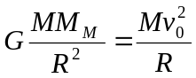,
where R = R_{M} + h is the primary orbit radius, v₀ -the rocket velocity on the circular orbit:
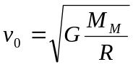
Since 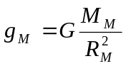 it yields
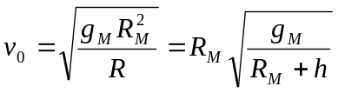 (1)
The rocket velocity will remain perpendicular to the radius-vector OA after the braking engine sends tangential momentum to the rocket (Fig.1). The rocket should then move along the elliptical trajectory with the focus in the Moon’s center.
Denoting the rocket velocity at points A and B as v_{A} and v_{B} we can write the equations for energy and momentum conservation as follows:

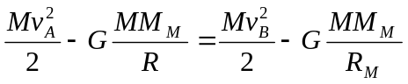 (2)
Mv_{A}R = Mv_{B}R_{M} (3)

Solving equations (2) and (3) jointly we find
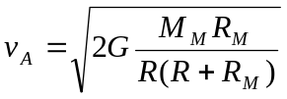
Taking (1) into account, we get

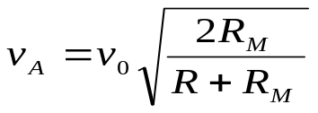.
Thus the rocket velocity change Δv at point A must be
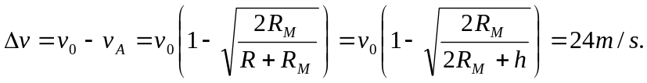
Since the engine switches on for a short time the momentum conservation low in the system “rocket-fuel” can be written in the form
(M – m₁)Δv = m₁u
where m₁ is the burnt fuel mass.
This yields
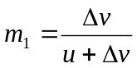
Allow for Δv << u we find
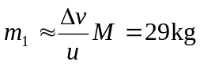
2) In the second case the vector is directed perpendicular to the vector thus giving
Based on the energy conservation law in this case the equation can be written as
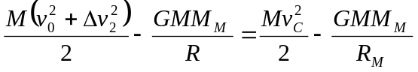 (4)
and from the momentum conservation law
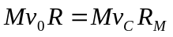. (5)

Solving equations (4) and (5) jointly and taking into account (1) we find
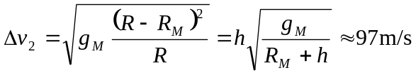.
Using the momentum conservation law we obtain
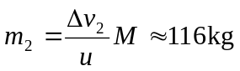.

Problem 2.
A sample and weights are affected by the Archimede’s buoyancy force of either dry or humid air in the first and second cases, respectively. The difference in the scale indication ΔF is determined by the change of difference of these forces.
The difference of Archimede’s buoyancy forces in dry air:
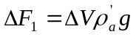
Whereas in humid air it is:
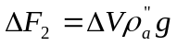
where ΔV - the difference in volumes between the sample and the weights, and 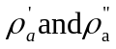 - densities of dry and humid air, respectively.
Then the difference in the scale indications ΔF could be written as follows:

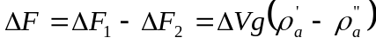 (1)

According to the problem conditions this difference should be distinguished, i.e.
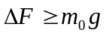 or 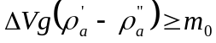 , wherefrom

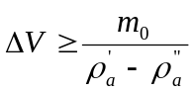 . (2)
The difference in volumes between the aluminum sample and brass weights can be found from the equation
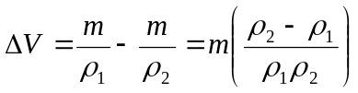 , (3)

where m is the sought mass of the sample. From expressions (2) and (3) we obtain

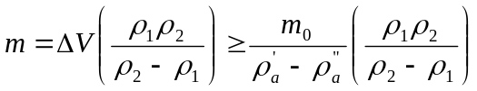 . (4)

To find the mass m of the sample one has to determine the difference 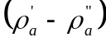 .
With the general pressure being equal, in the second case, some part of dry air is replaced by vapor:
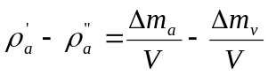 .

Changes of mass of air Δm_{a} and vapor Δm_{v} can be found from the ideal-gas equation of state
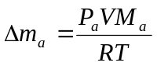 , 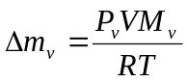,
wherefrom we obtain
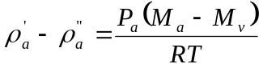 . (5)
From equations (4) and (5) we obtain
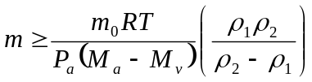 . (6)
The substitution of numerical values gives the answer: m ≥ 0.0432 kg ≈ 43 g.

Note. When we wrote down expression (3), we considered the sample mass be equal to the weights’ mass, at the same time allowing for a small error.
One may choose another way of solving this problem. Let us calculate the change of Archimede’s force by the change of the air average molar mass.
In dry air the condition of the balance between the sample and weights could be written down in the form of

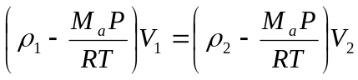 . (7)
In humid air its molar mass is equal to
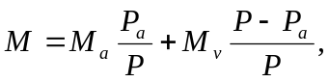 (8)

whereas the condition of finding the scale error could be written in the form
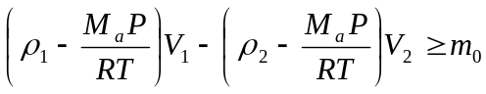. (9)
From expressions (7) –(9) one can get a more precise answer

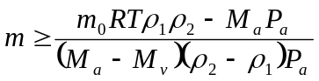 . (10)

Since 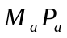<<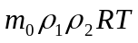 , then both expressions (6) and (10) lead practically to the same quantitative result, i.e. m ≥ 43 g.

Problem 3.
1) The beam divergence angle δφ caused by diffraction defines the accuracy of the telescope optical axis installation:
δφ ≈ λ/D ≈ 2.6∙10⁻⁷ rad. ≈ 0.05″ .

2) The part K₁ of the light energy of a laser, directed to a reflector, may be found by the ratio of the area of S₁ reflector ( S₁ = πd²/4 ) versus the area S₂ of the light spot on the Moon
(S₂ = πr² , where r = L δφ ≈ Lλ/D, L – the distance from the Earth to the Moon)

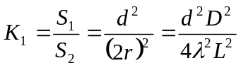

The reflected light beam diverges as well and forms a light spot with the radius R on the Earth’s surface:

R = λL/d, as r << R

That’s why the part K₂ of the reflected energy, which got into the telescope, makes

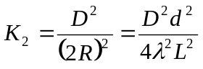
The part K₀ of the laser energy, that got into the telescope after having been reflected by the reflector on the Moon, equals
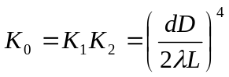≈ 10⁻¹²

3) The pupil of a naked eye receives as less a part of the light flux compared to a telescope, as the area of the pupil S_{e} is less than the area of the telescope mirror S_{t}:

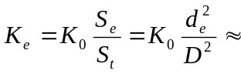3.7∙10⁻¹⁸ .
So the number of photons N getting into the pupil of the eye is equal
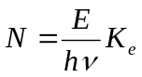= 12.
Since N<n, one can not perceive the reflected pulse with a naked eye.
4) In the absence of a reflector α =10% of the laser energy, that got onto the Moon, are dispersed by the lunar surface within a solid angle Ω₁ = 2π steradian.
The solid angle in which one can see the telescope mirror from the Moon, constitutes

Ω₂ = S_{t} /L² = πD²/4L²

That is why the part K of the energy gets into the telescope and it is equal

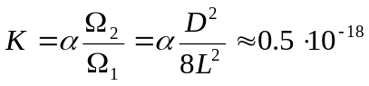

Thus, the gain β , which is obtained through the use of the reflector is equal
β = K₀/K ≈ 2·10⁶

Note. The result obtained is only evaluative as the light flux is unevenly distributed inside the angle of diffraction.

Solution of Experimental Problem.

A transformer is built-in in a “black box”. The black box has 4 terminals. To be able to determine the equivalent circuit and the parameters of its elements one may first carry out measurements of the direct current. The most expedient is to mount the circuit according to the layout in Fig.3 and to build volt-ampere characteristics for various terminals of the “box”. This enables one to make sure rightway that there were no e.m.f. sources in the “box” (the plot I=f(U) goes through the origin of the coordinates), no diodes (the current strength does not depend on the polarity of the current’s external source), by the inclination angle of the plot one may define the resistances between different terminals of the “box”. The tests allowed for some estimations of values R₁₋₂ and R₃₋₄. The ammeter did not register any current between the other terminals. This means that between these terminals there might be some other resistors with resistances larger than R_{L} :
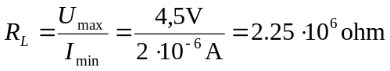
where I_{min} - the minimum value of the strength of the current which the instrument would have
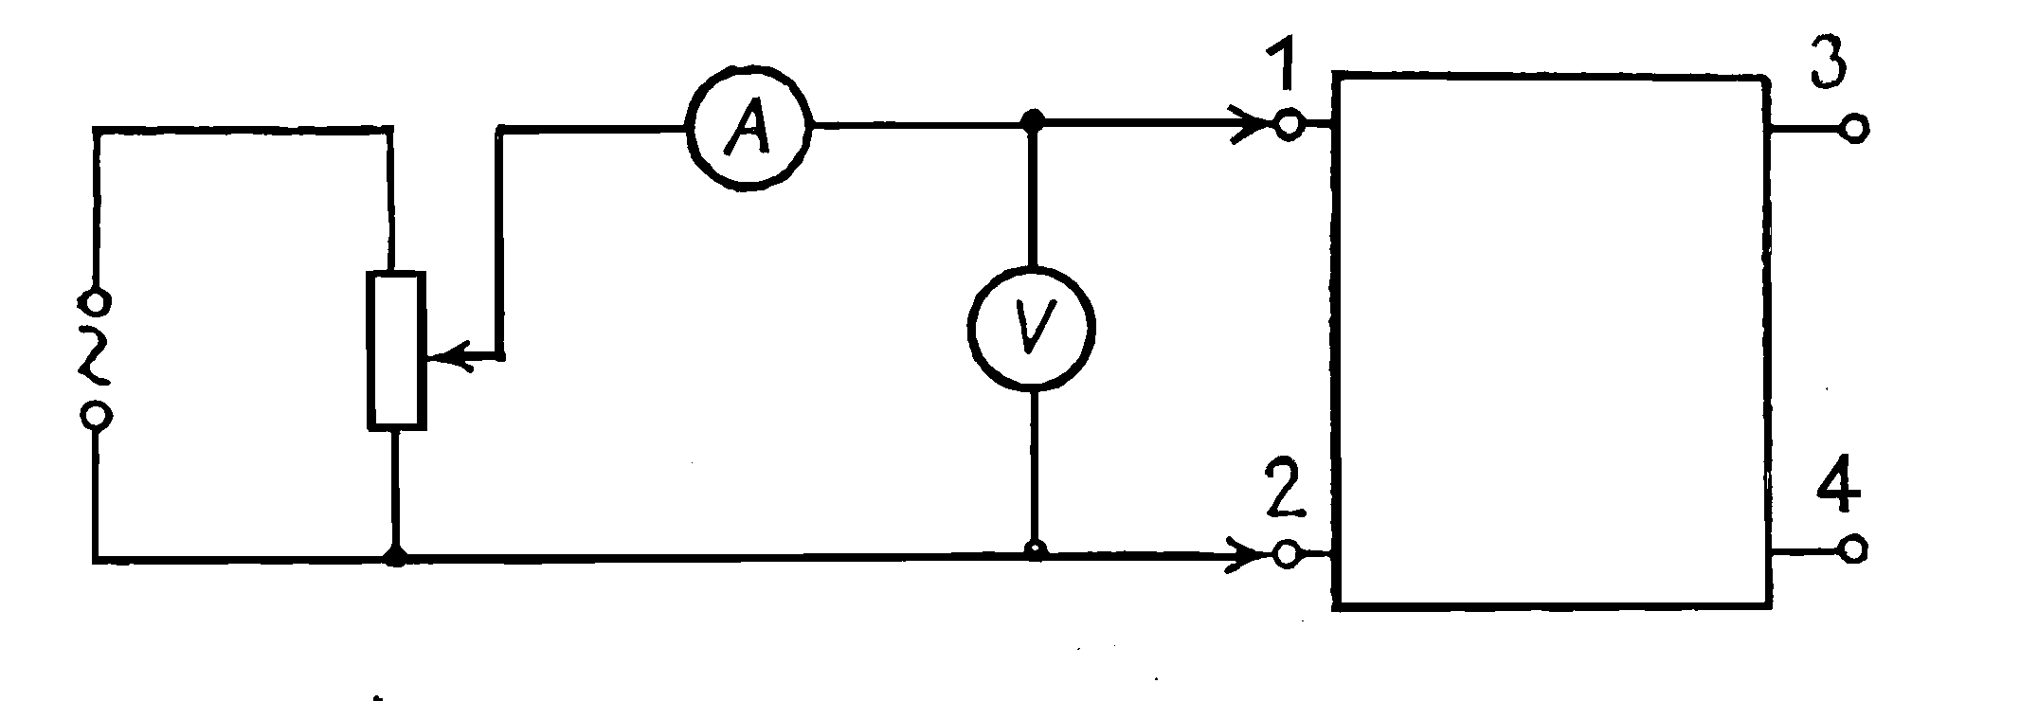

“Black
box”

Fig.3

registered. Probably there might be some capacitors between terminals 1-3, 1-4, 2-3, 2-4 (Fig.4).
Then, one can carry out analogous measurements of an alternative current. The taken volt-ampere characteristics enabled one to find full resistances on the alternative current of sections 1-2 and 3-4: Z₁ and Z₂ and to compare them to the values R₁ and R₂. It turned out, that Z₁>R₂ and Z₂>R₂.
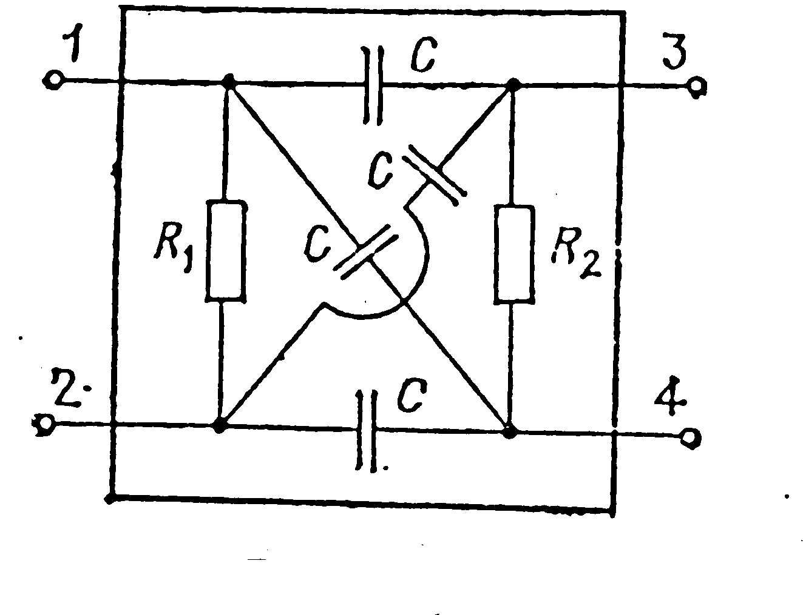
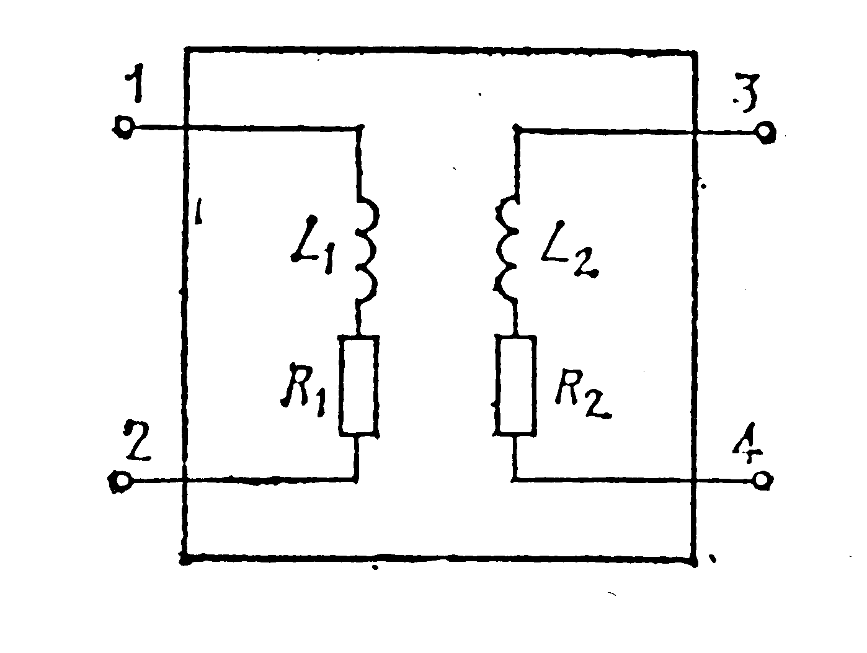

Fig.4 Fig.5
This fact allows one to conclude that in the “black box” the coils are connected to terminals 1-2 and 3-4 (Fig.5). Inductances of coils L₁ and L₂ can be determined by the formulas
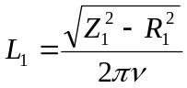 , 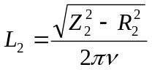.
After that the dependences Z = f(I), L=f(I) are to be investigated. The character of the found dependences enabled one to draw a conclusion about the presence of ferromagnetic cores in the coils. Judging by the results of the measurements on the alternative current one could identify the upper limit of capacitance of the capacitors which could be placed between terminals 1-3, 1-4, 2-3, 2-4:
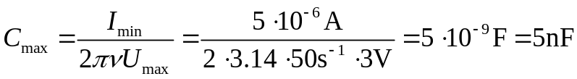
Then one could check the availability of inductive coupling between circuits 1-2 and 3-4. The plot of dependence of voltage U₃₋₄ versus voltage U₁₋₂ (Fig. 6) allows one to find both the transformation coefficient
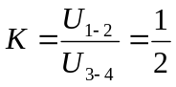
and the maximum operational voltages on coils L₁ and L₂, when the transformation

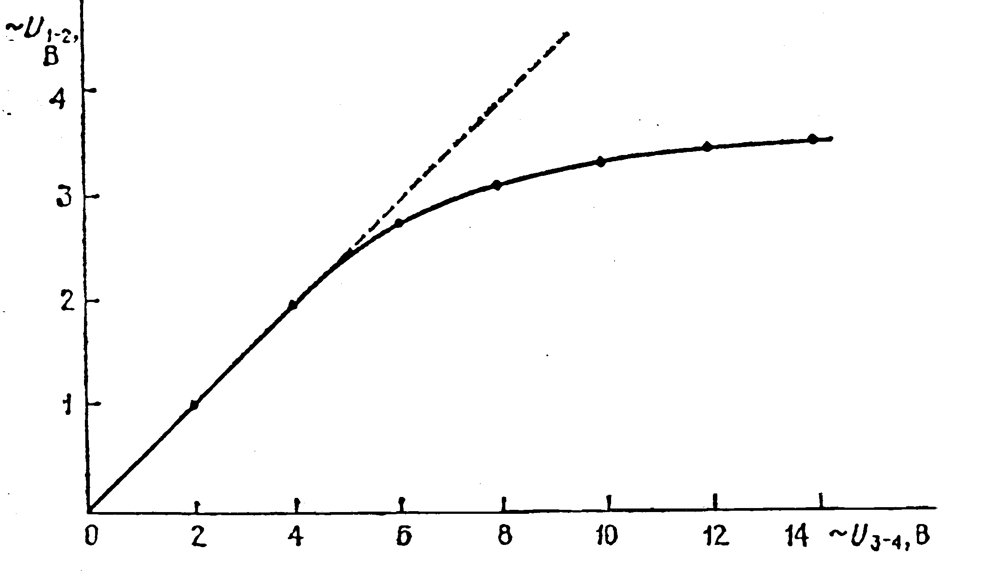

Fig.6

coefficient has not changed yet, i.e. before saturation of the core.
U_{1-2(max)} =2.5 V, U_{3-4(max)} = 5 V.
One could build either plot K(U₁₋₂) or K(U₃₋₄₎ (Fig. 7).
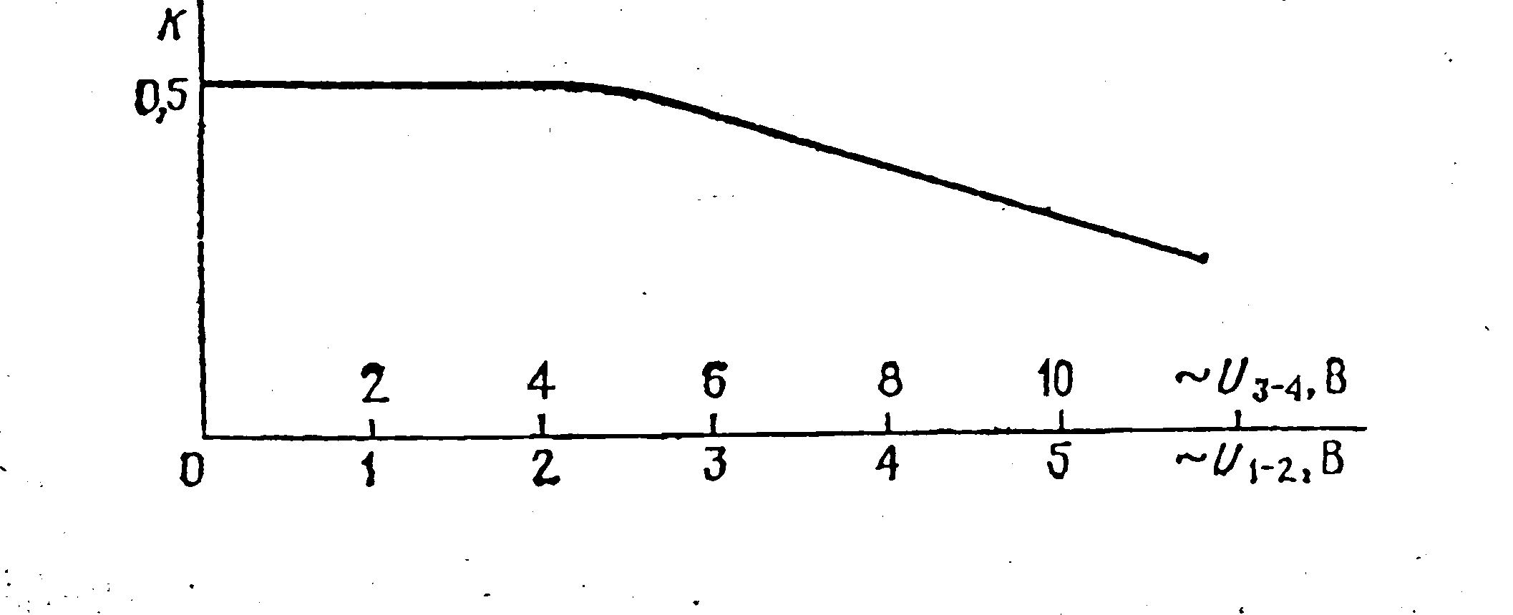

Fig.7

Note: It was also possible to define the “box” circuit after tests of the direct current. To do that one had to find the presence of induction coupling between terminals 1-2 and 3-4, that is the appearance of e.m.f. of induction in circuit 3-4, when closing and breaking circuits 1-2 and vice-versa. When comparing the direction of the pointer’s rejection of the voltmeters connected to terminals 1-2 and 3-4 one could identify directions of the transformer’s windings.

Acknowledgement
The authors would like to express their thanks and gratitude to Professor Waldemar Gorzkowski and Professor Ivo Volf for supplying the materials for the XI IphO in the Polish, Hungarian and Czech languages that have been of great help to the authors in their work at the problems of the Olympiad.

References:

- O.Kabardin, V.Orlov, International Physics Olympiads for Pupuls, Nauka, Moskva 1985.
- W.Gorzkowski, A.Kotlicki, Olimpiady Fizyczne XXVII i XXVIII, WsiP, Warszawa 1983
- R.Kunfalvi, Collection of Competition Tasks from the 1 trough XV International Physics Olympiads, 1867-1984, Roland Eotvos Physical Society an UNESCO, Budapest 1985
- V.Urumov, Megjunadodni Olimpijadi po Fisika, Prosvento Delo, Skopje 1999
- D.Kluvanec, I.Volf, Mezinarodni Fysikalni Olympiady, MaFy, Hradec Kralowe 1993

