XII International Physics Olympiad

Varna, Bulgaria, July 1981

The problems and the solutions are adapted by Miroslav Abrashev
University of Sofia, Faculty of Physics, 5 James Bourchier Blvd., 1164 Sofia, Bulgaria

Reference: O. F. Kabardin, V. A. Orlov, in “International Physics Olympiads for High School Students”, ed. V. G. Razumovski, Moscow, Nauka, 1985. (In Russian).

Theoretical Problem 1

A static container of mass M and cylindrical shape is placed in vacuum. One of its ends is closed. A fixed piston of mass m and negligible width separates the volume of the container into two equal parts. The closed part contains n moles of monoatomic perfect gas with molar mass M₀ and temperature T. After releasing of the piston, it leaves the container without friction. After that the gas also leaves the container. What is the final velocity of the container?
The gas constant is R. The momentum of the gas up to the leaving of the piston can be neglected. There is no heat exchange between the gas, container and the piston. The change of the temperature of the gas, when it leaves the container, can be neglected. Do not account for the gravitation of the Earth.

Theoretical Problem 2

An electric lamp of resistance R₀ = 2 Ω working at nominal voltage U₀ = 4.5 V is connected to accumulator of electromotive force E = 6 V and negligible internal resistance.
1. The nominal voltage of the lamp is ensured as the lamp is connected potentiometrically to the accumulator using a rheostat with resistance R. What should be the resistance R and what is the maximal electric current I_{max}, flowing in the rheostat, if the efficiency of the system must not be smaller than η₀ = 0.6?
2. What is the maximal possible efficiency η of the system and how the lamp can be connected to the rheostat in this case?

Theoretical Problem 3

A detector of radiowaves in a radioastronomical observatory is placed on the sea beach at height h = 2 m above the sea level. After the rise of a star, radiating electromagnetic waves of wavelength λ = 21 cm, above the horizont the detector registers series of alternating maxima and minima. The registered signal is proportional to the intensity of the detected waves. The detector registers waves with electric vector, vibrating in a direction parallel to the sea surface.
1. Determine the angle between the star and the horizont in the moment when the detector registers maxima and minima (in general form).
2. Does the signal decrease or increase just after the rise of the star?
3. Determine the signal ratio of the first maximum to the next minimum. At reflection of the electromagnetic wave on the water surface, the ratio of the intensities of the electric field of the reflected (E_{r}) and incident (E_{i}) wave follows the low:
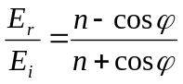,
where n is the refraction index and ϕ is the incident angle of the wave. For the surface “air-water” for λ = 21 cm, the refraction index n = 9.
4. Does the ratio of the intensities of consecutive maxima and minima increase or decrease with rising of the star?
Assume that the sea surface is flat.

Solution of the Theoretical Problem 1

Up to the moment when the piston leaves the container, the system can be considered as a closed one. It follows from the laws of the conservation of the momentum and the energy:
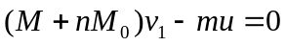 (1)
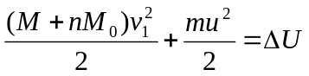, (2)
where v₁ – velocity of the container when the piston leaves it, u – velocity of the piston in the same moment, ΔU – the change of the internal energy of the gas. The gas is perfect and monoatomic, therefore
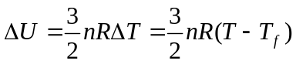; (3)
T_{f} - the temperature of the gas in the moment when the piston leaves the container. This temperature can be determined by the law of the adiabatic process:
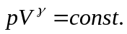
Using the perfect gas equation 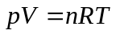, one obtains
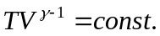, 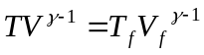
Using the relation 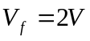, and the fact that the adiabatic coefficient for one-atomic gas is
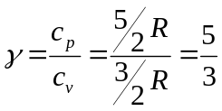, the result for final temperature is:
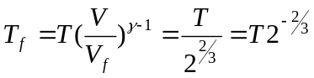 (4)
Solving the equations (1) – (4) we obtain
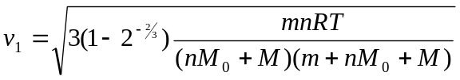 (5)
If the gas mass nM₀ is much smaller than the masses of the container M and the piston m, then the equation (5) is simplified to:
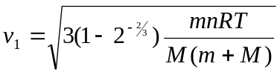 (5’)
When the piston leaves the container, the velocity of the container additionally increases to value v₂ due to the hits of the atoms in the bottom of the container. Each atom gives the container momentum:
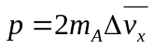,
where m_{A} – mass of the atom; 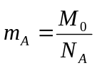, and 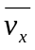 can be obtained by the averaged quadratic velocity of the atoms 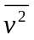as follows:
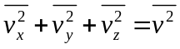, and 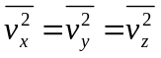, therefore 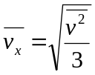. It appears that due to the elastic impact of one atom the container receives averaged momentum
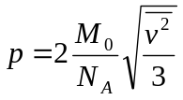
All calculations are done assuming that the thermal velocities of the atoms are much larger than the velocity of the container and that the movement is described using system connected with the container.
Have in mind that only half of the atoms hit the bottom of the container, the total momentum received by the container is
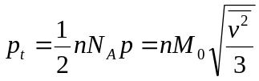 (6)
and additional increase of the velocity of the container is
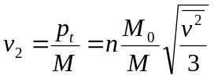. (7)
Using the formula for the averaged quadratic velocity
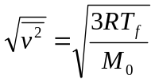
as well eq. (4) for the temperature T_{f} , the final result for v₂ is
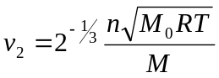. (8)
Therefore the final velocity of the container is
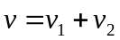=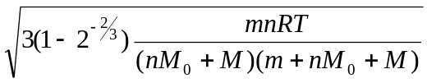+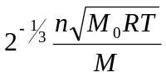≈
≈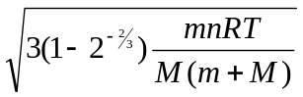+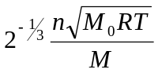. (9)

Solution of the Theoretical Problem 2

1) The voltage U₀ of the lamp of resistance R₀ is adjusted using the rheostat of resistance R. Using the Kirchhoff laws one obtains:
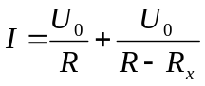, (1)
where 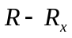 is the resistance of the part of the rheostat, parallel connected to the lamp, R_{x} is the resistance of the rest part,
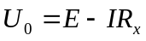 (2)
The efficiency η of such a circuit is
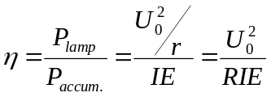. (3)
From eq. (3) it is seen that the maximal current, flowing in the rheostat, is determined by the minimal value of the efficiency:
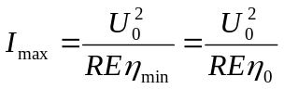. (4)
The dependence of the resistance of the rheostat R on the efficiency η can determined replacing the value for the current I , obtained by the eq. (3), 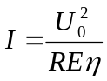, in the eqs. (1) and (2):
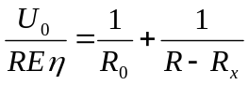, (5)
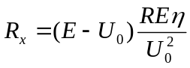. (6)
Then
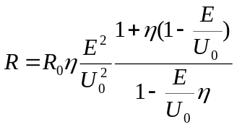. (7)
To answer the questions, the dependence 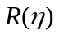 must be investigated. By this reason we find the first derivative 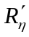:
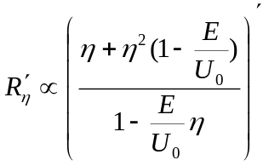
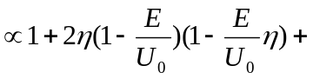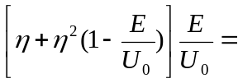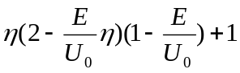.
η < 1, therefore the above obtained derivative is positive and the function R(η) is increasing.
It means that the efficiency will be minimal when the rheostat resistance is minimal. Then
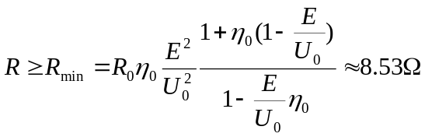.
The maximal current I_{max} can be calculated using eq. (4). The result is: I_{max} 660 mA.
2) As the function R(η) is increasing one, 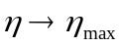, when 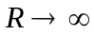. In this case the total current I will be minimal and equal to 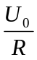. Therefore the maximal efficiency is
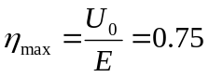
This case can be realized connecting the rheostat in the circuit using only two of its three plugs. The used part of the rheostat is R₁:
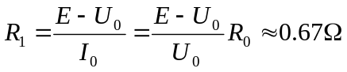.

Solution of the Theoretical Problem 3

1) The signal, registered by the detector A, is result of the interference of two rays: the ray 1, incident directly from the star and the ray 2, reflected from the sea surface (see the figure).
The phase of the second ray is shifted by π due to the reflection by a medium of larger refractive index. Therefore, the phase difference between the two rays is:
h
A
B
C
α
α
ϕ
2α
1
2
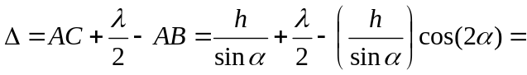
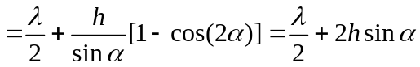 (1)
The condition for an interference maximum is:
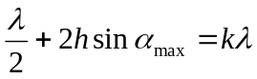, or
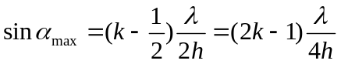, (2)
where k = 1,2,3,…,19. (the difference of the optical paths cannot exceed 2h, therefore k cannot exceed 19).
The condition for an interference minimum is:
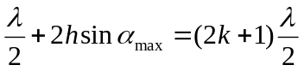, or
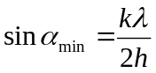 (3)
where k = 1,2,3,…,19.
2) Just after the rise of the star the angular height α is zero, therefore the condition for an interference minimum is satisfied. By this reason just after the rise of the star, the signal will increase.
3) If the condition for an interference maximum is satisfied, the intensity of the electric field is a sum of the intensities of the direct ray E_{i} and the reflected ray E_{r} ,
respectively: 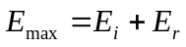.
Because 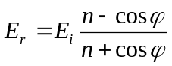, then 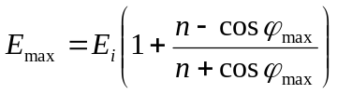.
From the figure it is seen that 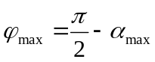, we obtain
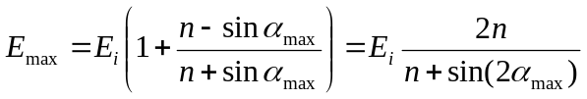. (4)
At the interference minimum, the resulting intensity is:
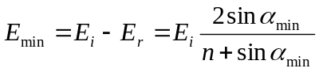. (5)
The intensity I of the signal is proportional to the square of the intensity of the electric field E, therefore the ratio of the intensities of the consecutive maxima and minima is:
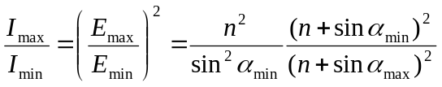. (6)
Using the eqs. (2) and (3), the eq. (6) can be transformed into the following form:
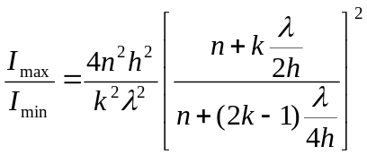. (7)
Using this general formula, we can determine the ratio for the first maximum (k =1) and the next minimum:

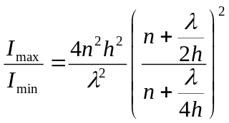= 3.10⁴
4) Using that 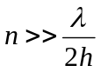, from the eq. (7) follows :
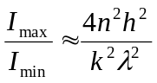.
So, with the rising of the star the ratio of the intensities of the consecutive maxima and minima decreases.

