

MARKING SCHEME FOR ANSWERS TO THE THEORETICAL QUESTION III -OPTICS
Part | MARKING SCHEME - THE THEORETICAL QUESTION III - Prisms | Total  Scores
III. a. | For:  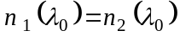 0.50p  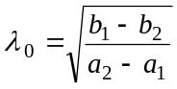 0.25p  final result: 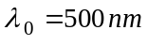 0.25p  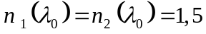 0.25p | 1.25 points
III. b. | For the rays with different wavelength (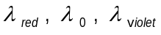) having the same incidence angle on first prism, the paths are illustrated in the figure III.1  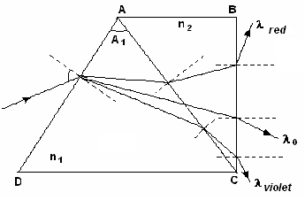  Figure III.1 | 2.00 points
III. c. | For:  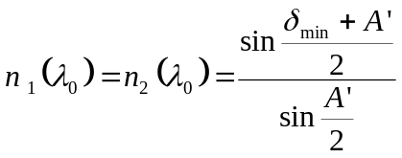 0.25p  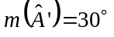 0.25p  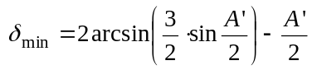 0.25p  final result: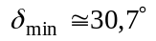 0.25p | 1.00 point
III. d. | For:  the refraction law on the 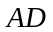 face 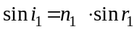 0.25p  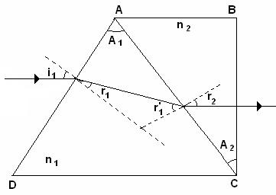  Figure III.2  the refraction law on the 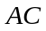 face 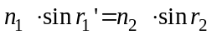 0.25p  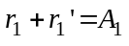 0.25p  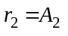 0.25p  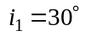 0.25p  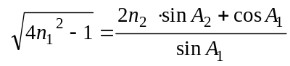 0.50p  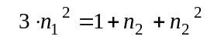 0.25p  0.50p  final result: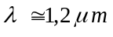 0.25p | 2.75 points
Total score theoretical question III |  | 7.00 points

Professor Delia DAVIDESCU, National Department of Evaluation and Examination–Ministry of Education and Research- Bucharest, Romania
Professor Adrian S.DAFINEI,PhD, Faculty of Physics – University of Bucharest, Romania

