

MARKING SCHEME FOR ANSWERS TO THE THEORETICAL QUESTION IV

Part | MARKING SCHEME - THE THEORETICAL QUESTION IV- COMPTON SCATTERING | Total  Scores
IV. | For:  the situation before the first scattering of photon  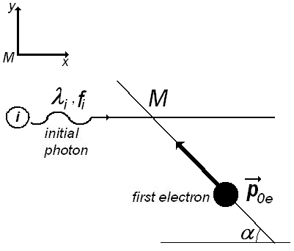  the momentum and the energy 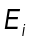of the initial photon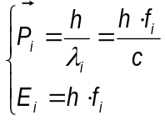 0.3p  the frequency of initial photon 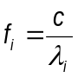 0.1p  the momentum 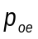 and the energy 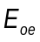 of initial, free electron in motion  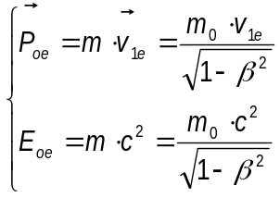 0.3p  De Broglie wavelength of the first electron 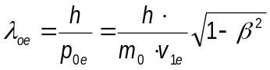 0.2p  the situation after the scattering of photon  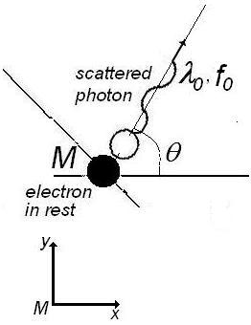  the momentum 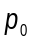 and the energy 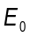 of the scattered photon 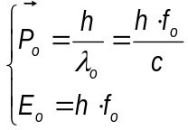 0.3p  the frequency of scattered photon 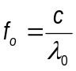 0.1p | 7.0 points
the principles of conservation of moments and energy 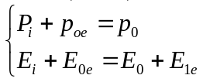 0.3p
the conservation of moment on 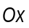 direction 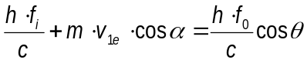 0.3p
the conservation of moment on 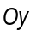 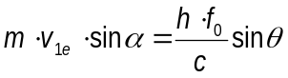 0.3p

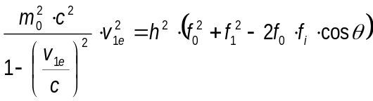 0.4p

The conservation of energy 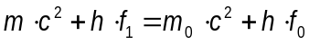 0.3p

or 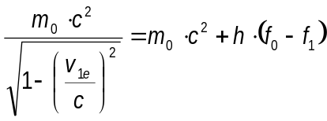 0.2p

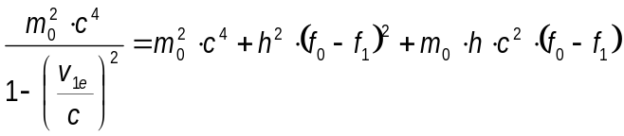 0.2p

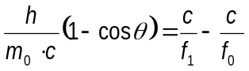 0.2p

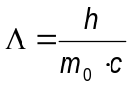 0.2p

the wavelength of scattered photon 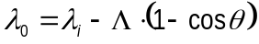 0.3p

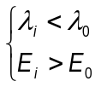 0.1p

the situation before the second collision

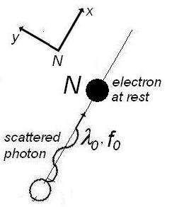

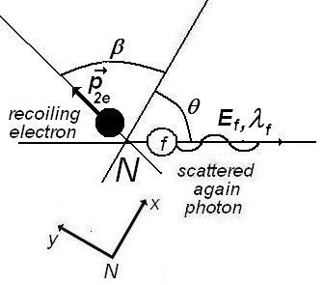
the situation after this scattering process

The conservation principle for moment in the scattering process

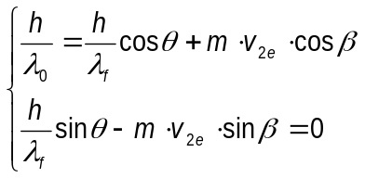 0.3p

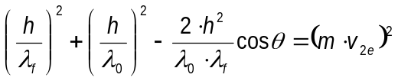 0.3p

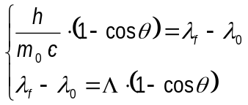 0.5p

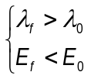 0.1p

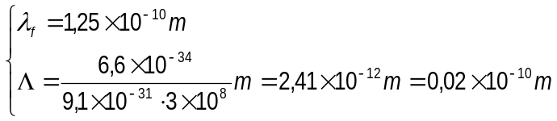 0.2p

the value of wavelength of photon before the second scattering 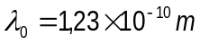 0.1p

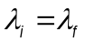 0.3p

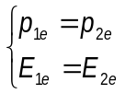 0.2p

the moment of final electron

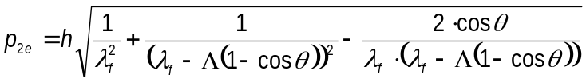 0.4p

The de Broglie wavelength of second electron after scattering (and of first electron before scattering)

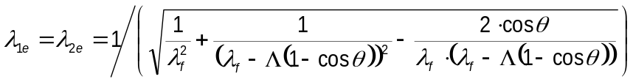 0.3p

final result: 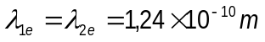 0.2p

Total score theoretical question IV |  | 7.0 points

Professor Delia DAVIDESCU, National Department of Evaluation and Examination–Ministry of Education and Research- Bucharest, Romania
Professor Adrian S.DAFINEI,PhD, Faculty of Physics – University of Bucharest, Romania

