

MARKING SCHEME FOR ANSWERS TO THE THEORETICAL QUESTION I

Part | MARKING SCHEME - THE THEORETICAL QUESTION I- JUMPING PARTICLE | Total  Scores
I.a. | For:  the distance covered by the particle to the stop  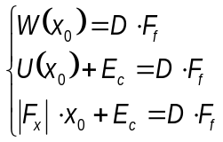 1.00 p  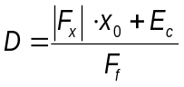 0.50 p  final result 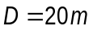 0.50 p | 2.00 points
I.b. | For:  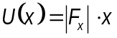 1.00 p  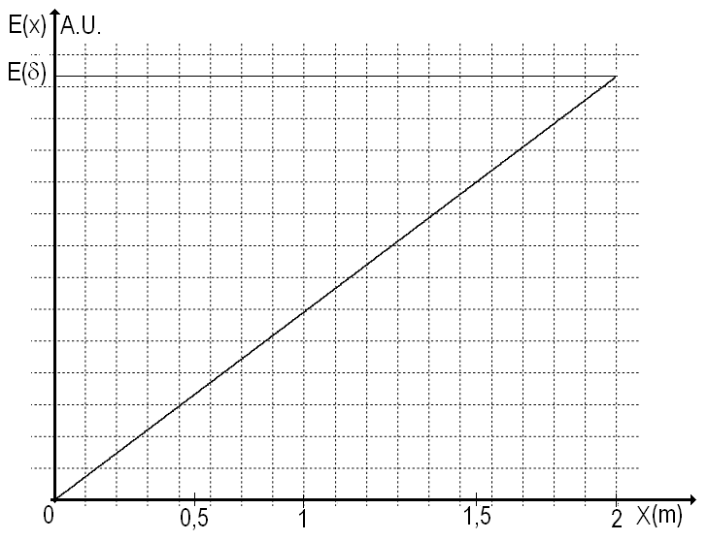  1.00 p | 2.00 points
I.c. | For :  the evolution of the square of the speed as function of the position  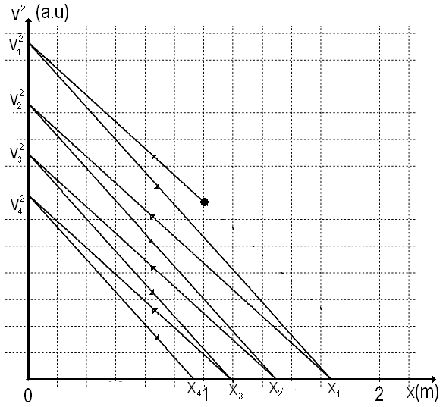  1.00 p | 4.00 points
the evolution of the speed as function of the position

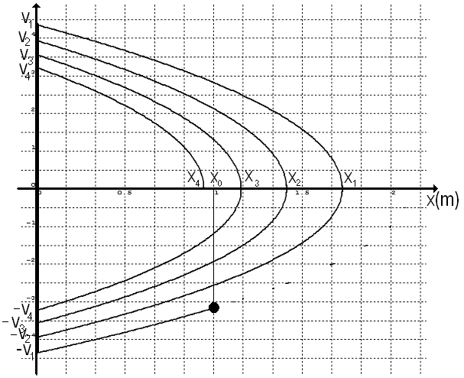

1.00 p

or
the evolution of the square of the speed as function of the position

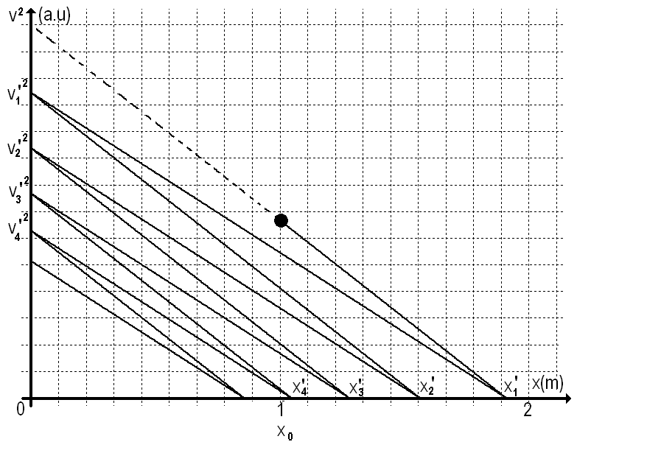

1.00 p
the evolution of the speed as function of the position

.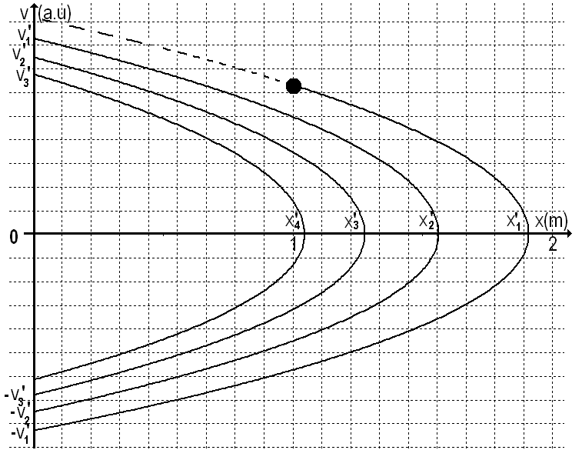

1.00 p
Total score - theoretical question I |  | 8.00 points

Professor Delia DAVIDESCU, National Department of Evaluation and Examination–Ministry of Education and Research- Bucharest, Romania
Professor Adrian S.DAFINEI,PhD, Faculty of Physics – University of Bucharest, Romania

