Optics – Problem III (7points)

Prisms

Two dispersive prisms having apex angles 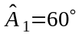 and 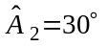 are glued as in the figure (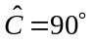). The dependences of refraction indexes of the prisms on the wavelength are given by the relations
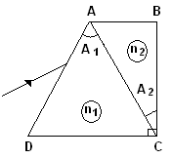
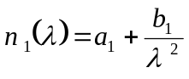;
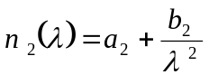
were

- Determine the wavelength 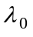 of the incident radiation that pass through the prisms without refraction on 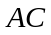 face at any incident angle; determine the corresponding refraction indexes of the prisms.
- Draw the ray path in the system of prisms for three different radiations 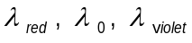 incident on the system at the same angle.
- Determine the minimum deviation angle in the system for a ray having the wavelength.
- Calculate the wavelength of the ray that penetrates and exits the system along directions parallel to DC.

Problem III - Solution

a. The ray with the wavelength pass trough the prisms system without refraction on face at any angle of incidence if :
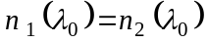
Because the dependence of refraction indexes of prisms on wavelength has the form :
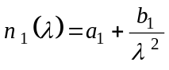 ( 3.)
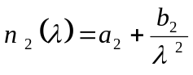 ( 3.)
The relation (3.1) becomes:
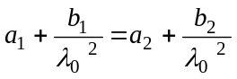 ( 3.)
The wavelength has correspondingly the form:
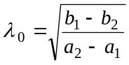 ( 3.)
Substituting the furnished numerical values
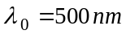 ( 3.)
The corresponding common value of indexes of refraction of prisms for the radiation with the wavelength is:
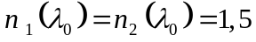 ( 3.)
The relations (3.6) and (3.7) represent the answers of question a.

b. For the rays with different wavelength (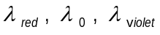) having the same incidence angle on first prism, the paths are illustrated in the figure 1.1.

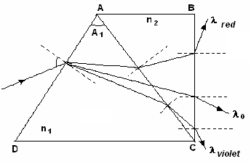
Figure 3.1
The draw illustrated in the figure 1.1 represents the answer of question b.

c. In the figure 1.2 is presented the path of ray with wavelength at minimum deviation (the angle between the direction of incidence of ray and the direction of emerging ray is minimal).
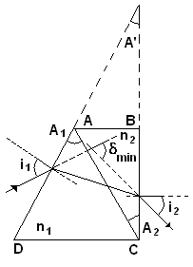

Figure 3.2
In this situation
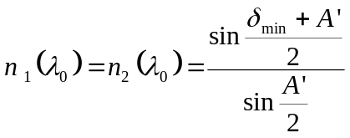 ( 3.)
where
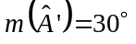,
as in the figure 1.1
Substituting in (3.8) the values of refraction indexes the result is
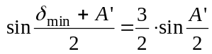 ( 3.)
or
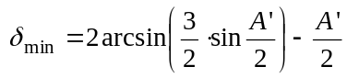 ( 3.)
Numerically
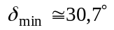 ( 3.)
The relation (3.11) represents the answer of question c.

d. Using the figure 1.3 the refraction law on the  face is
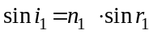 ( 3.)
The refraction law on the face is
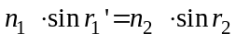 ( 3.)

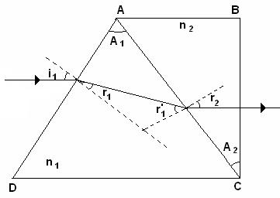

Figure 3.3

As it can be seen in the figure 1.3
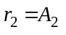 ( 3.)
and
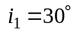 ( 3.)
Also,
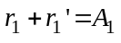 ( 3.)
Substituting (3.16) and (3.14) in (3.13) it results
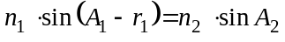 ( 3.)
or
( 3.)
Because of (3.12) and (3.15) it results that
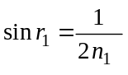 ( 3.)
and
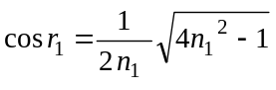 ( 3.)
Putting together the last three relations it results
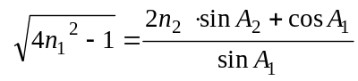 ( 3.)
Because
and
relation (3.21) can be written as
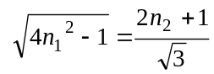 ( 3.)
or
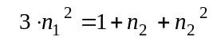 ( 3.)
Considering the relations (3.1), (3.2) and (3.23) and operating all calculus it results:
( 3.)
Solving the equation (3.24) one determine the wavelength 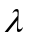 of the ray that enter the prisms system having the direction parallel with  and emerges the prism system having the direction again parallel with . That is
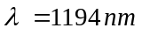 ( 3.)
or
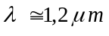 ( 3.)
The relation (3.26) represents the answer of question d.

Professor Delia DAVIDESCU, National Department of Evaluation and Examination–Ministry of Education and Research- Bucharest, Romania
Professor Adrian S.DAFINEI,PhD, Faculty of Physics – University of Bucharest, Romania

