Atomics - Problem IV (7 points)

Compton scattering

A photon of wavelength 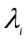 is scattered by a moving, free electron. As a result the electron stops and the resulting photon of wavelength 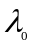 scattered at an angle 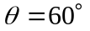 with respect to the direction of the incident photon, is again scattered by a second free electron at rest. In this second scattering process a photon with wavelength of 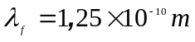 emerges at an angle 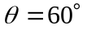 with respect to the direction of the photon of wavelength. Find the de Broglie wavelength for the first electron before the interaction. The following constants are known:
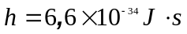 - Planck’s constant
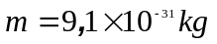 - mass oh the electron
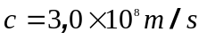 - speed of light in vacuum

Problem III - Solution

The purpose of the problem is to calculate the values of the speed, momentum and wavelength of the first electron.

To characterize the photons the following notation are used:
Table 4.1
 | initial  photon | photon –  after the  first scattering | final  photon
momentum | 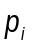 | 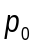 | 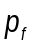
energy | 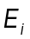 | 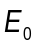 | 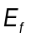
wavelength | 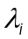 |  | 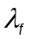
To characterize the electrons one uses
Table 4.2
 | first electron  before collision | first electron  after collision | second electron  before collision | Second electron  after collision
momentum | 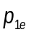 |  |  | 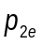
energy | 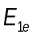 | 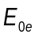 |  | 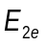
speed | 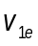 |  |  | 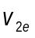

The image in figure 4.1 presents the situation before the first scattering of photon.

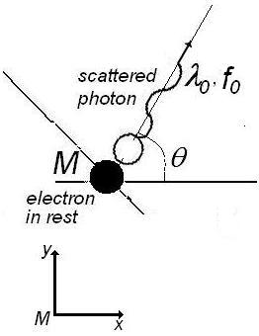
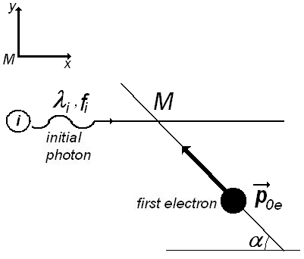

Figure 4.1 Figure 4.2

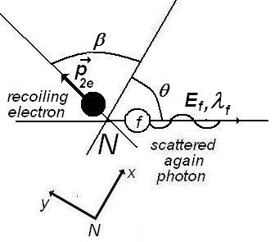
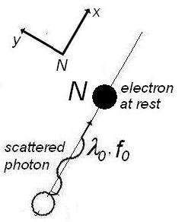
Figure 4.3 Figure 4.4
To characterize the initial photon we will use his momentum and his energy 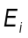
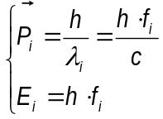 ( 4.)
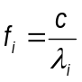 ( 4.)
is the frequency of initial photon.
For initial, free electron in motion the momentum 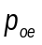 and the energy 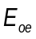are
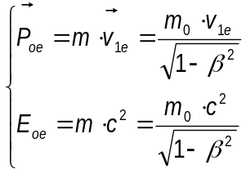 ( 4.)
where 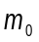 is the rest mass of electron and is the mass of moving electron. As usual, 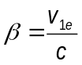. De Broglie wavelength of the first electron is

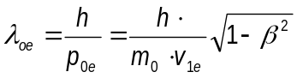
The situation after the scattering of photon is described in the figure 4.2.
To characterize the scattered photon we will use his momentum 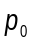 and his energy 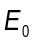
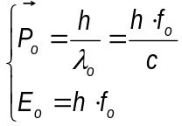 ( 4.).
where
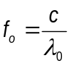 ( 4.)
is the frequency of scattered photon.

The magnitude of momentum of the electron ( that remains in rest) after the scattering is zero; his energy is 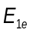. The mass of electron after collision is 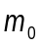 - the rest mass of electron at rest. So,
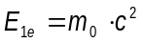
To determine the moment of the first moving electron, one can write the principles of conservation of moments and energy. That is
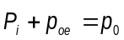 ( 4.)
and
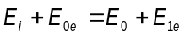 ( 4.)
The conservation of moment on  direction is written as
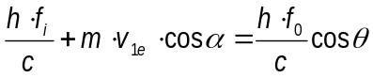 ( 4.)
and the conservation of moment on  is
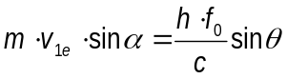 ( 4.)
To eliminate , the last two equation must be written again as
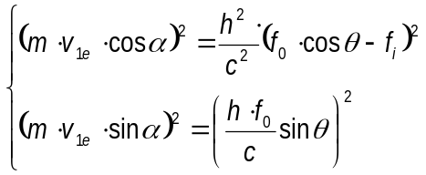 ( 4.)
and then added.
The result is
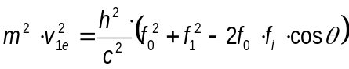 ( 4.)
or
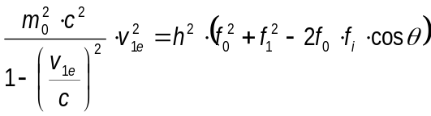 ( 4.)
The conservation of energy (4.7) can be written again as
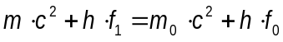 ( 4.)
or
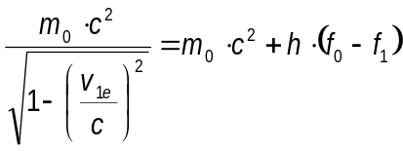 ( 4.)
Squaring the last relation results
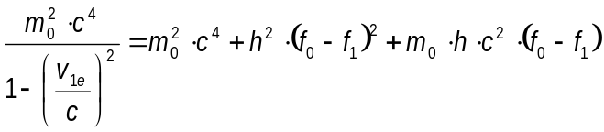 ( 4.)
Subtracting (4.12) from (4.15) the result is
( 4.)
or
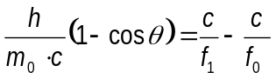 ( 4.)
Using
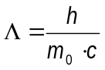 ( 4.)
the relation (4.17) becomes
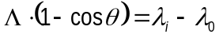 ( 4.)
The wavelength of scattered photon is
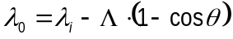 ( 4.)
shorter than the wavelength of initial photon and consequently the energy of scattered photon is greater that the energy of initial photon.
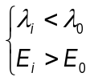 ( 4.)
Let’s analyze now the second collision process that occurs in point . To study that, let’s consider a new referential having  direction on the direction of the photon scattered after the first collision.

The figure 4.3 presents the situation before the second collision and the figure 4.4 presents the situation after this scattering process. The conservation principle for moment in the scattering process gives
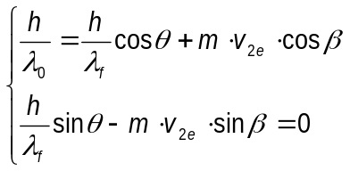 ( 4.)
To eliminate the unknown angle  must square and then add the equations (4.22)
That is
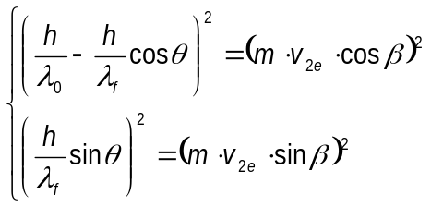 ( 4.)
or
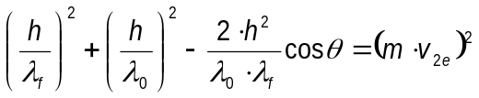 ( 4.)
The conservation principle of energy in the second scattering process gives
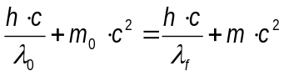 ( 4.)
(4.24) and (4.25) gives
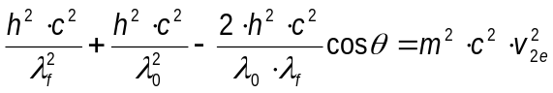 ( 4.)
and
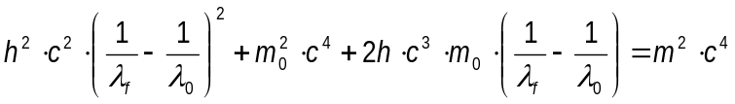 ( 4.)
Subtracting (4.26) from (1.27), one obtain
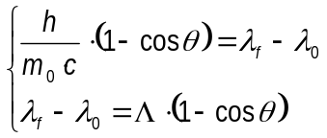 ( 4.)
That is

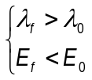 ( 4.)
Because the value of is know and  can be calculate as
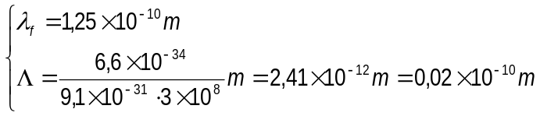 ( 4.)
the value of wavelength of photon before the second scattering is
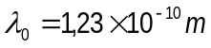 ( 4.)
Comparing (4.28) written as:
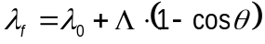 ( 4.)
and (4.20) written as
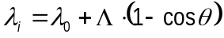 ( 4.)
clearly results
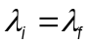 ( 4.)
The energy of the double scattered photon is the same as the energy of initial photon. The direction of “final photon” is the same as the direction of “initial” photon. Concluding, the final photon is identical with the initial photon. The result is expected because of the symmetry of the processes.
Extending the symmetry analyze on electrons, the first moving electron that collides the initial photon and after that remains at rest, must have the same momentum and energy as the second electron after the collision – because this second electron is at rest before the collision.
That is
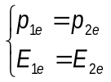 ( 4.)
Taking into account (4.24), the moment of final electron is
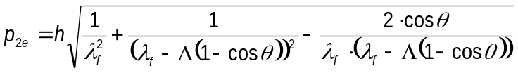 ( 4.)
The de Broglie wavelength of second electron after scattering (and of first electron before scattering) is
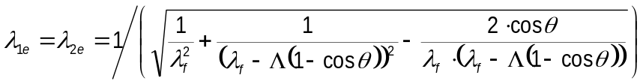 ( 4.)
Numerical value of this wavelength is
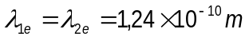 ( 4.)

Professor Delia DAVIDESCU, National Department of Evaluation and Examination–Ministry of
Education and Research- Bucharest, Romania
Professor Adrian S.DAFINEI,PhD, Faculty of Physics – University of Bucharest, Romania

