Problems of the XV International Physics Olympiad
(Sigtuna, 1984)

Lars Gislén
Department of Theoretical Physics, University of Lund, Sweden

Theoretical problems

Problem 1

a) Consider a plane-parallel transparent plate, where the refractive index, n, varies with distance, z, from the lower surface (see figure). Show that . The notation is that of the figure.
b) Assume that you are standing in a large flat desert. At some distance you see what appears to be a water surface. When you approach the “water” is seems to move away such that the distance to the “water” is always constant. Explain the phenomenon.

c) Compute the temperature of the air close to the ground in b) assuming that your eyes are located 1.60 m above the ground and that the distance to the “water” is 250 m. The refractive index of the air at 15 ˚C and at normal air pressure (101.3 kPa) is 1.000276. The temperature of the air more than 1 m above the ground is assumed to be constant and equal to 30 ˚C. The atmospheric pressure is assumed to be normal. The refractive index, n, is such that n – 1 is proportional to the density of the air. Discuss the accuracy of your result.
Solution:

a) From the figure we get

b) The phenomenon is due to total reflexion in a warm layer of air when β = 90˚. This gives

c) As the density, ρ, of the air is inversely proportional to the absolute temperature, T, for fixed pressure we have
The value given at 15 ˚C determines the value of k = 0.0795.
In order to have total reflexion we have or
with h = 1.6 m and L = 250 m
As h << L we can use a power expansion in :

Problem 2

In certain lakes there is a strange phenomenon called “seiching” which is an oscillation of the water. Lakes in which you can see this phenomenon are normally long compared with the depth and also narrow. It is natural to see waves in a lake but not something like the seiching, where the entire water volume oscillates, like the coffee in a cup that you carry to a waiting guest.

In order to create a model of the seiching we look at water in a rectangular container. The length of the container is L and the depth of the water is h. Assume that the surface of the water to begin with makes a small angle with the horizontal. The seiching will then start, and we assume that the water surface continues to be plane but oscillates around an axis in the horizontal plane and located in the middle of the container.

Create a model of the movement of the water and derive a formula for the oscillation period T. The starting conditions are given in figure above. Assume that . The table below shows experimental oscillation periods for different water depths in two containers of different lengths. Check in some reasonable way how well the formula that you have derived agrees with the experimental data. Give your opinion on the quality of your model.

Table 1. L = 479 mm

Table 2. L = 143 mm

The graph below shows results from measurements in lake Vättern in Sweden. This lake has a length of 123 km and a mean depth of 50 m. What is the time scale in the graph?
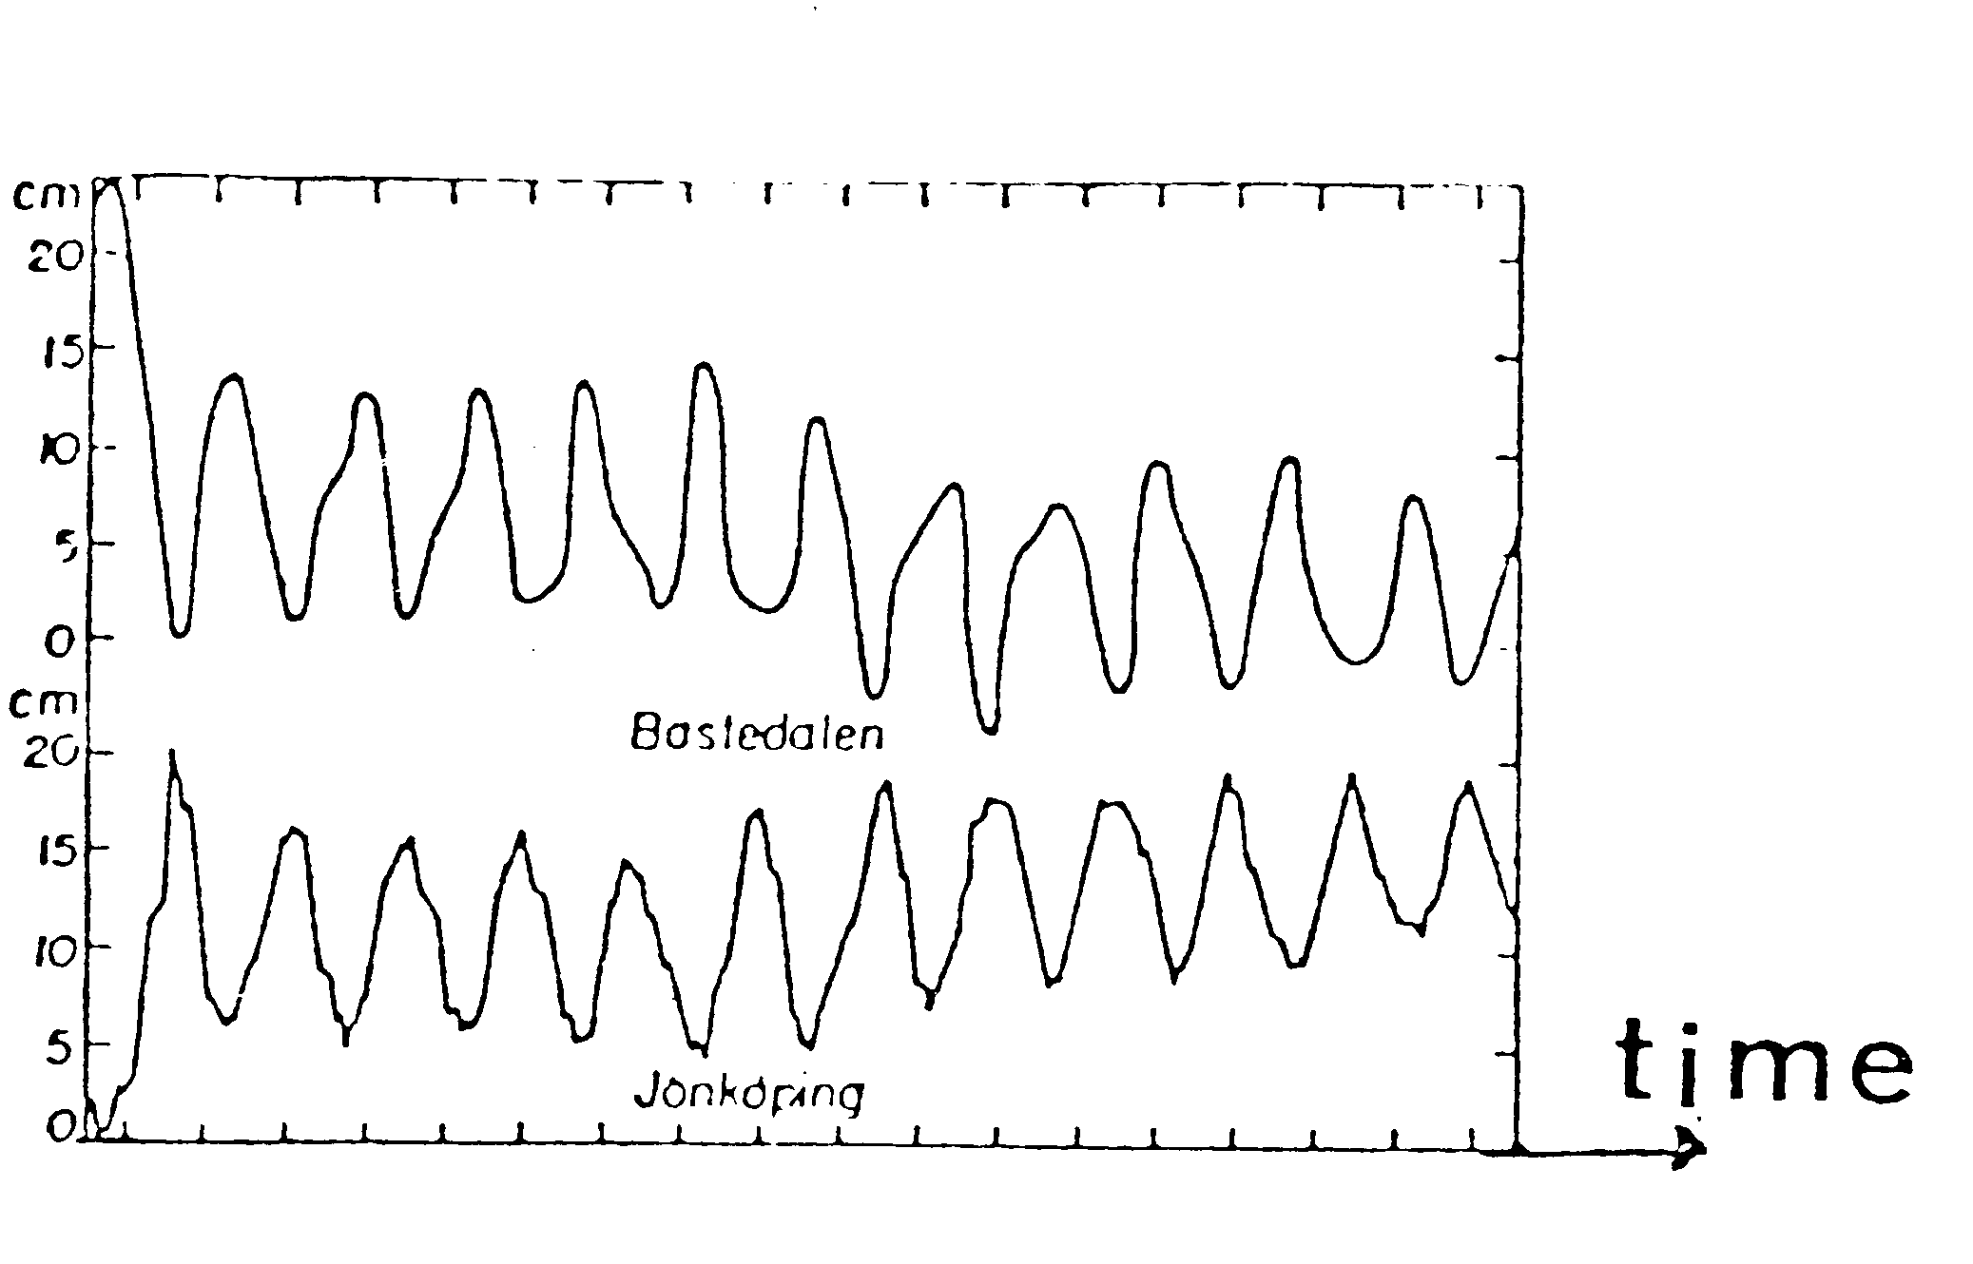
The water surface level in Bastudalen (northern end of lake Vättern) and Jönköping (southern end).

Solution:

In the coordinate system of the figure, we have for the centre of mass coordinates of the two triangular parts of the water
.
For the entire water mass the centre of mass coordinates will then be
Due to that the y component is quadratic in ξ will be much much smaller than the x component.
The velocities of the water mass are
,
and again the vertical component is much smaller the the horizontal one.
We now in our model neglect the vertical components. The total energy (kinetic + potential) will then be
For a harmonic oscillator we have
Identifying gives
or .
Comparing with the experimental data we find , our model gives a slight underestimation of the oscillation period.

Applying our corrected model on the Vättern data we have that the oscillation period of the seiching is about 3 hours.

Many other models are possible and give equivalent results.

Problem 3

An electronic frequency filter consists of four components coupled as in the upper figure. The impedance of the source can be neglected and the impedance of the load can be taken as infinite. The filter should be such that the voltage ratio has a frequency dependence shown in the lower where is the input voltage and is the output voltage. At frequency the phase lag between the two voltages is zero.

In order to build the filter you can choose from the following components:

2 resistors, 10 kΩ
2 capacitors, 10 nF
2 solenoids, 160 mH (iron-free and with neglible resistance)

Construct, by combining four of these components, a filter that fulfils the stated conditions. Determine the frequency and the ratio at this frequency for as many component combinations as possible.

Solution:

The conditions at very high and very low frequencies can be satisfied with for example the following circuit

Using either the graphic vector method or the analytic jω method we can show that the minimum occurs för a frequency when the ratio between the output and input voltages is 2/3. Switching the resistors and the capacitors gives a new circuit with the same frequency . Another two possibilities is to exchange the capacitors for solenoids where we get .
There are further eight solutions with unsymmetric patterns of the electronic components.
Experimental problems

Problem 1

You have at your disposal the following material:

(1) A sine wave voltage generator set to a frequency of 0,20 kHz.
(2) A dual ray oscilloscope.
(3) Millimeter graph paper.
(4) A diod.
(5) A capacitor of 0.10 μF (square and black).
(6) An unknown resistor R (red).
(7) A coupling plate.
(8) Coupling wires.
Build the circuit shown in the figure.

Connect the terminals A and B to the sine wave generator set to a frequency of 0.20 kHz. Determine experimentally the mean power developed in the resistor R when the amplitude of the generator voltage is 2.0 V (that is the peak-to-peak voltage is 4.0 V).

Solution:
The picture to the right shows the oscilloscope voltage over the resistor. The period of the sine wave is 5 ms and this gives the relation 1 horizontal division = 1.5 ms. The actual vertical scale was 0.85 V / division. The first rising part of the curve is a section of a sine wave, the second falling part is an exponential decay determined by the time constant of the resistor and capacitor. Reading from the display the "half-life" turns out to be 0.5 ms. This gives R = 7.2 kΩ. The mean power developed in the resistor is
. Numerical integration (counting squares) gives from which ≈ 0.1 mW.
Problem 2

Material:
(1) A glow discharge lamp connected to 220 V, alternating current.
(2) A laser producing light of unknown wavelength.
(3) A grating.
(4) A transparent “micro-ruler”, 1 mm long with 100 subdivisions, the ruler is situated exactly in the centre of the circle.
(5) A 1 m long ruler
(6) Writing material.

The spectrum of the glow discharge lamp has a number of spectral lines in the region yellow-orange-red. On of the yellow lines in the short wavelength part of this spectrum is very strong. Determine the wavelength of this spectral line. Estimate the accuracy of your measurement.

Note: If you happen to know the wavelength of the laser light beforehand you are not allowed to use that value in your computation.

Warning. Do not look into the laser beam. Do not touch the surface of the grating or the surface of the transparent micro-ruler.

Solution:

Using the micro-ruler with we can determine the wavelength of the laser light. Knowing this wavelength we can calibrate the grating and then use it to determine the unknown wavelength from the glow discharge lamp. We cannot use the micro-ruler to determine this wavelength because the intensity of the light from the lamp is too weak.

