**Subprograms in Dart**

1- Nested subprograms

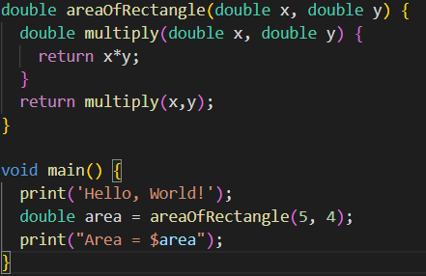

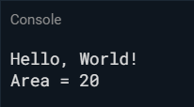

Dart gives opportunity to use nested subprograms. Nested subprogram can be a function which has a function in its block scope. As it can be seen in the program above, function areaofRectangle calls the function multiply as its return statement to calculate the area of rectangle with given parameters.

2- Scope of local variables

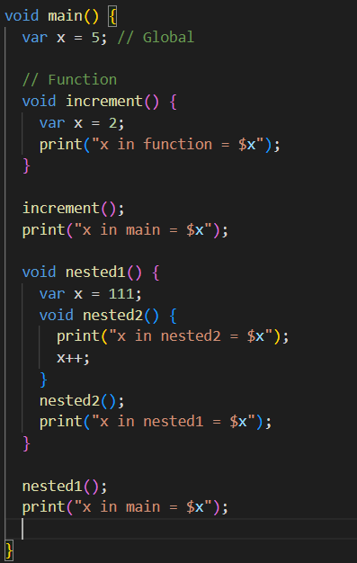

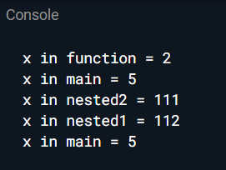

Attributes of local variables in dart shares the common attributes used in most of the other languages. Local variables in dart are block scoped and cannot be used outside of the block that it is declared. In order to investigate the scope of local variables in dart, program is prepared to compare globally declared variables and locally declared variables by looking at the output of program.

3- Parameter passing methods

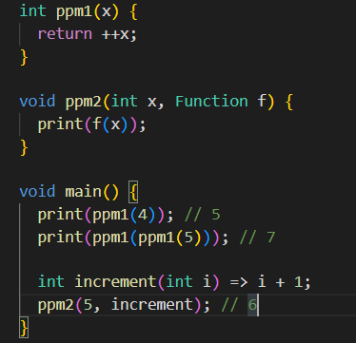



In dart as the programmer can pass the primitive type variables to the functions, it can also pass a function to function as a parameter to passed function. As it can be seen in the program above, it is possible to pass a parameter to ppm1 as a integer or as a function which also returns integer. In addition, dart presents another method to pass the function to another function as a parameter. The function must be typed as ‘Function’ to let the dart know that the parameter can be any function.

4- Keyword and default parameters

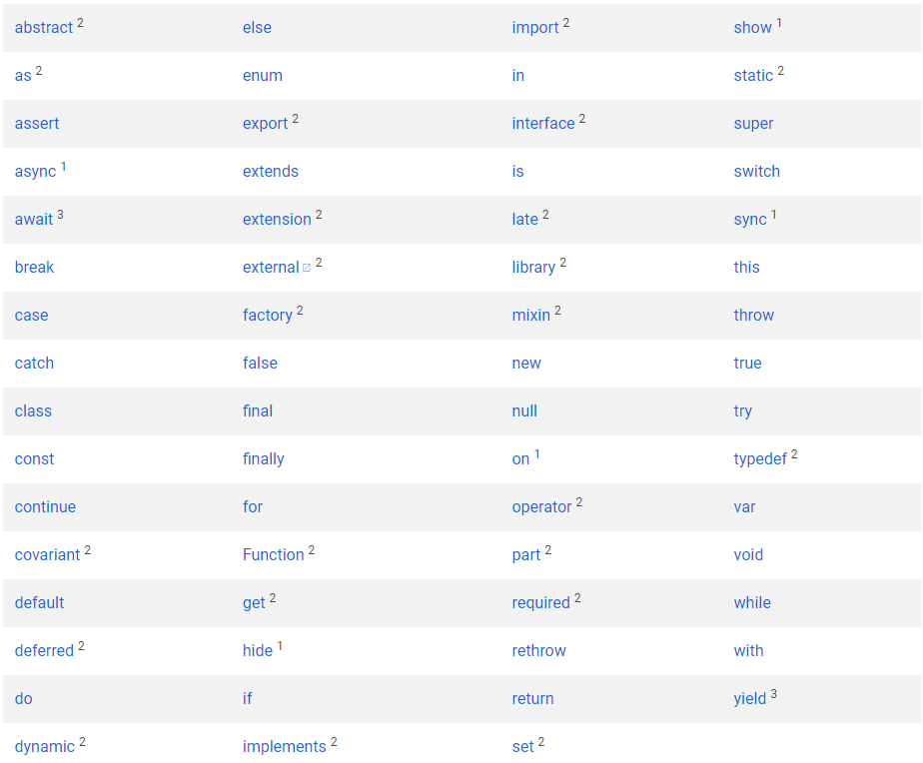

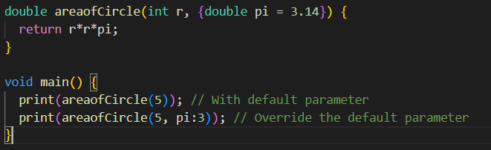



There are 63 reserved keywords in the dart as it can be seen in the table above. These keywords cannot be used as a variable name because each keyword has its own function. For example, the keyword ‘if’ cannot be used as int if because while the compiler compiles the program, it will give error because it will evaluate if statement to find a condition.

5- Closure

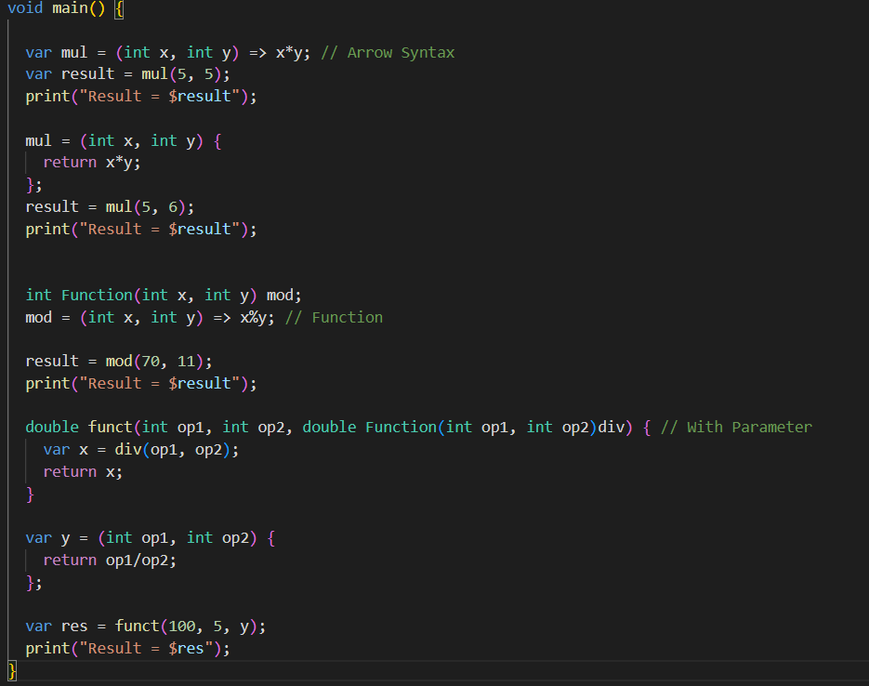

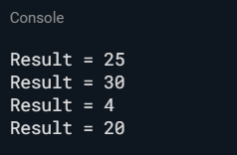

Closure is a special function in dart. It may not have a name. Programmer can identify a closure through variable. It does not have to return any value. In the program above, it is written to show the different usage of closure in dart. First one is arrow syntax which returns the operation pointes by arrow to the variable that closure is initialized. Second option is like a function instead the return value immediately writes into the variable that closure is initialized. Third is same principle instead it writes the return value of closure to function itself. Last, the closure is used as a parameter to function.

Evaluation of Dart

In terms of readability and writability, dart is easy to write and read the code. The block structure that dart used increases the readability and writability of program. As I mentioned in the previous homework assignments, I found dart’s structure easy to understand.

Learning Strategy

Throughout the process of working on a homework, lots of online research has been made to complete the programs as it should work. Because there was not a compiler for dart in dijkstra, online compiler has been used to run the programs.

Links

1- https://dartpad.dev/?