RESULTS

1 . DataSet: 12 Descriptors → pockets by proximity
number of pockets : 315611
number of pockets without na : 303771 (11 840 NA)
cleaned data : pockets < 60 res and >=14 residues and rows with NA :
number of pockets with n residues > 60 : 146
number of pockets with n residues < 14 : 192708
number of pockets : 110914

Tests on Hierarchical Classification
(DataSet: 12 Descriptors)
with 5% (5 542pockets):
- RUN
- 2 seconds
with 10% (11 091 pockets):
- RUN
- 9 sec
with 30% (33 274 pockets):
- RUN with difficulties (restarting R)
- 4,5 min
- Dont run on rstudio
- 44365
with 40% (44 365 pockets):
- DIDN’T RUN
- -
- Dont run on rstudio
ACP:
comp 1 et 2 : 50 % varianlity
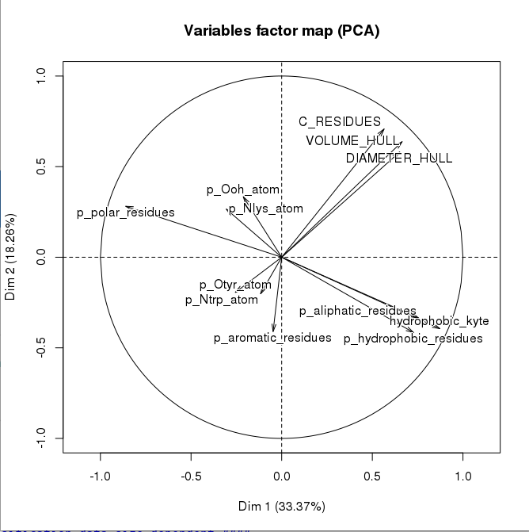

K-MEANS:
(DataSet: 12 Descriptors)

Number of seeds : 10% of total data set → 11091 seeds :
- 2 min
- max cluster size : 60
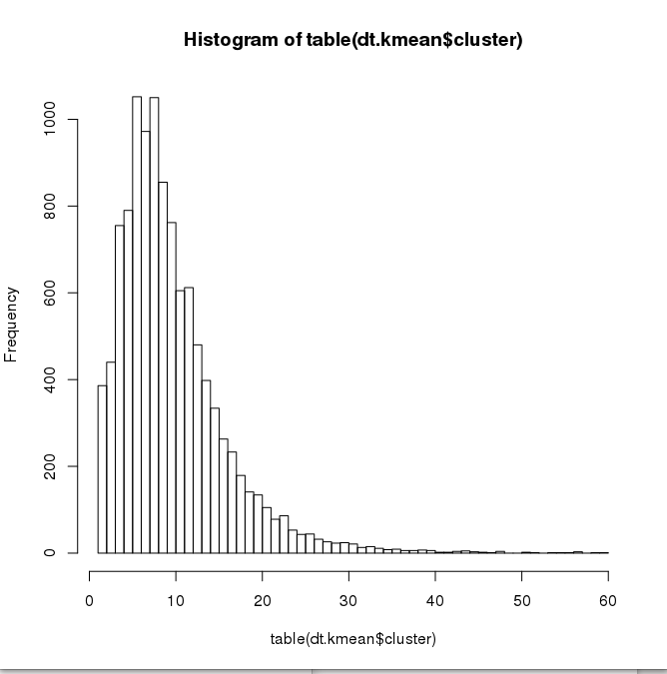
- min cluster size : 1

60 –> little
Number of seeds : 1→ 10:
- 8 secs
- with 10 seeds : max → 19 297 pockets ; min → 5242
R2: I.intra/I.total

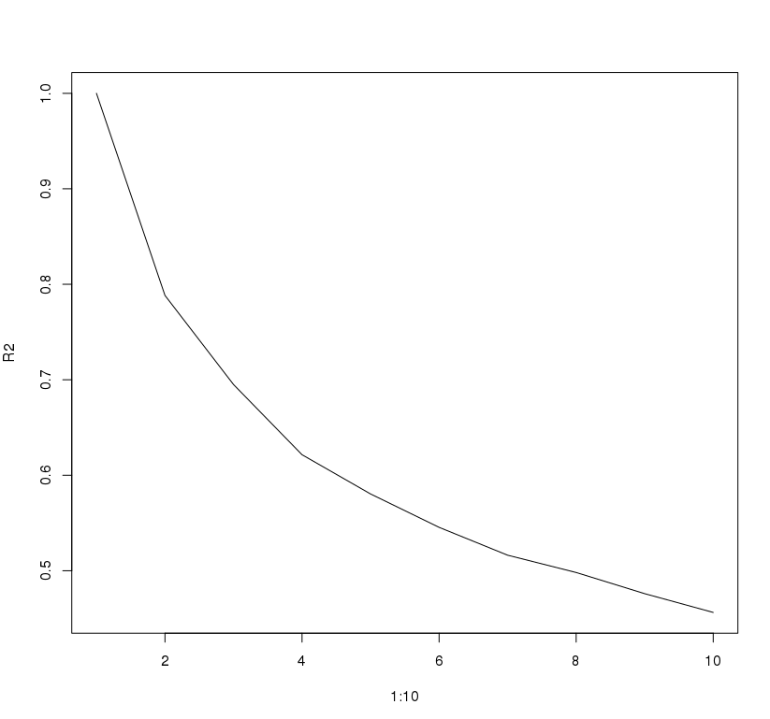
0.5% inertia explained with 10 clusters :
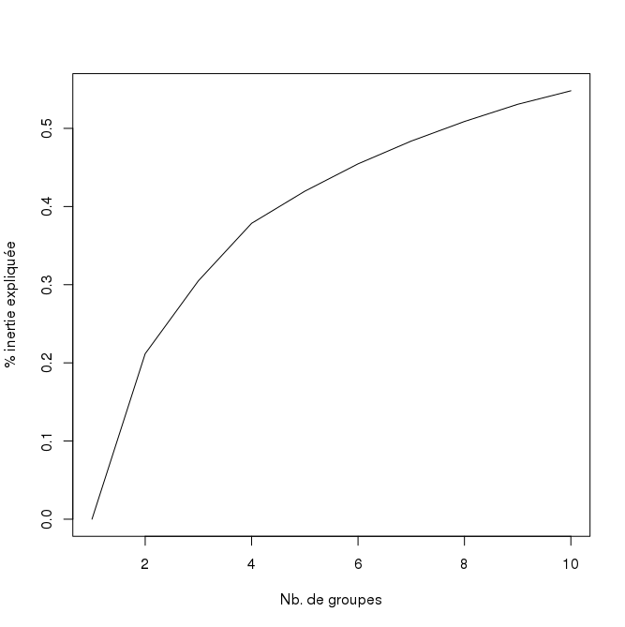
Although Hclust runed on 30 000pockets, it didnt when I tried tu run it 10 times on ~10 000/15 000 pockets.
With 20 clusters with K Means (nstart 10):
- RUN 40 sec
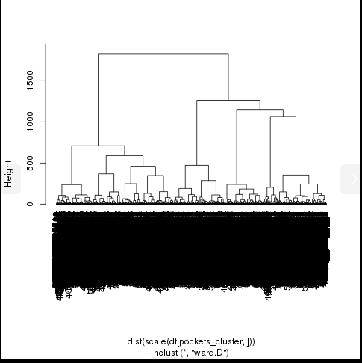
- ex first cluster :

Finally it worked with 10 clusters.
Inertie according the number of seeds with K MEANS:
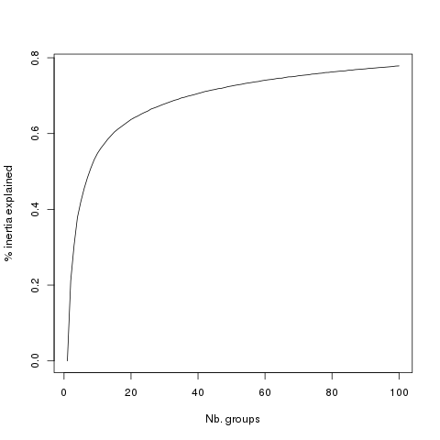
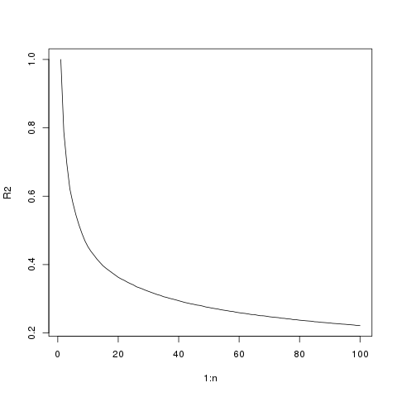

Kmeans with 10% values seed + Hclust on the centroids:
number of seeds : 11091
(nstart : 1)
distance euclidienne pondérée
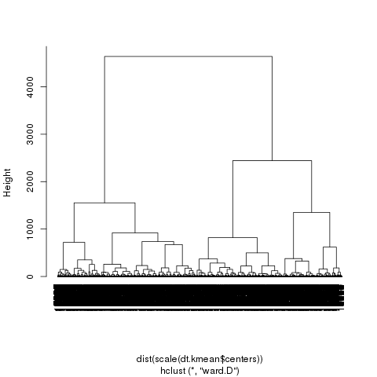
Inertie :

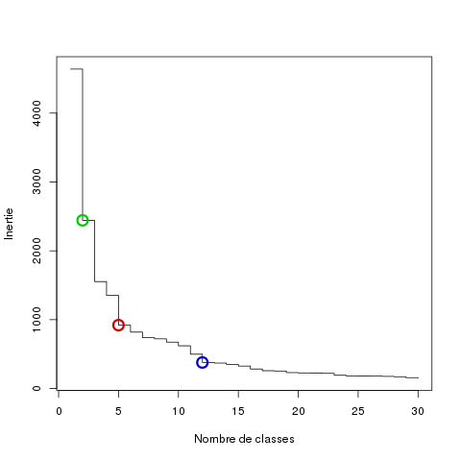
Optimal number of seeds for first K-MEANS (10% nstart 1) :
~12
Optimal number of seeds for first K-MEANS (5% nstart 1) :
~21

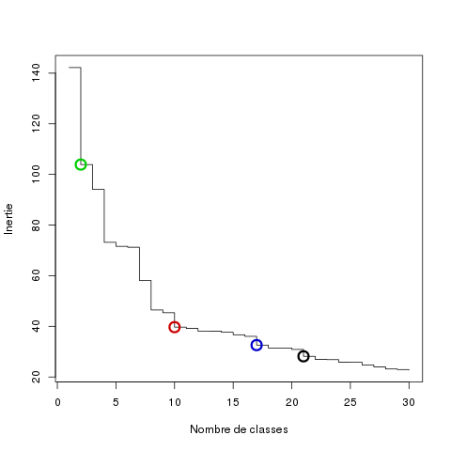

Optimal number of seeds for first K-MEANS (20% nstart 1) :
~15
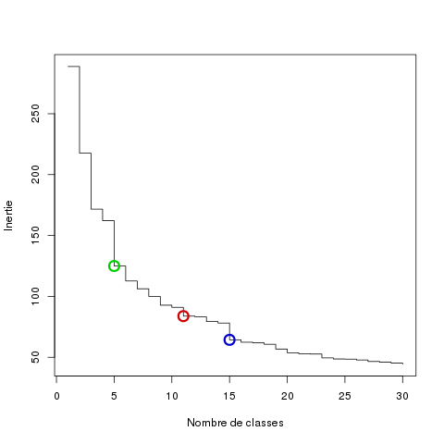
N seed, n start : 10 | 10% values seed  11091 | 12 | 20 | 50 | 100
Min cluster size | 1 | 3535 | 9472 | 4198 | 2343
Max cluster size | 60 | 16818 | 1824 | 476 | 168

2 . DataSet: 72 Descriptors → pockets by proximity
Number of pockets : 272189
Descriptors with lots of NA values :
- HEIGHT_MIN_CYLINDER → all of the values
- polarity → ~10%
- RADIUS_MIN_CYLINDER → almost all the values
- hydrophobicity → 10%
- VOLUME_HULL → almost all the values
- hydrophobic_kyte → ~5%

The others with NA :

drugg (4071); SURFACE_HULL (4071); p_S_atom (4044); p_carbone_atom
(1418); C_RESIDUES (4044); p_Ooh_atom (69); Y (4044); R (4049); p_Ccoo_atom (4049); p_sulfur_atom (); INERTIA_2 (4044); p_Car_atom (661); PCI (4071); CONVEX.SHAPE_COEFFICIENT (4055); RADIUS_CYLINDER (); INERTIA_1 (1418); p_Ooh_atom(213); p_Carg_atom (661)

Analysis without columns HEIGHT_MIN_CYLINDER, RADIUS_MIN_CYLINDER, VOLUME_HULL, drugg and the other individues with NA’s.

(! had to delete some rows with bad names)

Cleaned Number of pockets : 207100
cleaned data : pockets < 60 res and >=14 :
number of pockets with n residues > 60 : 103
number of pockets with n residues < 14 : 132512
number of pockets: 74485

5 columns to remove with with correlation > 0.95 :
"p_hydrophobic_atom" "p_main_chain_atom" "RADIUS_CYLINDER" "DIAMETER_HULL"
"p_Ooh_atom"

with cutoff 0.8 : 19 columns to remove
with cutoff 0.6 : 38 columns to remove

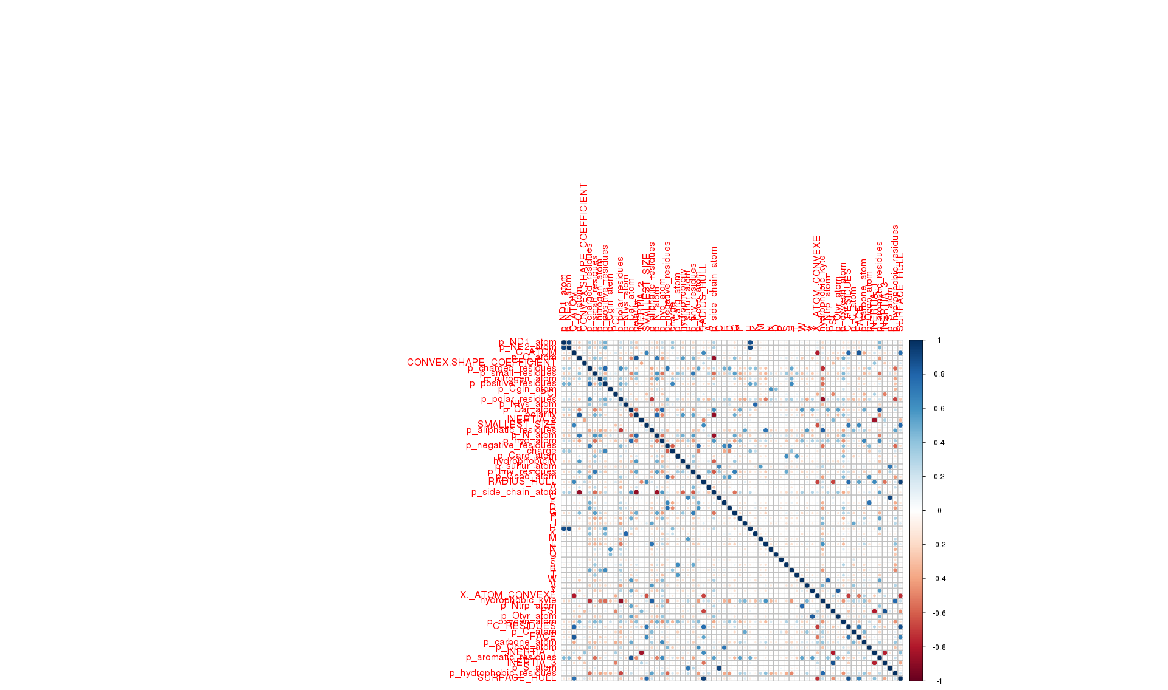

ACP :
30% variance explaine by the 2 first components
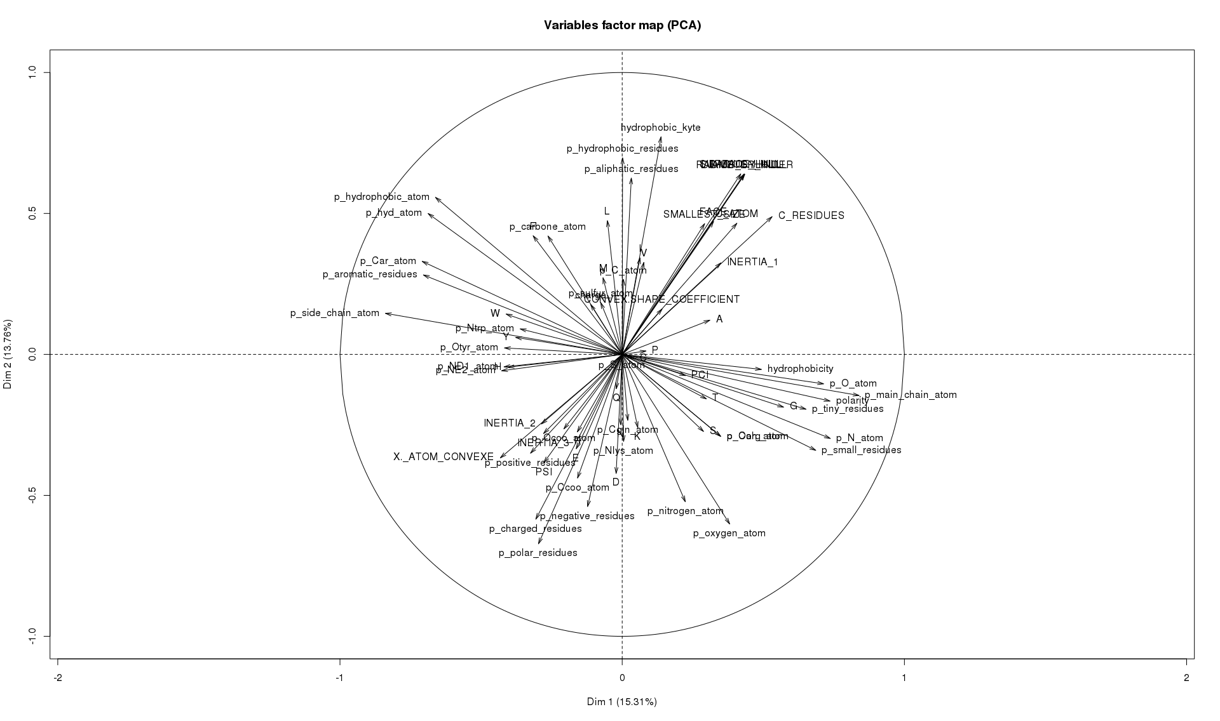
Max number of individues to make it visible is ~ 100
3 . INFOS: DRUGGABLE POCKETS → pockets by proximity

Number : 225578
Number of NA : 9313
Number of druggable pockets : 117097
Number of non druggable pockets : 99168
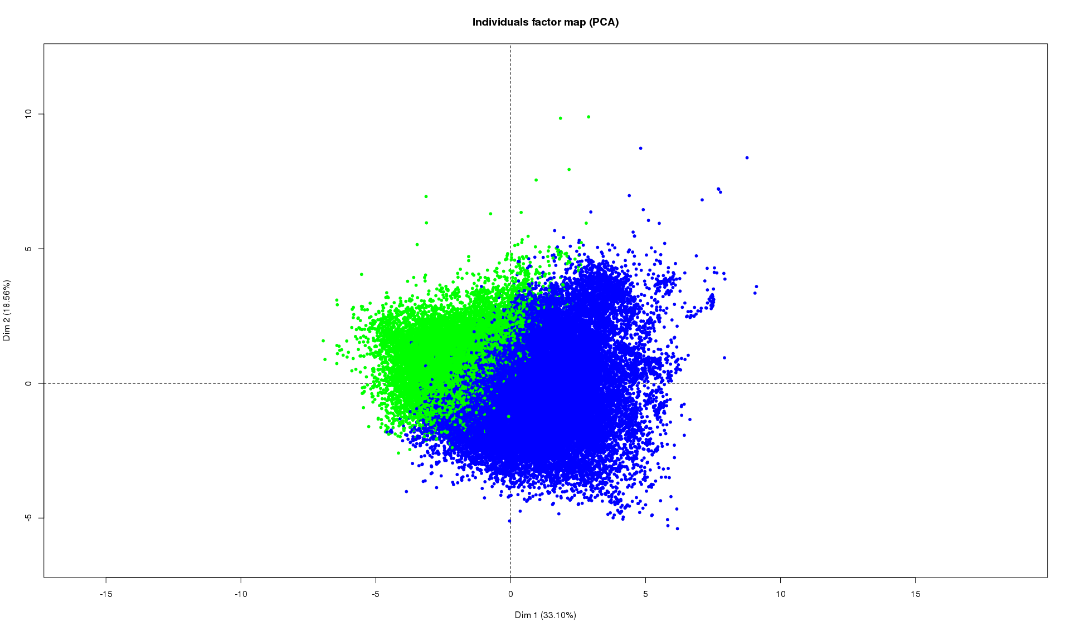
PCA :
Npockets with value for druggability and 12 descriptors : 79474
green : non druggable (21 485); blue : druggable (57 989)

4 . Dataset 72 descriptors + infos druggable pockets

Number of pockets with available druggability information for informative pockets : 74224
5 . Visualization descriptors according to clusters
- 12 descritptors dataset → k-means 20 seeds
made on the means of after scale
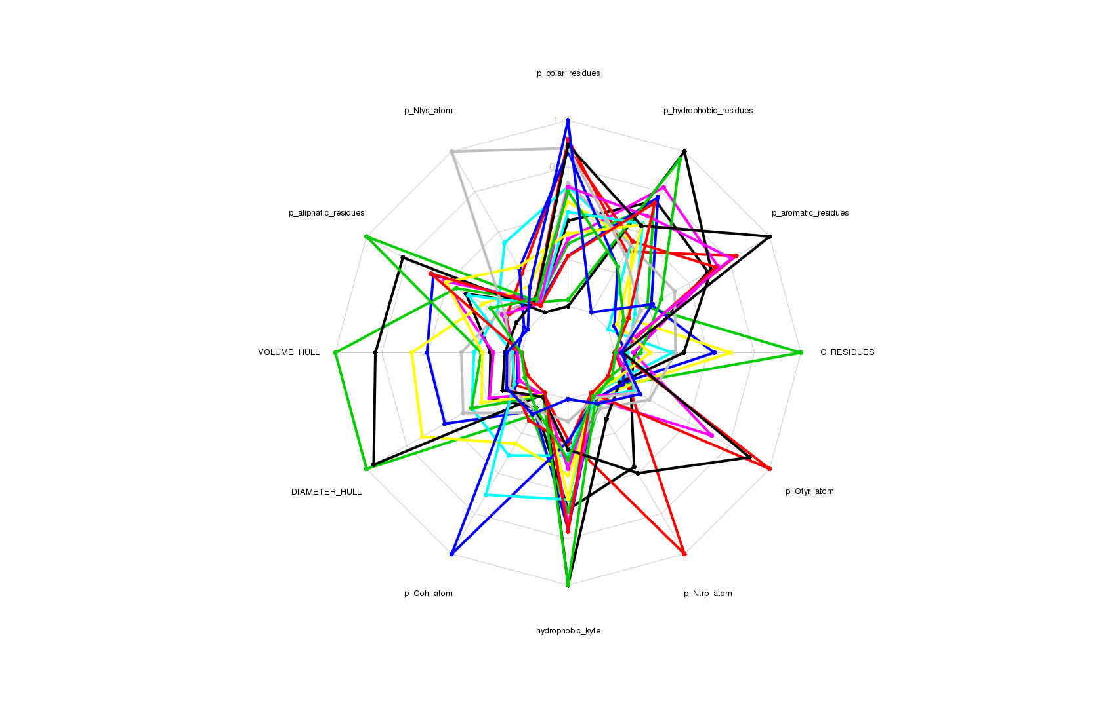
5 . Methode
https://austinpublishinggroup.com/proteomics-bioinformatics-genomics/fulltext/ajpbg-v2-id1008.pdf

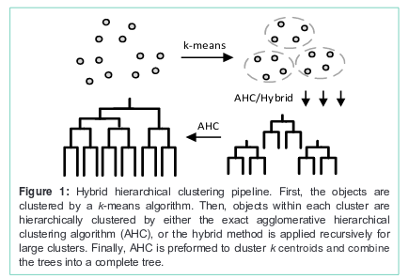

6 . Workflow
code take a matrix of the descriptors and return a tree structure computed with a mix of kmeans and hclust → the choice of optimal number of cluster need to be discussed.
At each node we can have access to the information of the descriptors of the centroid.
Ex:
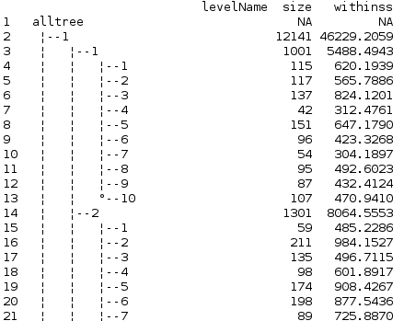

Problem : at each run the number of seed is 10 → this need to be optimized

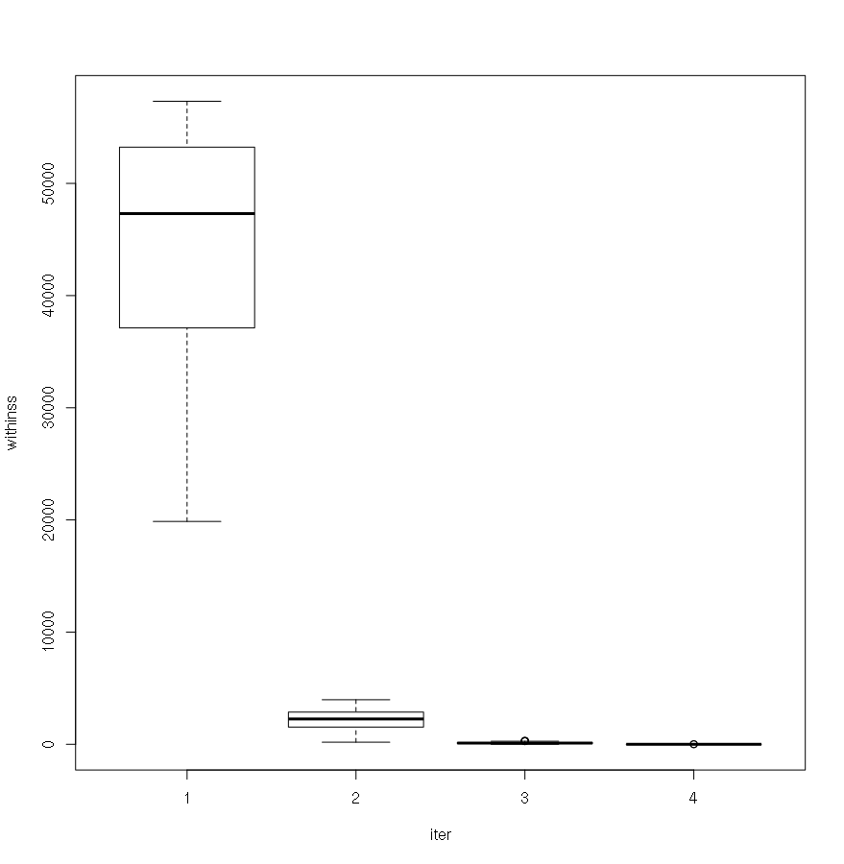
Withinss boxplot according the iteration

for first splitting :

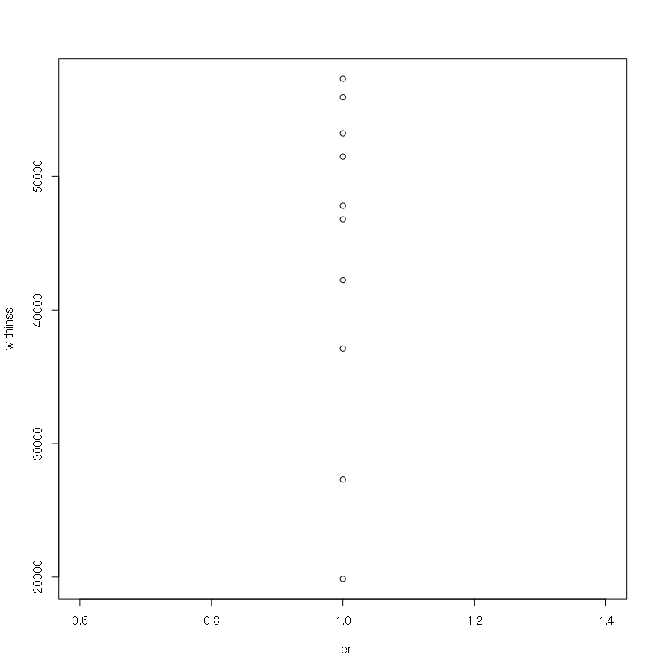
second :
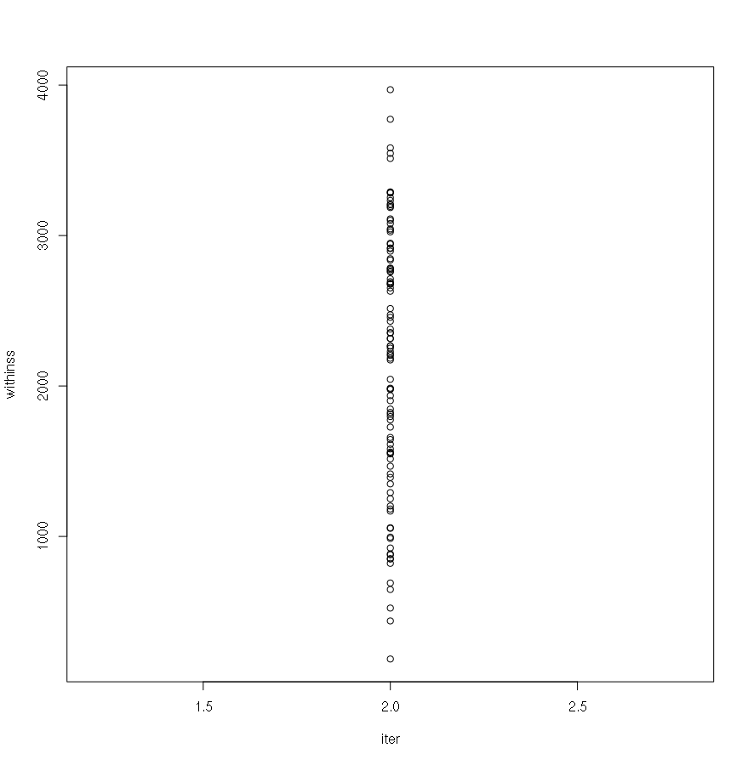
third :
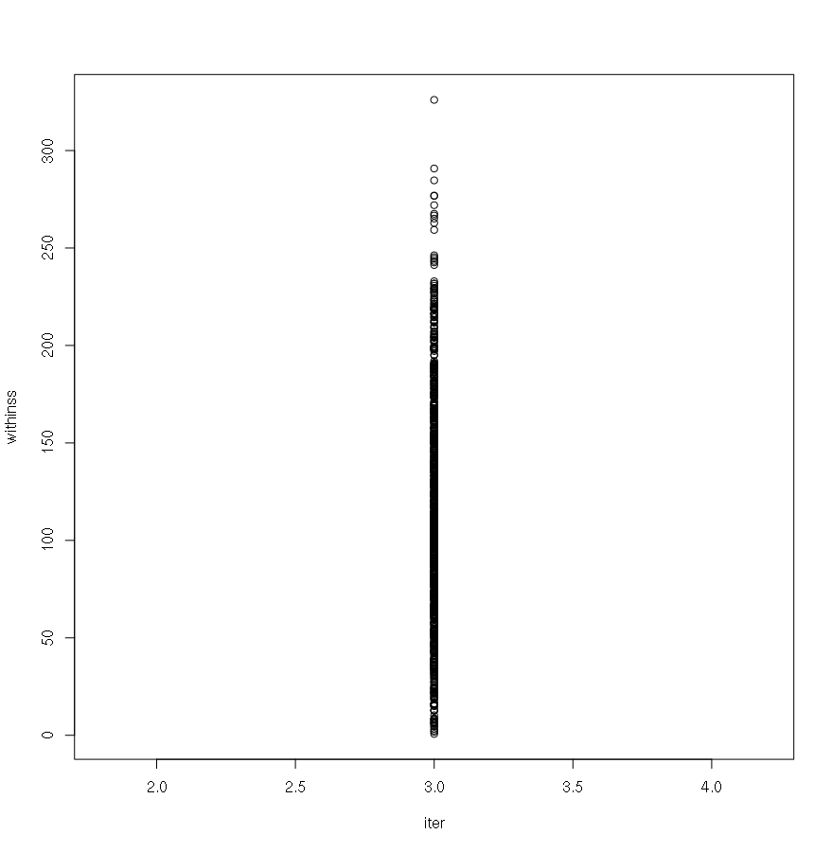
4:
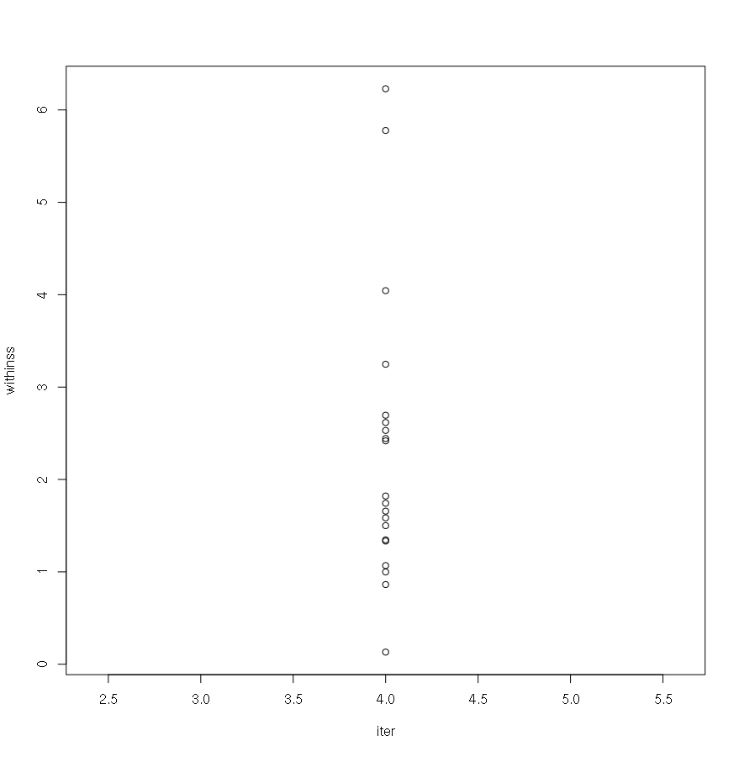
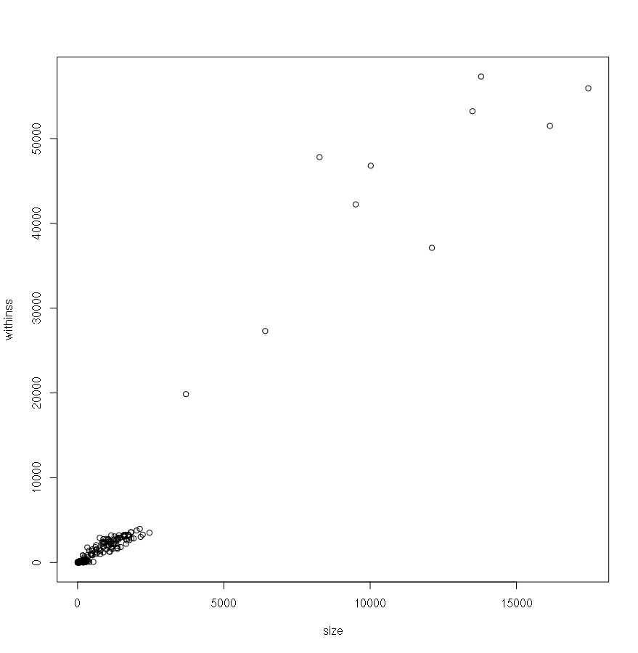
Withinss according to size of cluster:

With the inertia intra classes < 400:
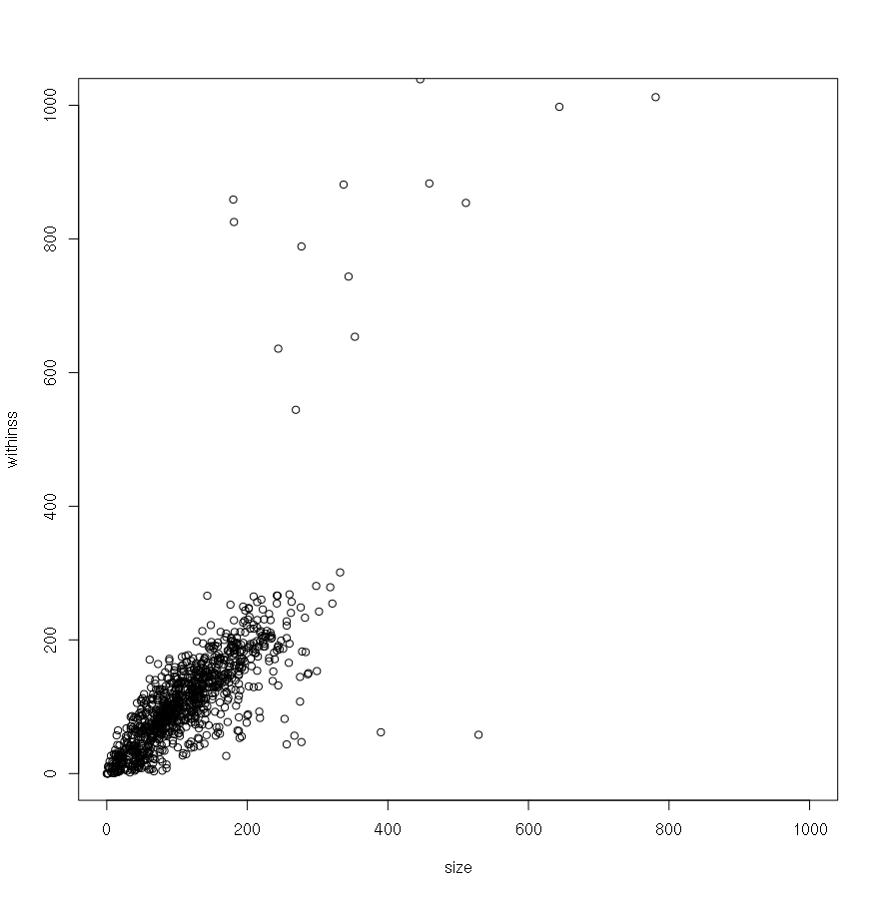
Size comparaison according method for firt clustering:

Algo | Clust1 | Clust2 | Clust3 | Clust4 | Clust5 | Clust6 | Clust7 | Clust8 | Clust9 | Clust10
McQ 400 | S:  17456  W:  55943 | S:  16144  W:  51495 | S:  6413  W:  27303 | S:  13496  W:  53231 | S:  8271  W:  47813 | S:  12111  W:  37115 | S:  10021  W:  46801 | S:  3704  W:  19863 | S:  13792  W:  57319 | S:  9506  W:  42241
McQ 1000 | ~same
Har  400  ~same as McQ | S:  9502  W:  42224 | S:  12111  W:  37115 | S:  8276  W:  47834 | S:  3704  W:  19863 | S:  17462  W:  55968 | S:  10024  W:  46813 | S:  6413  W:  27303 | S:  13776  W:  57243 | S:  16143  W:  51488 | S:  13503  W:  53273
Har  1000 | ~same

Kmeans on ACP :
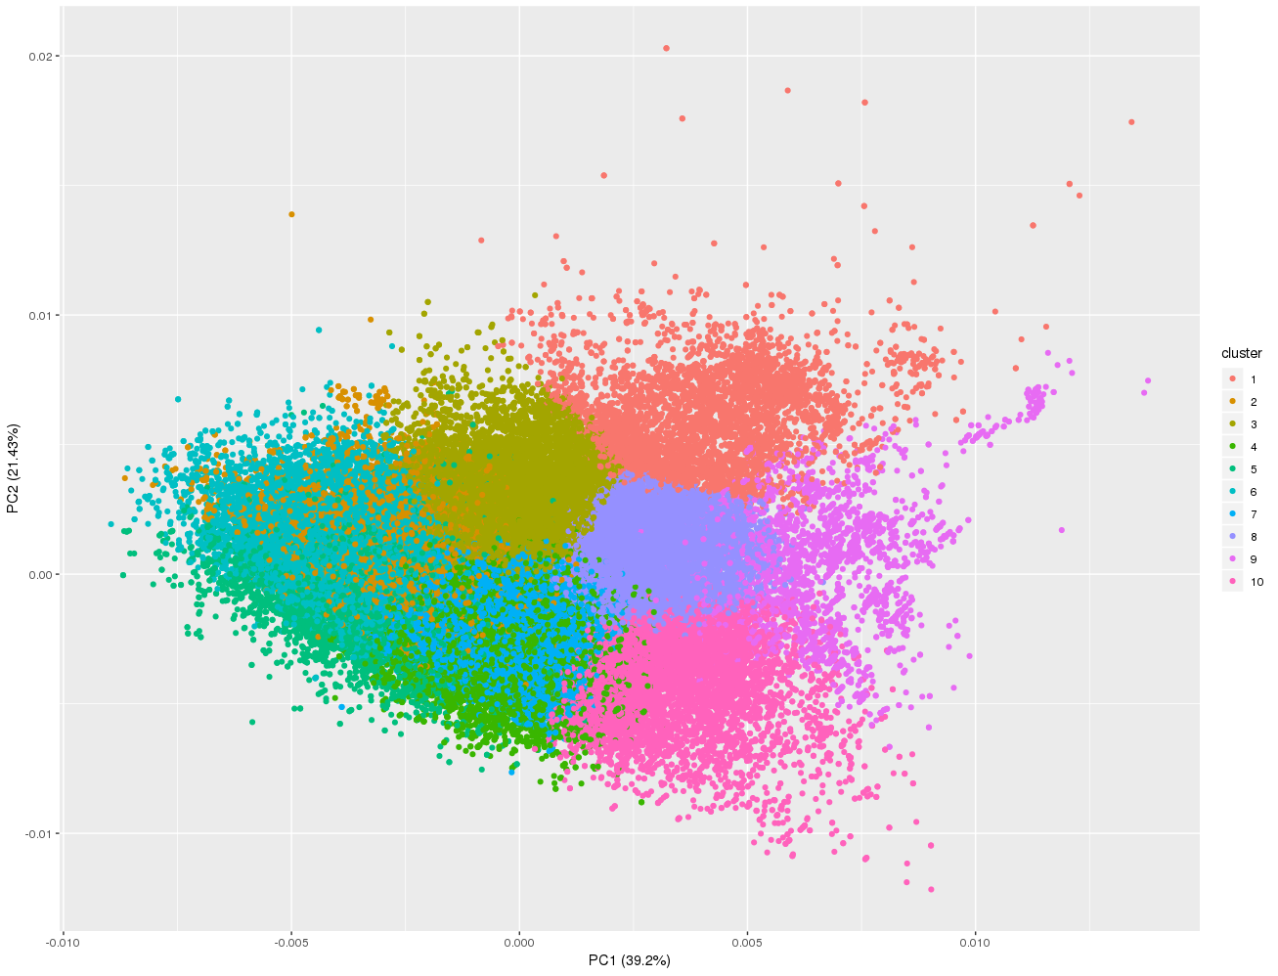

Plot “Inerte intra” against size 1054 clusters:
(tree MacQueen threshold 400 inertie intra)
for the Leaf of the tree :
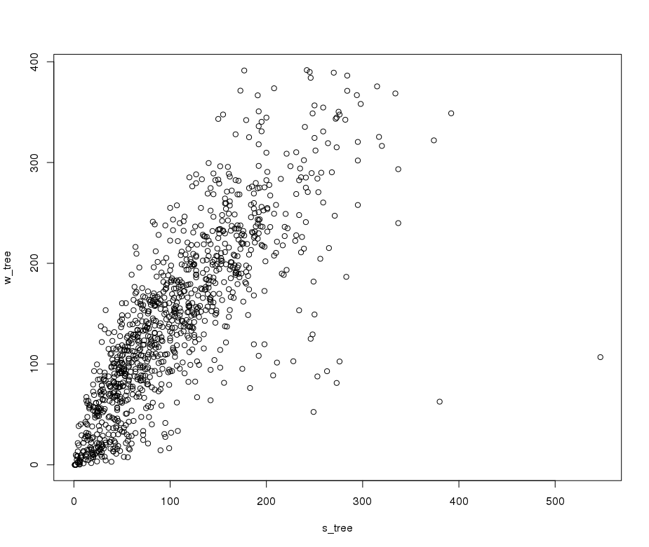
without threshold with 3 iterations of k means with at the end (10*10*10) 1000 clusters:
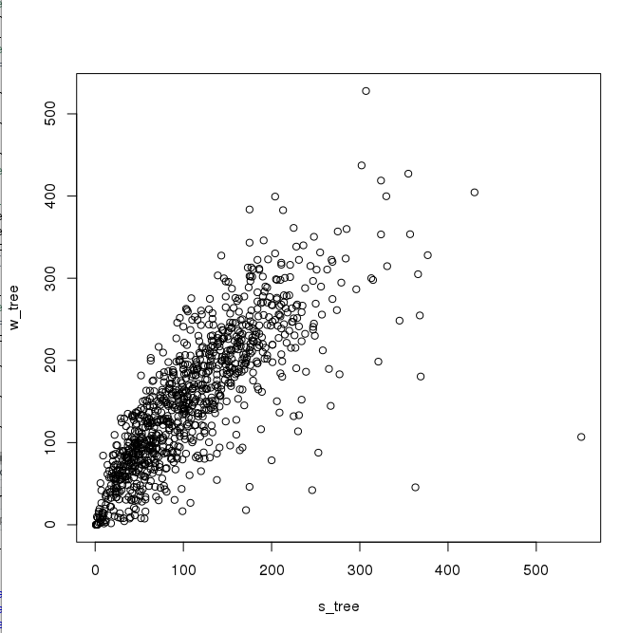
R2 variability explained by the model: inter/(total of the superior cluster)
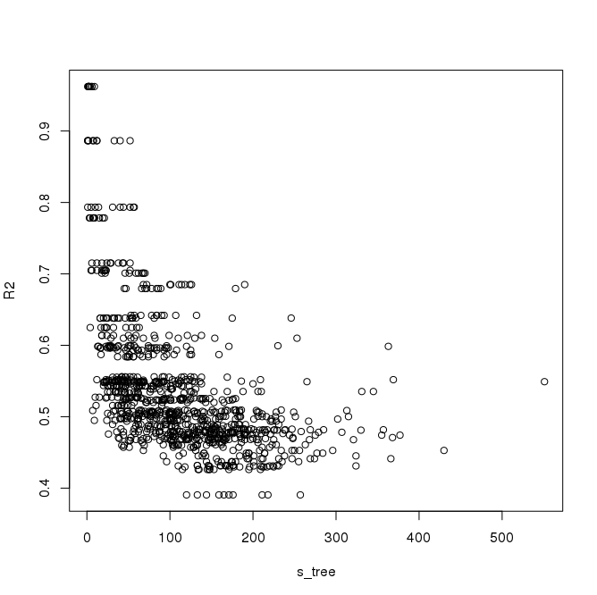
R2 with intertie intra:

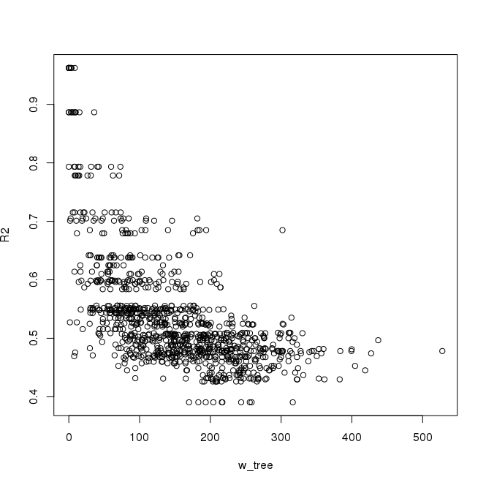
range from 0.4 to 1 the major part is around 0.5
For the first clustering :
0.54

R2 and size for first iteration of clustering:
0.54
R2 and size for second iteration of clustering:
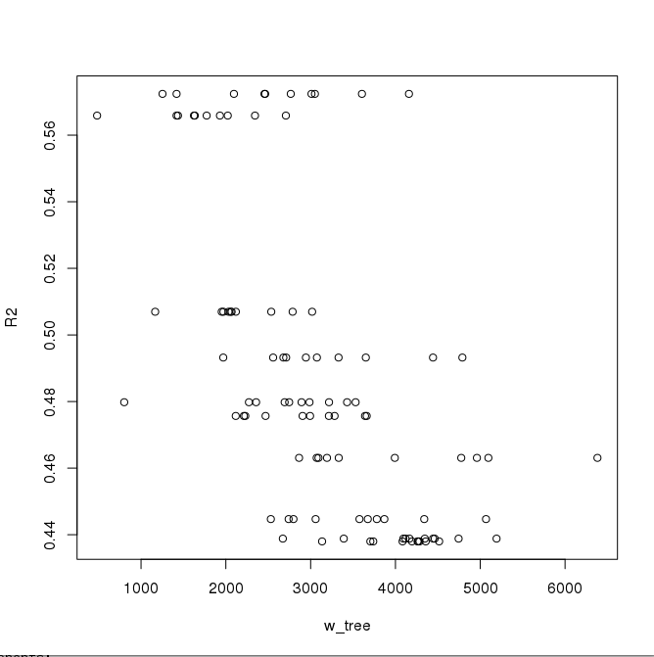
R2 of this method of clustering with 1054 clusters: 0.88
R2 with normal clustering with 1054 clusters: 0.899

R2 of this method of clustering with 100 clusters: 0.76
R2 with normal clustering with 100 clusters: 0.777

R2 of this method of clustering with 10 clusters: 0.548
R2 with normal clustering with 10 clusters: 0.554

R2 of this method of clustering with 9307 clusters (size > 20, 4 iterations): 0.93

Withinss/size for the last clusters (leaf in the graph):
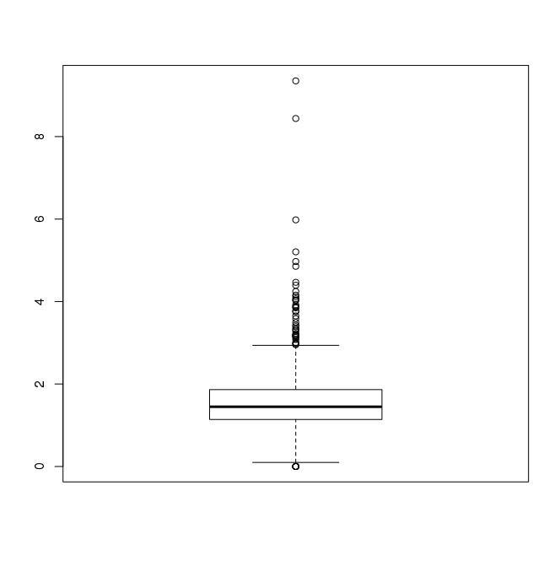

Withinss for leaf cluster for 3 iterations (1111clusters)
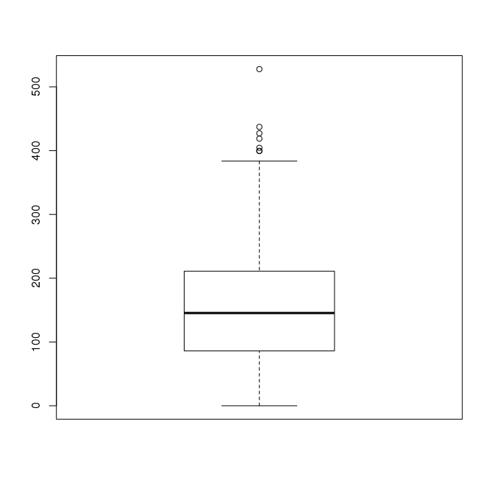

7 . Results for NS1 pockets during the MD

----For the tree with withinss threshold > 400 and with 4 iterations (max)----

10 first clusters centers :

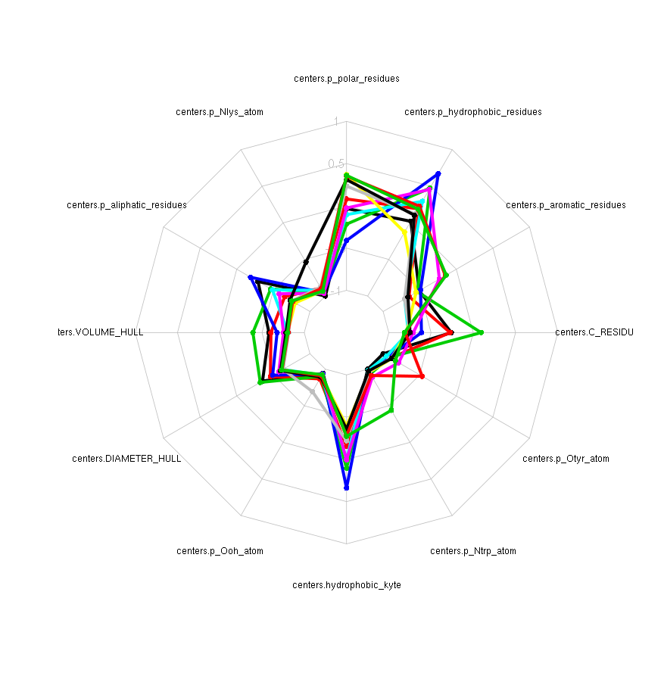

Pocket pocketConf0101-p0 (most druggable)
best cluster : 4.1.5 (dist : 1.4, withinss: 224, size : 198)
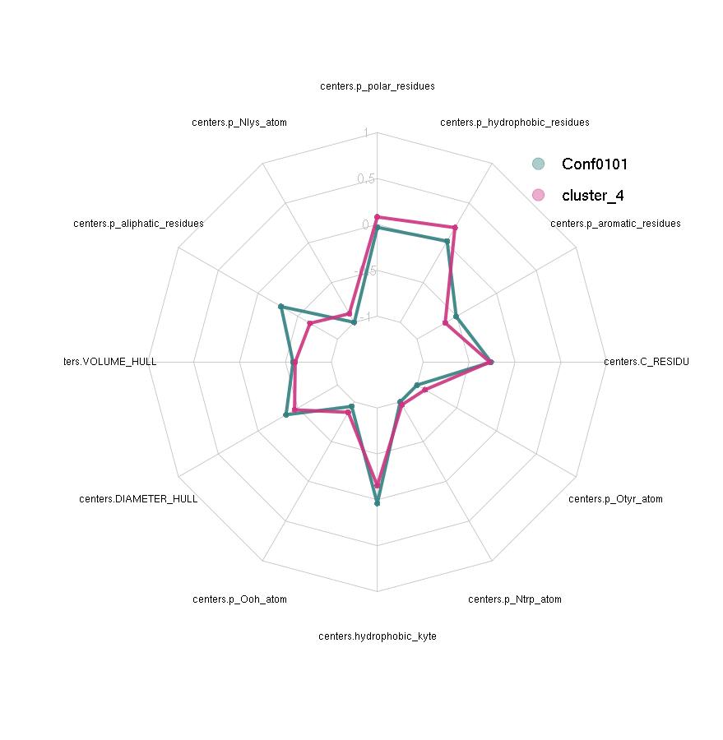
Pocket pocketConf047-p0
best cluster : 10.5.5 (dist : 1.33, withinss: 130, size : 106)

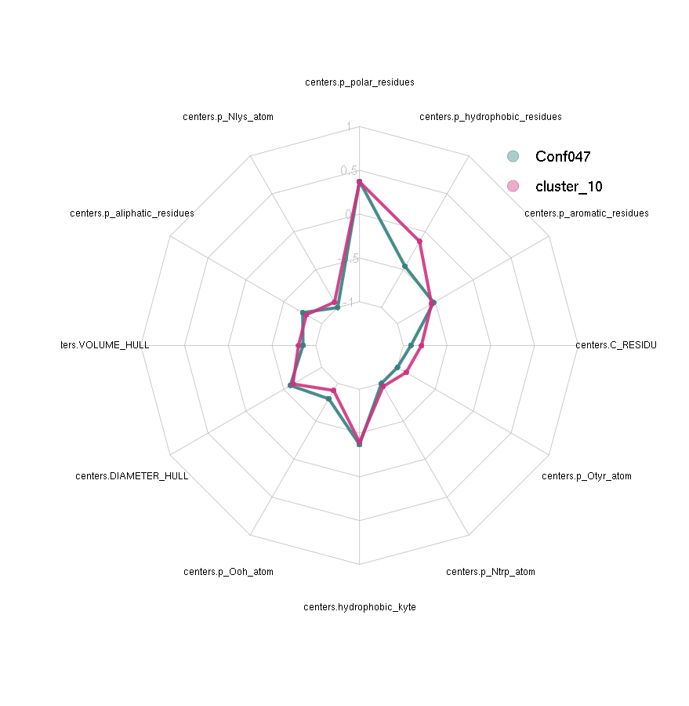
Pocket pocketConf137-p0
best cluster : 4.8.4 (dist : 1.85, withinss: 335, size : 169)

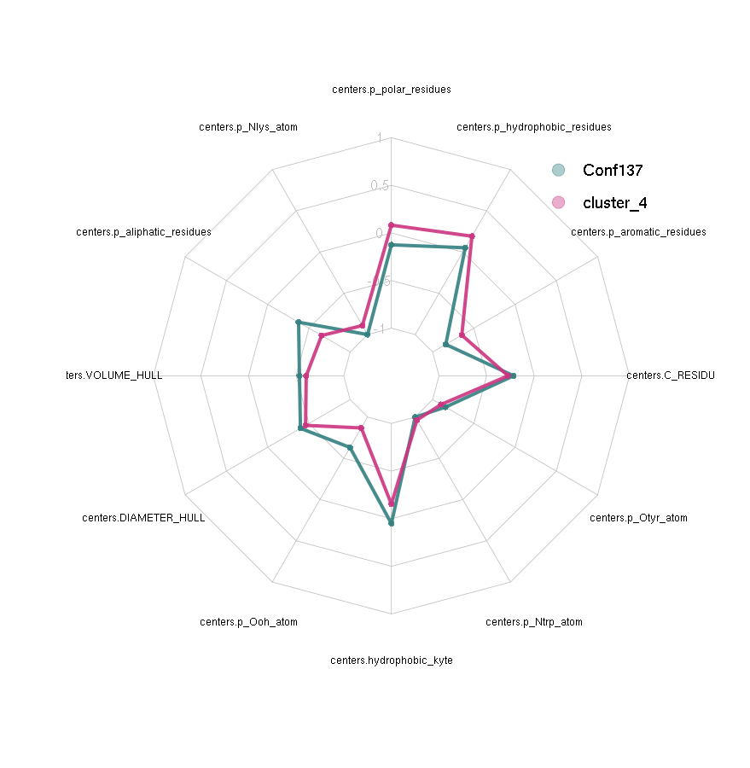
Pocket pocketConf0093-p0
best cluster : 10.3.3 (dist : 1.33, withinss: 61, size : 58)
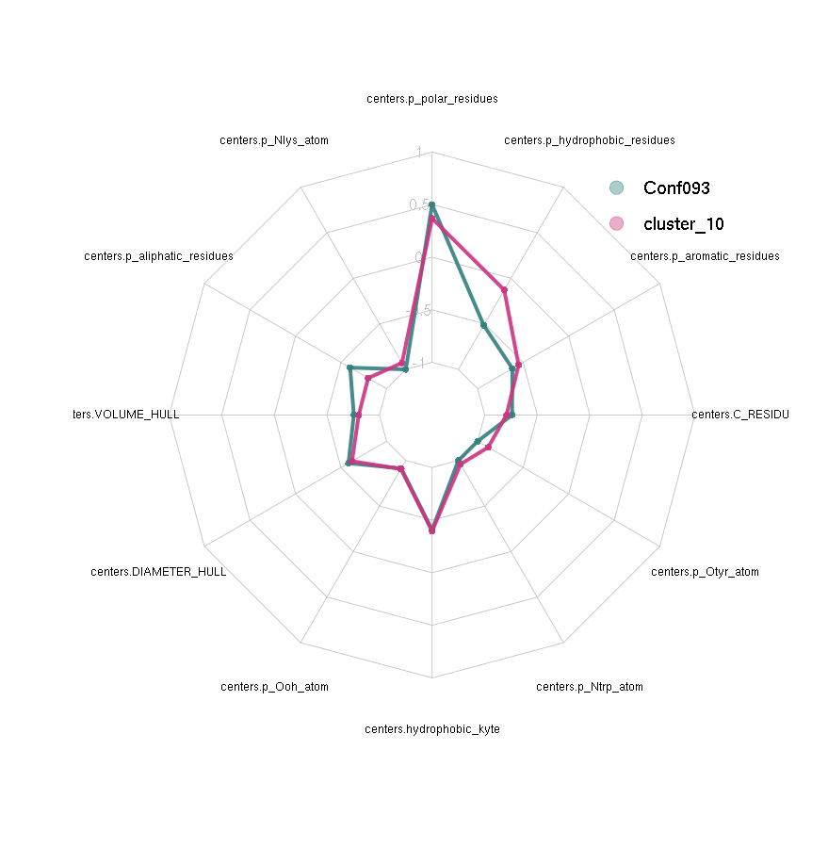

Table of distances:
 | pocketConf0093 | pocketConf137 | pocketConf047 | pocketConf0101
pocketConf0093 |  | 5.31 | 1.7 | 4.16
pocketConf137 |  |  | 5.09 | 3.66
pocketConf047 |  |  |  | 4.7
pocketConf0101

Hclust on centroids (first clustering):
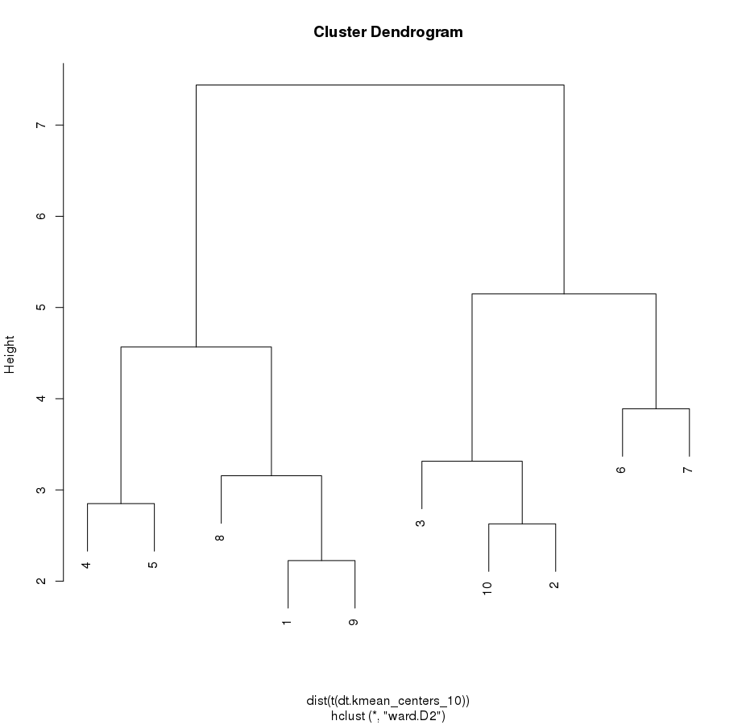

Conclusions :
pockets 0093 and 0137 of the RNA binding site are in the same clustering and they have a close distance.
pockets FLwt are in the same cluster as well and different subclusters.

----For the tree with withinss threshold > 400 and with 4 iterations (max) and the 71 descripors ----

Number of clusters : 7 723
Number of pockets : 74485

Pocket pocketConf0101-p0 (most druggable)
best cluster : 3.4.8.7 (dist : 6.40, withinss: 95, size : 12)

Pocket pocketConf047-p0
best cluster : 6.1.8.6 (dist : 6.67, withinss: 129, size : 8)

Pocket pocketConf137-p0
best cluster : 3.10.4.1 (dist : 7.40, withinss: 83, size : 6)

Pocket pocketConf0093-p0
best cluster : 6.9.3.4 (dist : 7.58 withinss: 306, size : 21)

 | pocketConf0093 | pocketConf137 | pocketConf047 | pocketConf0101
pocketConf0093 |  | 13.37 | 7.61 | 8.72
pocketConf137 |  |  | 10.94 | 10.61
pocketConf047 |  |  |  | 8.13
pocketConf0101

----For the tree with withinss threshold > 400 and with 4 iterations (max) the physicochemicals dt ----

7 descriptors

Pocket pocketConf0101-p0 (most druggable)
best cluster : 4.7.5 (dist : 0.085 withinss: 23, size : 290)

Pocket pocketConf047-p0
best cluster : 9.8.9 (dist : 0.11 withinss: 21, size : 211

Pocket pocketConf137-p0
best cluster : 9.2.2 (dist : 1.44, withinss: 67, size : 137)

Pocket pocketConf0093-p0
best cluster : 7.2.6 (dist : 0.28, withinss: 39, size : 327)

 | pocketConf0093 | pocketConf137 | pocketConf047 | pocketConf0101
pocketConf0093 |  | 3.50 | 1.43 | 1.38
pocketConf137 |  |  | 2.77 | 3.68
pocketConf047 |  |  |  | 2.55
pocketConf0101

Hclust on the cluster alltree$7 because the results of distance looks strange for Conf047-Conf137 and Conf0101-Conf0093:
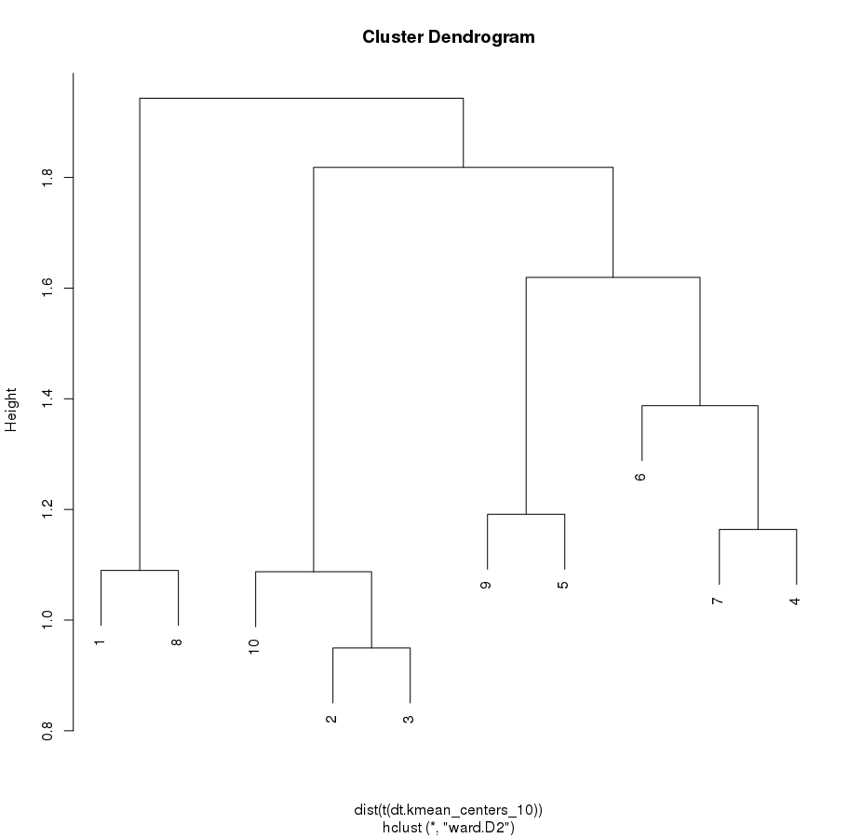
The clusters 8 and 2 are kind of far et should be seperated this could the differences of distances
hclust on the first clustering :
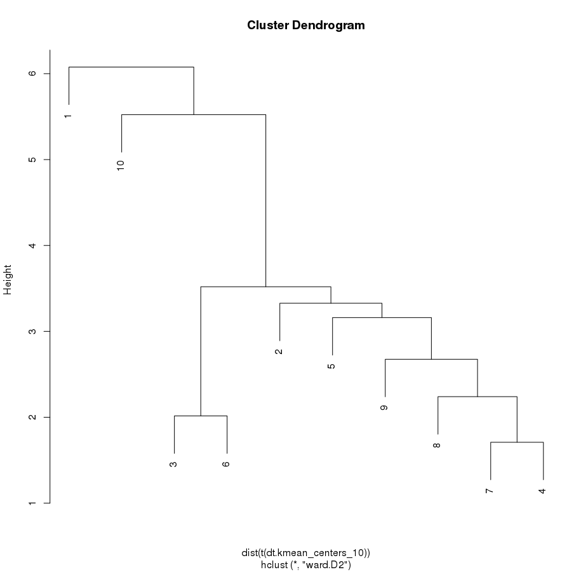
Clusters 4 and 7 are very close this explain why Conf0093 is close physicochymicaly to Conf0101

----For the tree with withinss threshold > 400 and with 4 iterations (max) the geometrical dt ----

6 descriptors

Pocket pocketConf0101-p0 (most druggable)
best cluster : 7.9 (dist : 0.65 withinss: 300, size : 641)

Pocket pocketConf047-p0
best cluster : 6.10 (dist : 0.46 withinss: 259, size : 1262

Pocket pocketConf137-p0
best cluster : 7.9 (dist : 1.07 withinss: 641, size : 641)

Pocket pocketConf0093-p0
best cluster : 6.7 (dist : 0.51, withinss: 380, size : 2491)

 | pocketConf0093 | pocketConf137 | pocketConf047 | pocketConf0101
pocketConf0093 |  | 3.26 | 0.90 | 3.47
pocketConf137 |  |  | 3.78 | 0.82
pocketConf047 |  |  |  | 3.9
pocketConf0101

----For the tree with withinss threshold > 400 and with 4 iterations (max) and the pharmacophores----

ndata : 65995

------------------ VALIDATION ON TOUGH C1 DATASET -----------------------
On tree 12 dsc withinss 400 for first 10 clusters :
clusters | 1 | 2 | 3 | 4 | 5 | 6 | 7 | 8 | 9 | 10
nucleotide pockets  (tot:1553) | 288 | 205 | 253 | 409 | 10 | 26 | 11 | 19 | 34 | 209
nucleotide pockets  (tot:596) | 44 | 18 | 14 | 139 | 153 | 13 | 7 | 124 | 100 | 27

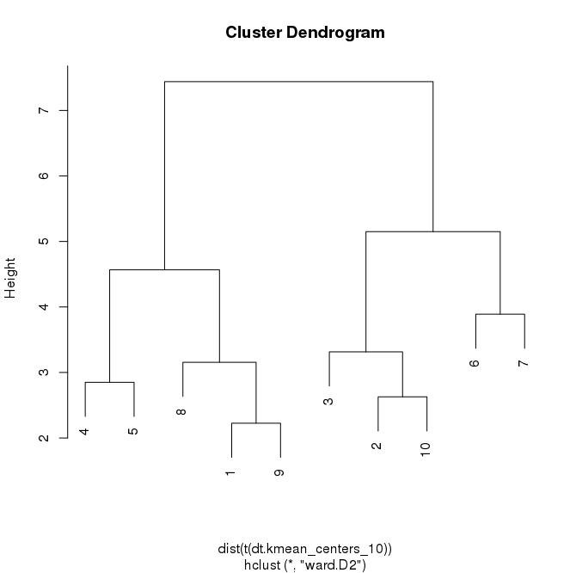
Reminder :

On tree 71 dsc withinss 400 for first 10 clusters :

clusters | 1 | 2 | 3 | 4 | 5 | 6 | 7 | 8 | 9 | 10
nucleotide pockets  (tot:1553) | 9 | 55 | 159 | 23 | 293 | 331 | 425 | 6 | 34 | 23
nucleotide pockets  (tot:596) | 27 | 20 | 63 | 26 | 39 | 26 | 20 | 292 | 1 | 35

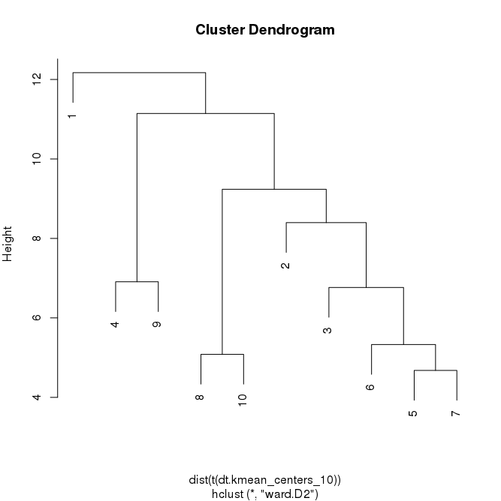

TEST KMEANS 1000 clusters:
dt12 dataset (R2 : 89.8)

TEST KMEANS 1000 clusters:
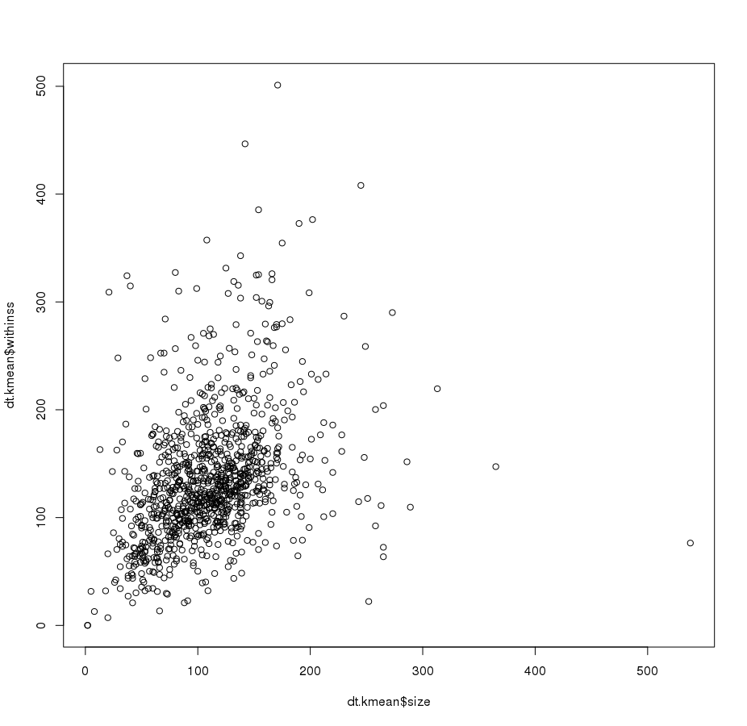
dt12 dataset (R2 : 89.8)

CLASSIC

sd according to mean in each leaf (tree: withinss 400 mcqueen dt12, 1063 ) :
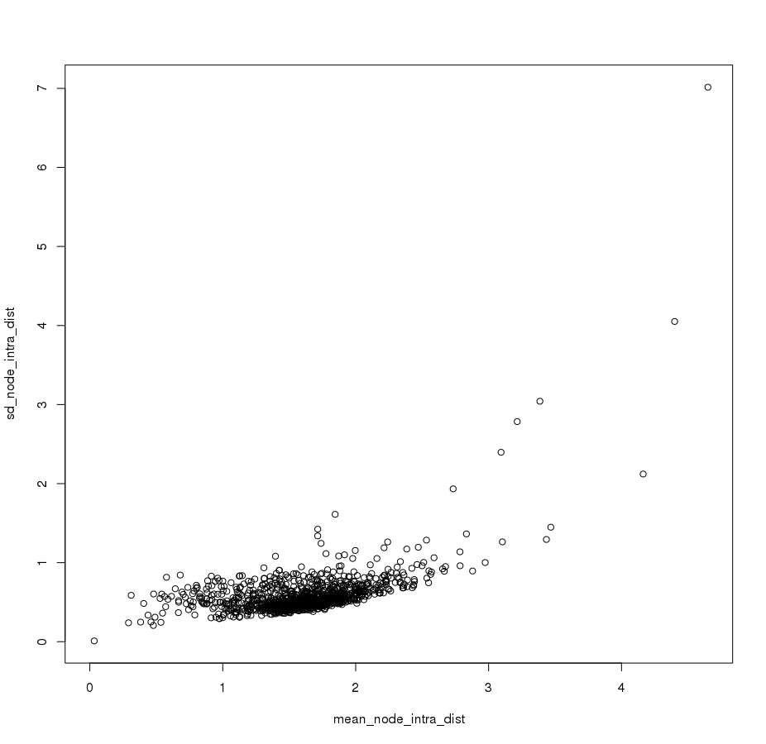
NESTED
size of leaf clusters according to the mean of the distance:
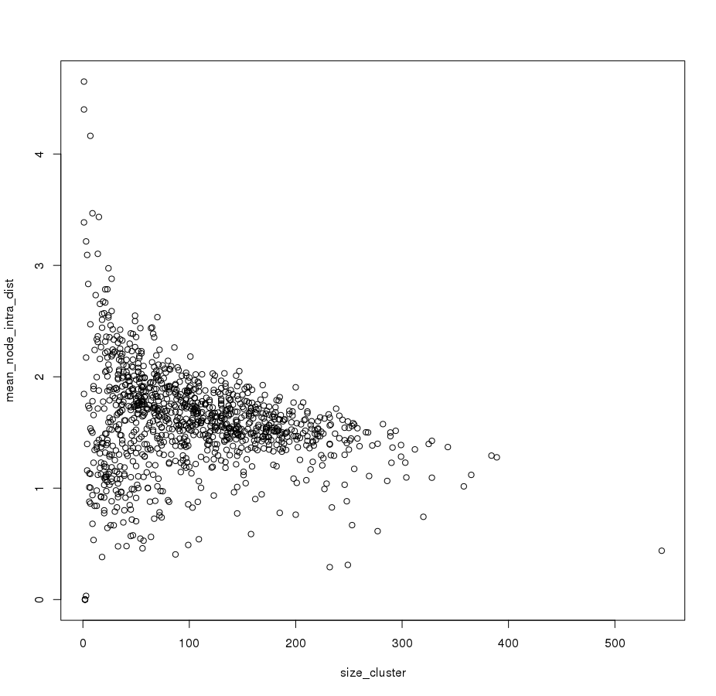
NESTED
sd :
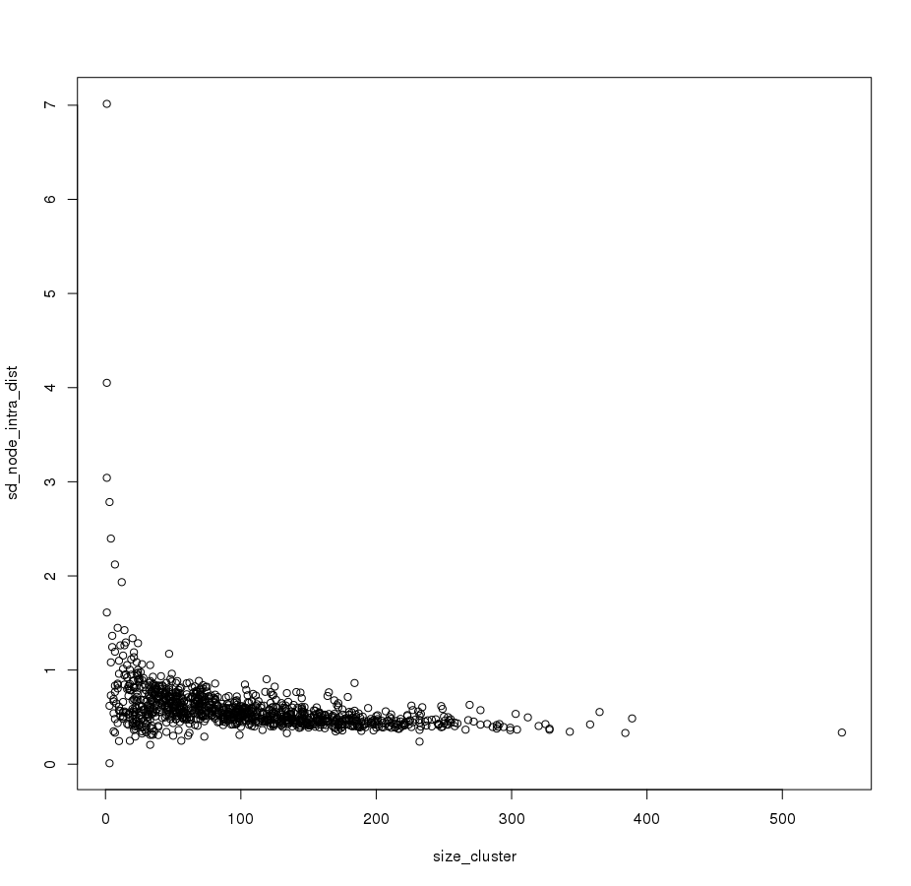
NESTED

With kmean on 1000 clusters in one go (no kmeans cascade):
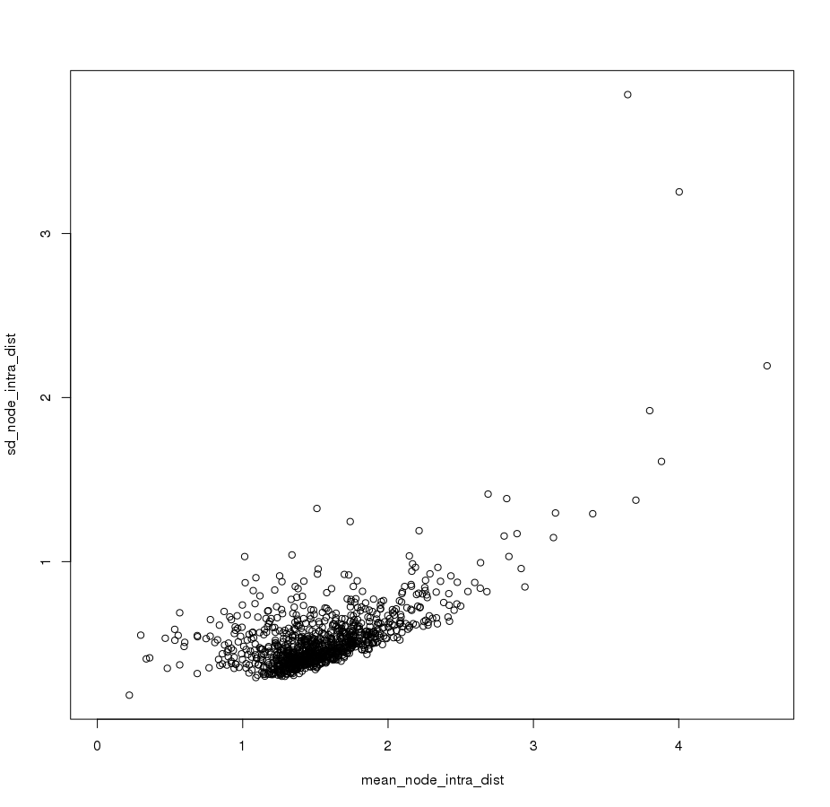
CLASSIC

CLASSIC
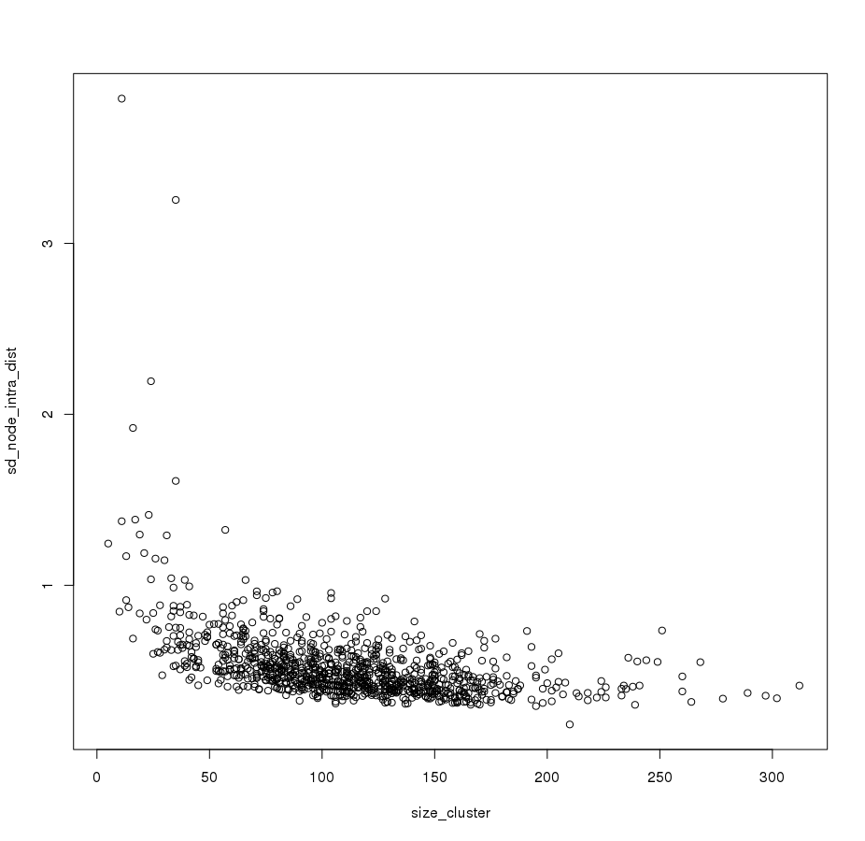

CLASSIC
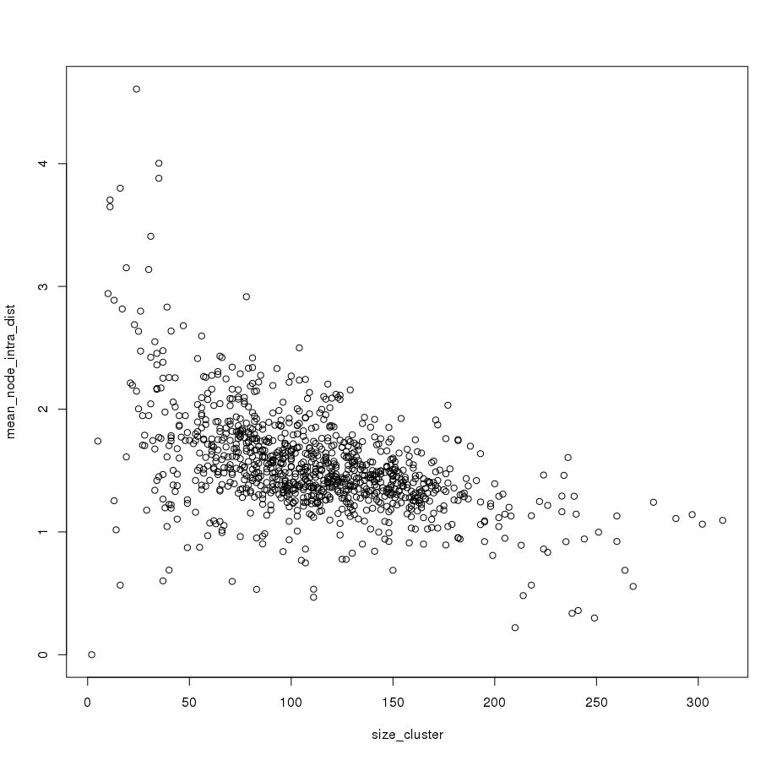

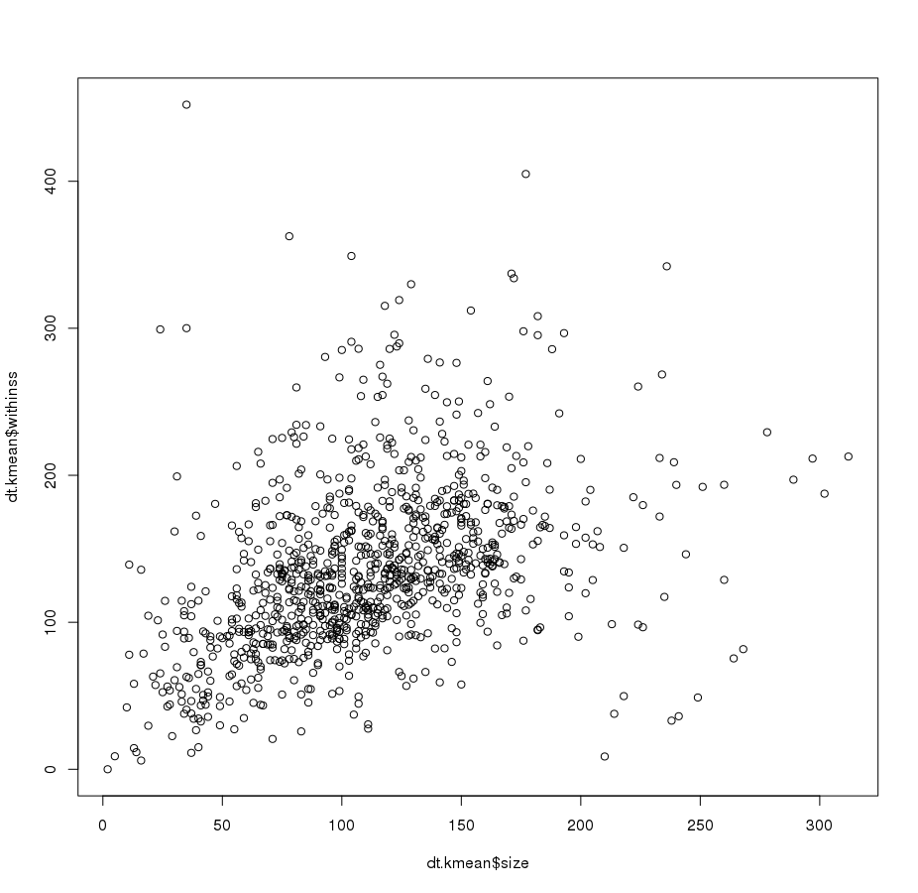
CLASSIC

Withins and average within for our protocol for 1000 clusters (NESTED):
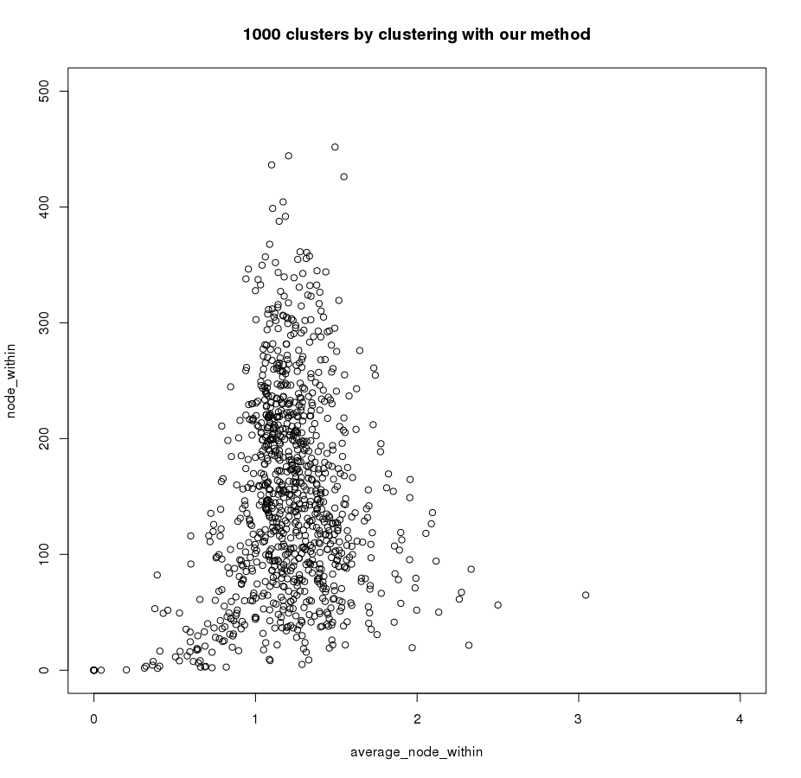
Withins and average within for one go of kmeans with 1000 seeds (CLASSIC):
NESTED
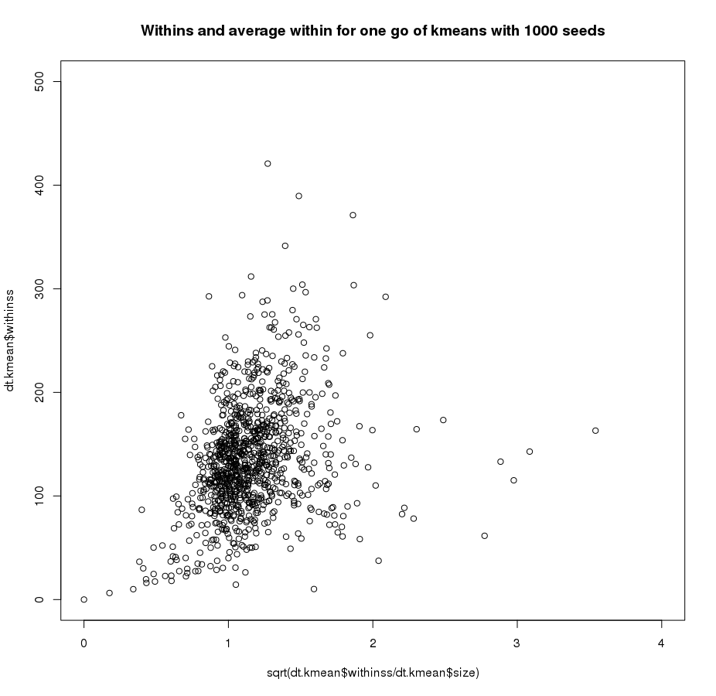
CLASSIC

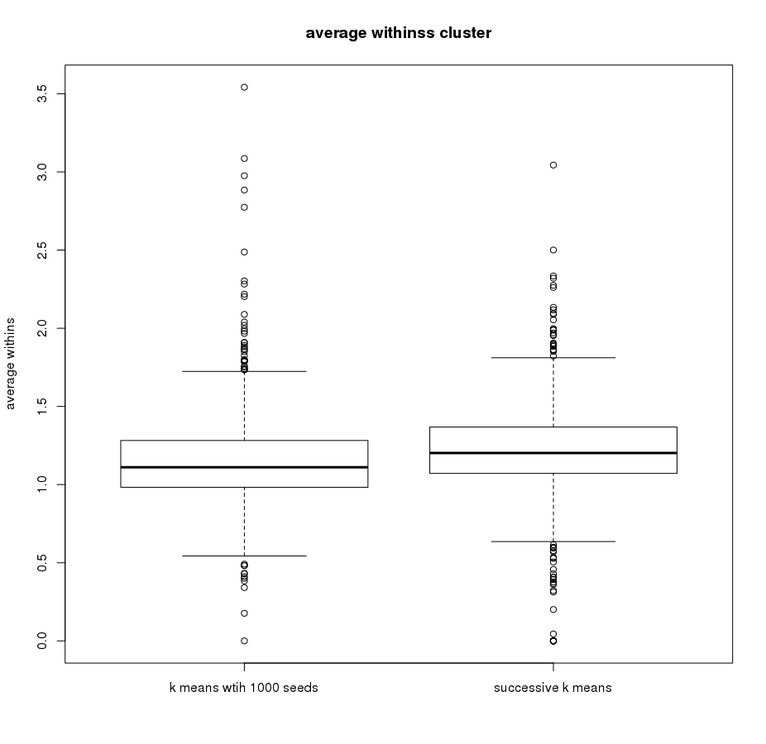
NESTED
CLASSIC

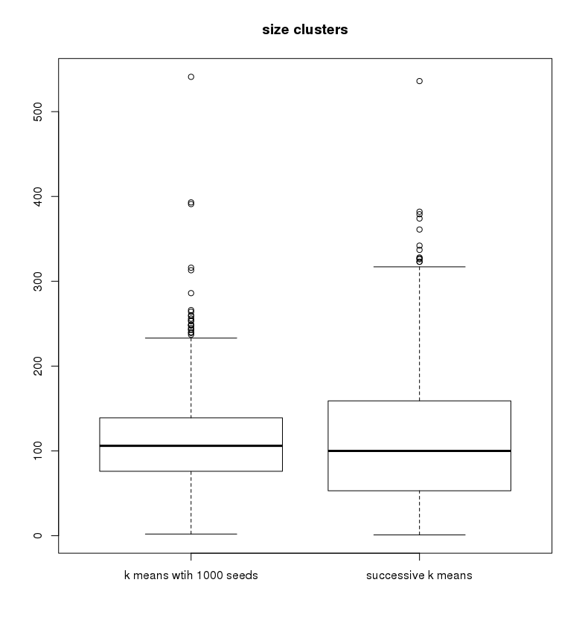
NESTED
CLASSIC

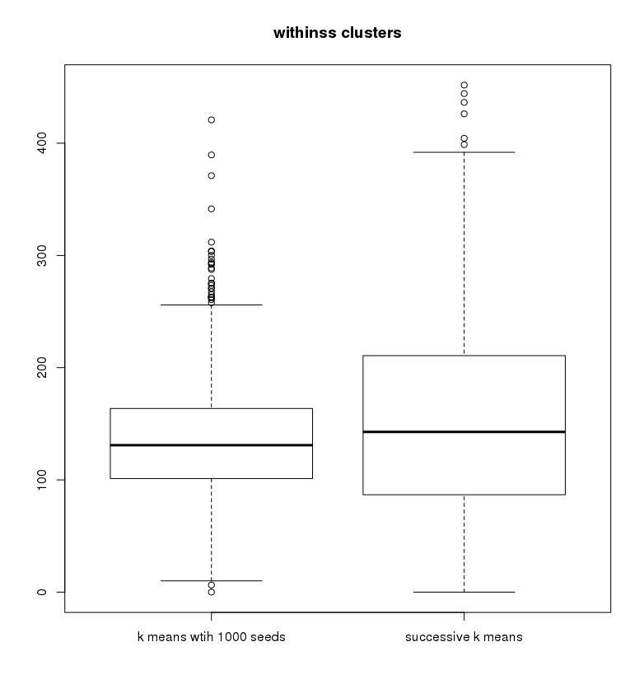
CLASSIC
NESTED
CLASSIC

HEATMAP of the table of corresponding cluster between the 2 methods (hard to interpret)
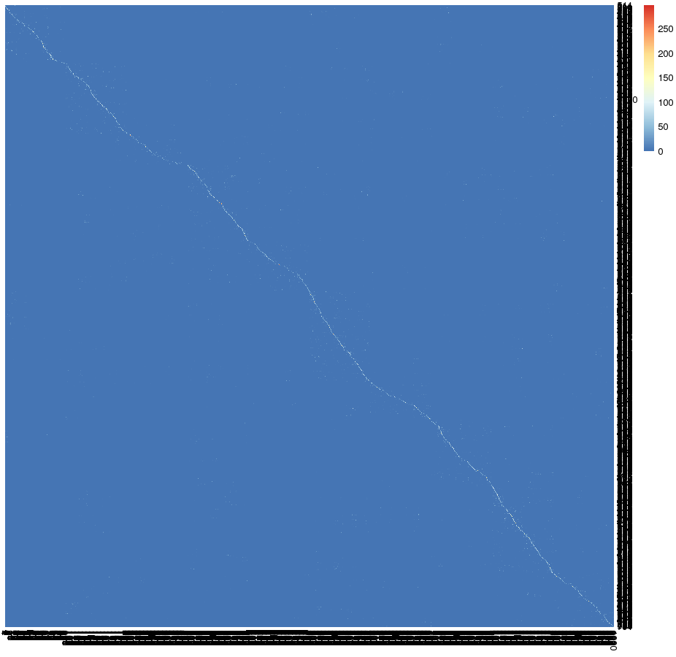

for 3 iteration (100 clusters)
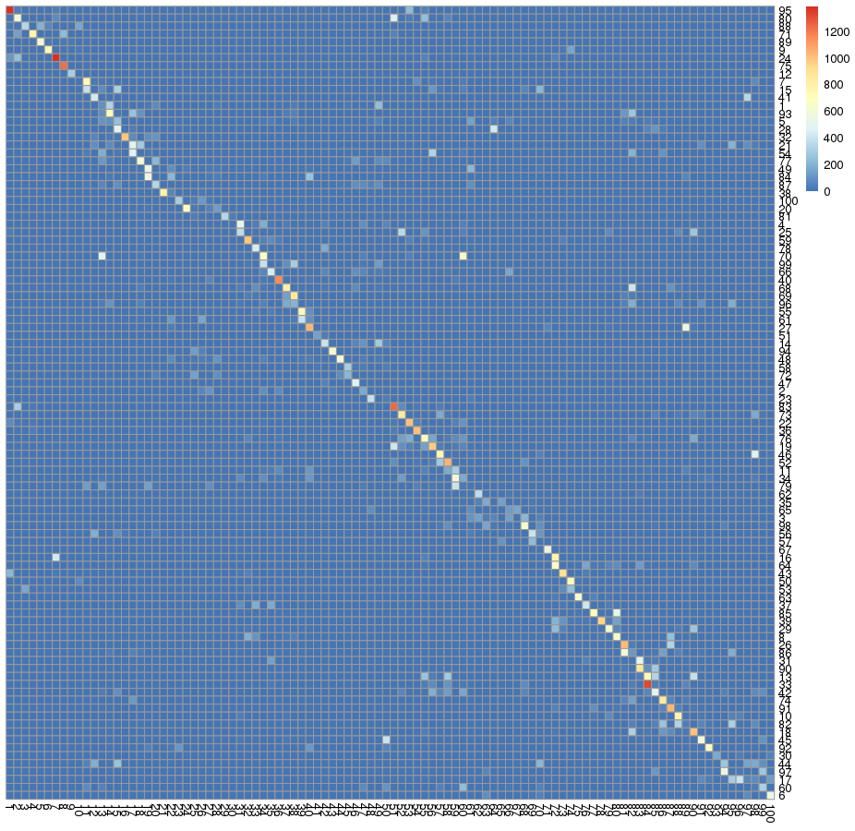

PROTEINS FAMILIES AND LIGANDS

47492 unique proteins in the final set (without proteins with ligands < 14 and > 60)

17626 unique ligands :
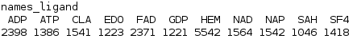

AUTRES DEMANDES :
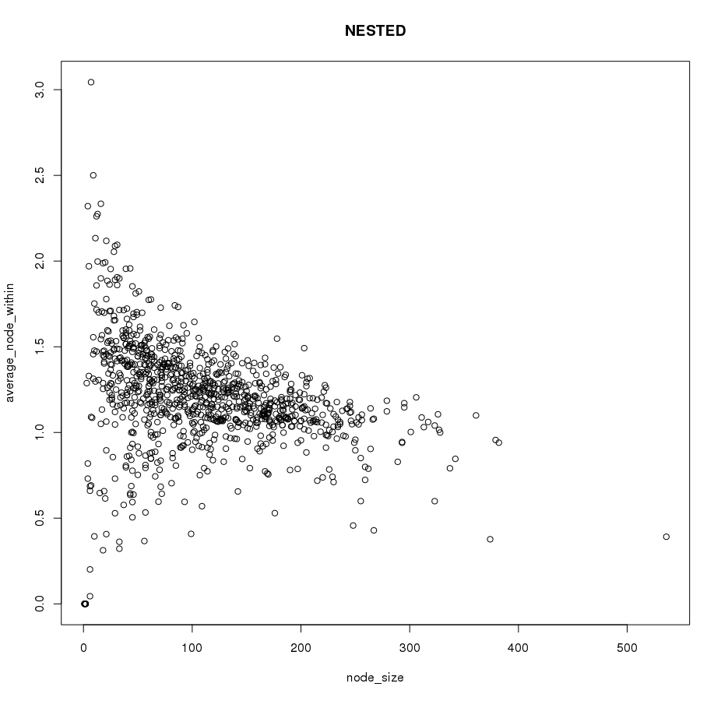

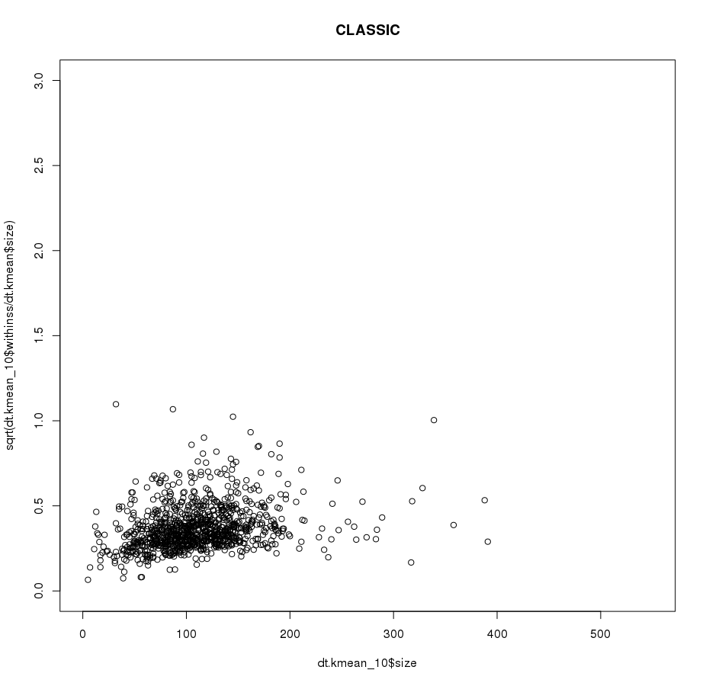

DISTANCE OF AVERAGE WITHIN IN EACH CLUSTER FOR CLASSIC CLUSTERING :

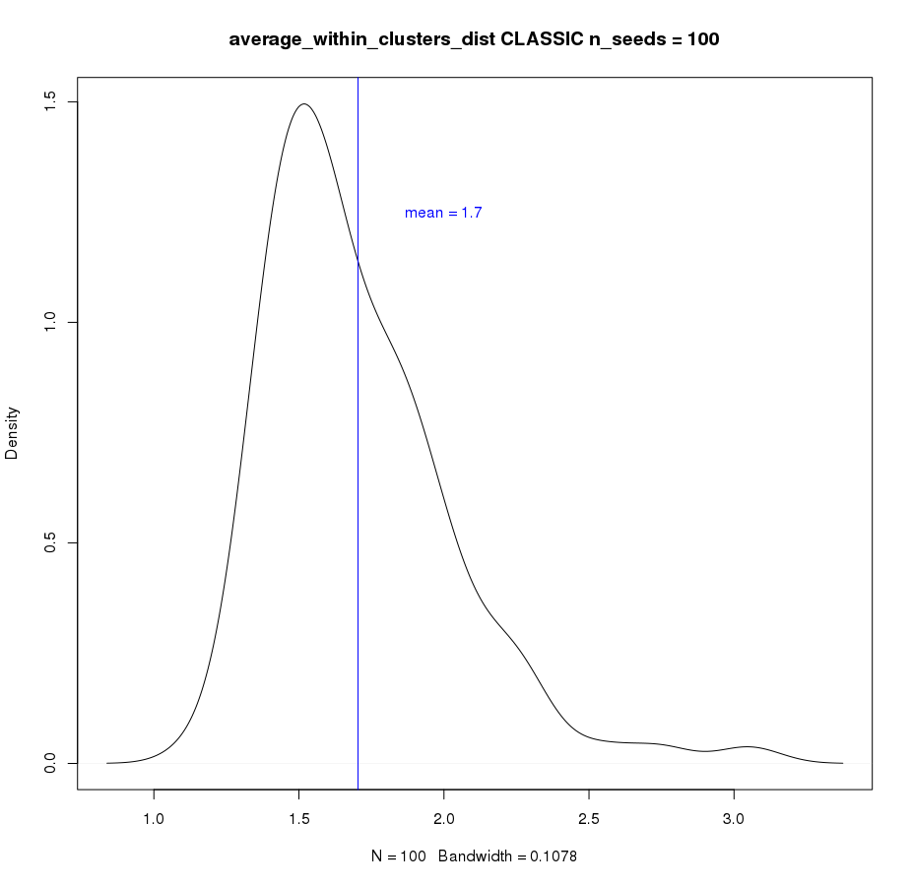

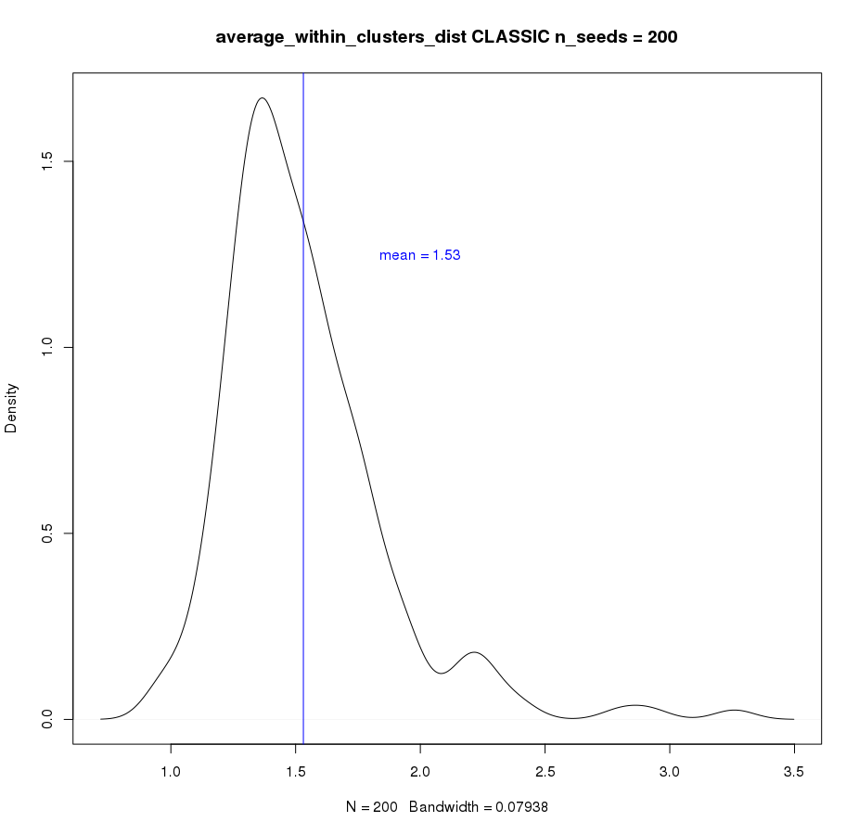

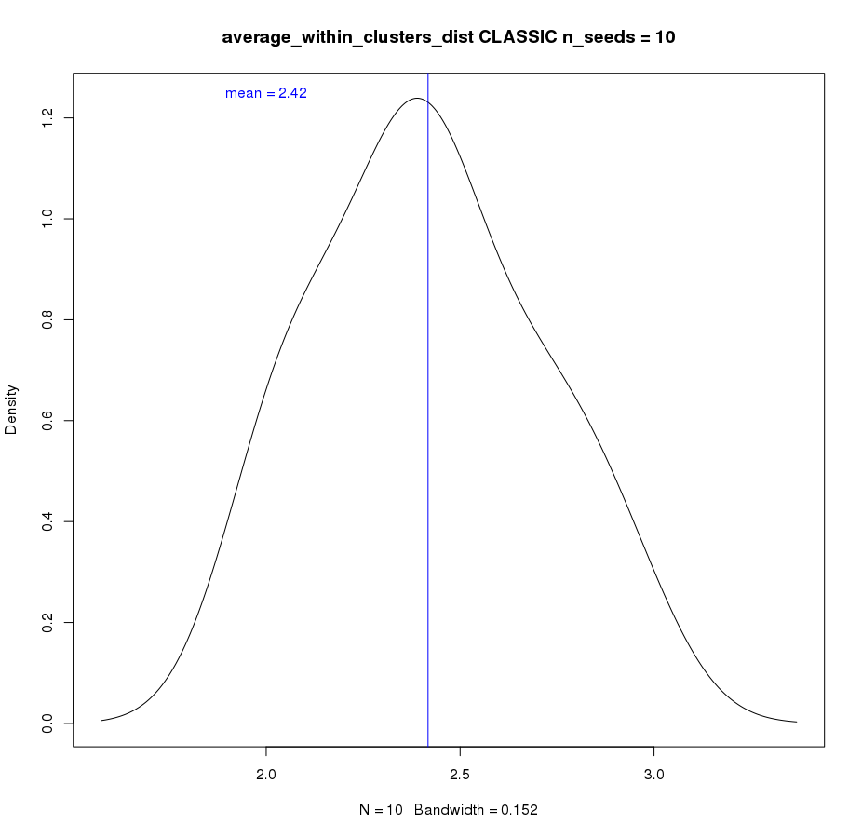
DENSITY PLOT

In red : distance between random pockets
in green (mean in blue) distance between pockets linked to the same ligand

DENSITY PLOT OF WITHIN LIGANDS POCKETS DISTANCES:
(without ligands associated with 1 pocket : 17626 ligands → 11223 ligands linked to multiples pockets)

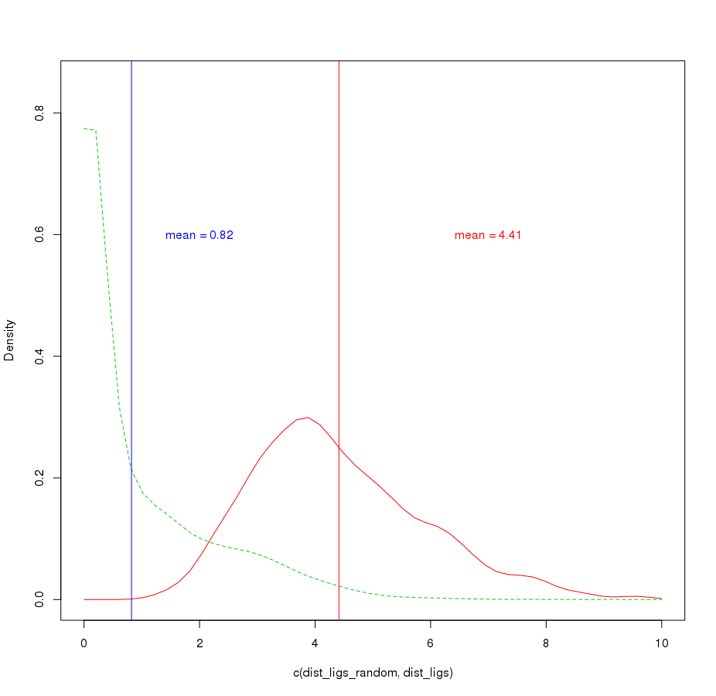

WITH ligands bounds to more than 1 pockets :

with ligands bound to more than 10 pockets :

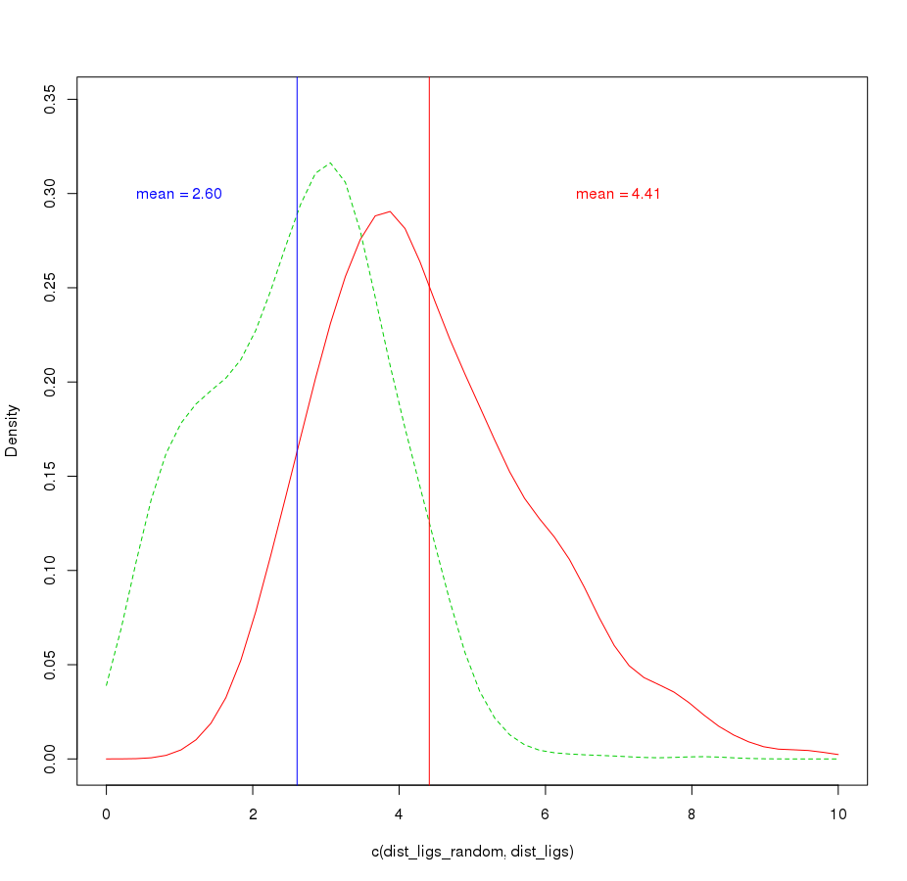

LIGAND ACCORDING THE NUMBER OF OBSERVED POCKETS CORRESPONDING


