Guillermo Gálvez

CPE301 – SPRING 2018

Design Assignment X

**DO NOT REMOVE THIS PAGE DURING SUBMISSION:**

The student understands that all required components should be submitted in complete for grading of this assignment.

|  |  |  |  |
| --- | --- | --- | --- |
| **NO** | **SUBMISSION ITEM** | **COMPLETED (Y/N)** | **MARKS**  **(/MAX)** |
| 1 | COMPONENTS LIST AND CONNECTION BLOCK DIAGRAM w/ PINS |  |  |
| 2. | INITIAL CODE OF TASK 1/A |  |  |
| 3. | INCREMENTAL / DIFFERENTIAL CODE OF TASK 2/B |  |  |
| 3. | INCREMENTAL / DIFFERENTIAL CODE OF TASK 3/C |  |  |
| 3. | INCREMENTAL / DIFFERENTIAL CODE OF TASK 4/D |  |  |
| 3. | INCREMENTAL / DIFFERENTIAL CODE OF TASK 5/E |  |  |
| 4. | SCHEMATICS |  |  |
| 5. | SCREENSHOTS OF EACH TASK OUTPUT |  |  |
| 5. | SCREENSHOT OF EACH DEMO |  |  |
| 6. | VIDEO LINKS OF EACH DEMO |  |  |
| 7. | GOOGLECODE LINK OF THE DA |  |  |
|  |  |  |  |
|  |  |  |  |

1. **COMPONENTS LIST AND CONNECTION BLOCK DIAGRAM w/ PINS**

List of Components used

Atmel Studio 7

Block diagram with pins used in the Atmega328P

N/A

1. **Assembly Program**
2. ;
3. ; Demo.asm
4. ;
5. ; Created: 2/8/2018 04:49:22 PM
6. ; Author : Guillermo Gálvez
7. ;
8. ; Replace with your application code
9. .equ SA = 0x0222 ;Starting adress
10. .equ cnt = 255 ;check for second loop
11. .equ cnt1 = 45
12. .equ five = 5
13. .org 0
14. RJMP start
15. ;STUFF CAN GO HERE
16. start:
17. clr r0 ;zero r0 register
18. ldi XL, low(SA) ;XL R26 = 0x--22 startadd[7:0]
19. ldi XH, high(SA) ;XH R27 = 0x02-- startadd[8:15]
20. ldi YL, low(0x400) ;Where to store low if div by 5
21. ldi YH, high(0x400) ;Where to store high if div by 5
22. ldi ZL, low(0x600) ;Where to store low if not div by 5
23. ldi ZH, high(0x600) ;Where to store low if not div by 5
24. ;conting registers "index"
25. ldi r20, cnt ;upper found
27. ;sum registers
28. clr r0 ;R0=0
29. clr r1 ;Have I been here/The Carry Bit
30. clr r2 ;take up to 300 check
31. clr r3 ;R3=0
32. clr r5 ;R5=0
33. clr r16 ;R16=0
34. clr r17 ;R17=0
35. clr r18 ;R18=0
36. clr r19 ;R19=0
37. clr r21 ;working register
38. clr r22 ;working register
39. clr r15 ;R15=0 ZERO

42. inc r1 ;did you already reset once check
43. ldi r24, 5
44. rjmp storeLP
45. keepcounting:
46. cp r3, r1 ;have you been here already
47. brlo to300 ;No then reset r0 to count another 44
48. rjmp doneStoring ;Yes then you're done
49. to300:
50. clr r0 ;reset loop control
51. inc r3 ;set check for next time
52. ldi r20, cnt1 ;set to go to 300
53. rjmp back ;
54. storeLP: mov r21, XH ;load values at SA =0x02-- high into r16
55. mov r22, XL ;load values at SA =0x--22 low into r17
56. back:
57. cp r20, r0 ;i > 254
58. breq keepcounting ;if so end
59. add r21, r22 ;R16 = XH + XL
60. ST X+, r21 ;store sum of 0x0222, X -> 0x0224
61. cp r21, r15
62. breq zero ;zero not div 5
63. mov r23, r21 ;set up r23 for divison by 5
64. rjmp divB5
65. inc r0
66. rjmp storeLP ;continue to 300 numbers
67. ;DIVISION LOOP
68. divB5: cp r23, r24 ;is r23 < 5
69. brlo isLT5 ;if r23 < 5 is it zero
70. sub r23, r24 ;r22 - 5
71. rjmp divB5
72. isLT5: cp r23, r15 ;is it equal to zero
73. breq isDiv5 ;if eq zero jump
74. ;NOT DIV 5/Zero not Div5
75. zero:
76. st Z+, r21 ;store not-div by 5 numb at 0x0600, Z -> 0x0604
77. add r19, r21 ;r18:r19
78. inc r0 ;next index
79. rjmp notB5
81. isDiv5: st Y+, r21 ;store div by 5 at 0x0400, Y -> 0x0400
82. add r17, r21 ;r16:r17
83. inc r0 ;next index
84. rjmp by5
86. by5: brcs addC5
87. rjmp storeLP
88. addC5: add r16, r1
89. rjmp storeLP
90. notB5: brcs addCN
91. rjmp storeLP
92. addCN: add r18, r1
93. rjmp storeLP
94. doneStoring: RJMP doneStoring
95. .EXIT

dsfsfd

**3. MODIFIED CODE OF TASK 2/A from TASK 1/A**

Insert only the modified sections here. Use more sections if needed

**4.** **SCHEMATICS**

N/A

**5. SCREENSHOTS OF EACH TASK OUTPUT (ATMEL STUDIO OUTPUT)**

**Stored numbers**

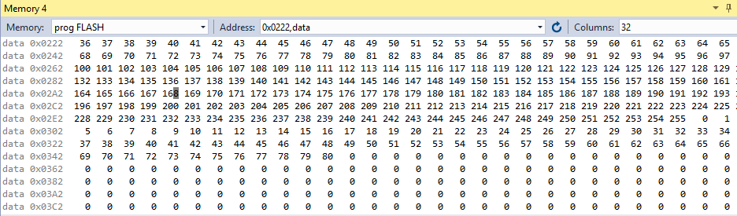

**Stored by 5 numbers**

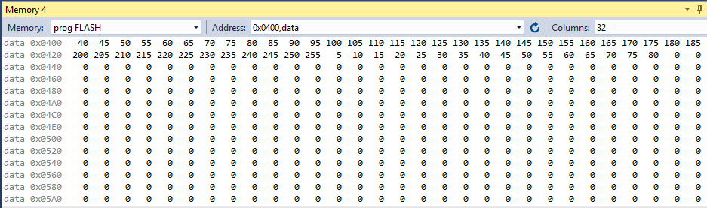

**Stored not by 5 numbers**

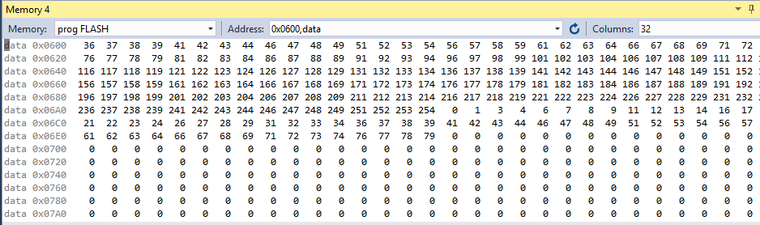

**Sums**

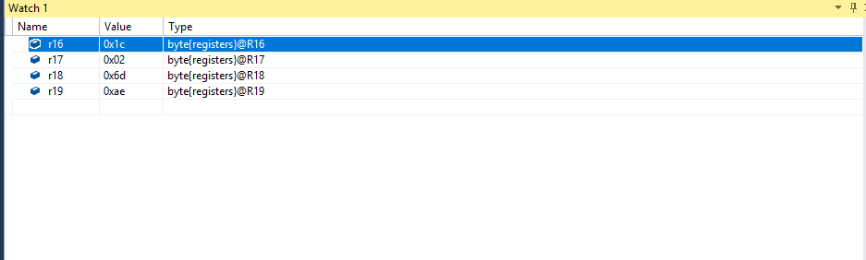

**6. SCREENSHOT OF EACH DEMO (BOARD SETUP)**

N/A

**7. VIDEO LINKS OF EACH DEMO**

N/A

**8. GITHUB LINK OF THIS DA**

git@github.com:galveg1/Design-Assignments.git

**Student Academic Misconduct Policy**

<http://studentconduct.unlv.edu/misconduct/policy.html>

“This assignment submission is my own, original work”.

NAME OF THE STUDENT