**Date Submitted: 11/20/2018**

**------------------------------------------------------------------------------------**

**Task 1: Tx**

Youtube Link: N/A

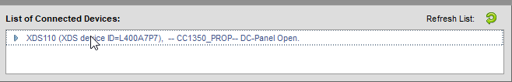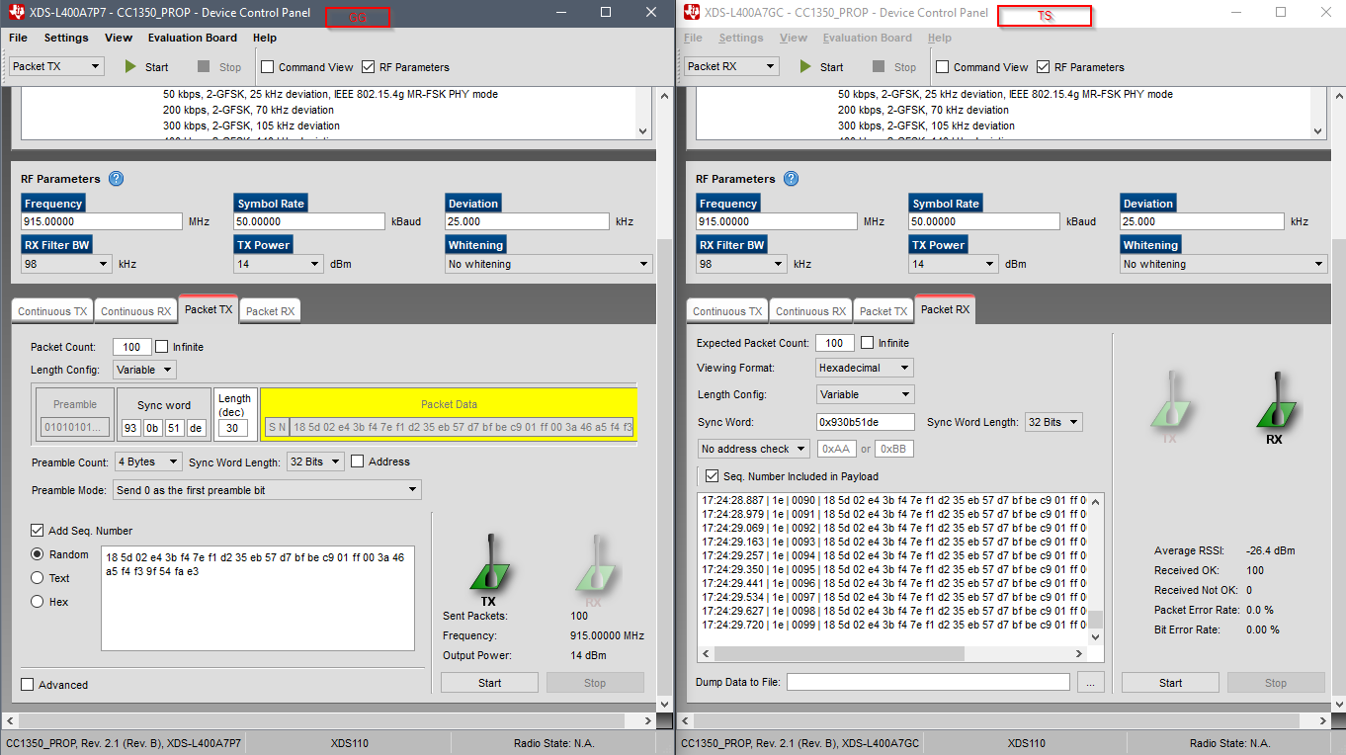

*/***** Includes *****/*

*/* Standard C Libraries */*

#include <stdlib.h>

#include <unistd.h>

*/* TI Drivers */*

#include <ti/drivers/rf/RF.h>

#include <ti/drivers/PIN.h>

#include <ti/drivers/pin/PINCC26XX.h>

*/* Driverlib Header files */*

#include DeviceFamily_constructPath(driverlib/rf_prop_mailbox.h)

*/* Board Header files */*

#include "Board.h"

#include "smartrf_settings/smartrf_settings.h"

*/***** Defines *****/*

*/* Do power measurement */*

*//#define POWER_MEASUREMENT*

*/* Packet TX Configuration */*

#define PAYLOAD_LENGTH 30

#ifdef POWER_MEASUREMENT

#define PACKET_INTERVAL 5 */* For power measurement set packet interval to 5s */*

#else

#define PACKET_INTERVAL 500000 */* Set packet interval to 500000us or 500ms */*

#endif

*/***** Prototypes *****/*

*/***** Variable declarations *****/*

**static** RF_Object rfObject;

**static** RF_Handle rfHandle;

*/* Pin driver handle */*

**static** PIN_Handle ledPinHandle;

**static** PIN_State ledPinState;

**static** uint8_t packet[PAYLOAD_LENGTH];

**static** uint16_t seqNumber;

*/\**

*\* Application LED pin configuration table:*

*\* - All LEDs board LEDs are off.*

*\*/*

PIN_Config pinTable[] =

{

Board_PIN_LED1 | PIN_GPIO_OUTPUT_EN | PIN_GPIO_LOW | PIN_PUSHPULL | PIN_DRVSTR_MAX,

#if defined Board_CC1352R1_LAUNCHXL

Board_DIO30_RFSW | PIN_GPIO_OUTPUT_EN | PIN_GPIO_HIGH | PIN_PUSHPULL | PIN_DRVSTR_MAX,

#endif

#ifdef POWER_MEASUREMENT

#if defined(Board_CC1350_LAUNCHXL)

Board_DIO30_SWPWR | PIN_GPIO_OUTPUT_EN | PIN_GPIO_HIGH | PIN_PUSHPULL | PIN_DRVSTR_MAX,

#endif

#endif

PIN_TERMINATE

};

*/***** Function definitions *****/*

void *mainThread(void *arg0)

{

RF_Params rfParams;

RF_Params_init(&rfParams);

*/* Open LED pins */*

ledPinHandle = PIN_open(&ledPinState, pinTable);

**if** (ledPinHandle == NULL)

{

**while**(1);

}

#ifdef POWER_MEASUREMENT

#if defined(Board_CC1350_LAUNCHXL)

*/* Route out PA active pin to Board_DIO30_SWPWR */*

PINCC26XX_setMux(ledPinHandle, Board_DIO30_SWPWR, PINCC26XX_MUX_RFC_GPO1);

#endif

#endif

RF_cmdPropTx.pktLen = PAYLOAD_LENGTH;

RF_cmdPropTx.pPkt = packet;

RF_cmdPropTx.startTrigger.triggerType = TRIG_NOW;

*/* Request access to the radio */*

rfHandle = RF_open(&rfObject, &RF_prop, (RF_RadioSetup*)&RF_cmdPropRadioDivSetup, &rfParams);

*/* Set the frequency */*

RF_postCmd(rfHandle, (RF_Op*)&RF_cmdFs, RF_PriorityNormal, NULL, 0);

**while**(1)

{

*/* Create packet with incrementing sequence number and random payload */*

packet[0] = (uint8_t)(seqNumber >> 8);

packet[1] = (uint8_t)(seqNumber++);

uint8_t i;

**for** (i = 2; i < PAYLOAD_LENGTH; i++)

{

packet[i] = rand();

}

*/* Send packet */*

RF_EventMask terminationReason = RF_runCmd(rfHandle, (RF_Op*)&RF_cmdPropTx,

RF_PriorityNormal, NULL, 0);

**switch**(terminationReason)

{

**case** RF_EventLastCmdDone:

*// A stand-alone radio operation command or the last radio*

*// operation command in a chain finished.*

**break**;

**case** RF_EventCmdCancelled:

*// Command cancelled before it was started; it can be caused*

*// by RF_cancelCmd() or RF_flushCmd().*

**break**;

**case** RF_EventCmdAborted:

*// Abrupt command termination caused by RF_cancelCmd() or*

*// RF_flushCmd().*

**break**;

**case** RF_EventCmdStopped:

*// Graceful command termination caused by RF_cancelCmd() or*

*// RF_flushCmd().*

**break**;

default:

*// Uncaught error event*

**while**(1);

}

uint32_t cmdStatus = ((**volatile** RF_Op*)&RF_cmdPropTx)->status;

**switch**(cmdStatus)

{

**case** PROP_DONE_OK:

*// Packet transmitted successfully*

**break**;

**case** PROP_DONE_STOPPED:

*// received CMD_STOP while transmitting packet and finished*

*// transmitting packet*

**break**;

**case** PROP_DONE_ABORT:

*// Received CMD_ABORT while transmitting packet*

**break**;

**case** PROP_ERROR_PAR:

*// Observed illegal parameter*

**break**;

**case** PROP_ERROR_NO_SETUP:

*// Command sent without setting up the radio in a supported*

*// mode using CMD_PROP_RADIO_SETUP or CMD_RADIO_SETUP*

**break**;

**case** PROP_ERROR_NO_FS:

*// Command sent without the synthesizer being programmed*

**break**;

**case** PROP_ERROR_TXUNF:

*// TX underflow observed during operation*

**break**;

default:

*// Uncaught error event - these could come from the*

*// pool of states defined in rf_mailbox.h*

**while**(1);

}

#ifndef POWER_MEASUREMENT

PIN_setOutputValue(ledPinHandle, Board_PIN_LED1,!PIN_getOutputValue(Board_PIN_LED1));

#endif

*/* Power down the radio */*

RF_yield(rfHandle);

#ifdef POWER_MEASUREMENT

*/* Sleep for PACKET_INTERVAL s */*

sleep(PACKET_INTERVAL);

#else

*/* Sleep for PACKET_INTERVAL us */*

usleep(PACKET_INTERVAL);

#endif

}

}

**Task 2: Tx**

Youtube: <https://youtu.be/nM4mXKl9i_w>

**The PDf states it should be the red LED blinking but the green is what was blinking after running the package.**

**Modified code:**

*/***** Includes *****/*

*/* Standard C Libraries */*

#include <stdlib.h>

#include <unistd.h>

*/* TI Drivers */*

#include <ti/drivers/rf/RF.h>

#include <ti/drivers/PIN.h>

#include <ti/drivers/pin/PINCC26XX.h>

*/* Driverlib Header files */*

#include DeviceFamily_constructPath(driverlib/rf_prop_mailbox.h)

*/* Board Header files */*

#include "Board.h"

#include "smartrf_settings/smartrf_settings.h"

*/***** Defines *****/*

*/* Do power measurement */*

*//#define POWER_MEASUREMENT*

*/* Packet TX Configuration */*

#define PAYLOAD_LENGTH 30

#ifdef POWER_MEASUREMENT

#define PACKET_INTERVAL 5 */* For power measurement set packet interval to 5s */*

#else

#define PACKET_INTERVAL 500000 */* Set packet interval to 500000us or 500ms */*

#endif

*/***** Prototypes *****/*

*/***** Variable declarations *****/*

**static** RF_Object rfObject;

**static** RF_Handle rfHandle;

*/* Pin driver handle */*

**static** PIN_Handle ledPinHandle;

**static** PIN_State ledPinState;

**static** uint8_t packet[PAYLOAD_LENGTH];

**static** uint16_t seqNumber;

*/\**

*\* Application LED pin configuration table:*

*\* - All LEDs board LEDs are off.*

*\*/*

PIN_Config pinTable[] =

{

Board_PIN_LED1 | PIN_GPIO_OUTPUT_EN | PIN_GPIO_LOW | PIN_PUSHPULL | PIN_DRVSTR_MAX,

#if defined Board_CC1352R1_LAUNCHXL

Board_DIO30_RFSW | PIN_GPIO_OUTPUT_EN | PIN_GPIO_HIGH | PIN_PUSHPULL | PIN_DRVSTR_MAX,

#endif

#ifdef POWER_MEASUREMENT

#if defined(Board_CC1350_LAUNCHXL)

Board_DIO30_SWPWR | PIN_GPIO_OUTPUT_EN | PIN_GPIO_HIGH | PIN_PUSHPULL | PIN_DRVSTR_MAX,

#endif

#endif

PIN_TERMINATE

};

*/***** Function definitions *****/*

void *mainThread(void *arg0)

{

RF_Params rfParams;

RF_Params_init(&rfParams);

*/* Open LED pins */*

ledPinHandle = PIN_open(&ledPinState, pinTable);

**if** (ledPinHandle == NULL)

{

**while**(1);

}

#ifdef POWER_MEASUREMENT

#if defined(Board_CC1350_LAUNCHXL)

*/* Route out PA active pin to Board_DIO30_SWPWR */*

PINCC26XX_setMux(ledPinHandle, Board_DIO30_SWPWR, PINCC26XX_MUX_RFC_GPO1);

#endif

#endif

RF_cmdPropTx.pktLen = PAYLOAD_LENGTH;

RF_cmdPropTx.pPkt = packet;

RF_cmdPropTx.startTrigger.triggerType = TRIG_NOW;

*/* Request access to the radio */*

rfHandle = RF_open(&rfObject, &RF_prop, (RF_RadioSetup*)&RF_cmdPropRadioDivSetup, &rfParams);

*/* Set the frequency */*

RF_postCmd(rfHandle, (RF_Op*)&RF_cmdFs, RF_PriorityNormal, NULL, 0);

**while**(1)

{

*/* Create packet with incrementing sequence number and random payload */*

packet[0] = (uint8_t)(seqNumber >> 8);

packet[1] = (uint8_t)(seqNumber++);

uint8_t i;

**for** (i = 2; i < PAYLOAD_LENGTH; i++)

{

packet[i] = rand();

}

*/* Send packet */*

RF_EventMask terminationReason = RF_runCmd(rfHandle, (RF_Op*)&RF_cmdPropTx,

RF_PriorityNormal, NULL, 0);

**switch**(terminationReason)

{

**case** RF_EventLastCmdDone:

*// A stand-alone radio operation command or the last radio*

*// operation command in a chain finished.*

**break**;

**case** RF_EventCmdCancelled:

*// Command cancelled before it was started; it can be caused*

*// by RF_cancelCmd() or RF_flushCmd().*

**break**;

**case** RF_EventCmdAborted:

*// Abrupt command termination caused by RF_cancelCmd() or*

*// RF_flushCmd().*

**break**;

**case** RF_EventCmdStopped:

*// Graceful command termination caused by RF_cancelCmd() or*

*// RF_flushCmd().*

**break**;

default:

*// Uncaught error event*

**while**(1);

}

uint32_t cmdStatus = ((**volatile** RF_Op*)&RF_cmdPropTx)->status;

**switch**(cmdStatus)

{

**case** PROP_DONE_OK:

*// Packet transmitted successfully*

**break**;

**case** PROP_DONE_STOPPED:

*// received CMD_STOP while transmitting packet and finished*

*// transmitting packet*

**break**;

**case** PROP_DONE_ABORT:

*// Received CMD_ABORT while transmitting packet*

**break**;

**case** PROP_ERROR_PAR:

*// Observed illegal parameter*

**break**;

**case** PROP_ERROR_NO_SETUP:

*// Command sent without setting up the radio in a supported*

*// mode using CMD_PROP_RADIO_SETUP or CMD_RADIO_SETUP*

**break**;

**case** PROP_ERROR_NO_FS:

*// Command sent without the synthesizer being programmed*

**break**;

**case** PROP_ERROR_TXUNF:

*// TX underflow observed during operation*

**break**;

default:

*// Uncaught error event - these could come from the*

*// pool of states defined in rf_mailbox.h*

**while**(1);

}

#ifndef POWER_MEASUREMENT

PIN_setOutputValue(ledPinHandle, Board_PIN_LED1,!PIN_getOutputValue(Board_PIN_LED1));

#endif

*/* Power down the radio */*

RF_yield(rfHandle);

#ifdef POWER_MEASUREMENT

*/* Sleep for PACKET_INTERVAL s */*

sleep(PACKET_INTERVAL);

#else

*/* Sleep for PACKET_INTERVAL us */*

usleep(PACKET_INTERVAL);

#endif

}

}

**Task 3: Exporting and using RF config**

Youtube:N/A

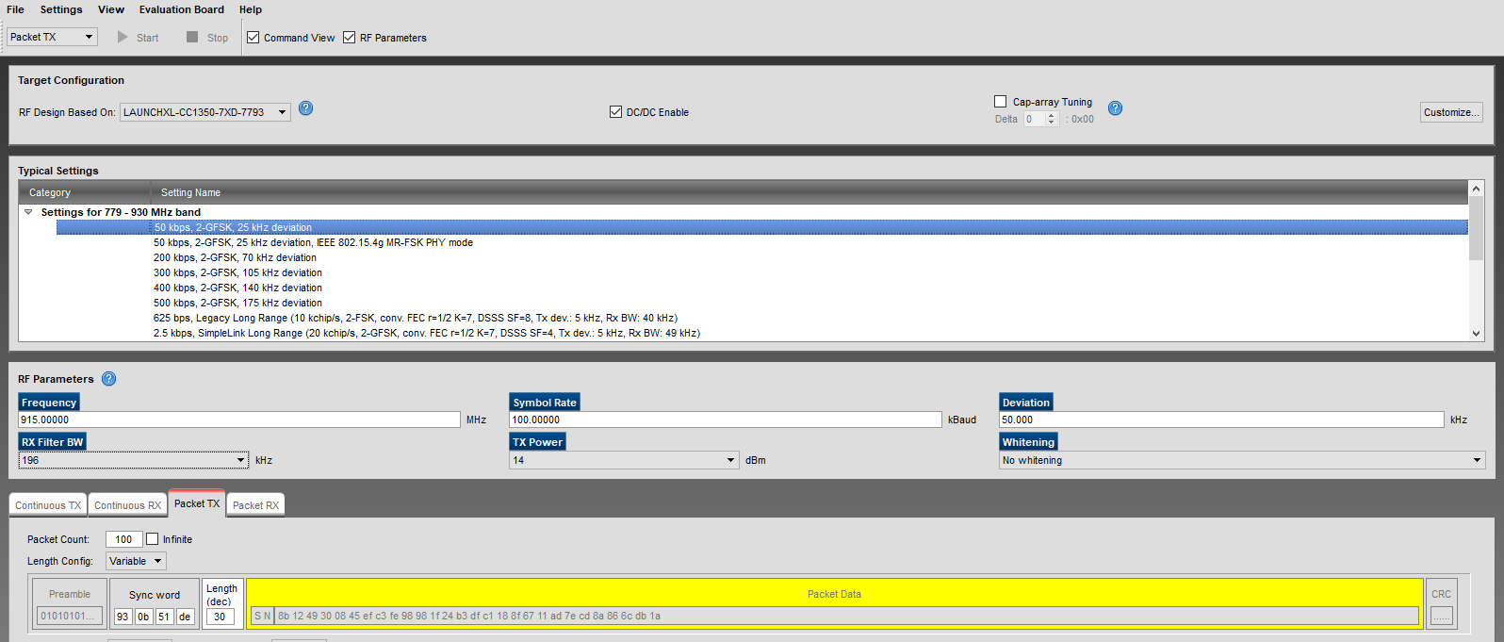

//*********************************************************************************

// Generated by SmartRF Studio version 2.11.0 (build#126)

// The applied template is compatible with CC13x0 SDK 2.30.xx.xx

// Device: CC1350 Rev. 2.1

//

//*********************************************************************************

EXPORTED:

//*********************************************************************************

// Parameter summary

// Address: 0

// Address0: 0xAA

// Address1: 0xBB

// Frequency: 915.00000 MHz

// Data Format: Serial mode disable

// Deviation: 50.000 kHz

// pktLen: 30

// 802.15.4g Mode: 0

// Select bit order to transmit PSDU octets:: 1

// Packet Length Config: Variable

// Max Packet Length: 255

// Packet Length: 20

// Packet Data: 255

// RX Filter BW: 196 kHz

// Symbol Rate: 100.00000 kBaud

// Sync Word Length: 32 Bits

// TX Power: 14 dBm (requires define CCFG_FORCE_VDDR_HH = 1 in ccfg.c, see CC13xx/CC26xx Technical Reference Manual)

// Whitening: No whitening

#include <ti/devices/DeviceFamily.h>

#include DeviceFamily_constructPath(driverlib/rf_mailbox.h)

#include DeviceFamily_constructPath(driverlib/rf_common_cmd.h)

#include DeviceFamily_constructPath(driverlib/rf_prop_cmd.h)

#include <ti/drivers/rf/RF.h>

#include DeviceFamily_constructPath(rf_patches/rf_patch_cpe_genfsk.h)

#include DeviceFamily_constructPath(rf_patches/rf_patch_rfe_genfsk.h)

#include "smartrf_settings.h"

// TI-RTOS RF Mode Object

RF_Mode RF_prop =

{

.rfMode = RF_MODE_PROPRIETARY_SUB_1,

.cpePatchFxn = &rf_patch_cpe_genfsk,

.mcePatchFxn = 0,

.rfePatchFxn = &rf_patch_rfe_genfsk,

};

// Overrides for CMD_PROP_RADIO_DIV_SETUP

uint32_t pOverrides[] =

{

// override_use_patch_prop_genfsk.xml

// PHY: Use MCE ROM bank 4, RFE RAM patch

MCE_RFE_OVERRIDE(0,4,0,1,0,0),

// override_synth_prop_863_930_div5.xml

// Synth: Set recommended RTRIM to 7

HW_REG_OVERRIDE(0x4038,0x0037),

// Synth: Set Fref to 4 MHz

(uint32_t)0x000684A3,

// Synth: Configure fine calibration setting

HW_REG_OVERRIDE(0x4020,0x7F00),

// Synth: Configure fine calibration setting

HW_REG_OVERRIDE(0x4064,0x0040),

// Synth: Configure fine calibration setting

(uint32_t)0xB1070503,

// Synth: Configure fine calibration setting

(uint32_t)0x05330523,

// Synth: Set loop bandwidth after lock to 20 kHz

(uint32_t)0x0A480583,

// Synth: Set loop bandwidth after lock to 20 kHz

(uint32_t)0x7AB80603,

// Synth: Configure VCO LDO (in ADI1, set VCOLDOCFG=0x9F to use voltage input reference)

ADI_REG_OVERRIDE(1,4,0x9F),

// Synth: Configure synth LDO (in ADI1, set SLDOCTL0.COMP_CAP=1)

ADI_HALFREG_OVERRIDE(1,7,0x4,0x4),

// Synth: Use 24 MHz XOSC as synth clock, enable extra PLL filtering

(uint32_t)0x02010403,

// Synth: Configure extra PLL filtering

(uint32_t)0x00108463,

// Synth: Increase synth programming timeout (0x04B0 RAT ticks = 300 us)

(uint32_t)0x04B00243,

// override_phy_rx_aaf_bw_0xd.xml

// Rx: Set anti-aliasing filter bandwidth to 0xD (in ADI0, set IFAMPCTL3[7:4]=0xD)

ADI_HALFREG_OVERRIDE(0,61,0xF,0xD),

// override_phy_gfsk_rx.xml

// Rx: Set LNA bias current trim offset to 3

(uint32_t)0x00038883,

// Rx: Freeze RSSI on sync found event

HW_REG_OVERRIDE(0x6084,0x35F1),

// override_phy_gfsk_pa_ramp_agc_reflevel_0x1a.xml

// Tx: Configure PA ramping setting (0x41). Rx: Set AGC reference level to 0x1A.

HW_REG_OVERRIDE(0x6088,0x411A),

// Tx: Configure PA ramping setting

HW_REG_OVERRIDE(0x608C,0x8213),

// override_phy_rx_rssi_offset_5db.xml

// Rx: Set RSSI offset to adjust reported RSSI by +5 dB (default: 0), trimmed for external bias and differential configuration

(uint32_t)0x00FB88A3,

// TX power override

// Tx: Set PA trim to max (in ADI0, set PACTL0=0xF8)

ADI_REG_OVERRIDE(0,12,0xF8),

(uint32_t)0xFFFFFFFF

};

// CMD_PROP_RADIO_DIV_SETUP

// Proprietary Mode Radio Setup Command for All Frequency Bands

rfc_CMD_PROP_RADIO_DIV_SETUP_t RF_cmdPropRadioDivSetup =

{

.commandNo = 0x3807,

.status = 0x0000,

.pNextOp = 0, // INSERT APPLICABLE POINTER: (uint8_t*)&xxx

.startTime = 0x00000000,

.startTrigger.triggerType = 0x0,

.startTrigger.bEnaCmd = 0x0,

.startTrigger.triggerNo = 0x0,

.startTrigger.pastTrig = 0x0,

.condition.rule = 0x1,

.condition.nSkip = 0x0,

.modulation.modType = 0x1,

.modulation.deviation = 0xC8,

.symbolRate.preScale = 0xF,

.symbolRate.rateWord = 0x10000,

.symbolRate.decimMode = 0x0,

.rxBw = 0x27,

.preamConf.nPreamBytes = 0x4,

.preamConf.preamMode = 0x0,

.formatConf.nSwBits = 0x20,

.formatConf.bBitReversal = 0x0,

.formatConf.bMsbFirst = 0x1,

.formatConf.fecMode = 0x0,

.formatConf.whitenMode = 0x0,

.config.frontEndMode = 0x0,

.config.biasMode = 0x1,

.config.analogCfgMode = 0x0,

.config.bNoFsPowerUp = 0x0,

.txPower = 0xAB3F,

.pRegOverride = pOverrides,

.centerFreq = 0x0393,

.intFreq = 0x8000,

.loDivider = 0x05

};

// CMD_FS

// Frequency Synthesizer Programming Command

rfc_CMD_FS_t RF_cmdFs =

{

.commandNo = 0x0803,

.status = 0x0000,

.pNextOp = 0, // INSERT APPLICABLE POINTER: (uint8_t*)&xxx

.startTime = 0x00000000,

.startTrigger.triggerType = 0x0,

.startTrigger.bEnaCmd = 0x0,

.startTrigger.triggerNo = 0x0,

.startTrigger.pastTrig = 0x0,

.condition.rule = 0x1,

.condition.nSkip = 0x0,

.frequency = 0x0393,

.fractFreq = 0x0000,

.synthConf.bTxMode = 0x0,

.synthConf.refFreq = 0x0,

.__dummy0 = 0x00,

.__dummy1 = 0x00,

.__dummy2 = 0x00,

.__dummy3 = 0x0000

};

// CMD_PROP_TX

// Proprietary Mode Transmit Command

rfc_CMD_PROP_TX_t RF_cmdPropTx =

{

.commandNo = 0x3801,

.status = 0x0000,

.pNextOp = 0, // INSERT APPLICABLE POINTER: (uint8_t*)&xxx

.startTime = 0x00000000,

.startTrigger.triggerType = 0x0,

.startTrigger.bEnaCmd = 0x0,

.startTrigger.triggerNo = 0x0,

.startTrigger.pastTrig = 0x0,

.condition.rule = 0x1,

.condition.nSkip = 0x0,

.pktConf.bFsOff = 0x0,

.pktConf.bUseCrc = 0x1,

.pktConf.bVarLen = 0x1,

.pktLen = 0x14, // SET APPLICATION PAYLOAD LENGTH

.syncWord = 0x930B51DE,

.pPkt = 0 // INSERT APPLICABLE POINTER: (uint8_t*)&xxx

};

// CMD_PROP_RX

// Proprietary Mode Receive Command

rfc_CMD_PROP_RX_t RF_cmdPropRx =

{

.commandNo = 0x3802,

.status = 0x0000,

.pNextOp = 0, // INSERT APPLICABLE POINTER: (uint8_t*)&xxx

.startTime = 0x00000000,

.startTrigger.triggerType = 0x0,

.startTrigger.bEnaCmd = 0x0,

.startTrigger.triggerNo = 0x0,

.startTrigger.pastTrig = 0x0,

.condition.rule = 0x1,

.condition.nSkip = 0x0,

.pktConf.bFsOff = 0x0,

.pktConf.bRepeatOk = 0x0,

.pktConf.bRepeatNok = 0x0,

.pktConf.bUseCrc = 0x1,

.pktConf.bVarLen = 0x1,

.pktConf.bChkAddress = 0x0,

.pktConf.endType = 0x0,

.pktConf.filterOp = 0x0,

.rxConf.bAutoFlushIgnored = 0x0,

.rxConf.bAutoFlushCrcErr = 0x0,

.rxConf.bIncludeHdr = 0x1,

.rxConf.bIncludeCrc = 0x0,

.rxConf.bAppendRssi = 0x0,

.rxConf.bAppendTimestamp = 0x0,

.rxConf.bAppendStatus = 0x1,

.syncWord = 0x930B51DE,

.maxPktLen = 0xFF, // MAKE SURE DATA ENTRY IS LARGE ENOUGH

.address0 = 0xAA,

.address1 = 0xBB,

.endTrigger.triggerType = 0x1,

.endTrigger.bEnaCmd = 0x0,

.endTrigger.triggerNo = 0x0,

.endTrigger.pastTrig = 0x0,

.endTime = 0x00000000,

.pQueue = 0, // INSERT APPLICABLE POINTER: (dataQueue_t*)&xxx

.pOutput = 0 // INSERT APPLICABLE POINTER: (uint8_t*)&xxx

};

**Task 4:** Firmware TX → SmartRF Studio RX

: <https://www.youtube.com/watch?v=M3qBRHW998k>

Second unit T. Stewart

TS 1350 Tx -> GG Rx 1350

Repeat of 3&4

