**Date Submitted: 11.18.2018**

**Task 01: *Setup SCS***

**Youtube Link:** [**https://youtu.be/_O2LIyFZ7Hw**](https://youtu.be/_O2LIyFZ7Hw)

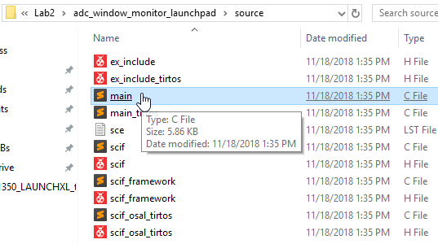

**0xL400A7**

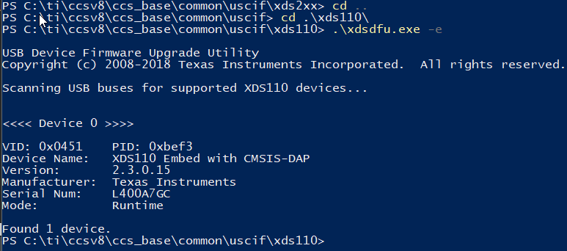

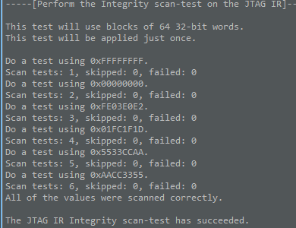

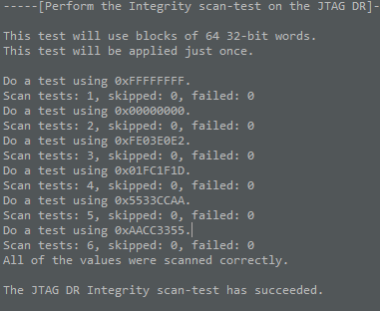

**Task 02: Download and Debug w/ CCS**

**Youtube Link: N/A**

**It’s hard to see the break arrow but following was where the program would break according to the position of the pots.**

**Pot full CCW**

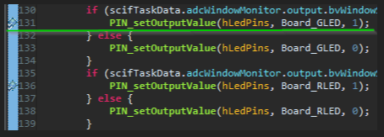

**Pot full Centered**

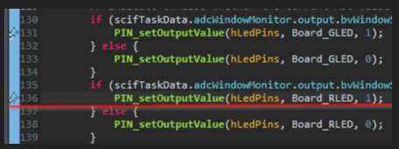

**Pot full CW no breaks**

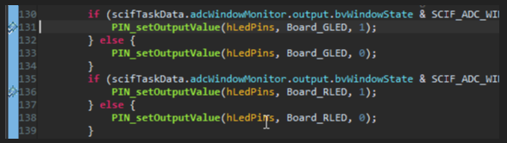

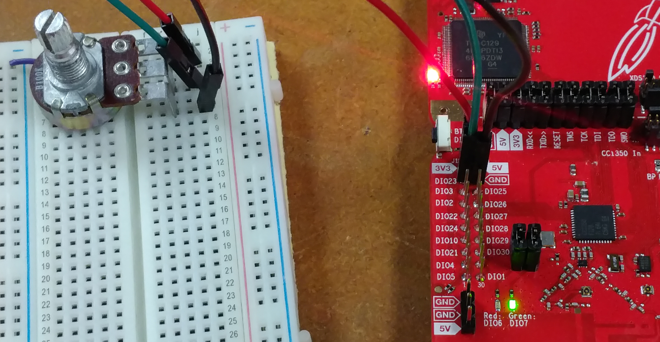

**Task 03: Download and Debug w/ SCS**

**Youtube Link:** [**https://youtu.be/E27OUAlOOYE**](https://youtu.be/E27OUAlOOYE)

**Here from the break point you see that the adcValue is setting at 249, taking one step after adjusting the potentiometer, adcValue changes.**

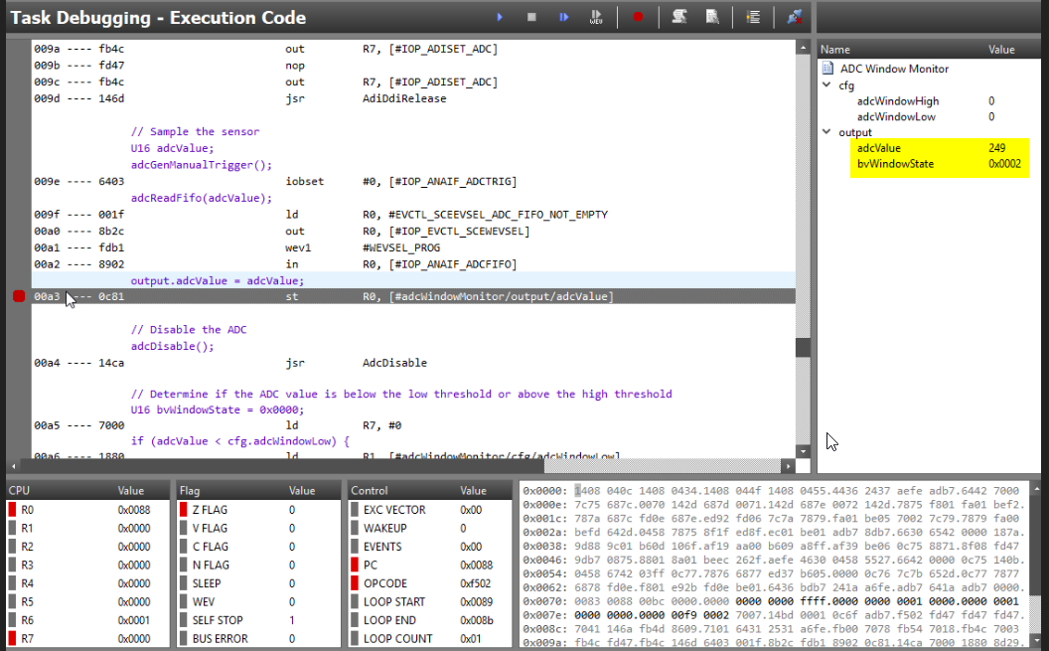

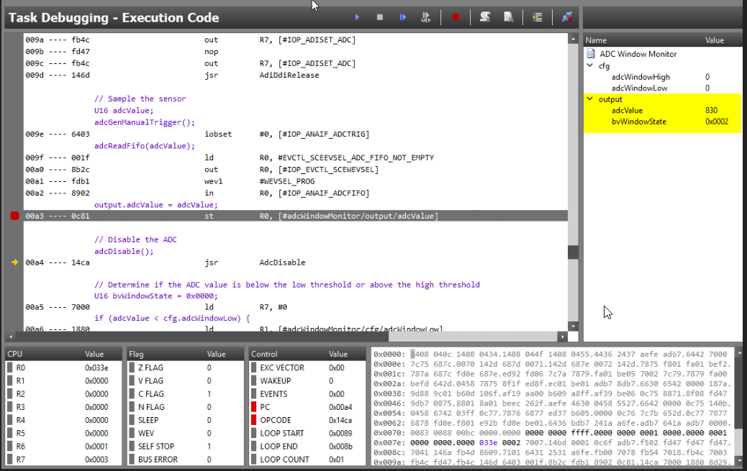

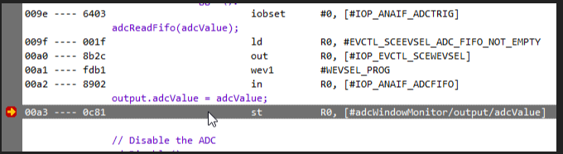

Here you can see the adcValue changing with changes in the potentiometer.

