**Date Submitted: 11.18.2018**

**Task 01:** Building and loading the collector example

**Youtube Link:**

Collector built and loaded

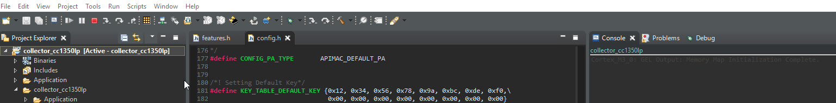

**Task 02:** Building and loading the sensor example

**Youtube Link:**

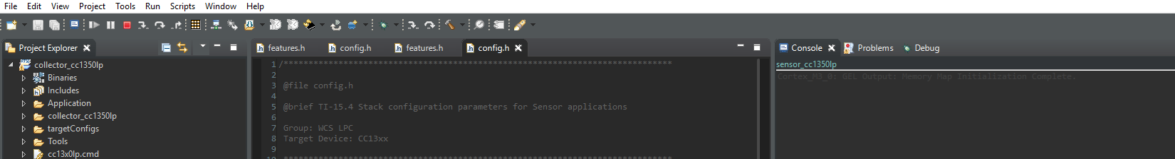

**Task 03:** Using the Collector and Sensor

**Youtube Link:**

**Working with T. Stewart we were able to use both builds**

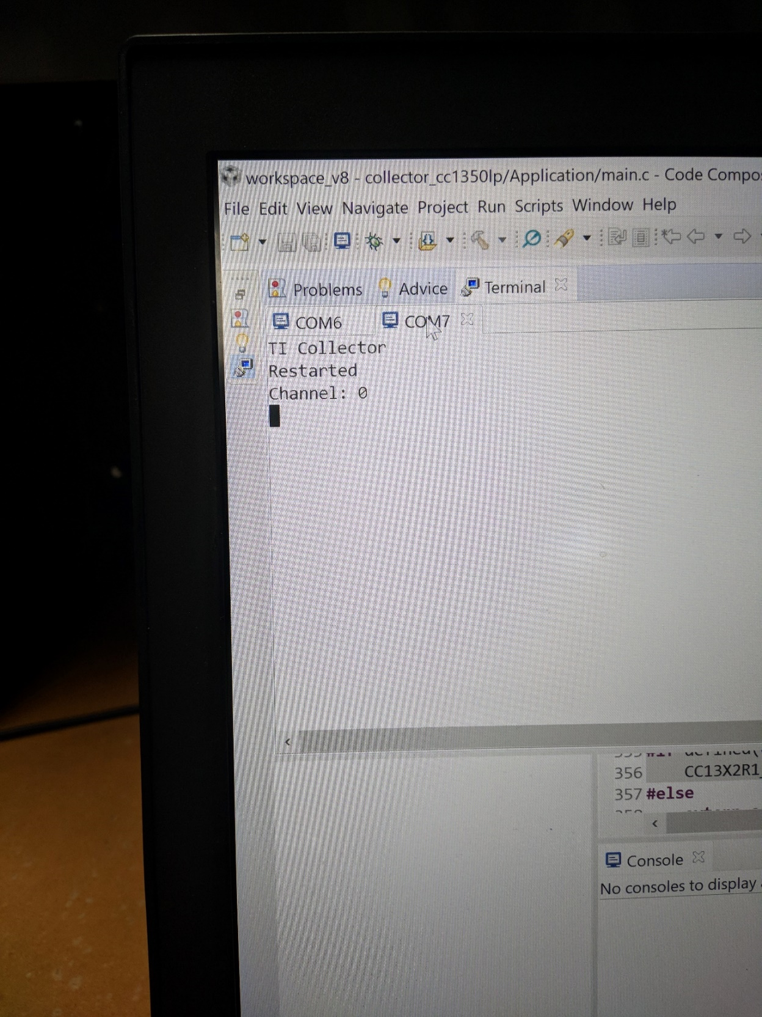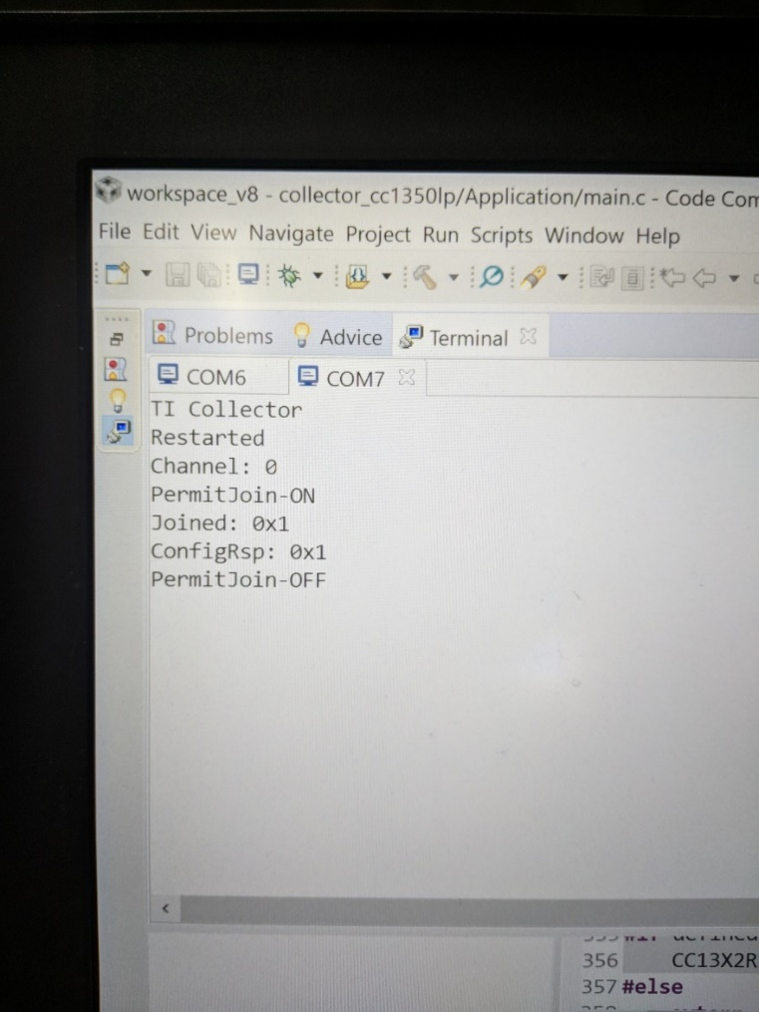

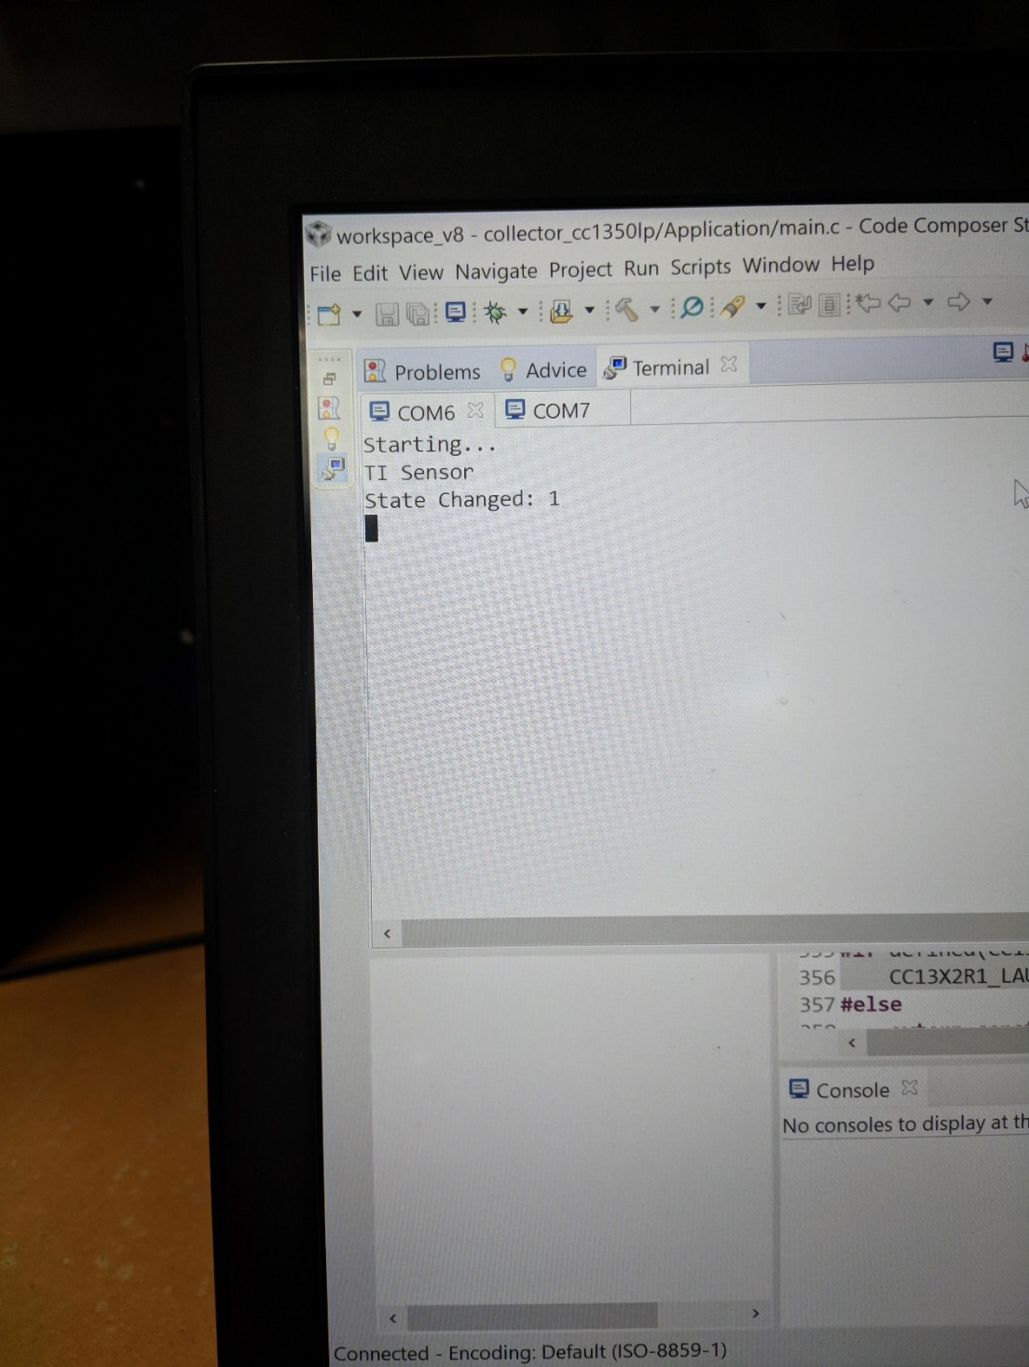

**Task 04:** Updating the sensor's reporting rate

**Youtube Link:**

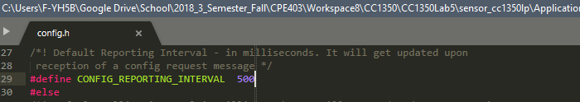

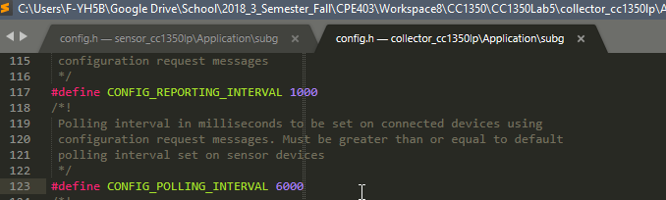

**Task 00 : Label your LaunchPads**

Nothing to show.

**------------------------------------------------------------------------------------**

**Task 01 : Building and loading the portable app**

Nothing to show.

**------------------------------------------------------------------------------------**

**Task 02 : Combine the portable app with the TI 15.4-Stack app**

Nothing to show.

.

**------------------------------------------------------------------------------------**

**Task 03 : Using the Stack to send temperature from the portable app**

Nothing to show.