**Date Submitted: 11.24.2018**

**Task 01-4 one: Do to limited Android support and lack of an iPhone we could not utilize the app. Nothing to show**

**Youtube Link:**

**Task 01: Importing WSN example**

**Nothing to show really**

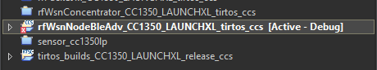

**Task 02: Putting it together**

**With both devices powered on we could see the values transmitted by the node in putty.**

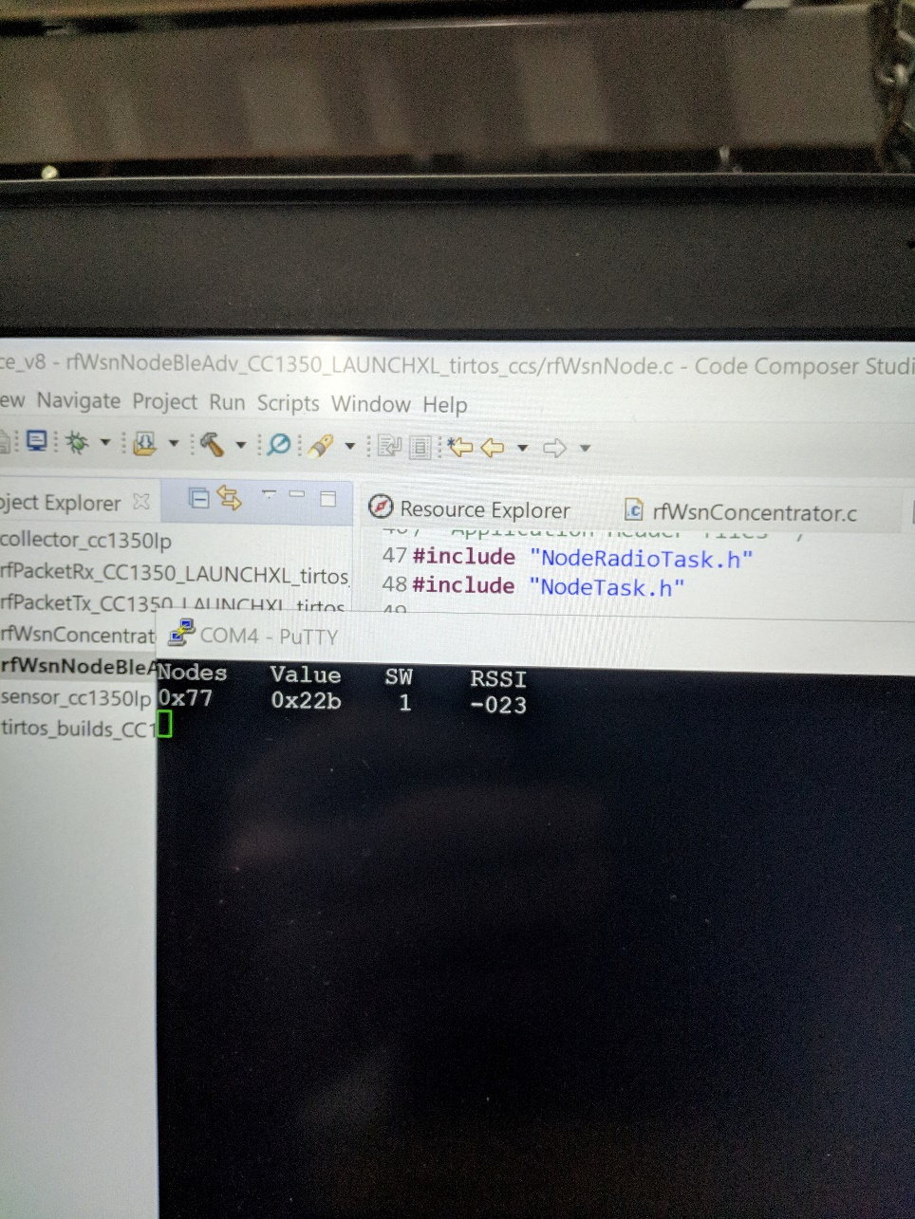





**Task 03: Change RF Channel**

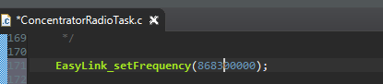

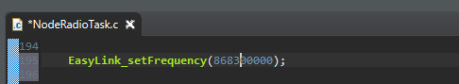

**Task 04: Switch from 2-GFSK 50kbps to Long Range Mode (LRM)**



**Task 05: Measure Power consumption of the node**

**We attempted to get current reading to produce the power consumption for the node however we CC1350 started making a strange humming noise when we connected to the 3V3 and GND pins so we didn’t push our luck. For a second it appeared to be in the milliamps range if that was correct then 3V * some milliamps would produce a milliwatts power range.**