**Date Submitted: 11.13.2018**

**------------------------------------------------------------------------------------**

**Task 01: Changing hello world content**

**Youtube Link:**

**Modifications**

*/* XDC Module Headers */*

*/* TI-RTOS Header files */*

#include <xdc/std.h>

#include <ti/sysbios/BIOS.h>

#include <ti/sysbios/knl/Task.h>

#include <ti/drivers/GPIO.h>

#include <ti/sysbios/knl/Clock.h>

*/* Example/Board Header files */*

#include "Board.h"

void myDelay(int count);

*/* Could be anything, like computing primes */*

#define FakeBlockingSlowWork() myDelay(12000000)

#define FakeBlockingFastWork() myDelay(2000000)

Task_Struct workTask;

Task_Struct urgentWorkTask;

*/* Make sure we have nice 8-byte alignment on the stack to avoid wasting memory */*

#pragma DATA_ALIGN(workTaskStack, 8)

#pragma DATA_ALIGN(urgentWorkTaskStack, 8)

#define STACKSIZE 1024

**static** uint8_t workTaskStack[STACKSIZE];

**static** uint8_t urgentWorkTaskStack[STACKSIZE];

void doUrgentWork(void)

{

GPIO_write(Board_GPIO_LED1, Board_GPIO_LED_OFF);

FakeBlockingFastWork(); */* Pretend to do something useful but time-consuming */*

GPIO_write(Board_GPIO_LED1, Board_GPIO_LED_ON);

}*//end doUrgentWork*

void doWork(void)

{

GPIO_write(Board_GPIO_LED0, Board_GPIO_LED_OFF);

FakeBlockingSlowWork(); */* Pretend to do something useful but time-consuming */*

GPIO_write(Board_GPIO_LED0, Board_GPIO_LED_ON);

}*//edn doWork*

Void workTaskFunc(UArg arg0, UArg arg1)

{

**while** (1) {

*/* Do work */*

doWork();

*/* Wait a while, because doWork should be a periodic thing, not continuous.*/*

*// myDelay(2400000);*

Task_sleep(Clock_tickPeriod/2); */*1000µs/2=500ms*/*

}

}*//end workTaskFunc*

*/** ======== main ========*

*\**

*\*/*

int main(void)

{

Board_initGeneral();

GPIO_init();

*/* Set up the led task */*

Task_Params workTaskParams;

Task_Params_init(&workTaskParams);

workTaskParams.stackSize = STACKSIZE;

workTaskParams.priority = 1;

workTaskParams.stack = &workTaskStack;

Task_construct(&workTask, workTaskFunc, &workTaskParams, NULL);

*/* Start kernel. */*

BIOS_start();

**return** (0);

}

*/\**

*\* ======== myDelay ========*

*\* Assembly function to delay. Decrements the count until it is zero*

*\* The exact duration depends on the processor speed.*

*\*/*

**__asm**(" .sect **\"**.text:myDelay**\"\n**"

" .clink**\n**"

" .thumbfunc myDelay**\n**"

" .thumb**\n**"

" .global myDelay**\n**"

"myDelay:**\n**"

" subs r0, #1**\n**"

" bne.n myDelay**\n**"

" bx lr**\n**");

**Task 02:** Debugging Tools, Runtime Object View

**Youtube Link: <https://youtu.be/gd6fs_X4gaM>**

**View**

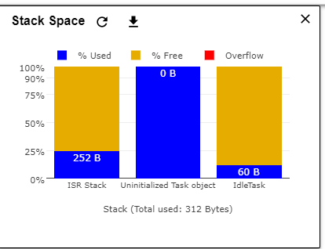

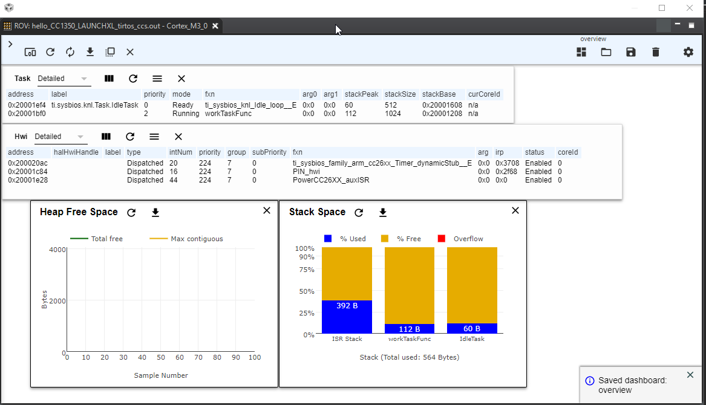

**Added/modification**



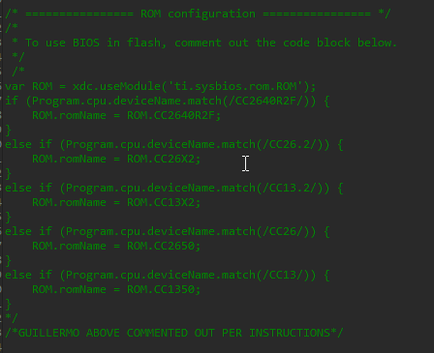

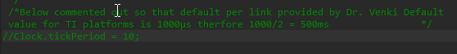

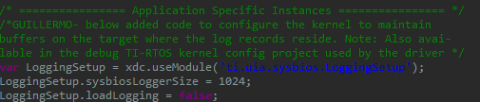

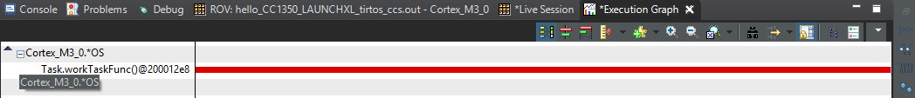

**Task 03: Sleeping Well**

**Youtube Link:** [**https://youtu.be/D6H_KYKxp9Y**](https://youtu.be/D6H_KYKxp9Y)

**Added/Modified**

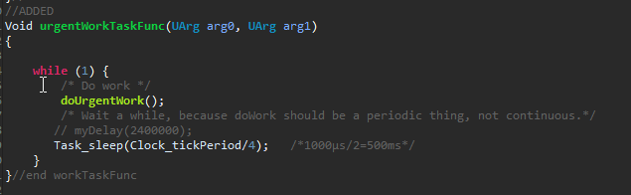

**Not sure if this is what the instructions meant**

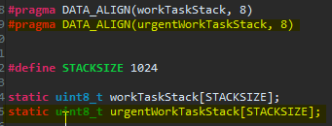

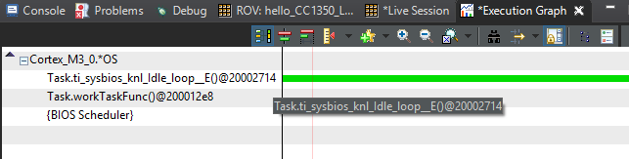

**3.1**

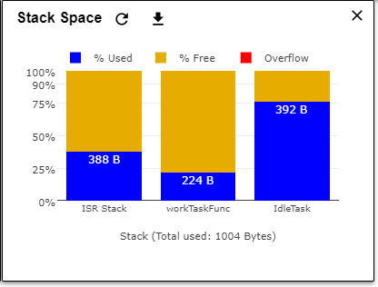

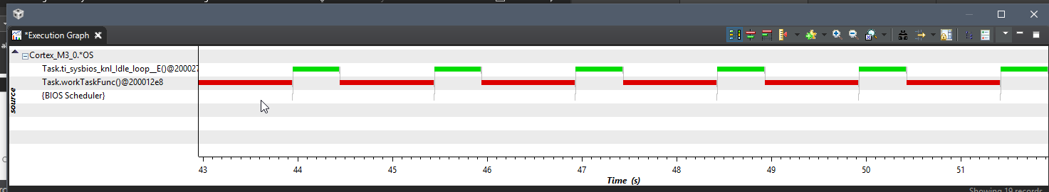

**Task 04: Executing urgent work**

**Youtube Link: N/A**

**Added/Modified**

