**Date Submitted: 10.01.2018**

**Task 00: *No submission***

**Youtube Link: N/A**

**------------------------------------------------------------------------------------**

**Task 01: Determine Current period and on-time of the LED Blinking. Change delay of LED blink to ~0.425 sec by changing the delay and clock source and configuration-determine the CLK ƒ then verify delay**

**Youtube Link:** [**https://youtu.be/wzpZnhlRxwI**](https://youtu.be/wzpZnhlRxwI)

As given the code provides an on-time of ~0.150s and off-time of ~0.751s. This makes our period ~0.9001s

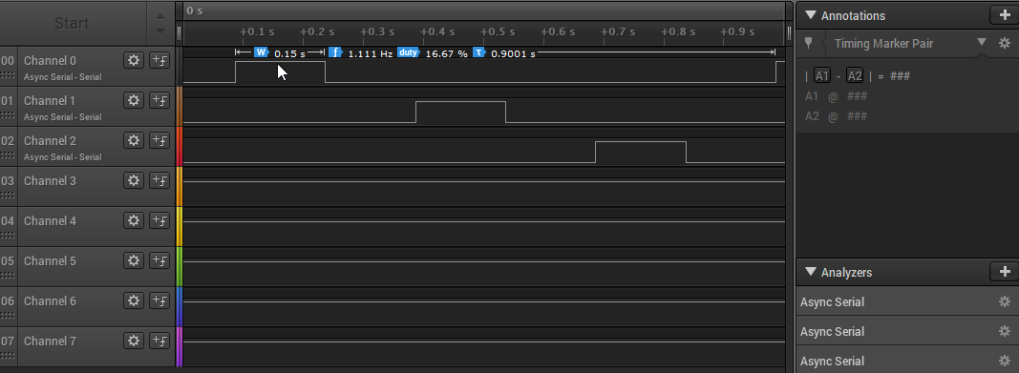

**#include** <stdint.h>

**#include** <stdbool.h>

**#include** "inc/hw_memmap.h"

**#include** "inc/hw_types.h"

**#include** "driverlib/sysctl.h"

**#include** "driverlib/gpio.h"

**uint8_t** ui8PinData=2;

**int** **main**(**void**)

{//Setup clock

**SysCtlClockSet**(SYSCTL_SYSDIV_5|SYSCTL_USE_PLL|SYSCTL_XTAL_16MHZ|SYSCTL_OSC_MAIN);

**SysCtlPeripheralEnable**(SYSCTL_PERIPH_GPIOF);

**GPIOPinTypeGPIOOutput**(GPIO_PORTF_BASE, GPIO_PIN_1|GPIO_PIN_2|GPIO_PIN_3);

}

**while**(1)

{

**GPIOPinWrite**(GPIO_PORTF_BASE, GPIO_PIN_1|GPIO_PIN_2|GPIO_PIN_3, ui8PinData);

**SysCtlDelay**(2000000);

**GPIOPinWrite**(GPIO_PORTF_BASE, GPIO_PIN_1|GPIO_PIN_2|GPIO_PIN_3, 0x00);

**SysCtlDelay**(2000000);

**if**(ui8PinData==8) {ui8PinData=2;} **else** {ui8PinData=ui8PinData*2;}

}}

}//end main

**Youtube Link:** [**https://youtu.be/nA-Wb1xLf20**](https://youtu.be/nA-Wb1xLf20)

If we take the delay count of 2000000 and divided by the on-time we see that each tick is approximately 75ns. Therefore, if we want an on-time of 0.425s we divide 0.425s by 75ns and get a count of approximately 5.6…million. From the analyzer data we can see the period is ~2.55s.

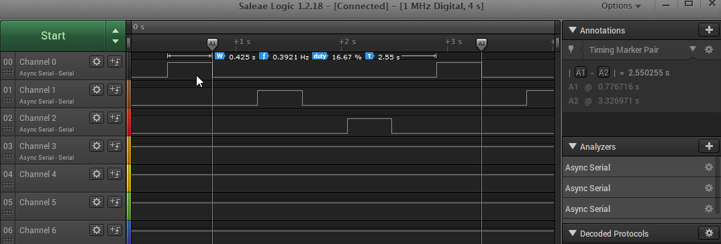

**while**(1)

{//Modified for 0.425s on-time

**GPIOPinWrite**(GPIO_PORTF_BASE,PIO_PIN_1|GPIO_PIN_2|GPIO_PIN_3, ui8PinData);

**SysCtlDelay**(5666666);

**GPIOPinWrite**(GPIO_PORTF_BASE, GPIO_PIN_1|GPIO_PIN_2|GPIO_PIN_3, 0x00);

**SysCtlDelay**(5666666);

**if**(ui8PinData==8) {ui8PinData=2;} **else** {ui8PinData=ui8PinData*2;}

**Task 02:** Change the a) sequence of LED blinking (from RGB sequence to BGR), and b) blink

one LED, two LED, and three LED at an instance and with a sequence (sequence of blinking with

delay – R, G, B, RG, RB, GB, RGB, R, G, …)

**Youtube Link:** [**https://youtu.be/81TU1GpTW0w**](https://youtu.be/81TU1GpTW0w)

**a)**

**uint8_t** ui8PinData=4; //Task 01 a. B

**int** **main**(**void**)

{

{

//Setup clock **SysCtlClockSet**(SYSCTL_SYSDIV_5|SYSCTL_USE_PLL|SYSCTL_XTAL_16MHZ|SYSCTL_OSC_MAIN);

**SysCtlPeripheralEnable**(SYSCTL_PERIPH_GPIOF);

**GPIOPinTypeGPIOOutput**(GPIO_PORTF_BASE, GPIO_PIN_1|GPIO_PIN_2|GPIO_PIN_3);

}

**while**(1)

{

**GPIOPinWrite**(GPIO_PORTF_BASE, GPIO_PIN_1 |GPIO_PIN_2|GPIO_PIN_3, ui8PinData);

**SysCtlDelay**(5666666);

**GPIOPinWrite**(GPIO_PORTF_BASE, GPIO_PIN_1 |GPIO_PIN_2|GPIO_PIN_3, 0x00);

**SysCtlDelay**(5666666);

//First pass !8 -> 4*2 = 8 G, BG

//Second pass is 8 -> 2 R, BGR

**if**(ui8PinData==8) {ui8PinData=2;} **else** {ui8PinData=ui8PinData*2;}

}

}//end main

**Task 02:b**

**Youtube Link:** [**https://youtu.be/UQHsSGh1QbI**](https://youtu.be/UQHsSGh1QbI)

**//Initially set to red**

**uint8_t** ui8PinData=2; //Task 02 b. Red

**int** **main**(**void**)

{

{

//Setup clock **SysCtlClockSet**(SYSCTL_SYSDIV_5|SYSCTL_USE_PLL|SYSCTL_XTAL_16MHZ|SYSCTL_OSC_MAIN);

**SysCtlPeripheralEnable**(SYSCTL_PERIPH_GPIOF);

**GPIOPinTypeGPIOOutput**(GPIO_PORTF_BASE, GPIO_PIN_1|GPIO_PIN_2|GPIO_PIN_3);

}

**while**(1)

{

**GPIOPinWrite**(GPIO_PORTF_BASE, GPIO_PIN_1 |GPIO_PIN_2|GPIO_PIN_3, ui8PinData); //Red

**SysCtlDelay**(5666666);

**GPIOPinWrite**(GPIO_PORTF_BASE, GPIO_PIN_1 |GPIO_PIN_2|GPIO_PIN_3, 0x08); //Green

**SysCtlDelay**(5666666);

**GPIOPinWrite**(GPIO_PORTF_BASE, GPIO_PIN_1 |GPIO_PIN_2|GPIO_PIN_3, 0x04); //Blue

**SysCtlDelay**(5666666);

**GPIOPinWrite**(GPIO_PORTF_BASE, GPIO_PIN_1 |GPIO_PIN_2|GPIO_PIN_3, 0x0A); //RG

**SysCtlDelay**(5666666);

**GPIOPinWrite**(GPIO_PORTF_BASE, GPIO_PIN_1 |GPIO_PIN_2|GPIO_PIN_3, 0x06); //RB

**SysCtlDelay**(5666666);

**GPIOPinWrite**(GPIO_PORTF_BASE, GPIO_PIN_1 |GPIO_PIN_2|GPIO_PIN_3, 0x0C); //GB

**SysCtlDelay**(5666666);

**GPIOPinWrite**(GPIO_PORTF_BASE, GPIO_PIN_1 |GPIO_PIN_2|GPIO_PIN_3, 0x0E); //RGB

**SysCtlDelay**(5666666);

}

}//end main

**------------------------------------------------------------------------------------**

**------------------------------------------------------------------------------------**