**Date Submitted: 10.06.2018**

**Task 00: *No submission***

**Youtube Link: N/A**

**------------------------------------------------------------------------------------**

**Task 01:** Change the toggle of the GPIO at 2 Hz using Timer0 with 75% duty cycle and verify the

waveform generated.

**Youtube Link**: <https://youtu.be/WXc8OrG1GSk>

Task 01 asks to modify the given example to generate a 2Hz signal with a 75% duty cycle. Using SysCtlDelay varied delays were used to toggle the LED on-off and achieve the desired signal.

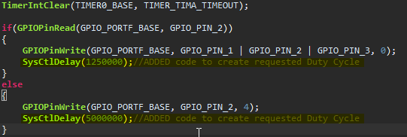

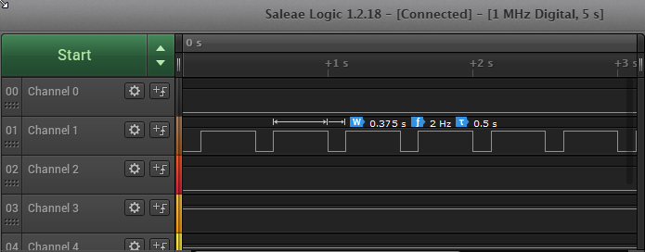

**Task 02:** Include a GPIO Interrupt to Task 02 from switch SW2 to turn ON and the LED for 1.5

sec. Use a Timer1 to calculate the 1.5 sec delay. The toggle of the GPIO is suspended when executing

the interrupt.

**Youtube Link:** [**https://youtu.be/WXc8OrG1GSk**](https://youtu.be/WXc8OrG1GSk)

**void** **Mytimer1A_Delay**(**uint32_t** ttime1)

{

// Dis-enable Timer 0 Interrupt

**TimerIntDisable**(TIMER0_BASE, TIMER_TIMA_TIMEOUT);

//Following code configures Timer1

//for use in Task 02

**int** i = 0;

SYSCTL_RCGCTIMER_R |= 2;

TIMER1_CTL_R = 0;

TIMER1_CFG_R = 0x04;

TIMER1_TAMR_R = 0X02;

TIMER1_TAILR_R = 64000-1;

TIMER1_TAPR_R = 250-1;

TIMER1_CTL_R |= 0X01;

**for**(i=0;i < ttime1;i++)

**while**((TIMER1_RIS_R & 0x1) == 0;

TIMER1_ICR_R = 0x1;

}//end timer1A_delaySec

**Additional handler added for Timer1**

**void** **Timer1IntHandler**(**void**)

{

//Clear GPIO Int

**GPIOIntClear**(GPIO_PORTF_BASE, GPIO_INT_PIN_0);

//LED ON

//Blue LED PIN2

**GPIOPinWrite**(GPIO_PORTF_BASE, GPIO_PIN_2, 4);

**Mytimer1A_Delay**(3529412);

//LED OFF

**GPIOPinWrite**(GPIO_PORTF_BASE, GPIO_PIN_1 | GPIO_PIN_2 | GPIO_PIN_3, 0);

//Re-Enable(INT_TIMER0A);

**TimerIntEnable**(TIMER0_BASE, TIMER_TIMA_TIMEOUT);

}//end Timer1Handler

**Below is a sample a 15s sample of the output wave. On the right you can see the desired ƒ and duty cycle from Task 01. From both wave forms the desired delay for Task 02 of 1.5s is obtained when SW2 is pressed which can also been seen at the start of the 1.5 pulse.**

