**Date Submitted: 10.13.2018**

**Task 00: *No submission***

**Youtube Link: N/A**

**------------------------------------------------------------------------------------**

**Task 01:** Change the PWM duty cycle to make the servo motor to do a loop of a complete sweep

from 0 to 180 deg.

**Youtube Link**: <https://youtu.be/kWquLqR_93A>

Modified Code:

ui8Adjust adjusting this variable to between 30 and 125 was the necessary modification from the give code to create a signal with a Pulse Width between

8ms ~2.2ms which generated the 180° sweep.

**if**(ROM_GPIOPinRead(GPIO_PORTF_BASE,GPIO_PIN_4)==0x00)

{

ui8Adjust--;

**if** (ui8Adjust < 30)

{

ui8Adjust = 30;*//1.82µs * 30 ~.55ms 0°*

}

ROM_PWMPulseWidthSet(PWM1_BASE, PWM_OUT_0, ui8Adjust * ui32Load / 1000);

}*//enf if1*

**if**(ROM_GPIOPinRead(GPIO_PORTF_BASE,GPIO_PIN_0)==0x00)

{

ui8Adjust++;

**if** (ui8Adjust > 125)

{

ui8Adjust = 125;*//1.82µs * 125 ~2.28ms 180°*

}

ROM_PWMPulseWidthSet(PWM1_BASE, PWM_OUT_0, ui8Adjust * ui32Load / 1000);

}*//end if2*

ROM_SysCtlDelay(13000);

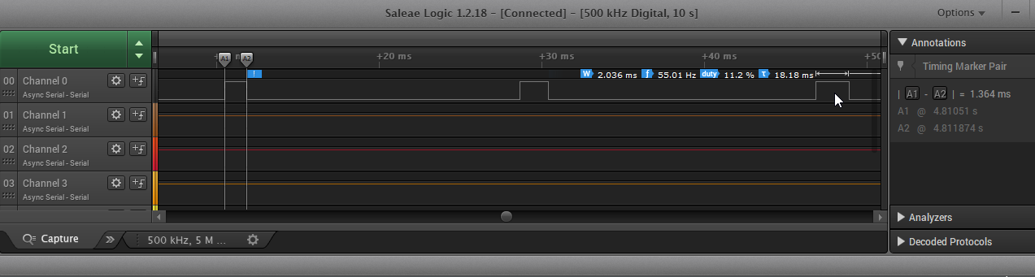

**Task 02:**

**Youtube Link: <https://youtu.be/7Ew1TgyXyko>**

Modified Added /Code:

*//Constants for Min and Max*

*//Values*

#define PWM_FREQUENCY 55

#define MN_Bright 100 *//10% Task 2&3*

#define MX_Bright 900 *//90% Task 2&3*

*//Values*

ROM_GPIOPinTypePWM(GPIO_PORTF_BASE, GPIO_PIN_1|GPIO_PIN_2|GPIO_PIN_3); *//Values Pins set to output*

ROM_GPIOPinConfigure(GPIO_PF1_M1PWM5);*//R Task 2*

*//To move between 10% and 90%*

**for**(; R <= MX_Bright; R++)

{

ROM_PWMPulseWidthSet(PWM1_BASE, PWM_OUT_5, R * ui32Load / 1000);

ROM_SysCtlDelay(12000);

}*//end for 1*

**for**(; R >= MN_Bright; R--)

{

ROM_PWMPulseWidthSet(PWM1_BASE, PWM_OUT_5, R * ui32Load / 1000);

ROM_SysCtlDelay(12000);

}*//end for2*

**Task 03:**

**Youtube Link:** **<https://youtu.be/NZHVQFW60hE>**

Modified Added /Code:

#define MN_Bright 100 *//10% Task 2&3*

#define MX_Bright 900 *//90% Task 2&3*

ROM_GPIOPinConfigure(GPIO_PF1_M1PWM5);*//R Task 2*

ROM_GPIOPinConfigure(GPIO_PF2_M1PWM6);*//G Task 2&3*

ROM_GPIOPinConfigure(GPIO_PF3_M1PWM7);*//B Task 2&3*

*//R&G get incremented once and in bottom loop B goes from 10-90% then the middle loop*

*//increases to 90% and finally the 1st loop, in the second set of for loops this happens in reverse*

**for**(; R <= MX_Bright; R++)

{

**for**(; G <= MX_Bright; G++)

{

**for**(; B <= MX_Bright; B++)

{

ROM_PWMPulseWidthSet(PWM1_BASE, PWM_OUT_5, B * ui32Load / 1000);

ROM_SysCtlDelay(12000);

}*//end*

ROM_PWMPulseWidthSet(PWM1_BASE, PWM_OUT_6, G * ui32Load / 1000);

ROM_SysCtlDelay(12000);

}

ROM_PWMPulseWidthSet(PWM1_BASE, PWM_OUT_7, R * ui32Load / 1000);

ROM_SysCtlDelay(12000);

}

**for**(; R >= MN_Bright; R--)

{

**for**(; B >= MN_Bright && R == MX_Bright; B--)

{

**for**(; G >= MN_Bright && B == MX_Bright && R == MX_Bright; G--)

{

ROM_PWMPulseWidthSet(PWM1_BASE, PWM_OUT_5, G * ui32Load / 1000);

ROM_SysCtlDelay(12000);

}*//end*

ROM_PWMPulseWidthSet(PWM1_BASE, PWM_OUT_6, B * ui32Load / 1000);

ROM_SysCtlDelay(12000);

}*//end 2nd for*

ROM_PWMPulseWidthSet(PWM1_BASE, PWM_OUT_7, R * ui32Load / 1000);

ROM_SysCtlDelay(12000);

}*//1st for*