**Date Submitted: 09.24.2018**

**Task 00: *Folder Structure for the Labs***

**Youtube Link: N/A**



**------------------------------------------------------------------------------------**

**Task 01: Create a New CCS Project & Add files to your project**

**Copied Linked**

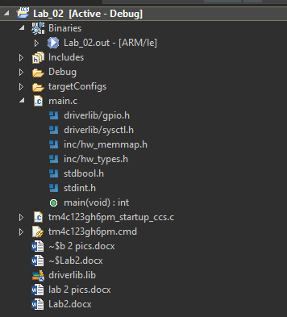

**Task 02: Add Path and Build Vars**

**Youtube Link: N/A**

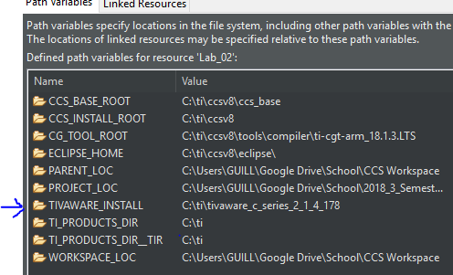

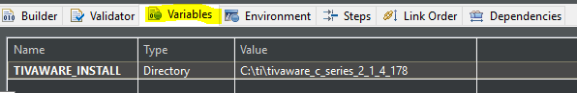

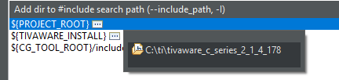

**Task 03: Explore Build Configs**

**Youtube Link: N/A**

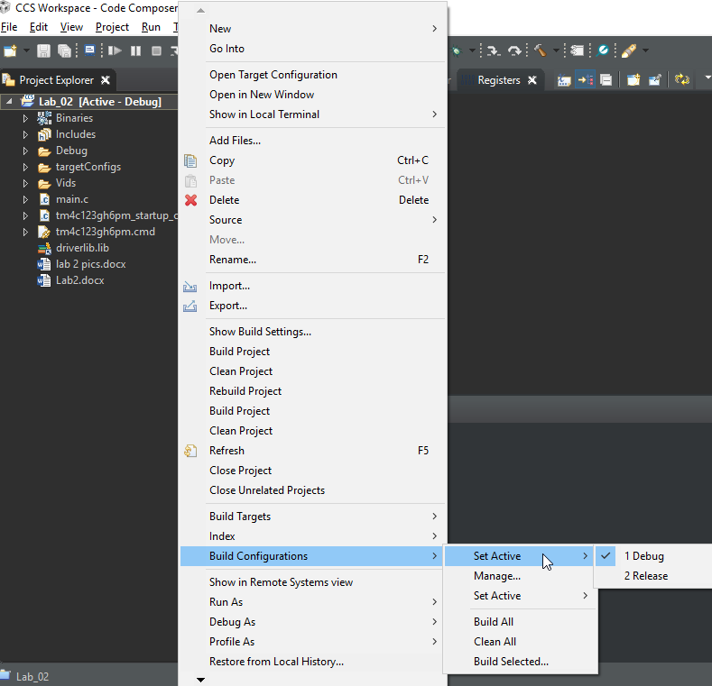



**Task 04: Build, Load, Run, provided code, registers**

**Youtube Link:** [**https://youtu.be/2HKztp0etHE**](https://youtu.be/2HKztp0etHE)

**Youtube Link:** [**https://youtu.be/27QJHZ9vo9w**](https://youtu.be/27QJHZ9vo9w)

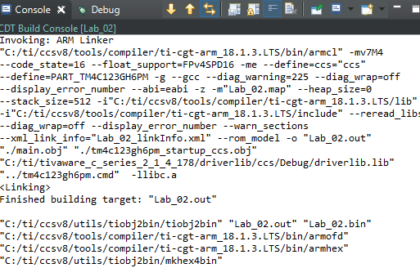

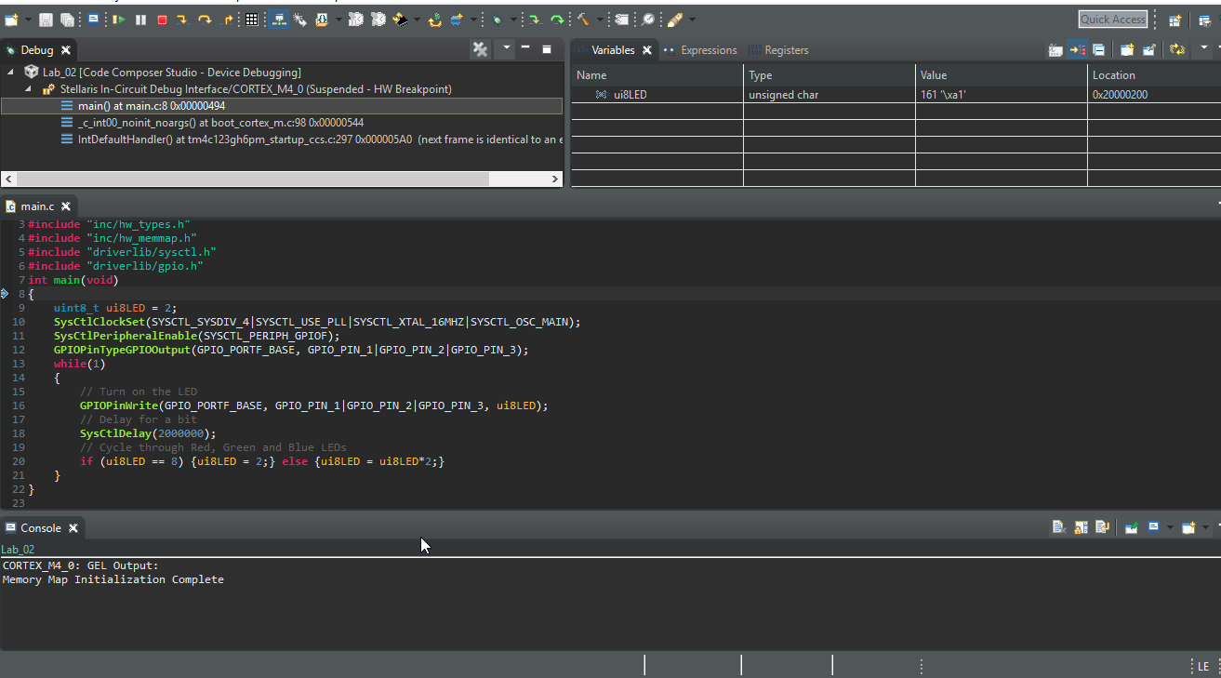

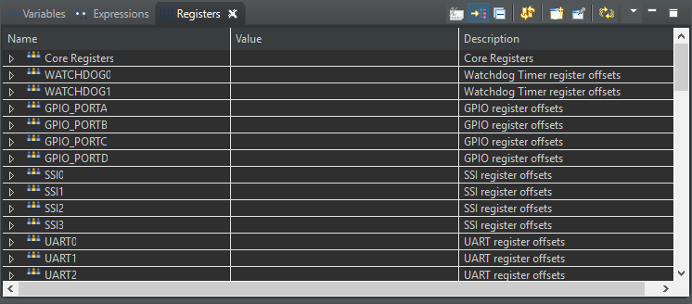

**Modified Schematic (N/A):**

**Modified Code:**

**// Insert code here**

#include <stdint.h>

#include <stdbool.h>

#include "inc/hw_types.h"

#include "inc/hw_memmap.h"

#include "driverlib/sysctl.h"

#include "driverlib/gpio.h"

int main(void)

{

uint8_t ui8LED = 2;

SysCtlClockSet(SYSCTL_SYSDIV_4|SYSCTL_USE_PLL|SYSCTL_XTAL_16MHZ|SYSCTL_OSC_MAIN);

SysCtlPeripheralEnable(SYSCTL_PERIPH_GPIOF);

GPIOPinTypeGPIOOutput(GPIO_PORTF_BASE, GPIO_PIN_1|GPIO_PIN_2|GPIO_PIN_3);

**while**(1)

{

*// Turn on the LED*

GPIOPinWrite(GPIO_PORTF_BASE, GPIO_PIN_1|GPIO_PIN_2|GPIO_PIN_3, ui8LED);

*// Delay for a bit*

SysCtlDelay(2000000);

*// Cycle through Red, Green and Blue LEDs*

**if** (ui8LED == 8) {ui8LED = 2;} **else** {ui8LED = ui8LED*2;}

}

}

**Task 05: Create bin file use standalone programming GUI**

**Youtube Link:** [**https://youtu.be/o51NQsXM0BQ**](https://youtu.be/o51NQsXM0BQ)





