**Date Submitted: 11.18.2018 test**

**Task 02: Hello World**

Modified code added a delay

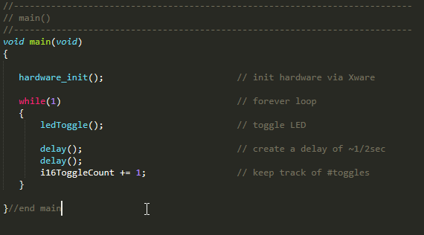

**Youtube Link:** [**https://youtu.be/cKuNaFQY2Ls**](https://youtu.be/cKuNaFQY2Ls)

**Youtube Link:** [**https://youtu.be/cxIepRHrfFA**](https://youtu.be/cxIepRHrfFA)

**Task 04: Sys/BIOS Blink LED**

**Youtube Link: N/A same as above blinking light**

Lab 4 walked us through setting up an actual Real Time Operation System project. We created an .cfg file “configuration”. Instead of a while loop we used a BIOS and h/w interrupt to trigger the blinking, from the questions it appears that when the idle module runs the ledToggle() function is called, so we created what was referred to in class as a hear beat.

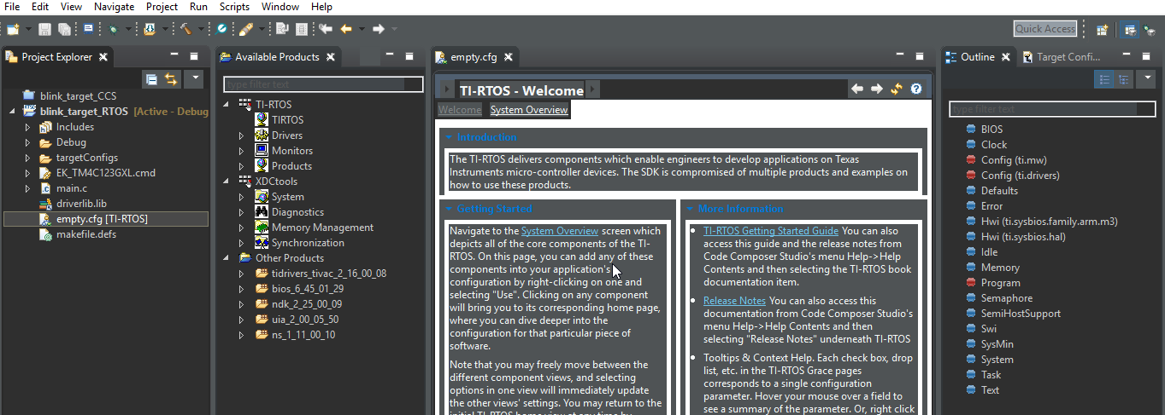

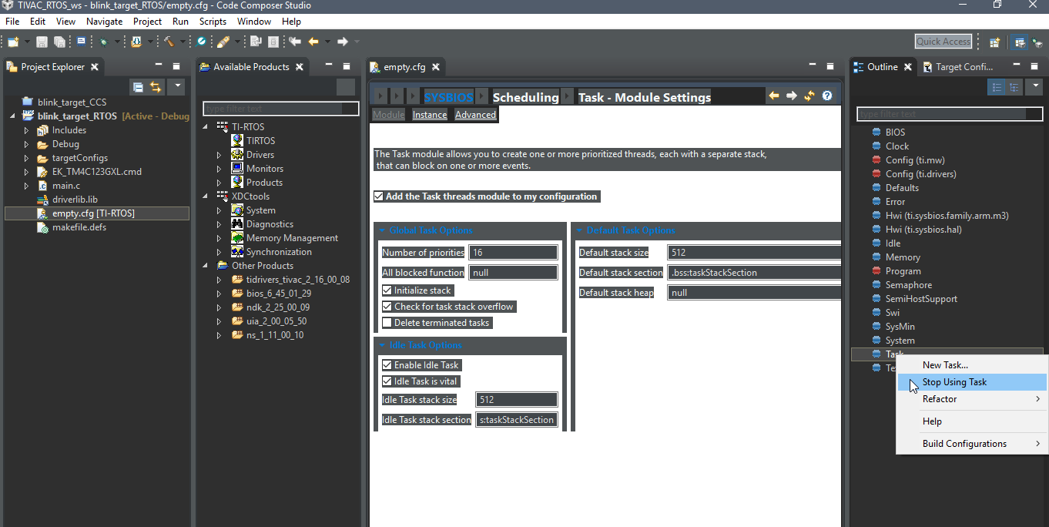 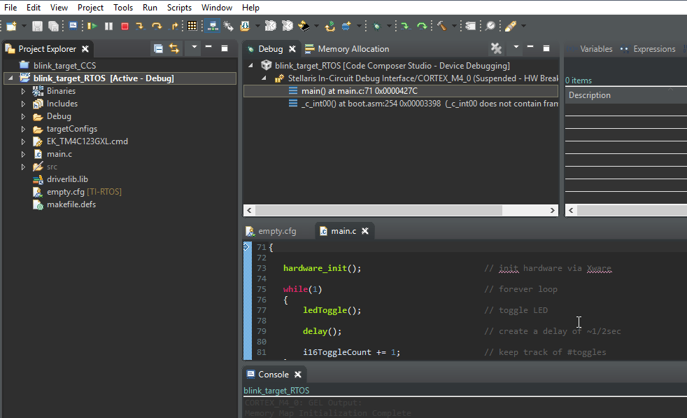

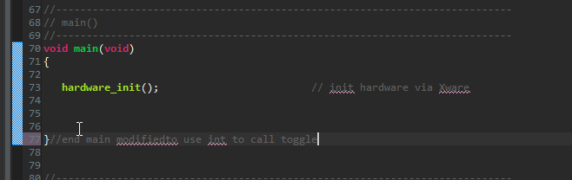

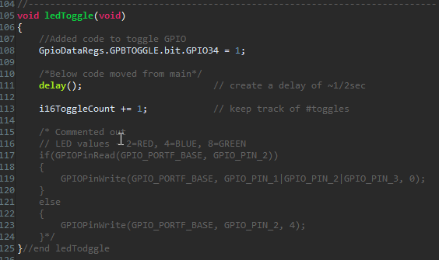 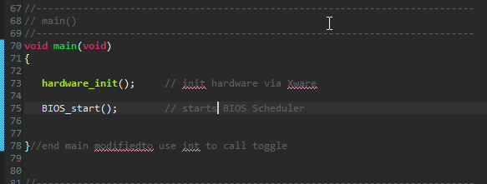

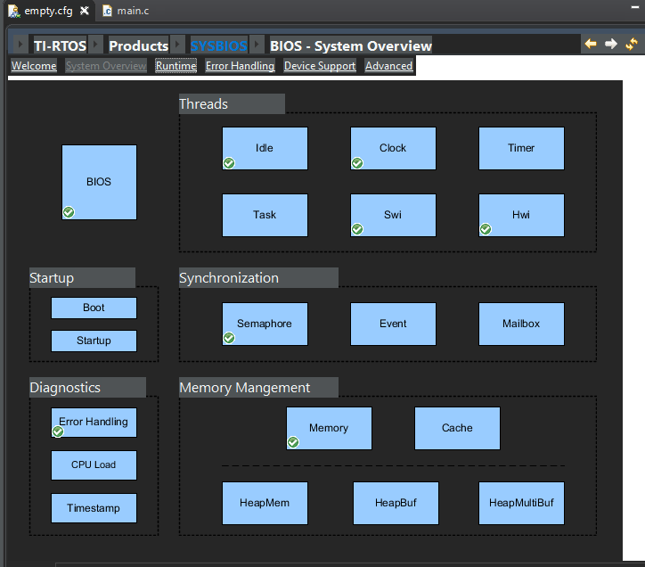 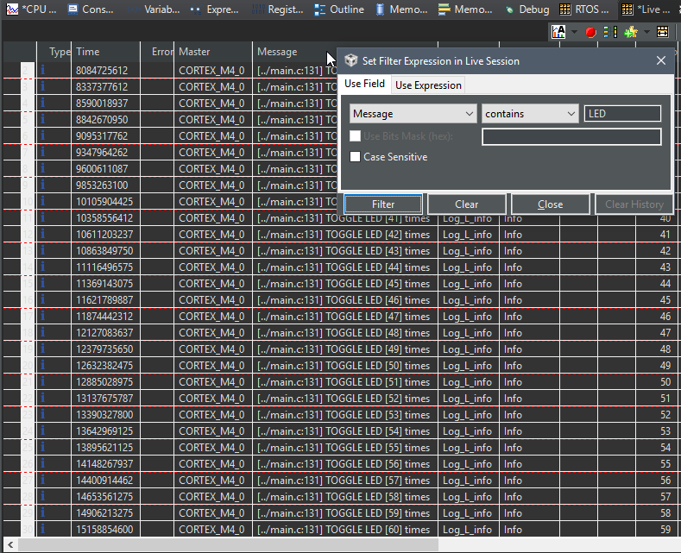

**Task 05: Sys/BIOS Blink LED Hwi**

**Youtube Link:** [**https://youtu.be/NvxQpw7whKI**](https://youtu.be/NvxQpw7whKI)

BIOS

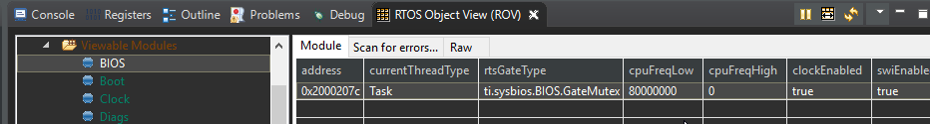

HWI’s

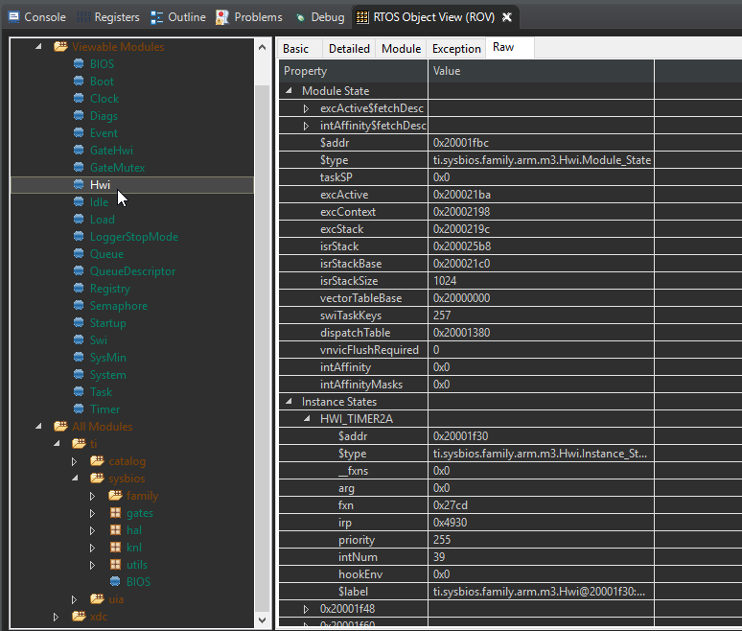

Mod

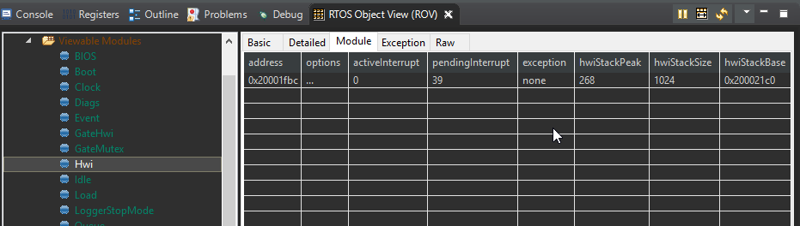

Idle

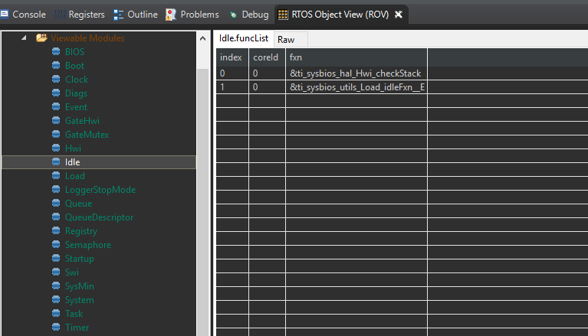

Tasks/Timer

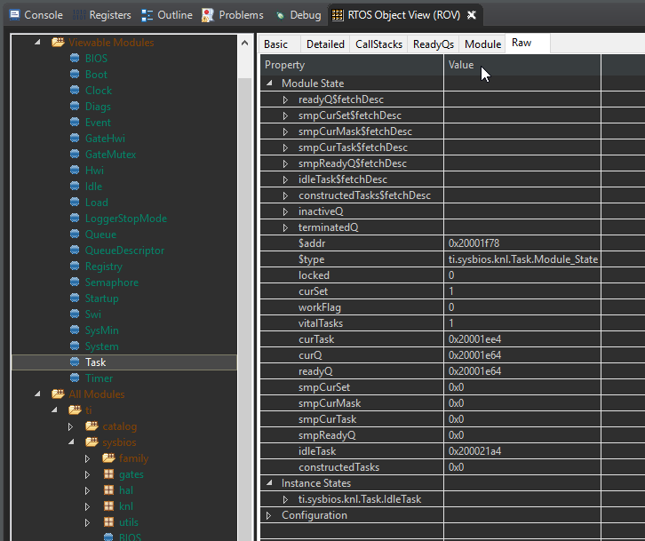

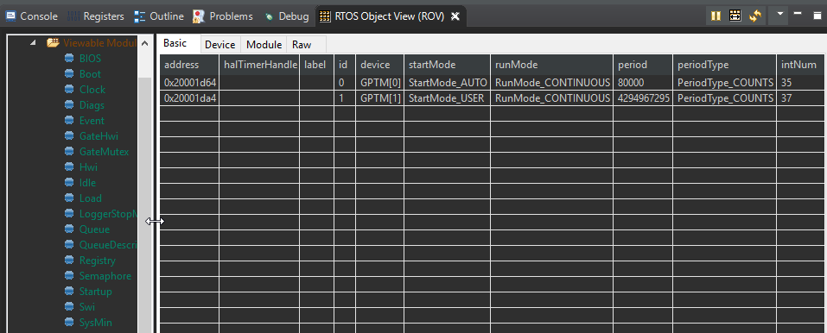

**Task 06: Sys/BIOS Blink LED Swi**

Unable to resolve import errors, two hours wasted. Git includes attempted project folder.

**Youtube Link:N/A**

**Task 07: Sys/BIOS Blink LED CLK**

Built stopped work folder included

**Youtube Link:**

**Task 08: Sys/BIOS Blink LED TASK**

not