**Using Autopsy in Kali Linux**

1. Upgrade Kali
2. FInd the autopsy tool in start menu otherwise follow step 3 to install
3. sudo apt-get install autopsy

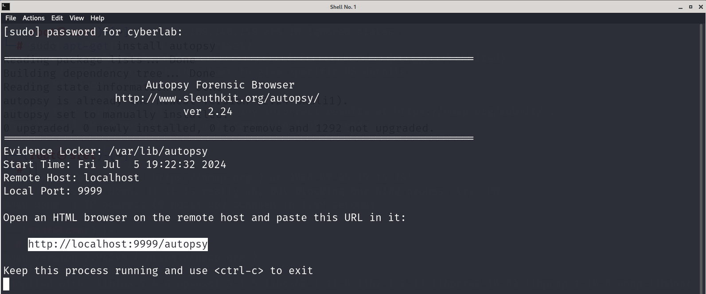

1. http://localhost:9999/autopsy

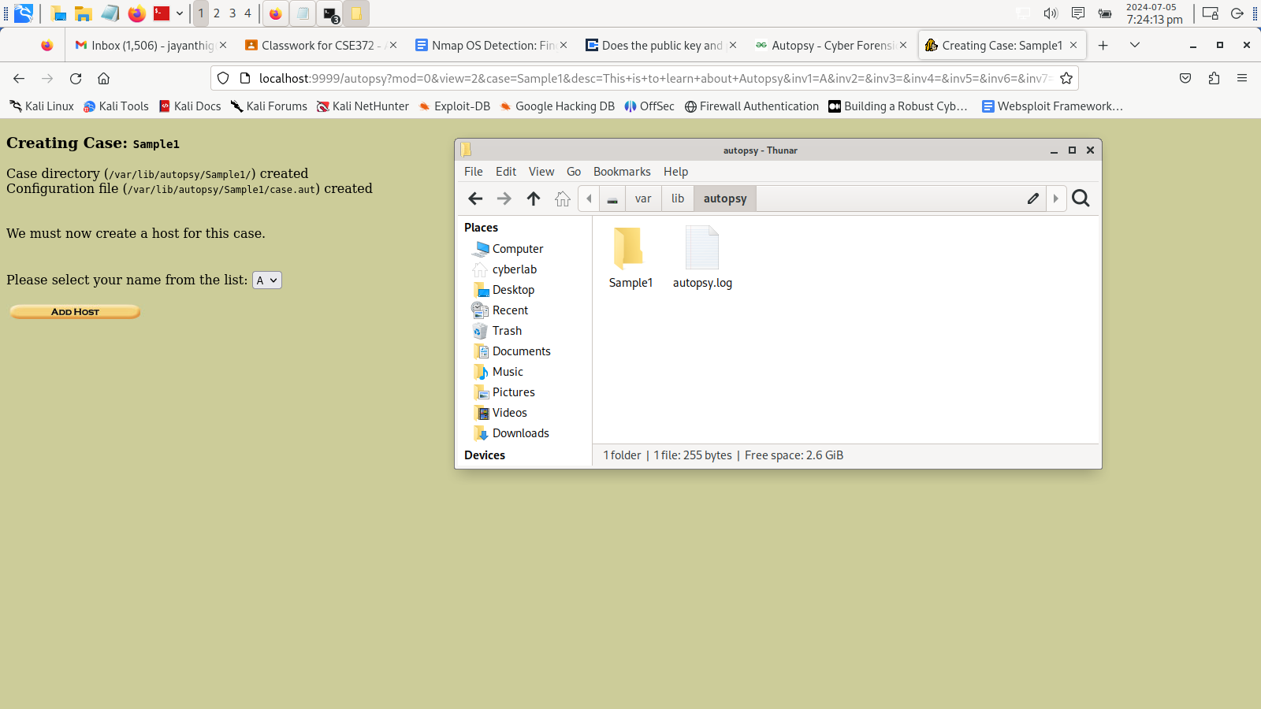

1. Add a host Computer and check your log files as shown below.

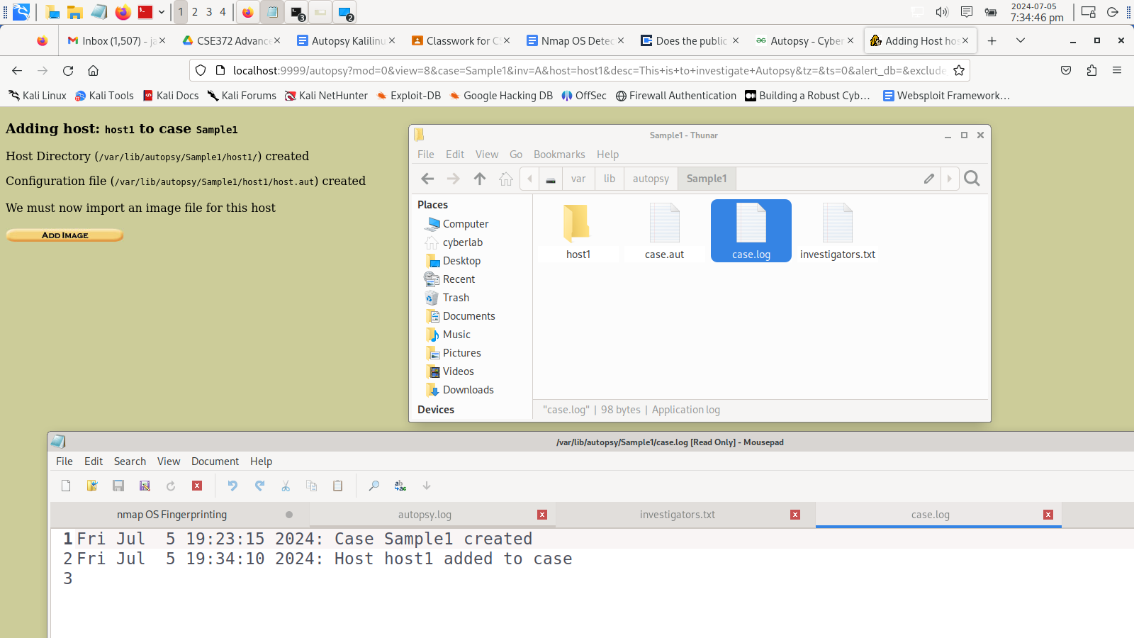

1. Check the case log file created

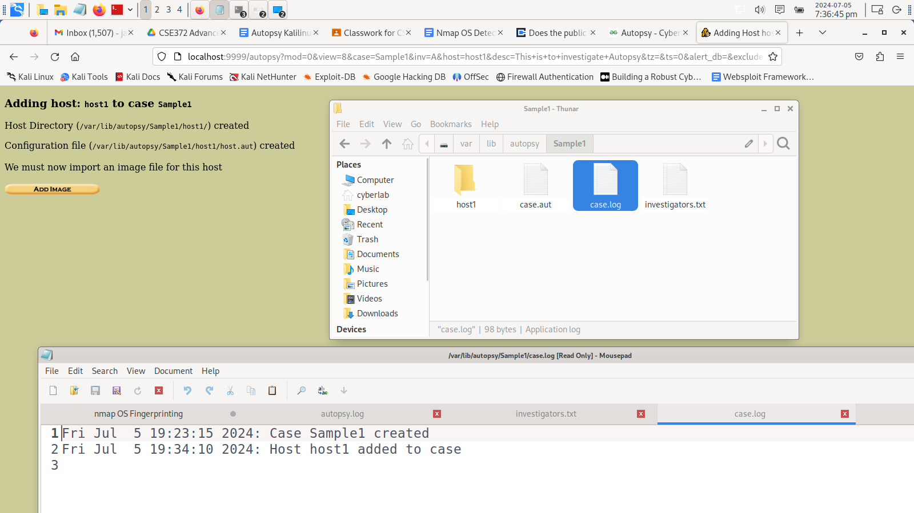

1. Check the configuration file as shown below

