In the following analysis I’ll analyze a dataset on the job market, and extract insights regarding the differences between men and women, more specifically, in the context of self-employment, unemployment, and the effect of COVID on both genders.

I’ll be using a dataset that I obtained from Israel’s CBS - <https://www.cbs.gov.il/he/Statistics/Pages/%D7%9E%D7%97%D7%95%D7%9C%D7%9C%D7%99%D7%9D/%D7%9E%D7%97%D7%95%D7%9C%D7%9C-%D7%A1%D7%93%D7%A8%D7%95%D7%AA.aspxn>

Self employment

First, we’ll look at the percentage of self-employed individuals as a share of total employment over time, looking at the difference between men and women.

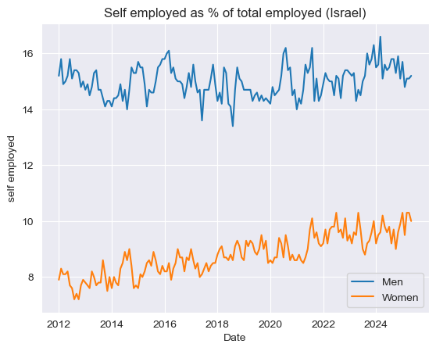

We can already draw some insights from examining the raw data.

- We can see that the % of self-employed men is generally much higher, almost 2 times more than the women.

- Although there is some noise in the data, the percentage for men remains relatively stable,but the women have a clear upward trend of increasing % self-employment each year, although it seems that around 2021 the trend became a bit less dominant and noticeable (with more careful testing we can still see it’s positive).

So while men’s trend is pretty stable, the women’s trend is clearly positive.

Now we’ll try to see whether, after excluding the trend and the general level of self-employment, the behaviour of men and women is similar – that is, if men’s and women’s decisions regarding self-employment is affected by the same factors in similar ways. To do that we’ll subtract the trend and the (yearly) seasonality effects, and examine the adjusted data.

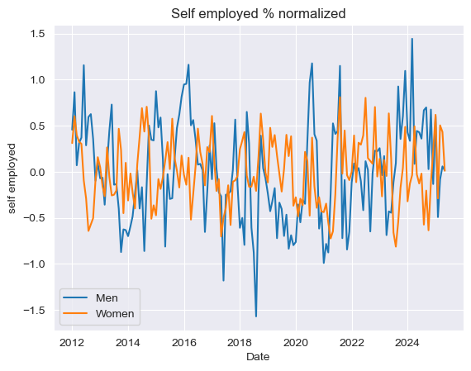

The correlation between the two series is 0.02, almost nonexistent, so it seems that although the decision is the same(whether or not becoming self-employed), men and women are influenced by different factors when making it(or similar factors but differently, although less probable because in that case we’ll often still see some correlation).

Another interesting insight we can get is that the data for men is much less stable than the women, with standard deviation almost twice as large.

Affects of covid on self-employment

Now we’ll try to understand what influences the decision, and see how it changed after the COVID crisis

We’ll look at the relationship between self-employment and unemployment before and after COVID, and we’ll see that the patterns changed for both men and women - but in different ways.

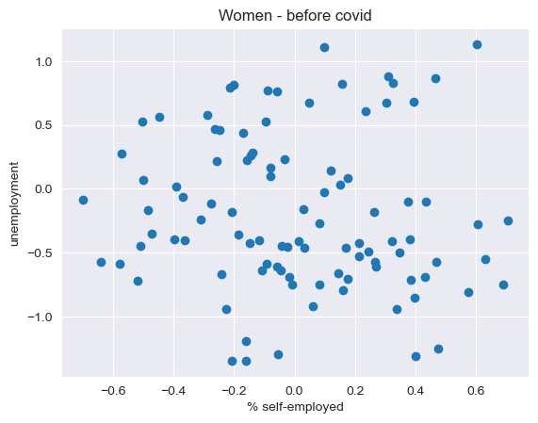

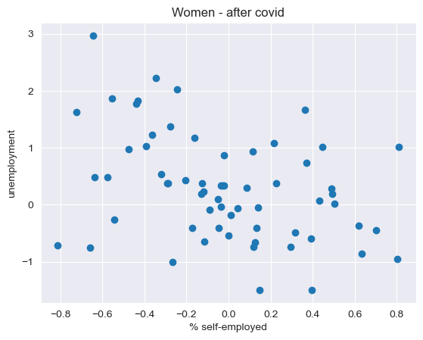

Correlation of self-employed women with unemployment before covid - (-0.082)

After covid - (-0.37)

We can see from both the correlation and the plots that before COVID there wasn’t any noticeable relationship between unemployment and self-employment for women. But after covid, there is a noticeable negative correlation between the two, a significant change in behaviour has clearly occurred.

For men, we observe the complete opposite pattern.

Correlation of self-employed men with unemployment before covid - (-0.33)

After covid - (0.01)

While before covid there was a noticeable negative correlation, after COVID it disappeared.

This further supports our hypothesis that men and women are taking the decision whether to become self-employed in very different ways.

Unemployment and salary – before and after COVID

It is already well known that during economic crises, we sometimes observe a rise in both median and average salaries. This can lead to a counterintuitive positive relationship between salary and unemployment.  
This effect was especially pronounced during COVID, due to the nature of the crisis — which prevented many physical (often lower-paid) workers from working.  
This phenomenon has been widely studied (e.g., [ADP Research Institute, 2025](https://www.adpresearch.com/wp-content/uploads/2025/07/TaW_2025_Issue2-2025.pdf)).

In this analysis, we demonstrate that this effect also appeared in Israel’s labor market data. Moreover, we explore how its impact differed between men and women.

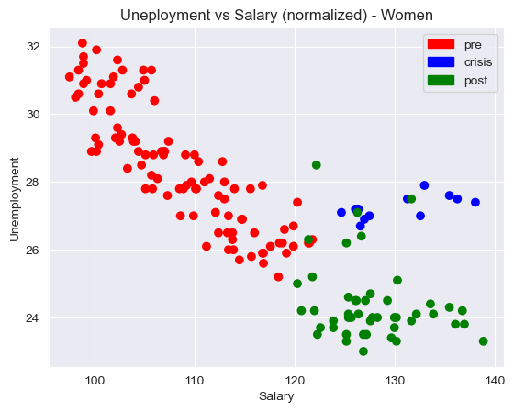

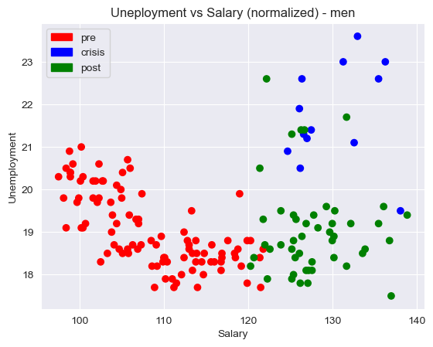

First, we can see that although the pre- and post-crisis periods are distinct, they appear to be part of the same overall trend — unlike the crisis period itself, which represents a clear shift in the relationship between unemployment and salary.

Also, we can see that the positive relationship (during the crisis) is much stronger for men than it is for women. One possible explanation is that low-wage men are more likely to work in physical jobs than low-wage women, and those jobs were hit hardest during the COVID lockdowns. To test that hypothesis, we would need more detailed data and further analysis.

In conclusion men and women show different patterns in self-employment and how it relates to unemployment. Before COVID, both had a negative connection between self-employment and unemployment, but after COVID, this link became stronger for women and disappeared for men. Also, the relationship between salary and unemployment changed from negative to positive during the pandemic, with a bigger effect for men. This might be because men and women work in different kinds of jobs that were affected differently by lockdowns.