Institute of Engineering & Technology

Full Stack - Project Synopsis

Real Time Chat Appliction

Submitted By :- Submitted to:-

Ashutosh Kumar Shukla(181500151) Mr. Pankaj Kapoor

Declaration

I hereby declare that the project work entitled “Real Time Chat Application”, submitted to Department of Computer Science & Engineering, GLA University, Mathura in mentorship of Mr. Pankaj Kapoor for the session 2020-2021. All the coding are result of my personal effort.

Ashutosh Kumar Shukla (181500151)

Acknowledgement

I have taken efforts on this project. However, it would not be possible without the help and kindness of many people and organizations. I would like to extend my gratitude to all.

I am indebted to Department of Computer Science & Engineering, GLA University, Mathura for their guidance and regular supervision and to provide the necessary information about the project and their support for the completion of the project.
I would like to express my gratitude to my parents and to the member of Department of Computer Science & Engineering, GLA University, Mathura for their good cooperation and encouragement which helps me in completing this work.
My thanks and thanks go to my colleagues in building the project and the people who volunteered to help me with their skills

INDEX

S.NO | Topic
1 | Introduction
2 | System Requirements
3 | Hardware Requirements
4 | Front End and Back End
5 | Idea
6 | Objective
7 | Scope
8 | DFD 0level 1 level and 2 level  Availability

- Introduction

Communication is a mean for people to exchange messages. It has started since the beginning of human creation. Distant communication began as early as 1800 century with the introduction of television, telegraph and then telephony. Interestingly enough, telephone communication stands out as the fastest growing technology, from fixed line to mobile wireless, from voice call to data transfer. The emergence of computer network and telecommunication technologies bears the same objective that is to allow people to communicate.
All this while, much efforts has been drawn towards consolidating the device into one and therefore indiscriminate the services. Chatting is a method of using technology to bring people and ideas together despite of the geographical barriers.
The technology has been available for years but the acceptance
it was quit recent. Our project is an example of a chat server. It is made
up of applications the client application which runs on the users mobile and server application which runs on any pc on the network. To start chatting our client should get connected to server where they can do Group and private chatting.

2. Software Requirements: -

a) HTML (front-end)
b) CSS
c) reactjs
d) ChatEngine.io (back-end)
e) GitHub
f) vsCode
g) Web Browser (Google Chrome)
h) Operating System (Windows, Linux, MacOS)

3. Hardware Requirements: -

a) Minimum Marshmallow version 7.0 (for android)
b) Window 8 or more
c) Hard-Disk 250GB or more
d) RAM 4GB or more
e) Internet Connection

4.1 Frontend

Reactjs is library of JavaScript. It is open source, front-end, for building user interface. It is maintained by Facebook and a community of individual developers and companies. React can be used as a base in the development of single-page or mobile applications.

4.2 Backend

The backend lies ChatEngine that is an object-oriented event emitter based framework for building chat applications in Javascript. It reduces the time to build chat applications drastically and provides essential components like typing indicators, online presence monitoring and message history out of the box.

5. IDEA

In today’s World Most of us are familiar with the use of real-time messaging applications, especially in mobile devices, in the
form of Whatsapp, Facebook Messenger, and numerous other messaging applications. However, real-time
messaging is used not limited to purely messaging applications. We see real-time messaging features in on demand
taxi apps, delivery apps, and collaborative platforms.

6. Objective

Communication is a mean for people to exchange messages. It has started
since the beginning of human creation. Distant communication began as
early as 1800 century with the introduction of television, telegraph and then
telephony. Interestingly enough, telephone communication stands out as the fastest growing technology, from fixed line to mobile wireless, from voice call to data transfer. The emergence of computer network and telecommunication technologies bears the same objective that is to allow people to communicate . All this while, much efforts has been drawn towards consolidating the device into one and therefore indiscriminate the services. Chatting is a method of using technology to bring people and ideas together despite of the geographical barriers. The technology has been available for years but the acceptance
it was quit recent. Our project is an example of a chat server. It is made
up of applications the client application which runs on the users mobile and
server application which runs on any pc on the network. To start chatting our
client should get connected to server where they can do Group and private
chatting.

7. DFD

0-Level DFD

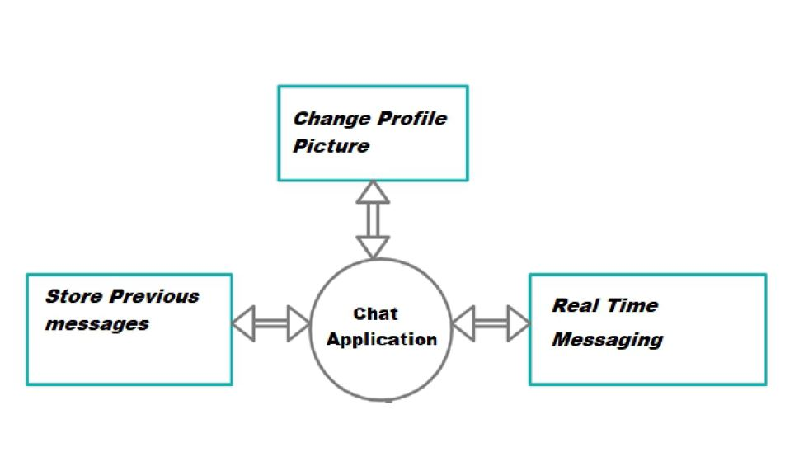

Availability

This website works for all Smartphones and PC.

