**MINI-PROJECT (2020-2021)**

**Real Time Chat Application**

**(Web Development)**

**PROJECT REPORT**

**Department of Computer Engineering & Applications**

Institute of Engineering & Technology



**Submitted by** :- **Submitted to** :-

Mridul Srivastav (181500395) Mr. Akash Choudhary

Lokesh Yadav(1815000351)

Sudhanshu Dixit (181500706)

Yash Pandey(181500826)

Sumit Sharma(181500733)

|  |
| --- |
| **TABLE OF CONTENTS** |
| **Certificate 4**  **Synopsis 5**  **Acknowledgement 7**  **Abstract… 8** |
| **1. Introduction….…………………………………………………………….** |
| 1.1 Overview 9 |
| 1.2 Motivation 9 |
| 1.3 Problem Statement 10 |
| 1.4 Objective… 10 |
| **2. Software Requirement Analysis…………………………………………..** |
| 2.1 System Analysis 11 |
| 2.2 Role of System Analyst 11 |
| 2.2.1 Main roles of System Analyst 12 |
| 2.3 Users 12 |
| * 1. Methodology 12   2. Dependencies /External Systems 13   3. DFD 15   4. Use-case Diagram 17 |
| 1. **Implementation details 18** 2. **Contribution Summary 18** 3. **Tables 19** |

|  |
| --- |
| 1. **Project Work 25**   **7.Availability… 40** |

**Certificate**

This is to certify that Mridul Srivastav, Lokesh Yadav ,Shudanshu Dixit,Yash Pandey , Sumit Sharma students of B.Tech (CSE) 3rd year has successfully Completed the MINI PROJECT named Real Time Chat Application on Web Development under the Guidance of Mrs. Akash Choudhary . During 2020-21.

**Signature:**

**Mrs. Akash Choudhary** (Mentor)

# Project Information:-

|  |  |
| --- | --- |
| Title Of Project/Training/Task | E-commerce For small vendor |
| Role & Responsibility | Mridul Srivastav: Front-end, Back-end and Designer of pages.  Lokesh Yadav: Testing components of front-end ,Documentation work.  Sudhanshu Dixit : Front- end designer and documentation work  Yash Pandey : Front- end designer and documentation work  Sumit Sharma : Front-end, Back-end . |
| Technical Details | Hardware Requirements:   * Minimum Marshmallow version 7.0 ( for android ) * Pentium IV or higher, (PIV-300GHz recommended) * Hard-Disk 250GB or more * RAM 4GB or more * Processor i3 (7th Gen) * 1024 x 768 Display * Internet   Software Requirements:   * SYSTEM SOFTWARE :-   Operating System (Windows , Linux , MacOS )   * APPLICATION SOFTWARE :-   a)Vscode  b) Reactjs  c) Nodejs  d) Chatengine.io  e) Web Browser ( Google Chrome , Firefox , Safari , Mozilla , Internet Explorer ) |

**Acknowlegment**

I have taken efforts on this project. However, it would not be possible without the help and kindness of many people and organizations. I would like to extend my gratitude to all.

I am indebted to Department of Computer Science & Engineering, GLA University, Mathura for their guidance and regular supervision and to provide the necessary information about the project and their support for the completion of the project.

I would like to express my gratitude to my parents and to the member of Department of Computer Science & Engineering, GLA University, Mathura for their good cooperation and encouragement which helps me in completing this work.

My thanks and thanks go to my colleagues in building the project and the people who volunteered to help me with their skills

**Abstract**

The report presents the three tasks that is being in continuation which are listed below:

1. Understanding of the Problem objective & implication.
2. Understanding of the data & building of the model.
3. Evaluation of the model.

All these tasks have been completed successfully and results were according to expectations. All the tasks were need very systematic approach, starting from the collection of the data to the implementation of the solution and till evaluation of the System. The most challenging task was the domain knowledge, to understand the language. It is one of the major areas and really need very fundamental and conceptual knowledge of MERN technology

# Introduction

* 1. Overview
     + All the functional/non-functional requirements, corresponding DFD’s, UML and Use Case Diagrams have been organized in this report. Along with these designs, this report also contain the essential data of this project.
     + The complete description of the application followed by the functionalities has been listed initially. Later on, the Webpage has been described diagrammatically with the help of different designing tools like Data Flow Diagram, Use Case Diagram, Interaction Diagram and E-R Diagram.
  2. Motivation

In today’s World Most of us are familiar with the use of real-time messaging applications, especially in mobile devices, in the

form of Whatsapp, Facebook Messenger, and numerous other messaging applications. However, real-time

messaging is used not limited to purely messaging applications. We see real-time messaging features in on demand

taxi apps, delivery apps, and collaborative platforms.

* 1. Objective

Communication is a mean for people to exchange messages. It has started

since the beginning of human creation. Distant communication began as

early as 1800 century with the introduction of television, telegraph and then

telephony. Interestingly enough, telephone communication stands out as the

fastest growing technology, from fixed line to mobile wireless, from voice call

to data transfer. The emergence of computer network and telecommunication

technologies bears the same objective that is to allow people to communicate.

All this while, much efforts has been drawn towards consolidating the device

into one and therefore indiscriminate the services. Chatting is a method of

using technology to bring people and ideas together despite of the geographical barriers.

The technology has been available for years but the acceptance

it was quit recent. Our project is an example of a chat server. It is made

up of applications the client application which runs on the users mobile and

server application which runs on any pc on the network. To start chatting our

client should get connected to server where they can do Group and private

chatting.

1. System and Requirement Analysis
   1. System Analysis

System analysis is a process of collecting and interpreting facts, identifying the problems, and decomposition of the system into its components.

It is a process of studying a system in order to define its goals or purposes and to discover operations and procedures for accomplishing them most efficiently.

Here the problem is new seller face a common problem of exposure. So, we design a website which solves all these problems.

Role of System Analyst

The system analyst is a person who is thoroughly aware of the system and guides the system development project by giving proper directions. He is an expert having technical and interpersonal skills to carry out development tasks required at each phase.

* + 1. Main Roles of System Analyst:
       - Defining and understanding the requirement of user through various fact finding techniques.
       - Prioritizing the requirements by obtaining user consensus.
       - Maintains analysis and evaluation to arrive at appropriate system which is more user friendly.
       - Draw certain specifications which are easily understood by users and programmer in precise and detailed form.
       - Implement the logical design of system which must be modular.
  1. Methodology

Our methodology is designed to help you take maximum advantage of the internet technologies. It incorporate all aspects related to our website and allows us to ensure that the final product is of the highest standards. Below are the steps we will take to ensure that all your deliverables are completed in time ,within budget also we will try to solve each and every problem efficiently.

Requirements analysis

The first step for us is to analyze your and your target`s requirements. Who will be visiting your website, what will be the purpose of their visit, what is the primary goal of your website, how can your organization best cater to their needs etc. Many such questions are analysed for the Needs Analysis stage.

If we are given access to the current website statistics, we would also like to analyze your current page views, average user time spent on the site, top landing pages, existing search engine rankings, existing bounce rates and many such factors. We analyze your online target audience and assess your differentiation strategy to best attract and retain your online visitors.

Your website will also undergo comprehensive search engine analysis twice during the course of the project; once during this stage and once again after the deployment (Go Live phase) of your website.

Website handover

Once the site is setup on your destination server, upon your approval we make the website live. One final set of testing is done on the live website for the quality assurance purposes. We then hand over the control of the site to you.

* 1. Dependencies/External Systems

User Interfaces:

UI-1: The webpage shall permit complete navigation; including all the functionalities described above, starting from a simple login or registration to access the company information , to go through the feedbacks given by placed students ,to see the references to study the specified subjects ,users can give their suggestion to the admins and to give a feedback form . The portal is universally accessible on almost all PCs and smart phones.

Hardware Interfaces:

There are three external machines/devices used by the portal, each related to a user interface. These are a server machine at the admin end, hosting the portal, a PC at club’s end, keeping log of the registration and membership entries made to them & providing them with an interface to do their part of

functionality offered, last one is a PC or a smart phone at user’s end to access the portal. The devices at the user end behave as terminals and not for storing any type of data. Also capable of taking user input. All order and transaction should be stored on server.

HARDWARE REQUIREMENT (MINIMUM)

* 20 GB OF HARDDISK
* Processor i3 (7th Gen)
* 1024 x 768 Display
* Internet
* Minimum Marshmallow version 7.0 ( for android )
* Pentium IV or higher, (PIV-300GHz recommended)
* Hard-Disk 250GB or more
* RAM 4GB or more
* Processor i3 (7th Gen)

SOFTWARE REQUIREMENT-

* SYSTEM SOFTWARE
  + Operating System (Windows 10, Linux)
* APPLICATION SOFTWARE
  + - Reactjs( front-end )
    - ChatEngine.io(backend)
    - Nodejs
    - Github
      * + Web Browser :-

Google Chrome , Firefox , Safari , Mozilla , Internet Explorer

**2.5**  DFD

**LEVEL 0 DFD**

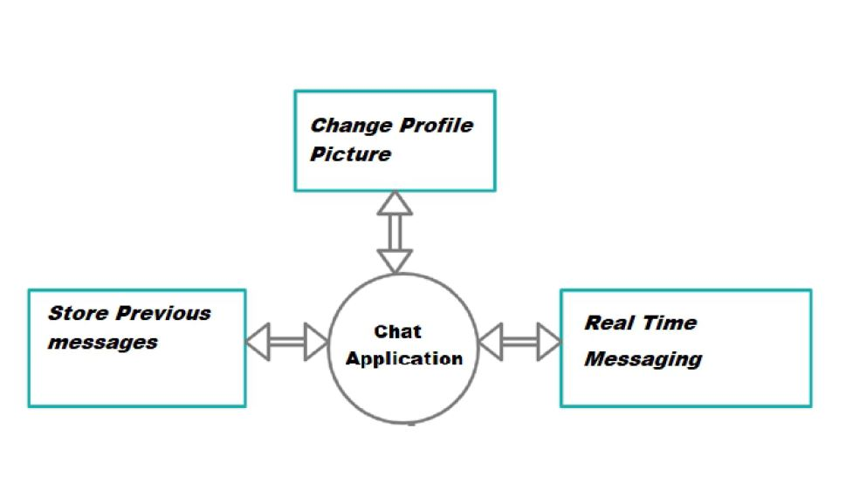

1. Implementation Details

**Frontend**

Reactjs is library of JavaScript. It is open source, front-end, for building user interface. It is maintained by Facebook and a community of individual developers and companies. React can be used as a base in the development of single-page or mobile applications.

**Backend**

The backend lies ChatEngine that is an object-oriented event emitter based framework for building chat applications in Javascript. It reduces the time to build chat applications drastically and provides essential components like typing indicators, online presence monitoring and message history out of the box.

## Contribution Summary

OUR TEAM:

Mridul Srivastav : Front-end , Back-end and Designer

Lokesh Yadav: Testing components of front-end , documentation work .

Shudanshu Dixit : Front- end designer and documentation work

Yash Pandey : Front- end designer and documentation work

Sumit Sharma : Front-end , Back-end and Designer.

.

**Project Work:**

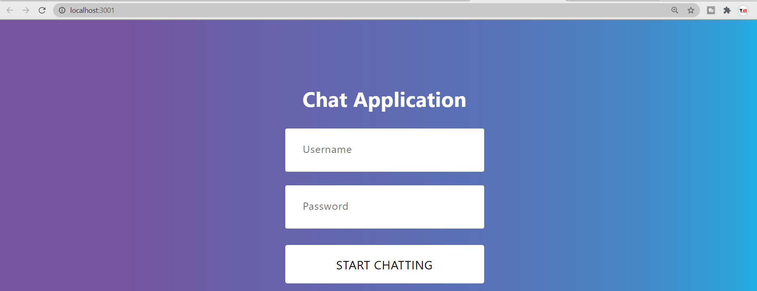

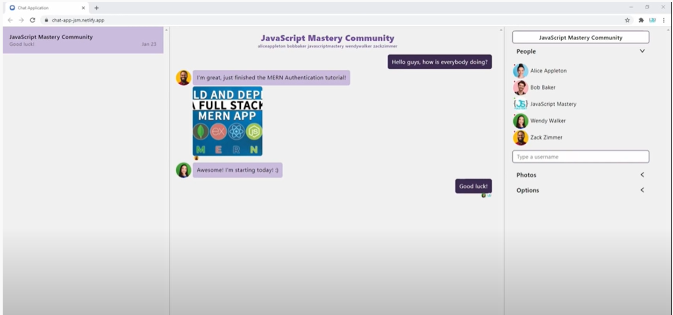

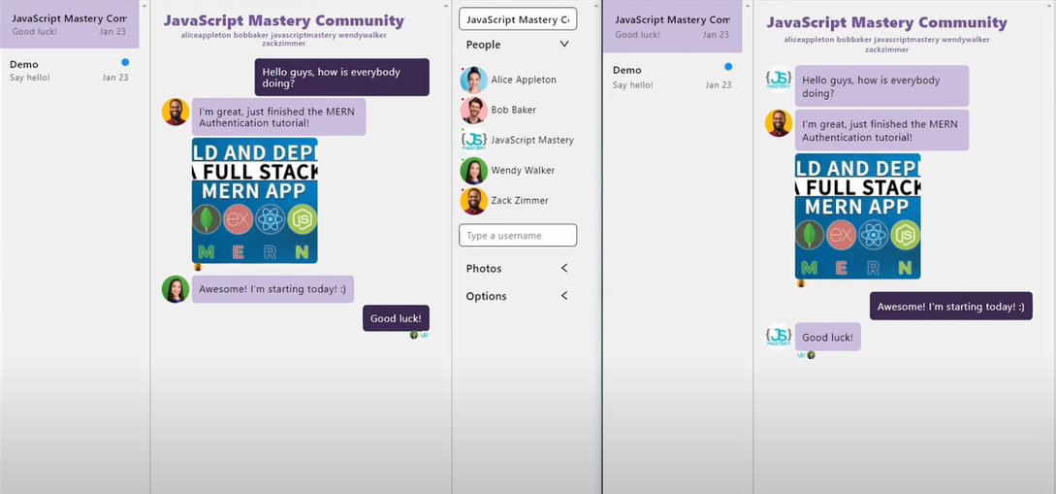

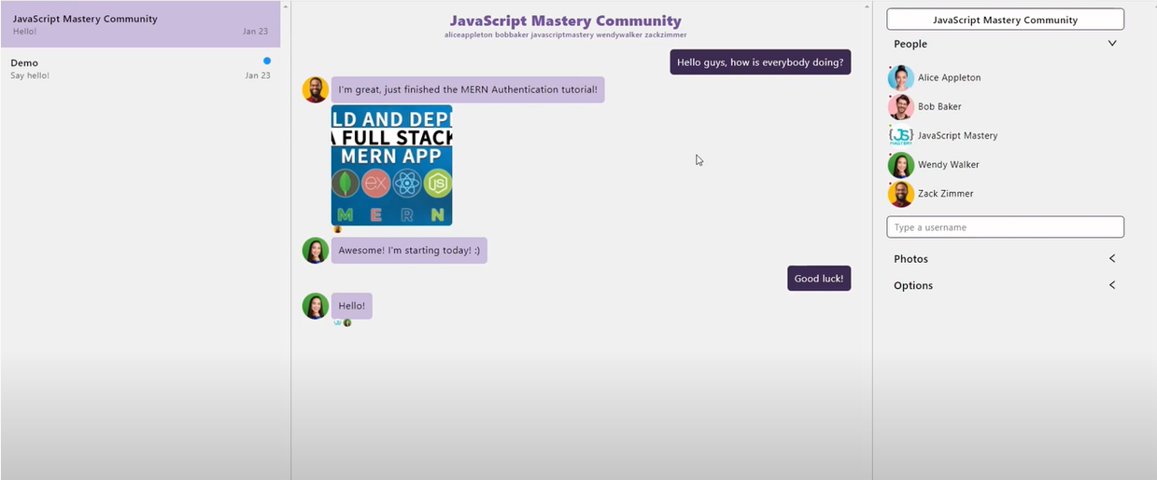

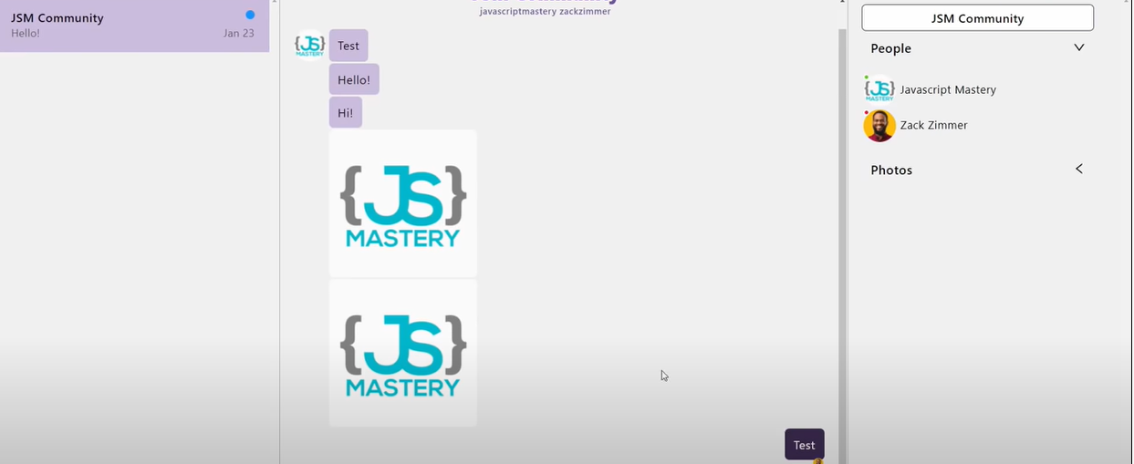

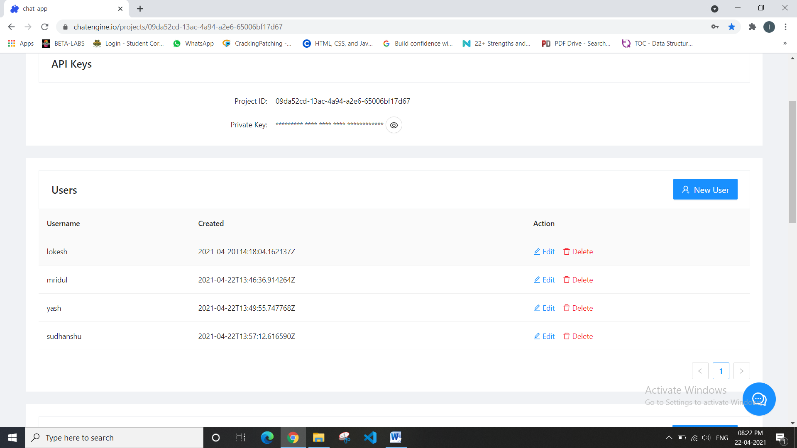

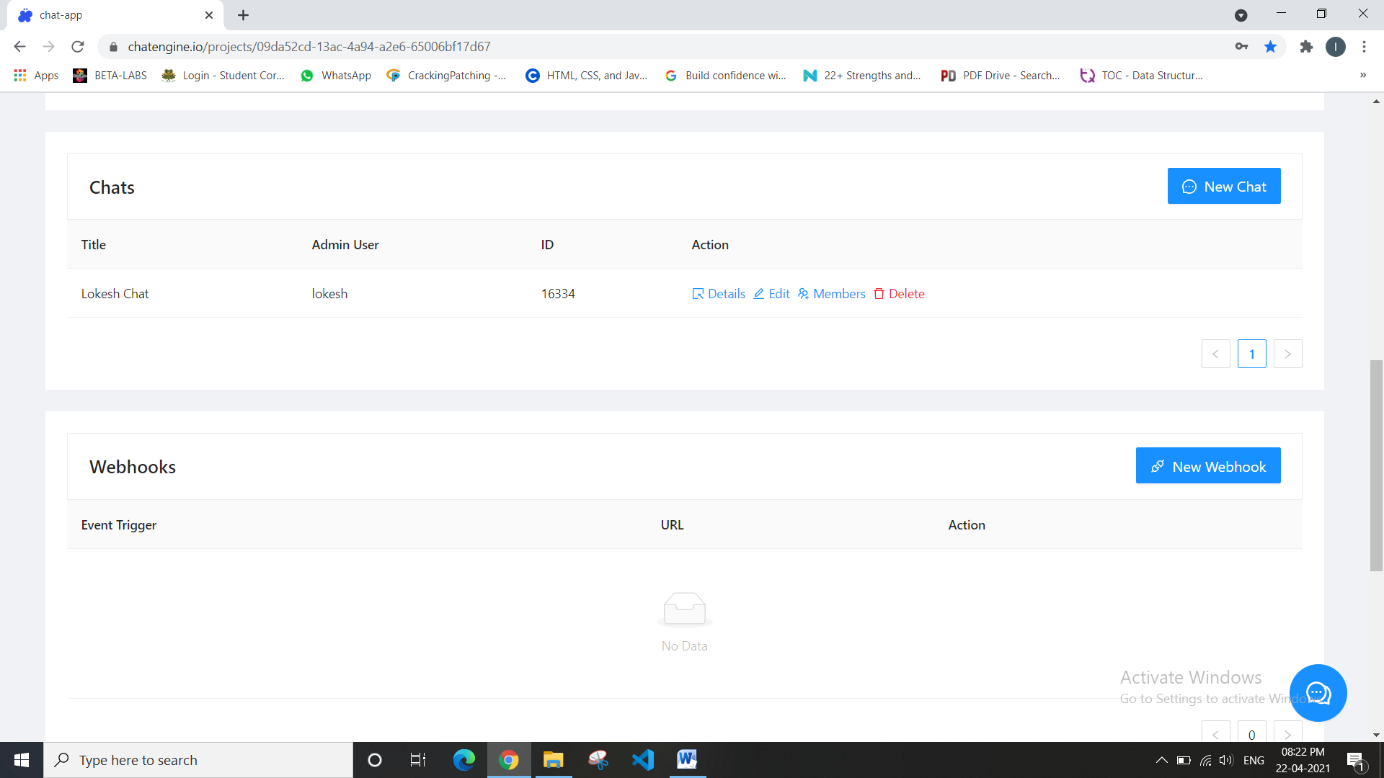

**Availability:**

This website works for all Smartphones and PC.

.

**References:**

* [**www.javatpoint.com**](http://www.javatpoint.com/)
* [**www.w3school.com**](http://www.w3school.com/)
* [**www.tutorialspoint.com**](http://www.tutorialspoint.com/)
* [**www.youtube.com**](http://www.youtube.com/)
* **www.google.com**
* **Faculty Guideline:**