GAMAL FARAG
DIGITAL ENGINEERING & OPERATIONS | PROJECT CONTROLS
Doha, Qatar • +974 777 38990 • gamaleldin.yousry@gmail.com
Project portfolio: https://gamaleldinyousryibrahimfarag.github.io/gamal-portfolio/digital.html
PROFESSIONAL PROFILE
Civil engineer and engineering-management professional with six years of experience across owner-representative, consultancy and contractor environments. Combines construction project controls with hands-on development of digital applications and AI-enabled workflows for procurement, document control, operational reporting and service discovery. Connects business needs to practical system logic: mapping processes, building tools, validating outputs, troubleshooting issues and supporting day-to-day use across teams.
WHAT I BRING
BUILD & AUTOMATE Develop practical applications and AI-assisted workflows that convert repetitive business tasks into structured digital processes.
OPERATE & IMPROVE Validate outputs, resolve data and workflow issues, support users and refine tools for reliable day-to-day operation.
COORDINATE & DELIVER Connect site engineering, finance, procurement, document control and management around clear handoffs, responsibilities and records.
SELECTED SYSTEMS AND PRACTICAL DIGITAL WORK
Primavera P6 progress-update automation Developed and tested spreadsheet/script-assisted P6 update workflows involving activity data mapping, progress-percentage normalization, date checks, import preparation and error logging.
Procurement Management Application Developed a cross-functional application connecting site engineers, finance/accounting and the procurement lead through a security-focused workflow.
AI-powered Document Control Application Developed an AI vision-enabled intake workflow that interprets incoming emails, identifies concerned engineers, routes correspondence, files records and creates a log.
Management performance systems Built structured P6/Excel/Power BI reporting around planned vs actual progress, resource and cost loading, S-curves, critical-path exposure and recovery actions.
Automotive Services Application Developed service-discovery features covering automotive service categories, vehicle price information and nearby service providers.
Predictive AI & historical-data modelling Trained and experimented with AI models using historical datasets to identify patterns and explore forecasts of future outcomes.
PROFESSIONAL EXPERIENCE
AL FAISAL HOLDING | Planning Engineer, Owner Representative Office | Mar 2024 – Present
Doha, Qatar | Private Royal Developments / Four Palaces Programme (QAR 200M+)
• Developed and coordinated resource-loaded Primavera P6 baselines of 4,000+ activities across four concurrent projects, integrating civil, MEP, fit-out, external works and procurement interfaces.
• Turned site updates into management information: milestone forecasts, earned-value indicators, critical-path analysis, delay exposure and clear recovery priorities.
• Prepared and improved project-control and procurement-related workflows, linking engineering decisions, package delivery, approvals and construction sequences.
• Coordinated contractors, subcontractors and owner-side stakeholders; reviewed tender programmes, evaluated slippages and supported delay, TIA and EOT assessments.

PROFESSIONAL EXPERIENCE | CONTINUED
MANNAI CORPORATION / GULF LABORATORIES | Planning Engineer (Civil) | Sep 2021 – Mar 2024
Doha, Qatar | ASHGHAL Deep Injection Wells Programme (QAR 150M)
• Integrated three subcontractor programmes into the P6 baseline, connecting execution logic with resources, procurement and infrastructure delivery constraints.
• Produced weekly/monthly earned-value analysis, S-curves, dashboards and corrective planning scenarios; supported time-impact and EOT records.
CEG INTERNATIONAL | Planning Engineer (Civil) | Nov 2020 – Aug 2021
Doha, Qatar | ASHGHAL Inner Doha Sewer Programme (QAR 500M)
• Consolidated five subcontractor schedules into a CPM master programme for tunnelling and civil infrastructure works.
• Monitored deviations, manpower and cost performance; supported risk escalation, delay review and recovery planning.
REPRESENTATIVE ENGINEERING DELIVERY
FOUR PALACES PROGRAMME | Qatar Owner-side controls across four parallel royal developments; integrated construction, fit-out, specialist procurement and decision milestones.
SOUQ AL NAJADA – GOLD SOUQ | Doha Resource- and cost-aware construction sequencing, performance tracking and recovery logic for a heritage/retail scope.
LEKHWIYA MULTI-BUILDING PROJECT | Qatar Steel erection and building-level programmes integrating engineering, procurement, workforce and site sequence.
DIRIYAH SQUARE – PACKAGE 3 | Riyadh Procurement and installation planning for specialist architectural packages across 76 buildings.
ASPIRE ZONE PHASE 2 – WEST ZONE | Qatar Design-build programme for roads, buildings, athletic facilities, power, lighting, irrigation and landscaping interfaces.
OFFICE TOWER 404 | Doha Corniche Planning an 8,303 m² curtain-wall replacement around occupied-building access and long-lead procurement.
ENGINEERING, TECHNICAL AND BUSINESS CAPABILITIES
Digital build and automation Python, Excel/VBA, application workflow design, scripting and data processing, AI-assisted development (Cursor, ChatGPT, Gemini), AI vision-enabled document workflows, predictive modelling with historical data, testing and iteration.
Procurement and operations Procurement application workflows connecting site, finance and purchasing; package sequencing, engineering/submittal milestones, supplier interfaces and contract controls.
Reporting and engineering tools Advanced Excel, Power BI, dashboards, AutoCAD, Revit, Microsoft Office.
EDUCATION, CREDENTIALS AND LANGUAGES
M.Sc. Engineering Management Qatar University, 2024 | GPA 3.92/4.0
B.Sc. Civil Engineering Ain Shams University, 2020
Professional credentials UPDA holder; Egyptian Engineers Syndicate; Federation of Arab Engineers. CIOB Professional Review preparation (MCIOB pathway).
Languages Arabic: Native | English: Professional working proficiency (IELTS 7.5)
GAMAL FARAG / SELECTED DIGITAL WORK
TURNING ENGINEERING TASKS INTO AUTOMATION
I translate repetitive engineering and procurement work into structured, testable tools - then help teams use, troubleshoot and improve them.
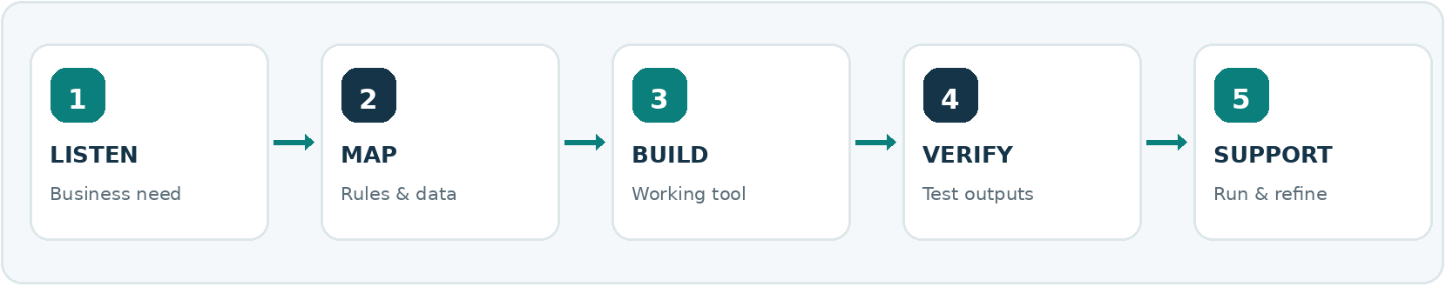
SELECTED WORKFLOWS & FEATURES
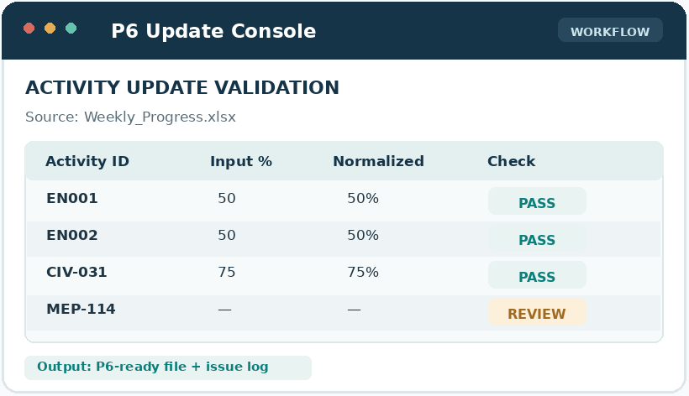 | 01 P6 PROGRESS UPDATE AUTOMATION  TASK Repeated weekly activity updates from Excel, with inconsistent dates, IDs and percentages.  AUTOMATION Read inputs, check activity IDs, normalize progress and dates, prepare import data and flag errors.  MY INVOLVEMENT Built and iterated the update workflow; tested P6 data handling, validation and error logging.

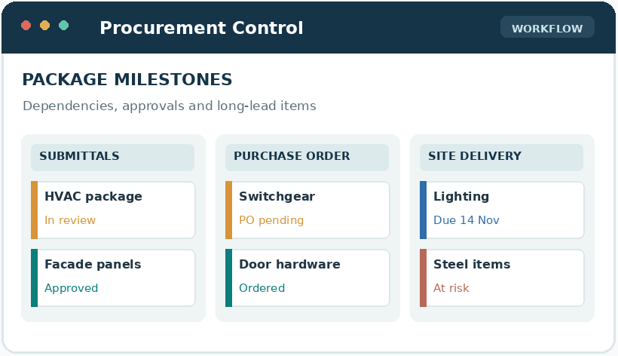 | 02 PROCUREMENT PACKAGE & CONTRACT CONTROL  TASK Multiple package approvals, purchasing stages, lead times and site dependencies to coordinate.  AUTOMATION APPROACH Structure submittal, PO, payment and delivery gates; monitor package status and exceptions.  MY INVOLVEMENT Developed procurement programmes and tracking logic linking supplier commitments to construction readiness.

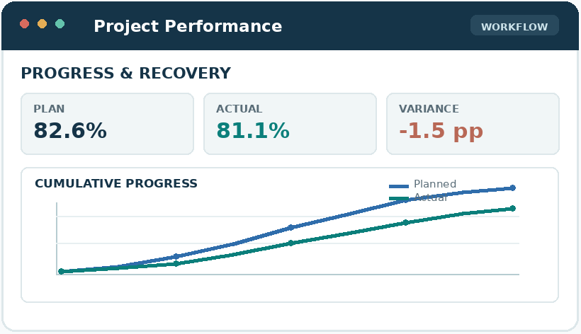 | 03 PERFORMANCE REPORTING & ACTIONS  TASK Turn scattered site, cost and P6 progress information into clear management priorities.  AUTOMATION APPROACH Standardize updates, compare plan vs. actual, surface milestone drift and build dashboards.  MY INVOLVEMENT Prepared reporting frameworks, reviewed outputs and coordinated recovery priorities with teams.
HOW I ADD VALUE
UNDERSTAND  Translate real site requests into practical requirements | BUILD & TEST  Python / Excel / VBA / AI-assisted development, with validation | OPERATE & IMPROVE  Support users, resolve issues and refine the workflow

GAMAL FARAG / DIGITAL PRODUCT PORTFOLIO
BUILDING APPLICATIONS THAT CONNECT TEAMS & AUTOMATE WORK
From cross-functional procurement workflows to AI-driven correspondence handling and location-based service discovery.
HOW I TURN A BUSINESS TASK INTO A WORKING DIGITAL PROCESS
01 UNDERSTAND  Task & users | 02 DESIGN  Workflow & rules | 03 AUTOMATE  Application & AI | 04 OPERATE  Test, support, improve

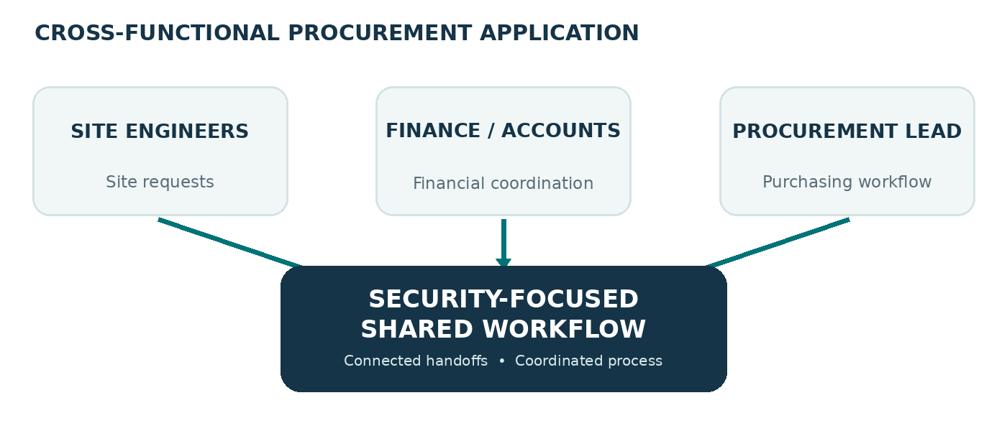 | 01 PROCUREMENT MANAGEMENT APPLICATION  CROSS-FUNCTIONAL BUSINESS WORKFLOW  CONNECTED TEAMS Site engineers, finance/accounting and the procurement lead work through one coordinated application workflow.  DESIGN FOCUS Security-focused process flow connecting stakeholders and their procurement handoffs.  VALUE Brings the procurement process and its participating functions into one connected digital environment.

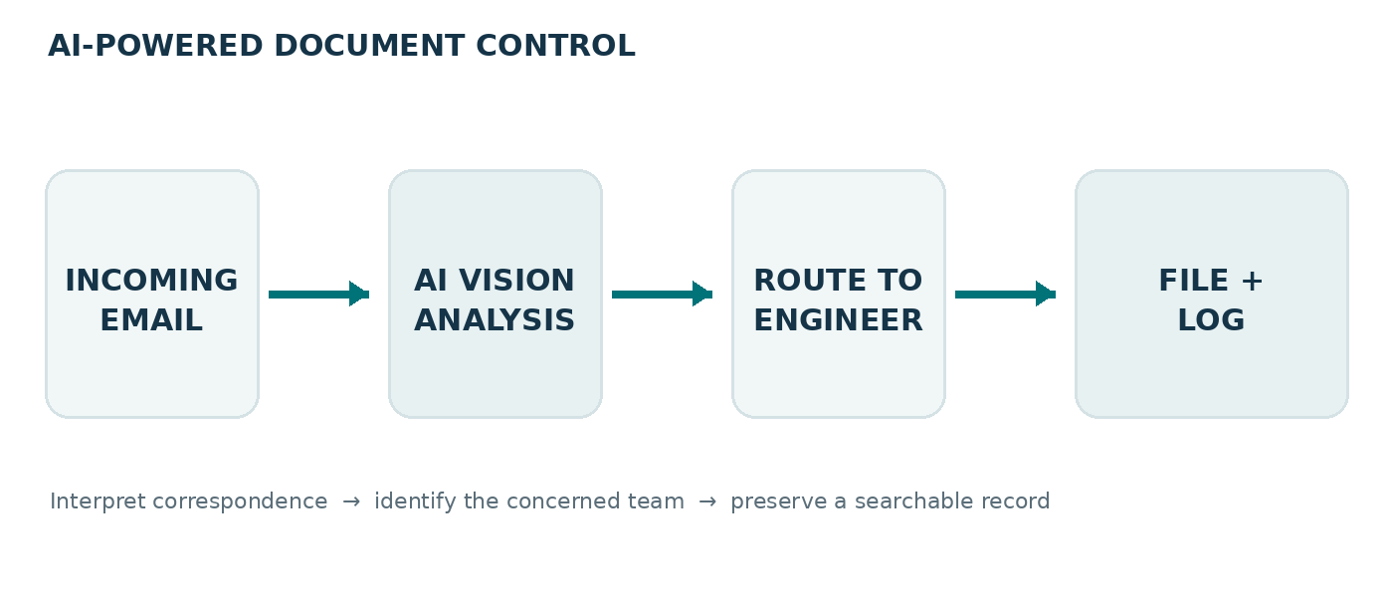 | 02 AI-POWERED DOCUMENT CONTROL APPLICATION  AI VISION • CORRESPONDENCE ROUTING • RECORDS  INTAKE AI vision model interprets incoming email content and identifies the relevant subject / responsible engineers.  AUTOMATION Routes correspondence to concerned engineers, files the related record and creates a log.  VALUE Reduces manual document-control handling and supports consistent routing, filing and traceability.

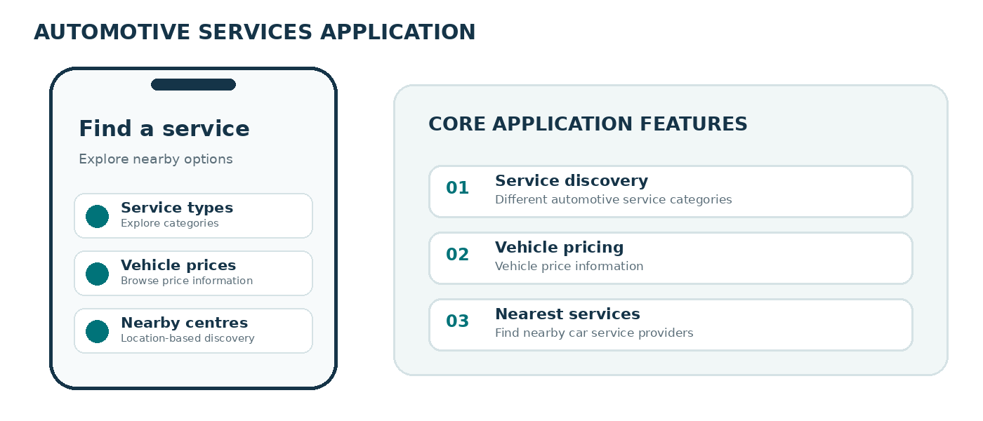 | 03 AUTOMOTIVE SERVICES APPLICATION  CONSUMER-FACING SERVICE DISCOVERY  FEATURES Automotive service categories and vehicle price information.  LOCATION Helps users discover nearby car service providers.  VALUE Brings service information, pricing context and location-based discovery into one application.

04 PREDICTIVE AI & HISTORICAL-DATA MODELLING
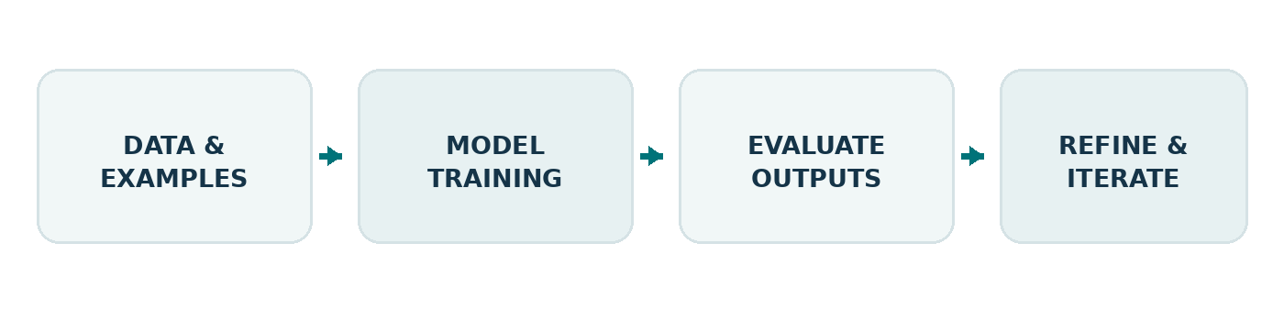 | Trained and experimented with AI models on historical datasets to identify past patterns and explore predictions of future outcomes. Applied a data-driven approach to model development and evaluation.

