1. **Write a Command to get the Python version u are using.**

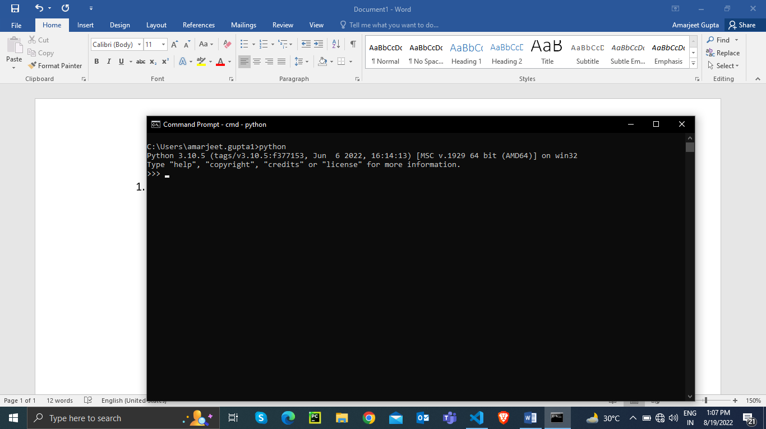

1. **Write a python script to print Hello Python on the screen directly in the command line.**

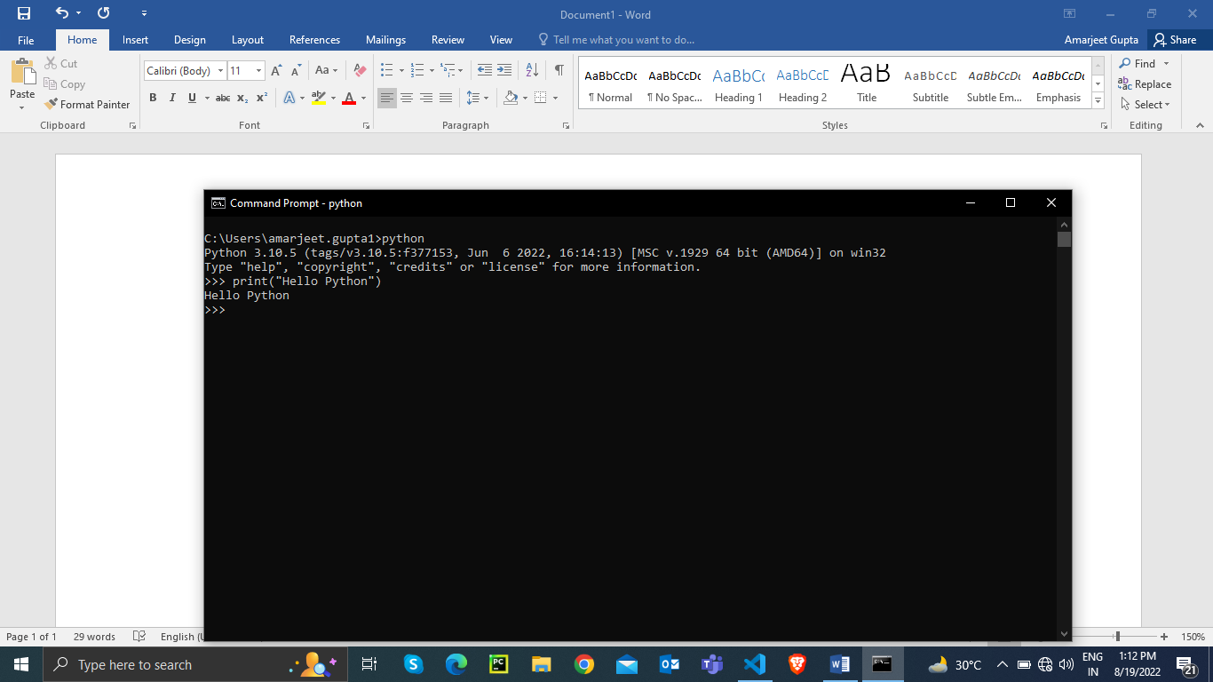

1. **Write a python script and store it in a file and execute the file from the command line.**

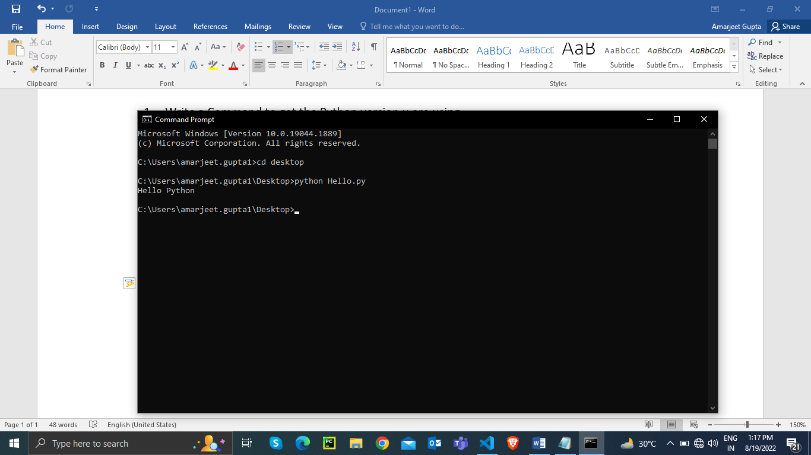

1. **Write a Python script to print Hello Python on the screen using visual studio code.**

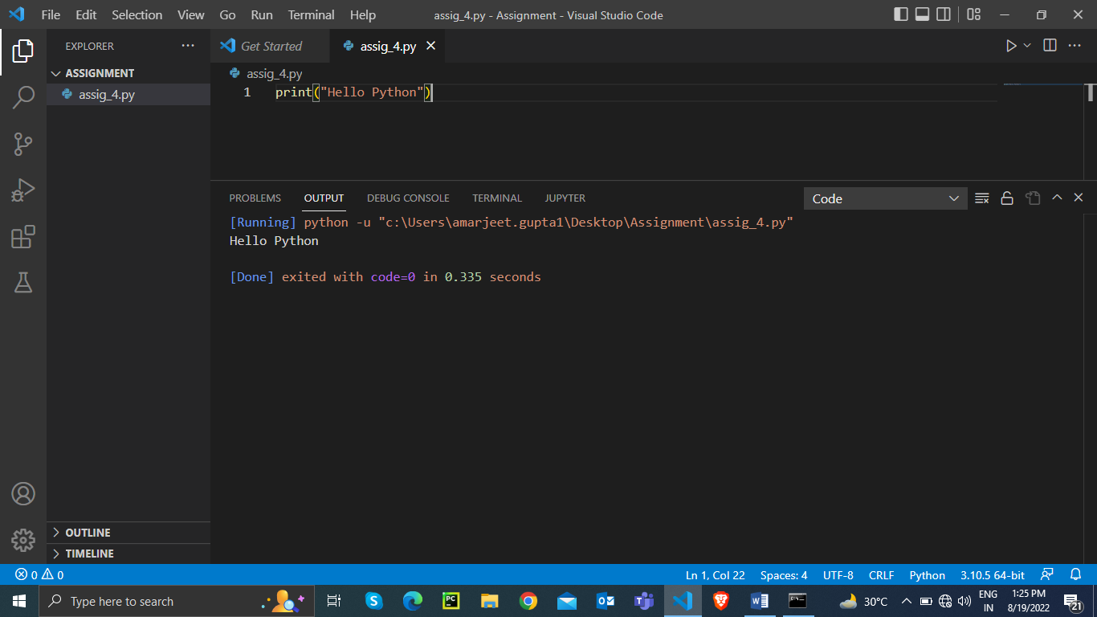

1. **Write a python script to print Hello on the first line and Python on the second line.**

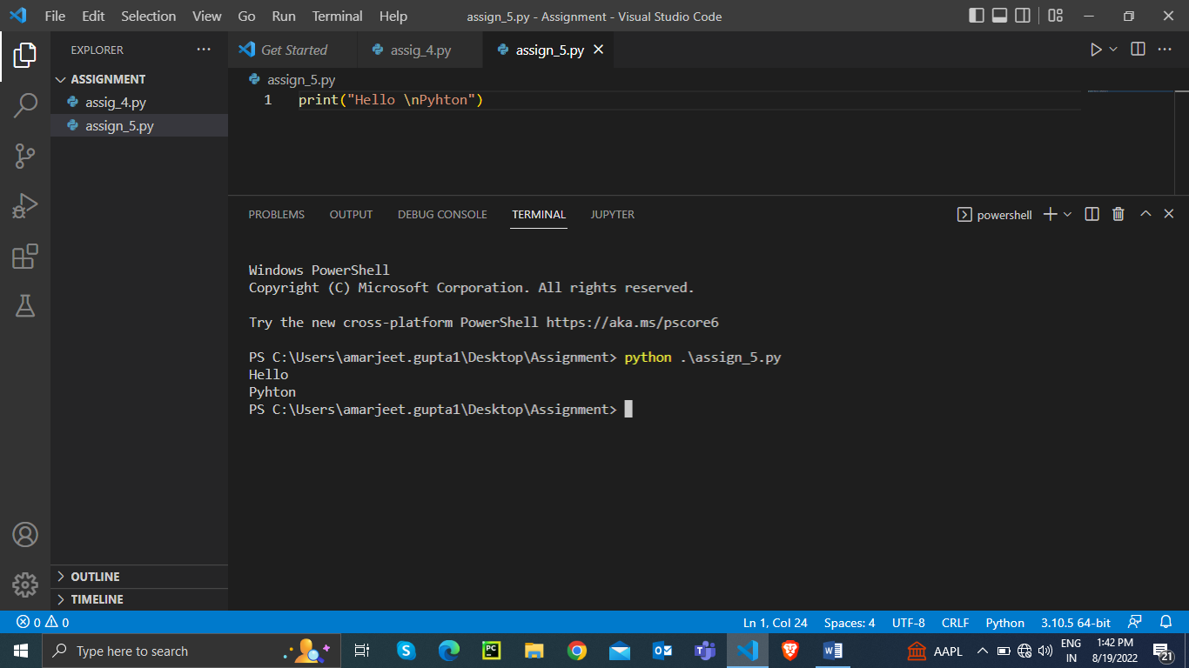

1. **Write a python script to print “MySirG” on the screen.**

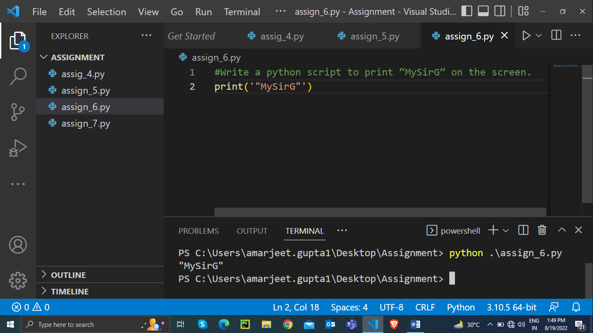

1. **Write a python script to print “Teacher’s Day” on the screen**

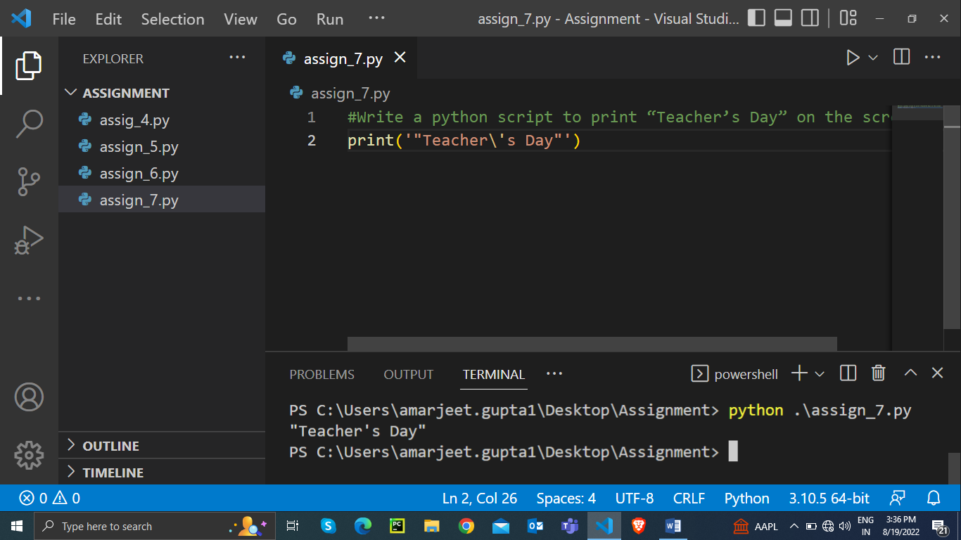

1. **Write a python script to print the value of a variable. Variable contains your name as data.**

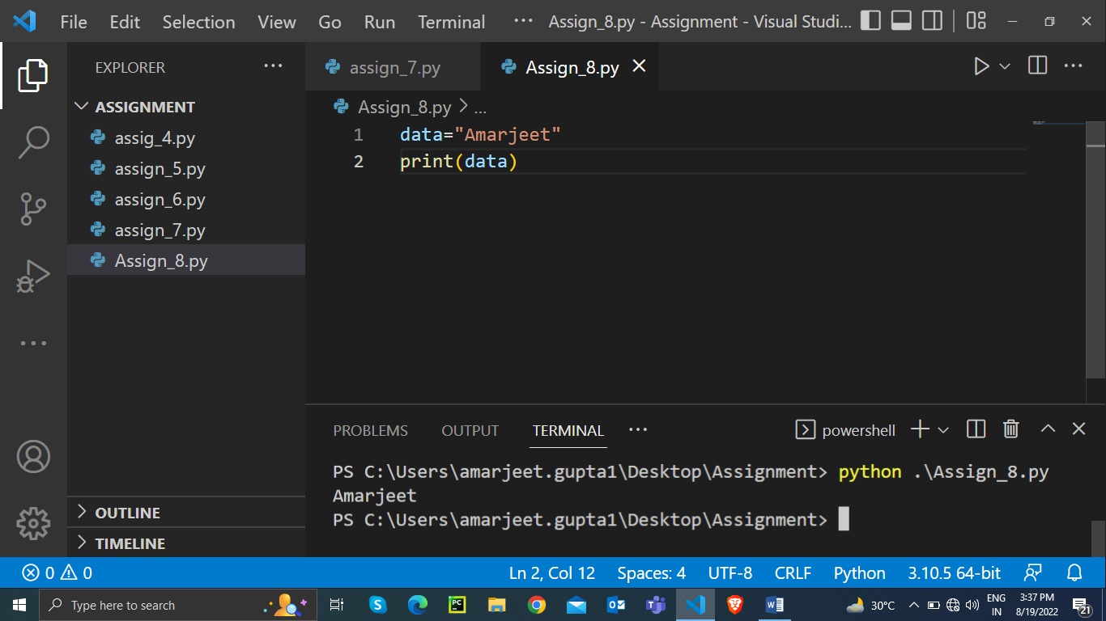

1. **Write a python script to create variables to store your name, age, qualification, years of experience and print it.**

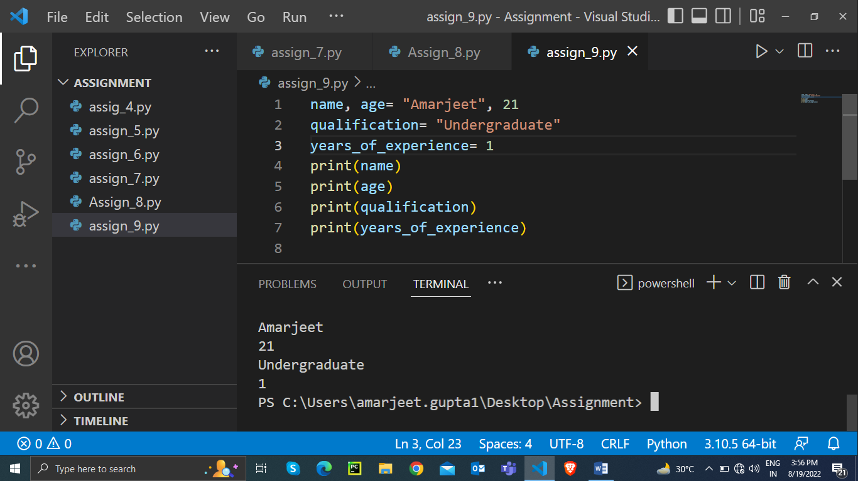

1. **Write a python script to print values of three variables, each in new line. Variable contains integer values.**

