SF Module Flow Review for PMS
From spares quotation to order dispatch and goods acknowledgement

Purpose
This document captures the proposed SF process for the PMS spares module so the PMS team can review and approve the business flow before development starts. The requested flow replaces the earlier built spares execution flow for this module after review approval.

Scope Of This Flow
- Starts from quotation finalization in the spares module.
- Covers quotation type, customer PO upload, SF creation, MRP, shortage, design BOM, purchase, store receipt, assembly where applicable, dispatch, and customer acknowledgement.
- Applies to domestic and international dispatch, with document requirements captured country wise.
- Keeps Custom Engg cases separate where Changeover or Speed Upgradation is selected.

Mandatory Selection Fields
Field | Allowed Values | Usage
Quotation Type | Consumable, Critical, Cons + Critical, Custom Engg. | Required at quotation stage.
Dispatch Mode | Self Pickup, Courier | Required at quotation stage.
Custom Engg Type | Changeover, Speed Upgradation | Required only when quotation type is Custom Engg.

Process Flow Diagram
The diagram below shows the proposed operational sequence and where conditional Custom Engg handling enters the flow.
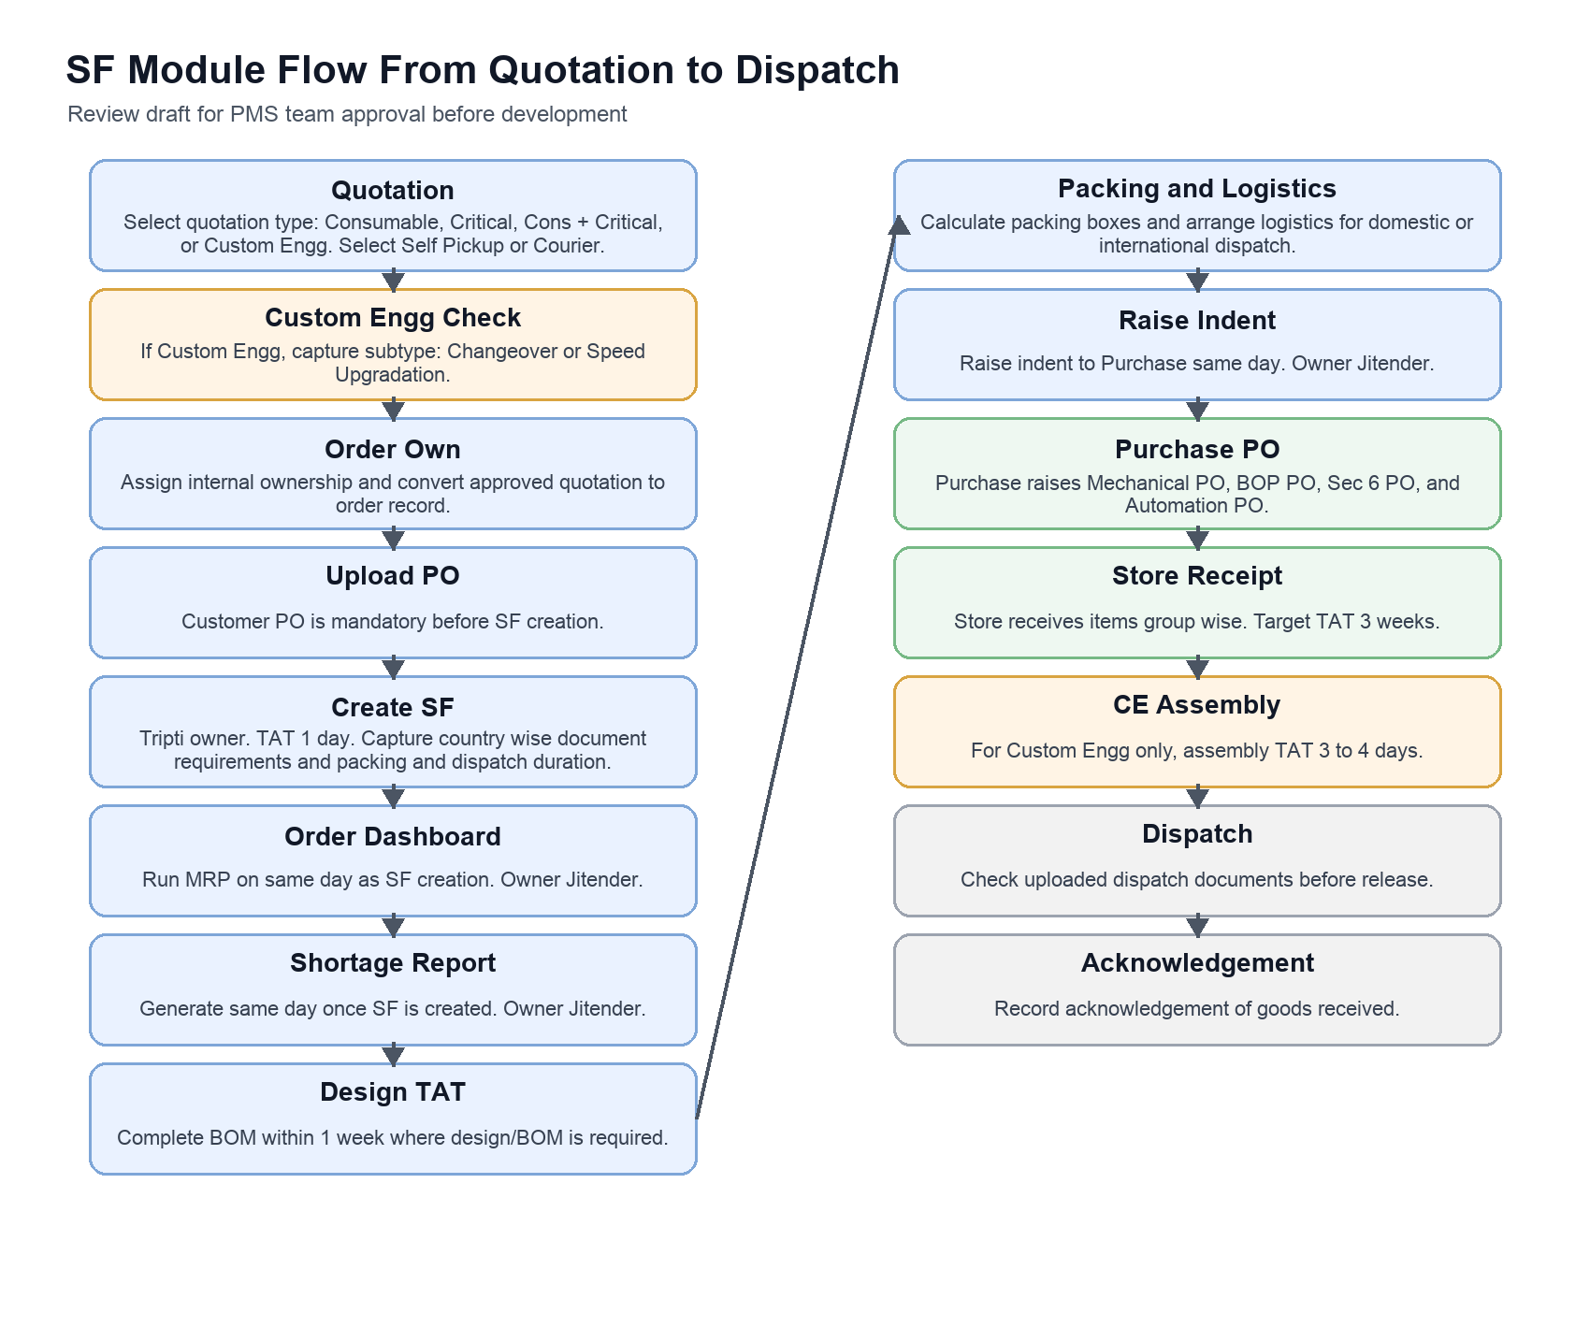

Stage Matrix For Review
This matrix converts the flow into PMS implementation checkpoints for review.
No | Stage | Action | Owner | TAT | PMS Requirement
1 | Quotation setup | Select quotation type, dispatch mode, and Custom Engg subtype if applicable. | Sales or spares user | Before order conversion | Add mandatory fields and validation.
2 | Order ownership | Assign internal order owner and confirm customer PO. | Order owner | Before SF creation | Create order ownership field and PO upload gate.
3 | Create SF | Create SF with document requirements country wise and packing and dispatch duration. | Tripti | 1 day | SF form must capture domestic or international handling.
4 | Run MRP | Run MRP from order dashboard after SF is created. | Jitender | Same day | Add dashboard action and date stamp.
5 | Shortage report | Generate shortage report once SF is created. | Jitender | Same day | Link shortage report to SF and MRP result.
6 | Design and BOM | Complete design requirement and BOM, mainly for Custom Engg where needed. | Design team | 1 week | Track BOM completion and design TAT.
7 | Packing and logistics | Calculate packing boxes and arrange logistics. | Planning or logistics | Before dispatch readiness | Capture box count and logistics status.
8 | Raise indent | Raise indent to Purchase. | Jitender | Same day | Indent should be generated from approved requirement.
9 | Purchase PO | Raise Mechanical PO, BOP PO, Sec 6 PO, and Automation PO. | Purchase department | As per purchase process | Track each PO group separately.
10 | Store receipt | Receive items group wise. | Store | 3 weeks | Store receipt must update group wise readiness.
11 | Assembly for CE | Complete assembly for Custom Engg cases. | Assembly team | 3 to 4 days | Conditional stage when Custom Engg is selected.
12 | Dispatch | Verify uploaded dispatch documents before dispatch. | Dispatch team | Before release | Document checklist must be mandatory.
13 | Acknowledgement | Capture acknowledgement that goods were received. | Customer or PMS user | After delivery | Add goods received acknowledgement upload or confirmation.

Review Points Before Development
- Confirm meaning and responsible person for Order Own.
- Confirm country wise document checklist fields for domestic and international dispatch.
- Confirm whether MRP and shortage report are system generated, manually uploaded, or both.
- Confirm if design TAT applies to all quotation types or only Custom Engg cases.
- Confirm purchase PO groups and whether Sec 6 should be shown as a separate vendor or internal department.
- Confirm acknowledgement format: checkbox, uploaded proof, received date, receiver name, or all of these.

