Req-Number: motherfucker

Company:

Country:

Account name:

Impacted user's ID(s):

Environment, Application, Sub Product, Dataset:

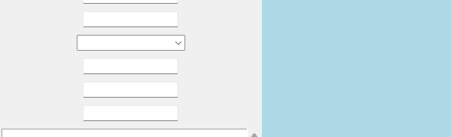

C:/Users/Utilizador/Pictures/Screenshots/Screenshot 2023-05-16 104034.png



Motherfucker

Is the issue replicable?:

Time and timezone of error: