Req-Number: motherfucker2

Company:

Country:

Account name:

Impacted user's ID(s):

Environment, Application, Sub Product, Dataset:

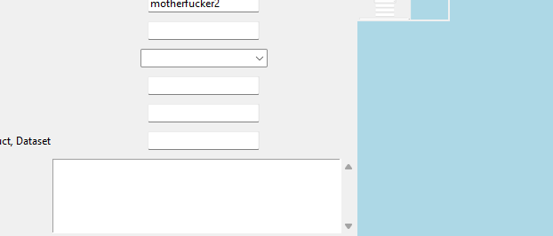

C:/Users/Utilizador/Pictures/Screenshots/Screenshot 2023-05-16 095359.png

Is the issue replicable?:

C:/Users/Utilizador/Pictures/Screenshots/Screenshot 2023-05-16 095359.png

Time and timezone of error: