**Typography**

**Headings**

All html headings, <h1> through to <h6> are available

*Examples*

h1.  h1:hover 

h2. 

h3. 

h4. 

h5. 

h6. 

* font-family: sacramento,cursive; is used across all heads

h1. - font-size: 45px; color: white; text-shadow: white, red, yellow, lightblue, blue, purpe;

* Heading 1 is used as the main title at the top of each page.

h2. font-size: 45px; font-family: sacramento,cursive; color: white;

* Heading 2 is used as the ending title at the bottom of each page

h3. font-size: 41px; color: black;

* Heading 3 is used as the opening title to an article or webpage

h4. font-size: 28px; color: #F00;

* Heading 4 is used for the heading of the quick links navigation on the side of web pages

h5. font-size: 21px; text-decoration: underline; color: black;

* h5 is used for the heading of recent articles preview, displayed on the home page

h6. Font-size: 14px; color: white;

* h6 is used for login and registration links at the top of the page.

**Navigation**

For the home bar navigation links the font-family used is cursive, color white, color greenyellow on hover, font-size 20px and displayed horizontally.



While the links for the “quick links” side by navigation are displayed vertically, color red and also font-size 20px, font-family cursive and greenyellow on hover.

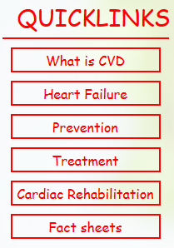

**Body**

Default font used across the body has size 14px, font-family: curisive and color: black.

**Colors and background**

A plain red semi-clear background is used for top section of the page, containing the title and home bar navigation.

background-color: rgba(242, 0, 0, 0.87);



For the background of the whole html page we used a high definition picture of gourmet wrap.



We used a semi-clear white color for the background of the main-middle section which holds the content and information.

background-color: rgba(255, 255, 255, 0.84);



**Colors and background**

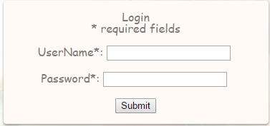

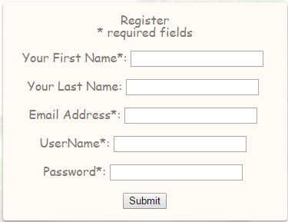

For the Log in and registration form, We use the same style for both of them.

First we use: width: 340px; margin: 60px auto 30px; padding: 15px and position: relative to get two forms with same size and position (like the picture above).

Then, we use background: #fffaf6 for the background color of the form. color: #7e7975 is for words in the form. border-radius: 4px for the corner of the form, and box-shadow for the shadow around the boarder.