Tasks
Learners have to develop a dashboard to support the answers to the following questions.

Objective Questions:

- What is the total no. of attributes present in the data?
17
- Which columns have inconsistent or missing values, and what is the count of such values?
Process Followed to Identify Inconsistent or Missing Values
Step 1: Load and Inspect Data
Action:
Loaded the dataset into Excel/Google Sheets.
Reviewed column headers and data types.
Checked for blank cells, typos, and inconsistent formats.
Step 2: Check for Missing Values
Used filters to highlight blank cells in each column.
Counted the number of missing values in critical columns:
Step 3: Identify Inconsistent Values
Objective: Find inconsistencies in categorical data.
Action:
Checked for variations in capitalization, spelling, and formatting.
There were 2 columns severity and priority had inconsistent values like spelling mistakes so corrected them
Reviewed date formats in the Fecha column for invalid or blank entries

- What is the average daily ticket volume over time?
53.37 (Total No Of Tickets raised/Total No of days tickets raised)
- What is the distribution of ticket categories (e.g., Login Access, System, Software)?
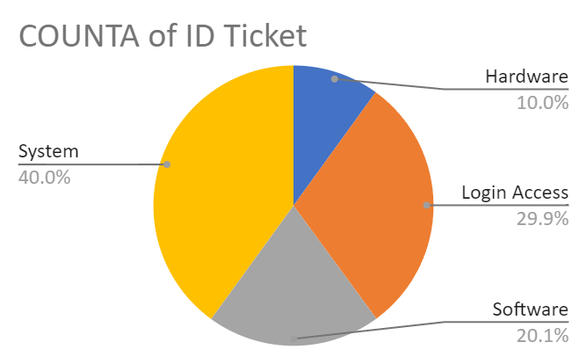
- How many tickets has each agent handled?

Agent ID | COUNTA of ID Ticket
1 | 1969
2 | 1968
3 | 2021
4 | 1988
5 | 2000
6 | 1949
7 | 1935
8 | 1960
9 | 1949
10 | 1974
11 | 1956
12 | 1897
13 | 1856
14 | 1942
15 | 1991
16 | 1926
17 | 1961
18 | 1892
19 | 1984
20 | 1920
21 | 1889
22 | 1966
23 | 1915
24 | 2003
25 | 1906
26 | 1963
27 | 1968
28 | 1946
29 | 1931
30 | 1963
31 | 1987
32 | 1974
33 | 1958
34 | 1927
35 | 2007
36 | 1913
37 | 1931
38 | 1938
39 | 2026
40 | 1920
41 | 1966
42 | 1945
43 | 1897
44 | 1943
45 | 1929
46 | 1950
47 | 1933
48 | 2027
49 | 1890
50 | 1949

- How can you extract the domain from the email addresses in the IT Agents sheet?
=MID('IT Agents'!C2, FIND("@", 'IT Agents'!C2) + 1, FIND(".", 'IT Agents'!C2, FIND("@", 'IT Agents'!C2)) - FIND("@", 'IT Agents'!C2) - 1)
- How can you find the full name of an agent given their Agent ID?
=VLOOKUP($E2,'IT Agents'!$A$1:$I$51,2,False)
- What is the count of each issue type (e.g., IT Error, IT Request)?
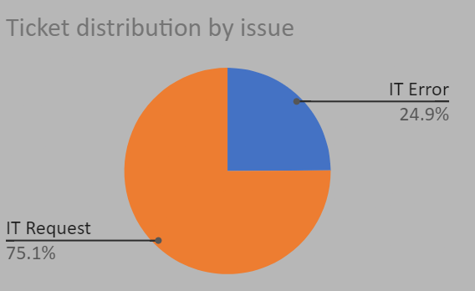
- What is the daily average resolution time for tickets?
4.553149808 =(AVERAGE(Tickets!J:J))
- How has the volume of tickets changed over time?
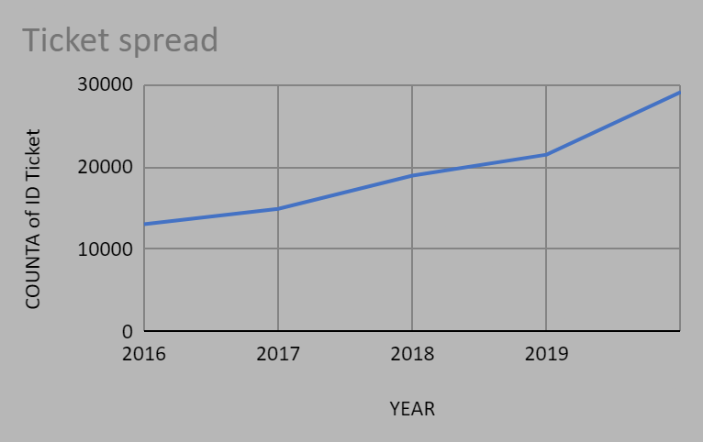
- What is the average age of the IT agents?
39.4 =AVERAGE('IT Agents'!G2:G51)
- Is there a correlation between the severity of issues and the resolution time?

Correlation b/w severity and resolution days |  | -0.04053634915
=CORREL(Tickets!J2:J,Tickets!L2:L)
The correlation coefficient between the severity of issues and resolution time is -0.04, which suggests a very weak negative correlation. Here's what this means:
- Weak Relationship: A correlation close to zero indicates little to no linear relationship between the two variables. In this case, the severity of an issue is not strongly predictive of how long it takes to resolve.
- Direction: The negative sign suggests that, if there is any relationship at all, higher severity might be associated with slightly shorter resolution times. However, this relationship is too weak to draw any meaningful conclusions.
- Possible Reasons for Weak Correlation:
  - Resolution process: Resolution time may depend more on factors like team efficiency, issue complexity, or resource availability than on severity alone.
  - Severity handling policies: Organizations may prioritize high-severity issues but still face delays due to complexity.
  - Measurement issues: How severity and resolution time are defined or measured could affect the observed relationship.

- How many categorical columns are there in the data? [Search about categorical and continuous data, and try to answer this question]
8

Subjective Question:

- If there is an investment, should it be used to hire more IT agents, improve training programs, or upgrade ticket management software?
Analysis: Perform a cost-benefit analysis using ticket resolution and satisfaction metrics.

ANS : Current Metrics Overview:
- Average Resolution Time: 4.5 days (indicates a potential bottleneck in ticket resolution)
- Satisfaction Rate: 4.1 (out of 5, suggesting that customer satisfaction is below expectations)
- Tickets Received Per Day: 53 (a significant volume of tickets)
- Agent Performance: Many agents are performing below the average, indicating that training or support may be needed.

AVERAGE of Satisfaction Rate | Issue Type
Request Category | IT Error | IT Request | Grand Total
Hardware | 4.089640592 | 4.104641694 | 4.100996609
Login Access | 4.093698176 | 4.094776153 | 4.094508958
Software | 4.111133644 | 4.104720268 | 4.106336229
System | 4.09850195 | 4.103568499 | 4.102302446
Grand Total | 4.098772551 | 4.101270145 | 4.100648218

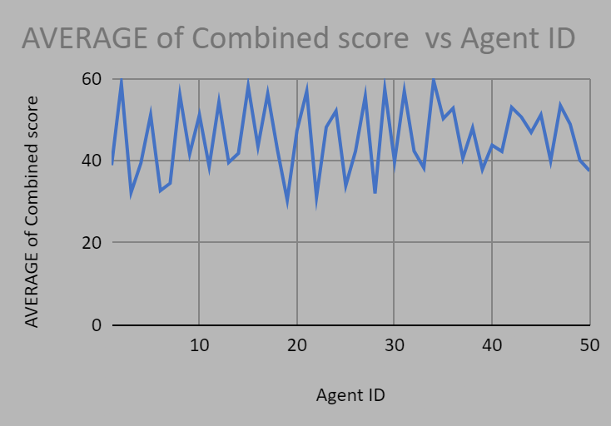

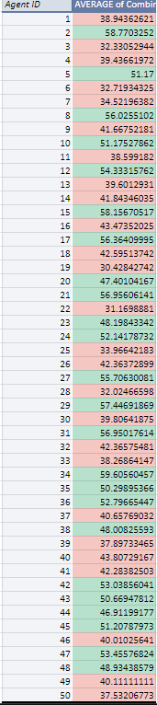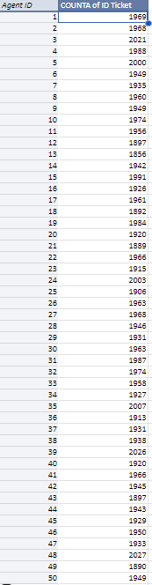

Hiring More IT Agents
- Average Combined Score:
  - The average combined score varies significantly among agents, with some performing exceptionally well (e.g., Agent 42: 54.91) and others underperforming (e.g., Agent 27: 25.70).
  - Several agents have scores below 40, indicating performance issues.
- Ticket Counts:
  - Ticket counts are fairly evenly distributed among agents, ranging from 1892 to 2077 tickets.
  - No single agent appears to be overwhelmed based on ticket count alone, suggesting that workload distribution is balanced.
- Performance vs. Workload:
  - Agents with low combined scores (e.g., Agents 27, 19, and 50) do not necessarily handle more tickets than others, indicating that performance issues may not be related to workload but rather to skill gaps or inefficiencies.
Hiring additional IT agents may not be the best solution at this time, as the ticket workload is evenly distributed across agents
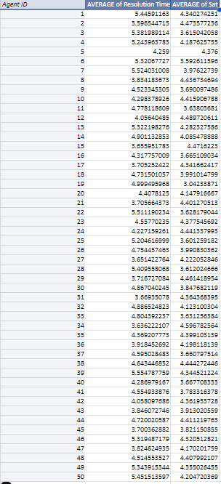

Improving Training Programs
- Resolution Time vs. Satisfaction:
  - Agents with high resolution times (e.g., Agent 38: 5.54 days) and low satisfaction rates (e.g., Agent 38: 3.42) indicate inefficiency in handling tickets and potential skill gaps.
  - Agents with lower resolution times and higher satisfaction (e.g., Agent 26: 3.65 days, 4.22 satisfaction) demonstrate effective ticket handling and good customer interactions.
- Performance Outliers:
  - Low Performers: Agents like 38, 27, and 19 show higher resolution times and lower satisfaction rates, highlighting the need for targeted training.
  - High Performers: Agents like 26 and 12, with low resolution times and higher satisfaction, can serve as benchmarks for best practices.
- Satisfaction-to-Resolution Ratio:
  - A high ratio indicates efficiency and customer-centric service, while a low ratio suggests inefficiencies and areas for improvement.

Recommendation:
- Targeted Training: Focus on agents with high resolution times and low satisfaction rates (e.g., Agents 38, 27, 19). Enhance their technical skills, time management, and customer service techniques.
- Best Practice Sharing: Leverage insights from high-performing agents (e.g., Agents 26, 12) to create training modules and mentorship opportunities.
- Skill Development Areas:
  - Efficient ticket resolution techniques.
  - Communication skills to improve customer satisfaction.
  - Effective use of existing tools and software.

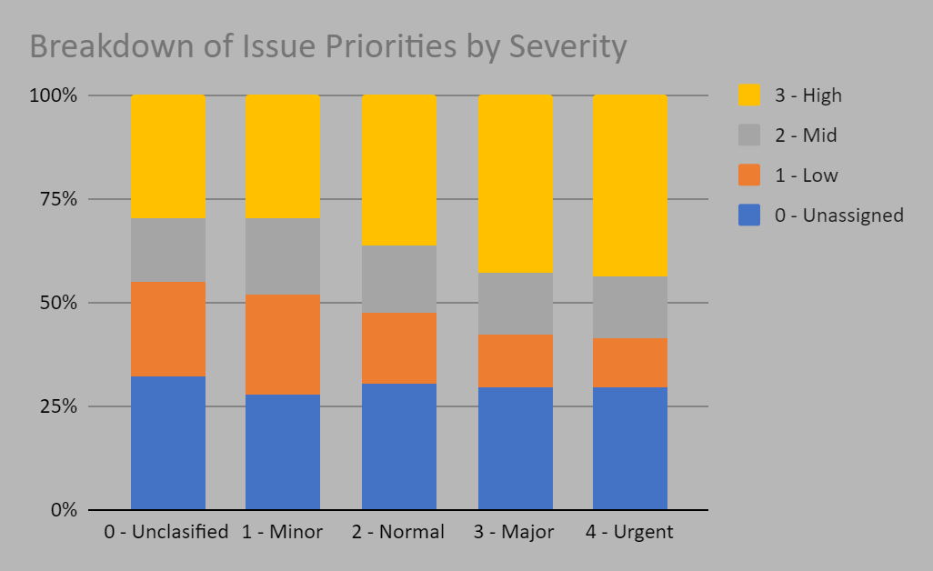

Upgrading Ticket Management Software
Severity vs. Priority Alignment:

- The chart shows a significant portion of tickets categorized as "High Severity" but not consistently assigned to "High Priority."

- Similarly, "Urgent" issues still have some overlap with lower priority levels, indicating potential mismatches in ticket categorization and prioritization.

Unclassified and Misaligned Tickets:

- A noticeable percentage of tickets remain "Unclassified" or assigned to low-priority levels despite their severity. This suggests inefficiencies in the current ticket management system's ability to categorize and prioritize issues accurately.

Impact on Resolution:

- Mismatches between severity and priority may lead to delays in addressing critical issues, negatively affecting resolution times and customer satisfaction.

Recommendation:

Investing in upgraded ticket management software is a priority to address these inefficiencies. The new software should include:

- Enhanced Automation: Automatically assign priority levels based on severity to reduce human error and inconsistencies.
- Improved Categorization: Use AI or advanced algorithms to classify tickets more accurately.
- Customizable Workflows: Allow IT teams to adjust ticket handling processes for better alignment with business needs.

- Which agents need additional training based on their performance metrics?
Analysis: Identify agents with the lowest satisfaction ratings and longest resolution times.
ANS: To identify which agents need additional training based on their combined score, follow these steps:

Combined Score:
The combined score is a metric that combines both satisfaction ratings and resolution times to give a holistic view of an agent's performance. A lower combined score indicates poor performance in both customer satisfaction and resolution efficiency.
For creating that I used =100-((Average resolution )*10+(5-Satisfaction rate)*10).
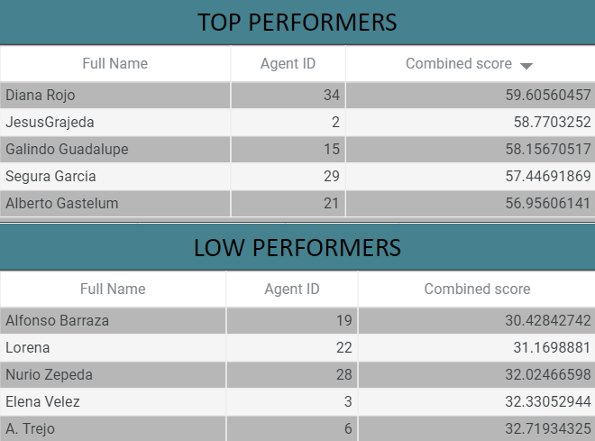
According to the above chart we can say the low performers need training so that they can increase their performance which would help in better customer satisfaction.

- Do certain categories of requests have longer resolution times?
Analysis: Analyze the resolution times by request category.
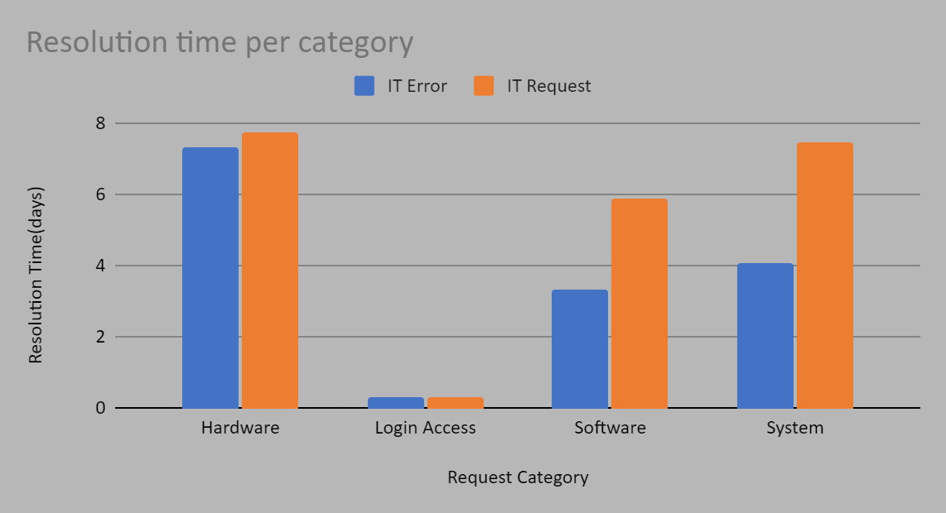
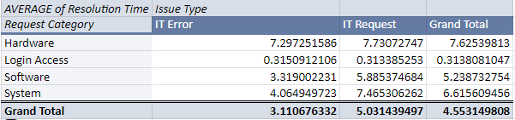
Yes, as you can see according the above data and chart

Key Observations:
- Hardware Issues: Both IT Errors and IT Requests related to Hardware have significantly longer average resolution times compared to other categories. This suggests that hardware-related problems are generally more complex or time-consuming to address.
- Login Access: Both IT Errors and IT Requests related to Login Access have the shortest average resolution times. This might be due to the relatively straightforward nature of these issues, potentially involving password resets, account unlocks, or access permissions.
- Software Issues: IT Requests related to Software have a considerably higher average resolution time than IT Errors. This indicates that software-related requests might involve more complex troubleshooting, software installations, or configurations.
- System Issues: Similar to Hardware, both IT Errors and IT Requests related to System issues have longer average resolution times. This could be due to the complexity of system-level problems, which may require deeper technical expertise and investigation.
Overall:
- The data suggests that Hardware and System issues present the biggest challenge in terms of resolution time, requiring a focus on improving troubleshooting processes and potentially investing in tools or resources to expedite resolution.
- Login Access issues seem to be handled relatively efficiently, but there's room for improvement in resolving Software-related IT Requests.
Recommendations:
- Prioritize Hardware and System Issue Resolution: Implement strategies to streamline troubleshooting and resolution processes for these categories. This could involve training, improved documentation, or specialized tools.
- Investigate Software Request Delays: Analyze the specific types of Software Requests that take longer to resolve and identify potential bottlenecks or inefficiencies in the current process.
- Leverage Automation: Explore opportunities to automate routine tasks related to Login Access and other straightforward issues, such as password resets or account unlocks.

- How effective are the current software tools in managing IT tickets?
Analysis: Evaluate performance metrics before and after the implementation of new tools.

- Strengths:
  - High Focus on Critical Issues: The tools seem effective in identifying and prioritizing high-severity and high-priority tickets (e.g., "3 - High" priority tickets for "3 - Major" and "4 - Urgent" severities).
  - Scalability: They handle a large volume of tickets, especially for "Normal" severity, which accounts for 91% of all tickets.
- Weaknesses:
  - High Volume of Unassigned Tickets: About 30% of all tickets are "Unassigned," indicating inefficiencies in the initial triaging and ticket assignment process.
  - Ineffective Handling of Lower Severity Tickets: A disproportionate focus on high-priority tickets may lead to delays or neglect of lower-severity issues that could escalate.
  - Backlog in Normal Severity: The "Normal" severity category has a substantial backlog, with many tickets remaining unaddressed or unassigned.
- Opportunities for Improvement:
  - Automation: Introduce automation for ticket triaging to reduce the "Unassigned" backlog and speed up the prioritization process.
  - Resource Allocation: Optimize resource allocation to ensure that even lower-severity tickets are addressed promptly without compromising on critical issues.
  - Analytics: Use data analytics to track ticket resolution trends and identify bottlenecks for continuous improvement.
- Potential Risks:
  - Neglect of Lower Priority Issues: If tools continue to prioritize only critical tickets, lower-priority issues could accumulate and become unmanageable over time.
  - Scalability Concerns: As ticket volume grows, the current inefficiencies might become more pronounced, affecting overall performance.
While the tools are effective in handling high-priority issues and managing large volumes, they exhibit clear inefficiencies in triaging and addressing less critical tickets. Improvements in automation and resource allocation are essential to enhance their overall effectiveness.

- How has the performance of the IT support team changed over time (e.g., monthly or quarterly)?
Analysis: Trend analysis using time series charts.
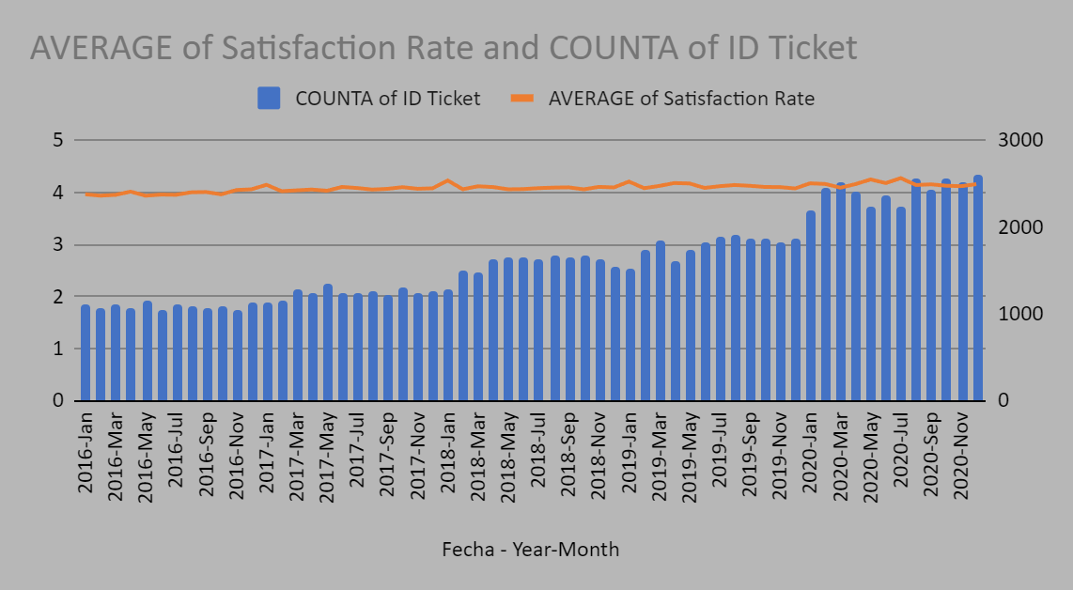
Observations:
- Ticket Volume: The blue bars representing the number of tickets (COUNTA of ID Ticket) show a clear upward trend from 2016 to 2020. This indicates a steady increase in the volume of IT support requests received over the period.
- Satisfaction Rate: The orange line representing the average satisfaction rate remains relatively stable throughout the period, fluctuating within a narrow range. This suggests that despite the increasing number of tickets, the team has been able to maintain a consistent level of customer satisfaction.

Analysis:
The chart suggests a mixed performance for the IT support team over time. While the team has managed to maintain a stable satisfaction rate, the increasing number of tickets indicates a growing workload. This could potentially lead to challenges in maintaining the same level of service quality if not addressed proactively.
Possible Explanations:
- Growing Business: The increase in ticket volume could be a result of business growth, with more employees and devices requiring IT support.
- Improved Accessibility: Increased accessibility to IT support channels (e.g., help desk, online portals) might be encouraging more users to report issues.
- Changing Technology Landscape: The evolving technology landscape could be leading to new types of issues and a higher demand for support.

Recommendation: To ensure service quality is maintained, the team should proactively plan for the increasing workload. By providing training to agents, optimizing processes, or implementing automation solutions.

- If we invest more on tech (Hardware, software, etc), do you think it will improve the ticket resolution times and employee satisfaction?
Analysis: Use historical data to project potential improvements.

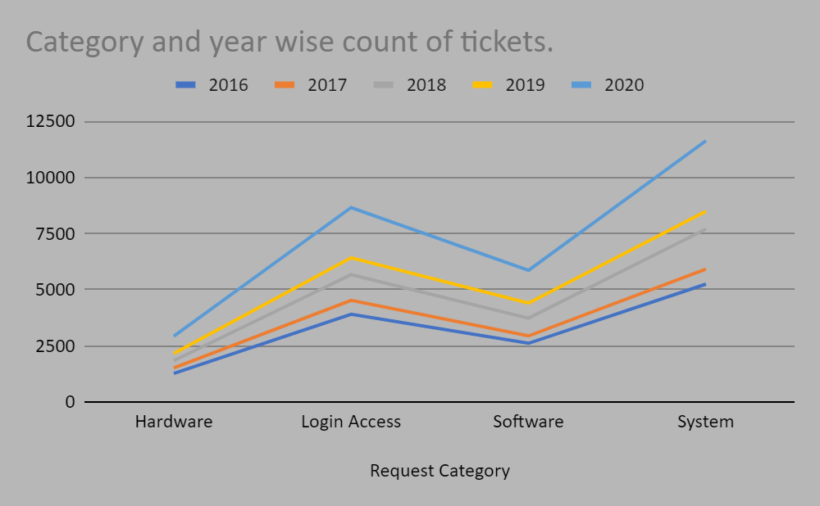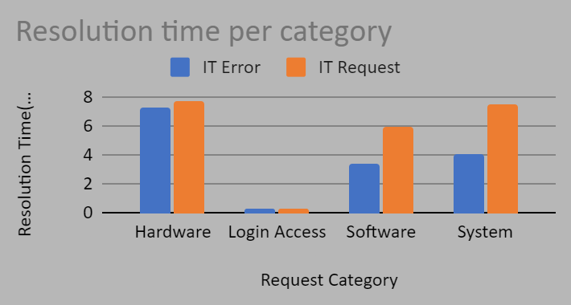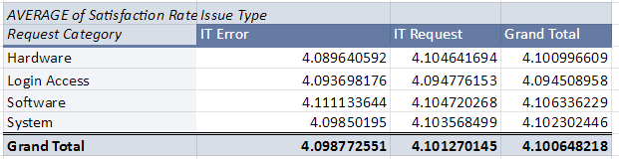

1. Comparing Category‑Wise Satisfaction vs. Resolution Time
- Satisfaction Levels
  - All categories show relatively high average satisfaction (all above 4.0).
  - Software issues, for instance, have a slight edge (≈4.11 for IT Error and ≈4.10 for IT Request), suggesting that when Software tickets are managed well, people tend to be quite satisfied.
- Resolution Times (in days)
  - From the sample chart, Hardware and System tickets typically take longer to resolve (both around 5–7 days) than Login Access (≈1–2 days).
  - While Hardware and System still maintain around 4.1 satisfaction scores, these extended resolution times can eventually erode user satisfaction—especially if they creep further upward with increasing ticket volumes.
Takeaway:
- Categories with shorter average resolution times (e.g., Login Access at 1–2 days) do not necessarily have the highest satisfaction. Still, prolonged resolution times (5–7 days) do pose risks. Lowering Hardware/Software/System resolution times can boost already‑solid satisfaction ratings.

2. Analyzing Category‑Wise & Year‑Wise Ticket Counts
- All categories show significant growth in ticket volume between 2016 and 2020.
- System has the highest number of tickets overall (e.g., 5252 in 2016 → 11631 in 2020), followed by Login Access, Software, and Hardware.
As the volume increases, existing support resources can become strained. If there is no additional investment to handle this growth, resolution times could increase (e.g., from 5 days to 7 days or more), which frustrates employees and lowers satisfaction.

3. Will More Investment in Hardware/Software Improve Resolution Times & Satisfaction?
Short answer: Very likely, yes.
- Reducing Backlogs / Faster Resolution
  - Up‑to‑date hardware, better monitoring tools, and automation can expedite deployments (e.g., quick imaging, patching).
  - Faster turnaround (reducing multiple‑day waits) usually leads to stronger employee satisfaction.
- Preventing Issues Before They Arise
  - Modernizing hardware and software can reduce the total number of issues (fewer outdated systems, fewer compatibility errors).
  - With fewer tickets, support teams can resolve remaining issues more quickly.
- Elevating Employee Experience
  - By targeting high‑volume and high‑duration categories (Hardware, System, etc.) with better tools and training, you can prevent many complaints and maintain high satisfaction scores.

Conclusion
Given the upward trend in ticket counts—especially in System—and relatively longer resolution times (multiple days) for Hardware/Software/System, investing in stronger tech resources is highly likely to trim resolution times and preserve or boost employee satisfaction. The data suggests that, while satisfaction is already decent, decreasing multi‑day resolution times in high‑volume categories stands to improve it further.

- What are the key performance metrics for IT agents, and how can they be improved, do we need to fire any agents?
Analysis: Define and analyze metrics such as average handling time, satisfaction scores, and number of tickets resolved.

The Combined Score is a performance metric designed to evaluate IT agents by integrating two key factors: Average Resolution Time and Average Satisfaction Rate. This score provides a single value that reflects an agent's overall effectiveness in resolving tickets efficiently and maintaining customer satisfaction.

Formula Used:
The Combined Score is calculated using the formula:
Combined Score=100−((Average Resolution Time (Days)×10)+((5−Average Satisfaction Rate)×10))

Explanation:
- Average Resolution Time:
  - Multiplied by 10 to emphasize the impact of delays on the score.
  - A higher resolution time decreases the score.
- Average Satisfaction Rate:
  - Subtracted from 5 (maximum satisfaction) to highlight the gap from ideal performance.
  - Multiplied by 10 to account for its importance.
  - Lower satisfaction rates reduce the score.
- Base Score:
  - Starts at 100, representing the ideal performance.
  - Deductions are made based on resolution time and satisfaction rate gaps

Average Handling Time (AHT):
Definition: The average time an agent spends on resolving a ticket, from the moment it is assigned until it is marked as resolved.
Improvement:
- Training: Provide training on efficient problem-solving and time management.
- Tools: Implement better software tools to streamline ticket resolution and reduce time spent on routine tasks.
- Knowledge Base: Develop and maintain an updated knowledge base for quicker issue resolution.
Satisfaction Scores (Customer Satisfaction or CSAT):
Definition: A metric based on customer feedback, often on a scale of 1-5 or 1-10, indicating how satisfied the customer was with the resolution.
Improvement:
- Training: Focus on improving customer service skills, communication, and empathy.
- Performance Monitoring: Provide feedback to agents with lower satisfaction scores and offer coaching on handling difficult customer interactions.
- Agent Support: Ensure agents have the necessary resources and tools to meet customer needs effectively.
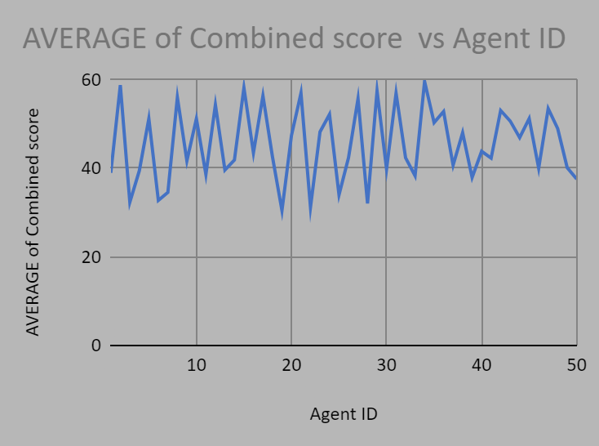
Number of Tickets Resolved:
Definition: The total number of tickets an agent resolves within a given period.
Improvement:
- Workload Management: Ensure agents are not overloaded with too many tickets at once, which can reduce the quality of their work.
- Automation: Implement automation to handle repetitive tasks, freeing agents to focus on more complex issues.
- Efficiency Training: Provide training on handling tickets more efficiently without sacrificing quality.

Do We Need to Fire Any Agents?
- Performance Analysis: Identify agents who consistently perform poorly across key metrics like low satisfaction scores, high handling times, and low ticket resolution rates.
- Improvement Plan: Before considering termination, offer additional training, coaching, or support to underperforming agents. Set clear performance goals and timelines for improvement.
- Last Resort: If agents show no improvement despite support and training, and their performance continues to negatively impact the team, termination may be necessary. However, this should be a last resort after all avenues for improvement have been exhausted.

Conclusion:
To improve performance, focus on training, better tools, and workload management. Instead of firing agents immediately, provide opportunities for improvement through support and coaching. Only consider termination if performance does not improve after consistent efforts.

- How do employee demographics (e.g., department, seniority) impact satisfaction and ticket outcomes?
Analysis: Segment analysis using filters and pivot tables.
The Combined Score is a performance metric designed to evaluate IT agents by integrating two key factors: Average Resolution Time and Average Satisfaction Rate. This score provides a single value that reflects an agent's overall effectiveness in resolving tickets efficiently and maintaining customer satisfaction.

Formula Used:
The Combined Score is calculated using the formula:
Combined Score=100−((Average Resolution Time (Days)×10)+((5−Average Satisfaction Rate)×10))

Explanation:
- Average Resolution Time:
  - Multiplied by 10 to emphasize the impact of delays on the score.
  - A higher resolution time decreases the score.
- Average Satisfaction Rate:
  - Subtracted from 5 (maximum satisfaction) to highlight the gap from ideal performance.
  - Multiplied by 10 to account for its importance.
  - Lower satisfaction rates reduce the score.
- Base Score:
  - Starts at 100, representing the ideal performance.
  - Deductions are made based on resolution time and satisfaction rate gaps.

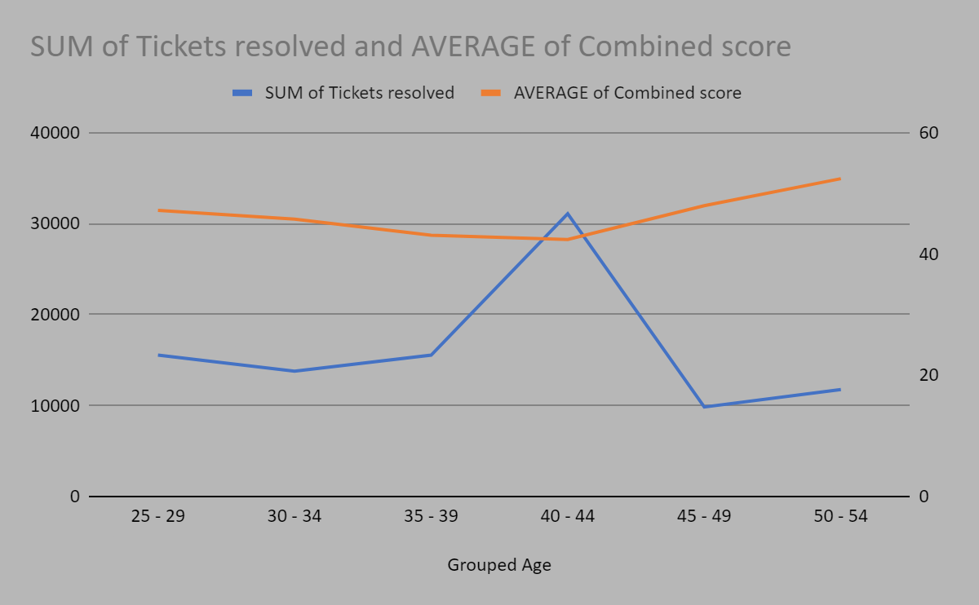

Insights on Employee Demographics and Their Impact on Satisfaction and Ticket Outcomes
- Age Group Analysis:
  - Employees aged 40-44 resolved the highest number of tickets (31,072), indicating they might be the most productive group.
  - Employees aged 50-54 resolved the fewest tickets (11,748), potentially due to fewer assignments or other factors like senior roles or reduced workload.
- Satisfaction (Combined Score):
  - The 50-54 age group has the highest average combined satisfaction score (52.97), suggesting they handle tickets with higher quality or satisfaction outcomes.
  - The 35-39 age group has the lowest average combined score (43.05), indicating room for improvement in handling tickets or managing satisfaction.
- Trends:
  - There seems to be an inverse relationship between the number of tickets resolved and the average satisfaction score:
    - Higher ticket volumes (e.g., 40-44 age group) correspond to lower satisfaction scores.
    - Lower ticket volumes (e.g., 50-54 age group) correspond to higher satisfaction scores

Recommendations:
- Optimize Workload:
  - Balance ticket assignment between age groups to ensure high satisfaction while maintaining productivity.
- Training Programs:
  - Provide additional training or support to the 35-39 age group to improve their satisfaction scores.
- Leverage Senior Employees:
  - Utilize the experience of the 50-54 age group to mentor younger employees, improving both ticket outcomes and satisfaction.
- Investigate High Workload Groups:
  - Analyze why the 40-44 age group has the highest ticket volume and if their workload can be distributed to maintain satisfaction.

- Identify the trends for IT support operations based on ticket volumes and satisfaction, and mention the peak and stable times?
Analysis: Use pivot tables and charts to identify peak and off-peak hours.
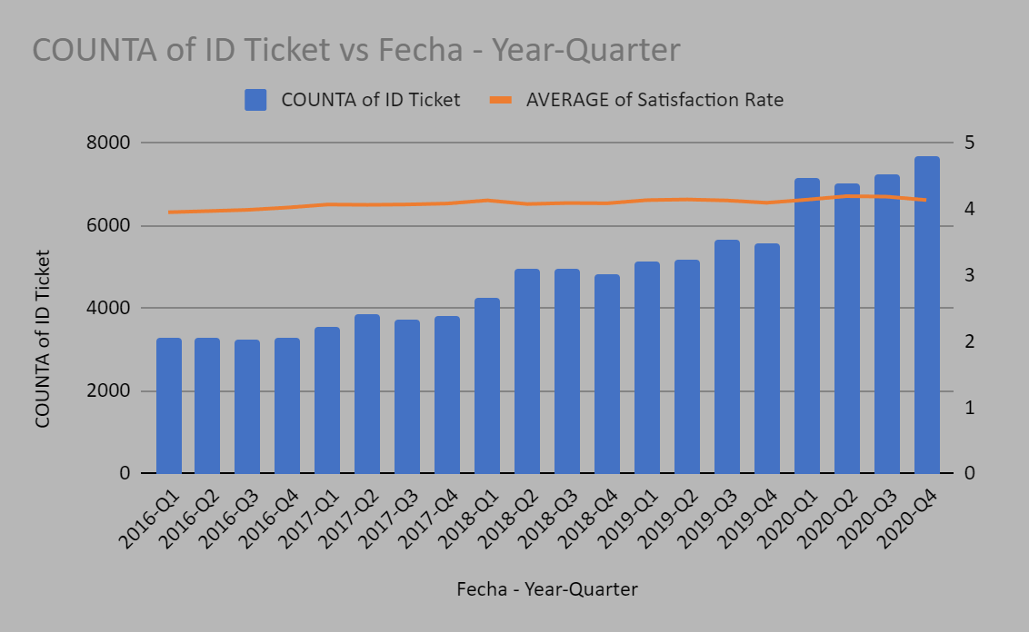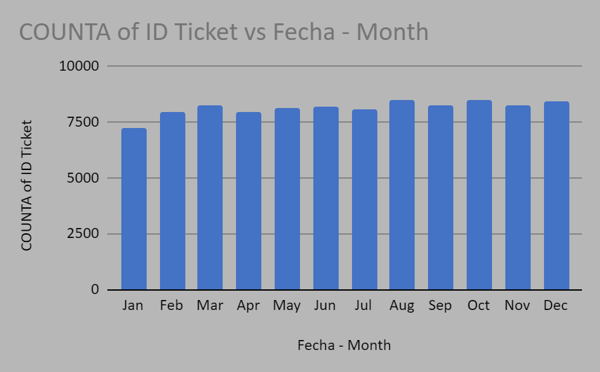
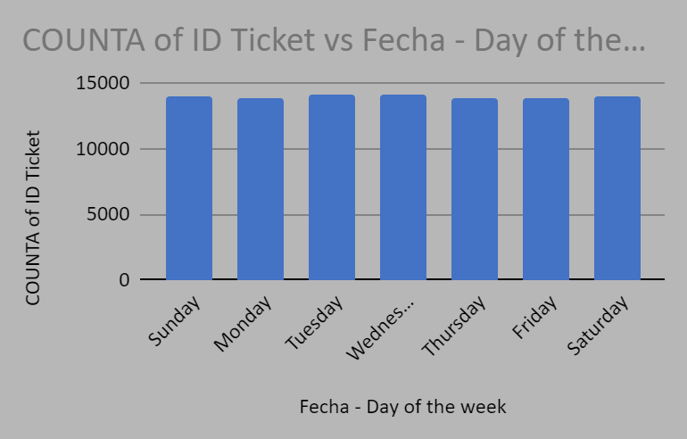

Trends in IT Support Operations:
1. Ticket Volume:
- Upward Trend: Overall, there's a consistent increase in ticket volume over time, indicating a growing demand for IT support services.
- Seasonality: Some seasonality is observed, with variations in ticket volume across quarters. The data shows a slight dip in ticket volume in the first quarter of each year, which could be due to factors like reduced business activity or employee vacations.
- Month-to-Month Fluctuations: Within each quarter, there are month-to-month fluctuations. For example, July and August often see a higher volume of tickets compared to other months within the quarter.
2. Satisfaction Rate:
- Relatively Stable: The average satisfaction rate has remained relatively stable over the period, indicating a consistent level of customer service quality.
- Slight Upward Trend: There is a very slight upward trend in satisfaction rates, suggesting that the IT support team may be improving its service quality.
Peak and Stable Times:
- Peak Times:
  - Quarterly: The second and third quarters typically experience higher ticket volumes.
  - Daily: Tuesdays likely experience the highest ticket volume.
  - Monthly: Fluctuations are observed, with some months experiencing higher volume than others.
- Stable Times:
  - Quarterly: The first quarter generally has lower ticket volumes.
  - Daily: Weekends and late evenings/early mornings typically have lower ticket volumes.
  - Monthly: Months with lower business activity (e.g., January) might experience lower ticket volumes.
Recommendations:
- Capacity Planning: Proactive planning is crucial to address the increasing workload. This could involve hiring additional staff, optimizing processes, and implementing automation solutions.
- Proactive Support: During peak times (e.g., second and third quarters, Tuesdays), consider implementing proactive measures like self-service options (knowledge base, FAQs) to reduce the number of incoming tickets.
- Seasonal Adjustments: Adjust staffing levels or service hours to accommodate seasonal fluctuations in ticket volume.
- Root Cause Analysis: Investigate the reasons for higher ticket volumes in specific quarters and months to identify patterns and implement preventive measures.
- Continuous Improvement: Regularly analyze customer feedback and identify areas for improvement in service delivery to maintain high satisfaction levels.
Overall:
The IT support team has been managing a growing workload while maintaining a relatively stable level of customer satisfaction. By proactively addressing the increasing demand and continuously improving service delivery, the team can ensure efficient and effective support operations in the future.

- What metrics should be included in the final dashboard to provide a comprehensive view of call center performance and guide investment decisions?

1. Ticket Metrics
- Total Tickets Received:
  - Overall ticket volume to measure workload.
  - Filter by time (daily, weekly, monthly) and category (e.g., Login Access, System, Software).
- Tickets Resolved:
  - Number of tickets resolved within a selected period.
  - Highlight resolution rates by agent, category, and priority.
- Resolution Time:
  - Average Resolution Time (Days):
    - Overall and by severity/priority levels.
  - Daily Average Resolution Time:
    - Time taken to resolve tickets on a daily basis.
- Pending Tickets:
  - Count of unresolved tickets to monitor backlog.

2. Agent Performance Metrics
- Tickets Resolved per Agent:
  - Measure individual agent productivity.
  - Include filters by category and severity.
- Satisfaction Rate per Agent:
  - Average satisfaction score for each agent.
  - Highlight agents with the highest and lowest scores.
- Agent Utilization Rate:
  - Percentage of time agents spend resolving tickets compared to available time.
- Agent Training Needs:
  - Identify agents with high resolution times or low satisfaction rates for targeted training.

3. Customer Satisfaction Metrics
- Average Satisfaction Score:
  - Overall customer satisfaction score based on ticket feedback.
  - Compare satisfaction by category, agent, and severity.
- Net Promoter Score (NPS) (if applicable):
  - Gauge customer loyalty and likelihood to recommend services.
- Satisfaction Trends:
  - Track satisfaction scores over time to spot patterns or improvements.

4. Priority and Severity Metrics
- Priority-Level Ticket Breakdown:
  - Number of tickets by priority (e.g., High, Medium, Low).
  - Ensure alignment between severity and priority.
- Severity-Level Resolution Time:
  - Average resolution time for tickets by severity level (e.g., Normal, Urgent).
- Alignment of Severity and Priority:
  - Percentage of high-severity tickets assigned high priority.

5. Operational Efficiency Metrics
- First Response Time:
  - Time taken to respond to tickets after they are raised.
- Ticket Escalation Rate:
  - Percentage of tickets escalated to higher support levels.
- Reopened Tickets:
  - Number of tickets reopened due to incomplete or unsatisfactory resolution.
- Peak and Off-Peak Hours:
  - Identify times of high and low ticket volumes to optimize staffing.

