CM515: Intro to Image Processing & Analysis Assignment
Part 1:
  - Exercise 1: Quantify a Western Blot
- Open “WesternBlot1.tif” from the Image Bank folder and open it in FIJI
- Using the guide in the lecture slides, quantify the bands.
- In your favorite plotting software, create a bar plot showing the volume of each band, and paste it here.
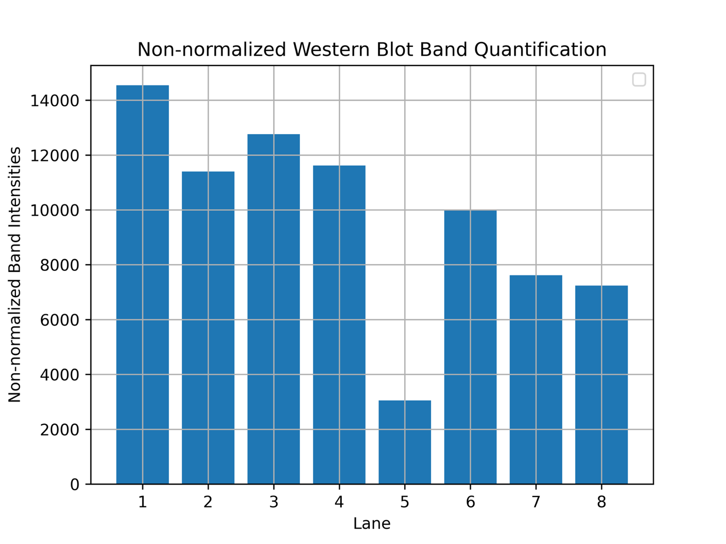
- Next, open “Western1_LoadingControl.tif”
- Quantify the bands
- Divide your quantification of each lane from the first Western Blot by the quantification of the same lane in the Loading control blot. Use this value to create a plot showing the values of the bands normalized to the loading control, and paste it here

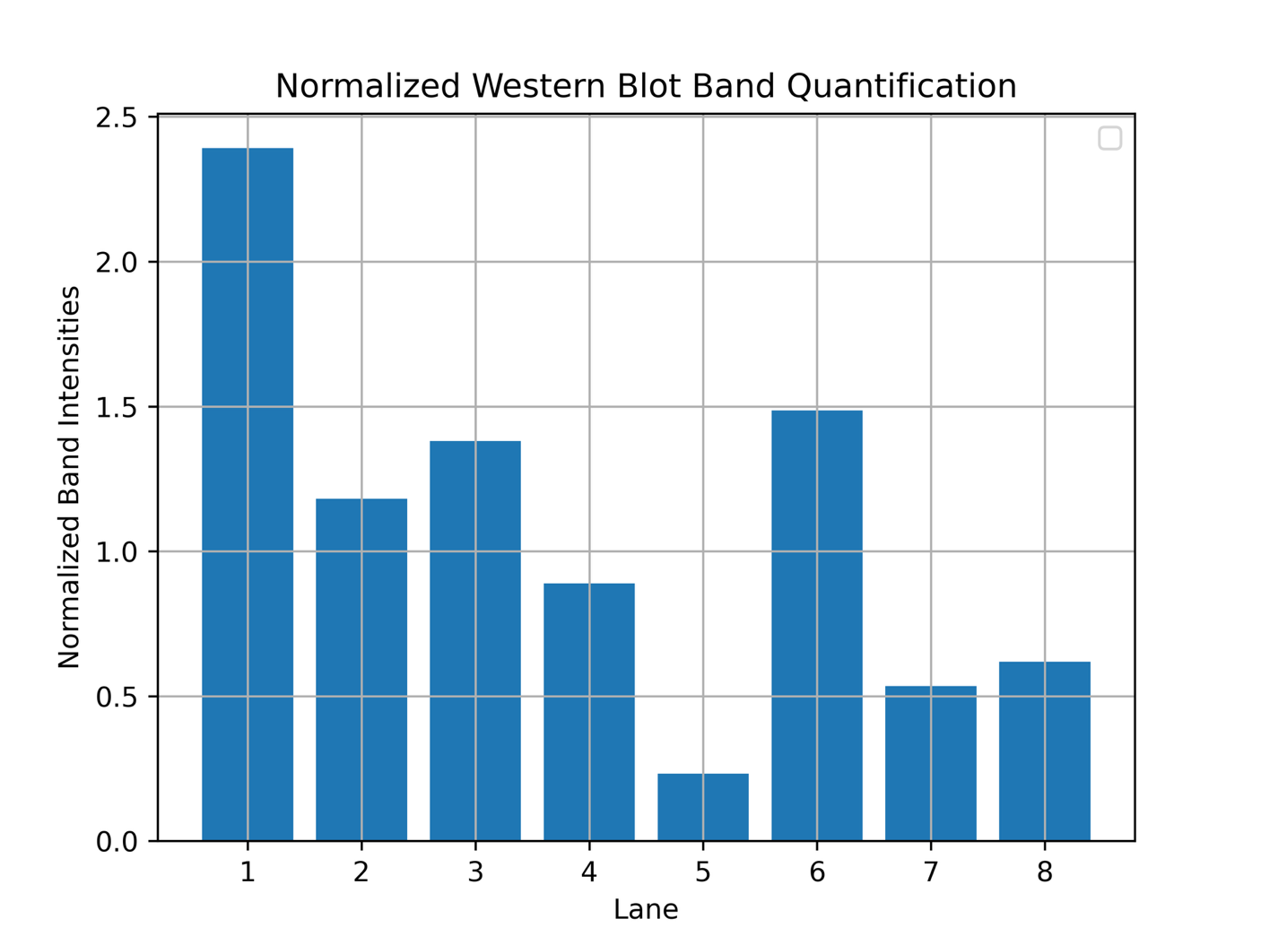
  - Exercise 2: Record a Macro
- Navigate to Plugins > Macros > Record (or use keyboard shortcut Cmd/Ctrl + U)
  - Dialog box will pop up, and record all the actions you do
- Open an image from the provided sample images in FIJI (File > Open Samples), from one of the databases listed on the last slide, or from your own work/ a colleague’s
- Make 2 modifications to the image (whatever you want! Adjust brightness contrast, change image type, add scale bar, etc!), and then close it.
- Copy & paste the record and the final product image here:
run("Sharpen");
setOption("BlackBackground", true);
run("Convert to Mask");
run("Despeckle");
run("Remove Outliers...", "radius=2 threshold=50 which=Dark");

- Bonus (not required but fun!): Make this record into a macro that can be applied to another image!

