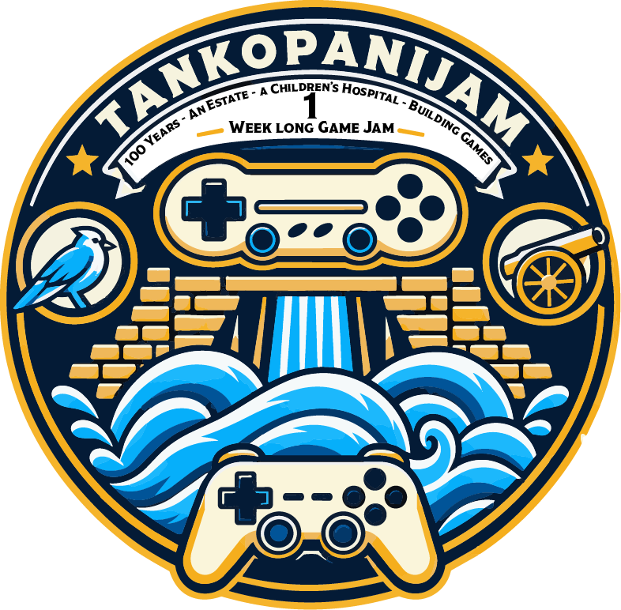
TankopaniJam
Sponsorship prospectus

April 4–9, 2027 · The Nemours Estate and Hospital, Wilmington, Delaware
A hundred years ago Alfred I. duPont filled this place with everything he loved. Then he left it to children going through medical treatment. Now five college teams get seventy-two hours to build something for them, out of it.
A tinkerer, an inventor, a musician filled this house. Fund the next generation of creators.
SAMPLE DOCUMENT — figures shown in brackets are illustrative and not yet set.

The event
One week, five teams, an audience of one.
TankopaniJam is a college game jam run inside the Nemours Estate and Nemours Children’s Hospital. Five teams of two to five students arrive on the Sunday, tour the Estate, and meet the panel of present and former patients who wrote their brief. The prompt is revealed that evening. They have until 5pm on Wednesday.
Every game is built out of the Estate itself — two physical objects from the collection, one educational aspect, one piece of historical context, and a tune from Alfred duPont’s own music library. On Thursday the teams rest while the patients, their families, hospital staff and a panel of judges play every submission and score it. On Friday the patients hand out the awards.
The games do not get archived afterwards. They go into the Estate’s collection and into rotation at the bedside, played by patients long after the week is over.
Why it matters
For the patients | A say in something built for them, a day of play with their families, and a judging role that puts them in charge of the outcome. Distraction, agency and a story that is theirs.
For the students | A real client, a hard deadline, and a portfolio piece that went into service. For many it is the first time their work is played by the person who asked for it.
For the Estate | New content that works as both a Child Life tool and a way to teach the Estate’s own history — and a living extension of the founder’s intent for the place.
For you | Five students backed by name, in a first-of-its-kind event at the historic Nemours Estate, with a story worth telling.

What sponsorship does
Adopt a team.
Each of the five teams is backed by a sponsor — a company, a foundation, or the student’s own school. The sponsor drives fundraising for that team, and the money raised goes to the patients and the students who are actually in the room. Every team is expected to raise a minimum of $200 by the end of the event.
Funds support Child Life gaming at the bedside and the scholarship fund, and cover the cost of running the event for the students — meals, equipment and on-site needs.
What you receive
— Named on the team · Your name carried on that team’s materials through the week and on the event livestream.
— Meet the team · A meet-the-team session and photograph with the five students you are backing.
— In the credits · Recognition in the credits of a game that stays in service at the bedside long after the week.
— Coverage · Inclusion in event communications and press around a first-of-its-kind event at the Estate.
— In-kind welcome · Hardware, engine and software licences, or mentors — in place of or alongside a cash contribution.
Sample levels
Structure shown for discussion. Amounts are placeholders and have not been set.
Level | Contribution | Includes
Team Sponsor | [$10,000] | Sole backing of one of the five teams — everything above, plus your name paired with that team throughout the week and on the awards broadcast.
Supporting | [$5,000] | Named on team materials and the livestream, meet-the-team session, credits, event communications.
Contributing | [$1,000] | Named on event materials and in the credits.
In-kind | By arrangement | Hardware, licences, or mentor time. Recognition matched to the value contributed.

The week
What your team is doing, day by day.
Sun 4 Apr | Arrival and the prompt | Estate tour, and the teams meet the patients who wrote their brief. The prompt is revealed around 5pm.
Mon 5 Apr | Build day 1 | Concept and mechanics settled, asset production starts. Two check-ins.
Tue 6 Apr | Build day 2 | Full build day. Two check-ins.
Wed 7 Apr | Build day 3 | Last build day, two check-ins, and final builds due at 5pm.
Thu 8 Apr | Rest and play-testing | Teams stand down. Judges, patients, staff and families play and score every submission.
Fri 9 Apr | Awards | Winners announced by the patients who wrote the brief.
Good to know

Ownership · The Nemours Estate owns everything created during the event. Students keep the permanent right to say they made it, and their schools may showcase it as evidence of their academic programs. No compensation is paid to students, schools or sponsors.
Patients · Patient participation is voluntary and coordinated through Child Life. No patient is photographed, recorded or streamed without documented prior guardian authorisation.
The awards · Named awards map to the three judging measures — Alfred for technology, Jessie for education, Alicia for design — alongside the daily “Minors” and the Patients’ Pick, chosen by the patients themselves.

Next step
Tell us which team you would like to back, or ask for a conversation. We will follow up with the agreement, the recognition plan and the fundraising timeline.
help@tankopanijam.com
Scott [last name] · [phone]
Sponsorships close [date].
Sample prospectus. Contribution levels, recognition details and deadlines are placeholders for discussion and are not final.

