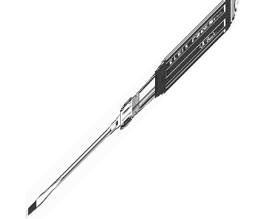

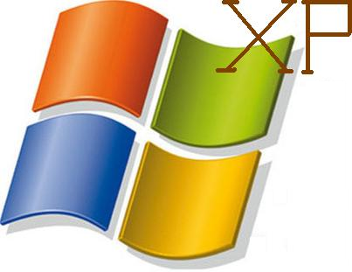
Windows XP

Administration

Optimization

Tuning




ACKNOWLEDGEMENT

A project is always a coordinated, guided and scheduled team effort aimed at realizing common minimum goals. It is executed by team members, though it never reaches completion by team efforts alone, nor does it reach the far off shores, unless there are light houses to guide the ship sailing astray.

We express our deep gratitude and special thanks to our internal project guide Mr. Pramod Shanbhag, external project guide Mr. Mehul Parikh, project coordinators Ms. Nazneen Ansari, Ms. Prachi Raut and Ms. Sumitha for their earnest efforts and constant support to guide and provide encouragement for our project work. Without their vision and support this synopsis work would never have been possible.

We are also grateful to all the teaching and non-teaching staff, those who have directly or indirectly helped us to make this report a success. We are also thankful to our friends for helping us out in making this project report a success.

Hardik Shah
Alok Sarang
Ankith Shetty

ABSTRACT

- W.A.O.T. is a tool for Windows operating system users who wish to tweak the PC system to the optimal performance, tweaking the features to their own discretion and performing additional operations which otherwise may be hidden or impossible.

- The program enables you to manage registry backups, optimize system and administer Windows XP using various other utilities like screen locking, screen capturing, file locking, etc.

- It includes the advanced toolkits to help you eliminate unwanted start-up services, manage start-up applications, uninstall unwanted applications and make widespread changes to Windows explorer.

- Some of the other handy tools provided by W.A.O.T. permit thorough administration over the LAN by allowing remote and time based shutdown, remote messaging, etc.

- There are a variety of tools available over the Internet like Registry Mechanic, Toolkit Utilities 2008, Advanced PC tweaker, Network Admin Elite, etc which provide the same features to the user. W.A.O.T. acts as a superset of all of the above applications by providing all of the features bundled together with a precise and a lucid interface.

TABLE OF CONTENTS:

Sr. No. | Contents | Page No.
1 | Industry Profile (For out-house projects) | 9
2 | Problem definition | 12
3 | Requirements gathering:  - Project Overview  - Feasibility study  - Technical  - Operational  - Economical | 14
4 | Analysis & Design:  - Use Case Analysis  - Process model (Incremental model)  - Data Flow Diagrams (DFD)  - Data Dictionary  - Entity Relationship Diagram  - Sequence Diagram  - Graphical User Interfaces (GUI) | 17
5 | Introduction to Programming Tools / Technologies | 29
6 | Limitations and Future Scope | 31
7 | Bibliography and References | 32

LIST OF FIGURES

Fig. No. | Name of Figure | Page No.
1 | Use Case Diagram | 17
2 | Incremental Model | 18
3 | Data Flow Diagram | 19
4 | Data Dictionary | 23
5 | Entity Relationship Diagram | 24
6 | Sequence Diagram | 25
7 | Graphical User Interfaces | 27

- INTRODUCTION:


- Company Profile:

Zetta Business Solutions is a website development and ecommerce software development company implementing IT projects of any complexity. Combining our solid business domain experience, technical expertise, profound knowledge of latest industry trends and quality-driven delivery model we offer progressive end-to-end web solutions. We are committed to quality and constantly work on improving it. We use the best industry standards in project management, development and testing.
By understanding the processes that make your business unique, we are able to utilize our creative skills and technological know-how to build a bespoke solution that will support your business now and in the future. We provide Complete strategic, creative, and technical expertise needed to achieve your business objectives.
Whether your project entails strategy, web design, E-Commerce and multimedia application development, or site hosting and maintenance, turn to Zetta for a single point of accountability. Our phased approach puts key deliverables to work for you faster. And that gives you the fastest possible ROI (Return on Investment).
In Zetta we bring our passion, integrity and innovation to each of our client projects. Whether it is applying the best techniques or bringing the latest thinking on process or architecture, all our projects are responsibility.

- OBJECTIVES OF ZETTA:


“Dreams are like the paints of a great artist. Your dreams are your paints; the world is your canvas. Believing, is the brush that converts your dreams into a masterpiece of reality.” -unknown
We never set out to be the biggest, most cutting edge, or hippest firm out there, because good business isn’t about those things – it’s about delivering outstanding solutions that are sensible and that drive profit. What’s more, talent isn’t found in Cool light fixtures or expensive coffee machines – it’s found in amazing employees who truly believe in what they do, not just in their paychecks.
Our priorities were fixed from the beginning on three things – doing great work, treating our employees really well, and exceeding our clients’ expectations.
Zetta develops custom Web-based solutions that automate processes and unify business resources. This enables your business to handle more volume, and use information and resources more effectively. In short, Zetta can help your business grow faster and more sustainable:
1. We can automate your business processes, including subscriptions, client data, and data services.
2. We can enable you to gain better insight into customer profiles, needs, and suggestions — including statistical analysis of business trends and customer information.
3. We can help you unify online resources, by linking all of your systems together in an integrated solution.
4. We implement exceptional, award-winning designs and have experience building dynamic, customer-oriented systems.
5. Our applications are flexible and can change as your business needs evolve.
6. We give our clients the benefit of the latest technological advances that enable greater productivity.
We strive to exceed your expectations. So we're never too busy to return a call or e-mail. That means you'll always know the status of your project. And since we're not a large firm, we can remain nimble and flexible - ready to spring into action or switch gears when you need us to. And we always deliver on time. Always.

- Products of ZETTA:
At Zetta, we provide turnkey project solutions to meet your unique business needs. Our system analysts and developers have extensive experience in building database-driven enterprise applications. From conceptualization through implementation, testing and beyond, the Zetta development team has the right mix of resources to help you reach your technology goals.
Our software is rigorously tested before being made available to you and we assure you that when you choose any of our software you will be receiving a secure, standards-based, enterprise quality application. Following are some of the upcoming projects:

Z-Sytes
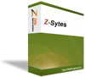
Z-Sytes is a next generation application to produce and manage Multiple Websites. All the websites created by Zsytes are monitored and backed up.

Z-Works
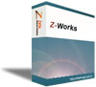
Z-Works is a rapid development framework that provides an extensible architecture for developing, maintaining, and deploying innovative web applications. It uses most of the best practices of web development and integrates some great third-party libraries.

Z-commerce

Z-commerce applications are designed in order to maximize the revenues and are developed so that you can have a flourishing online business with minimal investment.

Z-Mail

Z-Mail is a powerful E-mail and Newsletter Marketing application that will allow you to easily design HTML and text based newsletters deliver personalized emails to your target audiences through mailing lists.

Z-CRM
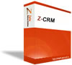
Z-CRM is a custom build CRM system for your firms needs. The right CRM solution can help you turn potential customers and existing customers into lifelong customers.

- PROBLEM DEFINITION:

- Microsoft Windows XP operating system has undisputedly been the best operating system till date with respect to it’s number of users worldwide, low system requirements, easy interface etc. But as the users began to grow old and sophisticated on the Windows XP platform they seem to require additional features and utilities apart from those provided by default from the OS.
- For example for a layman, he may require the following but it is not easy to perform various tasks such as restricting access to several key Windows XP applications, registry backup, tweaking Windows features dealing with the start menu, desktop and internet explorer, running manual scandisk of desired local drives, creating virtual drives etc.
- Even for a skilled computer professional, it can be a tedious job to perform the above mentioned tasks.
- Furthermore, it is not possible to carry out the required tasks via a single application. It requires the user to switch between several applications, including modifying registry values, which can prove to be quite hazardous for the computer in case some crucial registry values are accidentally modified or deleted.
- An efficient and user friendly application is greatly required to help the user perform the above mentioned tasks and modify registry values without worrying about the risk of corrupting essential files.
- Also, it would be very helpful to the user if the tasks could be performed with the help of just one application.

Why Use W.A.O.T.?
- Does your PC run more and more slowly?
- Do you want to modify the look and feel of XP beyond your imagination?
- Does your computer pop up mysterious error messages?
- Do you suffer from the system's memory strike all the time?
- Do you suffer from slow services and Internet speed?
- Do you want your computer automated?

- Scope:

- W.A.O.T. is a collection of tools to customize, maintain, and optimize your Windows.

- It includes more than 20 tools that can help you to optimize your Windows performance.

- Whether you're a business person who needs to ensure that your computer is stable and reliable, a serious game player who wants to optimize your computer for the latest games' demands on computer resources, or a home user who wants to personalize the look and feel of Windows and Internet Explorer, W.A.O.T. provides the tools you need to modify your computer safely.

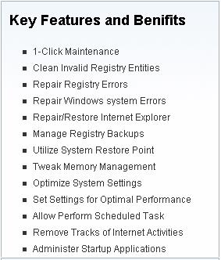
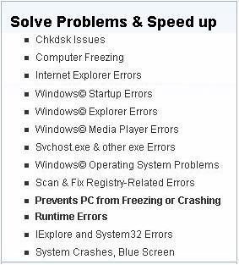

Targeted Users:

- Users that are not well versed with the nitty-gritty's involved in performance and hidden functions of Windows.
- Cyber Café Administrators.
- Computer professionals working with frequent registry changes.
- Network Administrators

3. REQUIREMENTS GATHERING:

  - Project Overview:

- Administration:

- Restricting access to several key Windows XP applications.
- Screen Locking.
- Screen Capturing.
- Registry Backup in case of accidental changes or system crash.
- User authentication for security reasons in W.A.O.T. application.

- Optimization:

- Tweaking Windows features through Windows Registry Editor v5.1
- The above motive can be achieved over the following:
  - Windows Explorer
  - Start-Menu
  - Control Panel
  - Desktop
  - Internet Explorer

- Tuning:

- Manual Scan – disk of local drives with additional features of:
  - Performing scan disk as and when required, and not just in case of irregular shut down.
  - Dismounting the drives
  - Fixing the errors.
  - Generating a status report
  - Recovering lost file-fragments.
- Explained defragmentation of any of the local hard drives.
- Time based Shutdown/Restart/Log Off with an alert.

      - FEASIBILITY STUDY AND REQUIREMENTS ANALYSIS:

- Technical Feasibility:

To check if the project is technically feasible, we consider the technical feasibility of each major module.

Screen Locking and screen capturing is an inbuilt feature given along with the application. Hence this module is technically feasible.

Registry changes, registry backups and login details are based on database activities. All the changes that will be made to the registry, details of the modified registry and login name with password will be stored in the database. Whatever the registry changes that are made by the user for the session will be appended to the database for a temporary period of time and when finalized, the database will be read and the entries will be implemented. Database storage space is provided in the MS-Access file. Hence these modules are technically feasible. Hence these modules are technically feasible.

On account of the fact, since all the above modules are technically feasible, we conclude that the project is also technically feasible.

Client Requirement Specification:-

Software Requirement:
1. JRE(Java Runtime Environment) 1.6.1 or above.
- MS-Access 2003 or above.

Hardware Requirement [Minimum]:

- Operating System : Windows XP Home/Professional with SP1/SP2/SP3.
- Computer & Processor : Intel Pentium II(400 GHz) or AMD Duron 1000+ or equivalent.

- Memory : 64 MB RAM.

- Hard Disk : Max. 100 MB HDD space.
- Display : VGA driver that supports a resolution of 800 x 600 pixels.

- Operational Feasibility:

The application to be prepared will not only act as a sponsored product of the company
Zetta Business Solutions, but will also allow it’s clients to submit any feedback regarding any potential flaws or inoperability. Zetta Business Solutions is a fast growing company that expects its business to grow exponentially over time. Hence it is possible to develop a tweaking application for the company. These modules are operationally feasible and there is no risk involved.

The current version of the application is not compatible with Windows Vista, Server 2008 and Linux. Therefore clients have to either switch to Windows XP or use the applications with majority of it’s features handicapped. This is a tough task, taking into consideration the different versions of Operating Systems existing from different vendors in the industry.

- Economic Feasibility:

In economical feasibility, we evaluated the development cost against the ultimate income or benefit from the developed application. It was determined that the benefits of the project far outplayed its costs, making it economically feasible.
The configuring maintenance and using the application does not require any special skills which eliminates training costs.

The economic feasibility of the project includes the fact that the Java language is freely available on the internet and completely open-source.
Thus keeping all the above aspects in mind, it can be concluded that the project which will be developed by us is economically feasible.

4. ANALYSIS AND DESIGN:

- Use-Case Diagram:

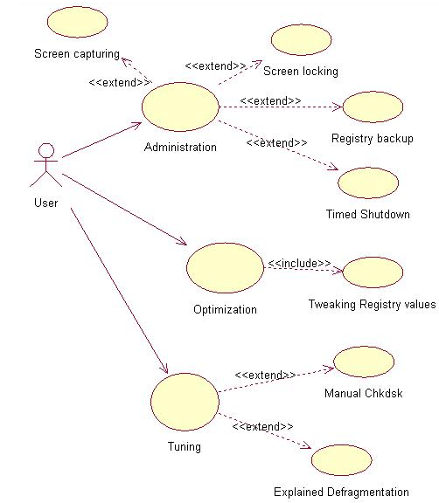

- Process Model

Incremental Model
The Incremental build model is a method of software development where the model is designed, implemented and tested incrementally (a little more is added each time) until the product is finished. It involves both development and maintenance. The product is defined as completed when it satisfies all of its requirements. This model combines the elements of the waterfall model with the iterative philosophy of prototyping.

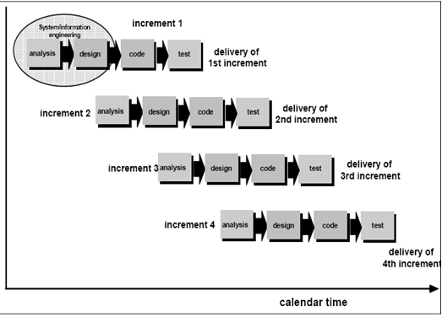

- DFD:

- Level 0:

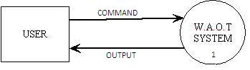

- Level 1:

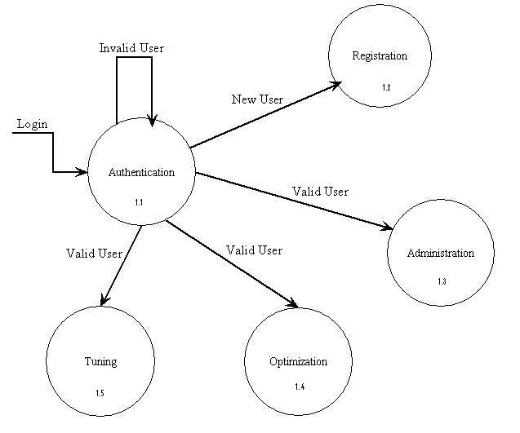

- Level 2:

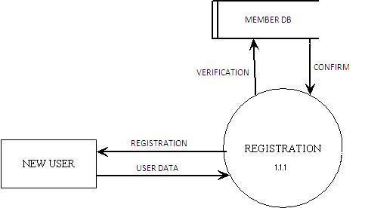

Registration

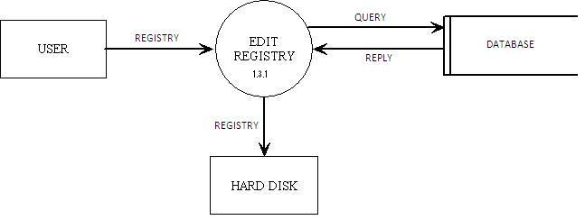
Optimization

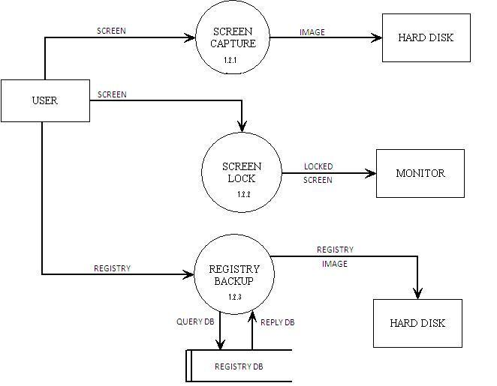

Administration
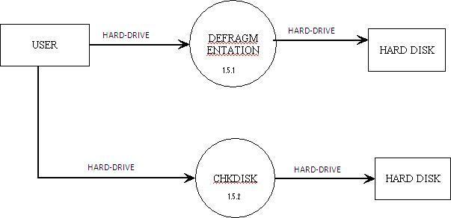

Tuning

- Data Dictionary:

- Login
NAME | DATATYPE | LENGTH | DESCRIPTION
Login name | text | 10 | Login name of user
Password | text | 10 | Login user password for the registered user

- Temporary registry entries
NAME | DATATYPE | LENGTH | DESCRIPTION
Serial no. | number | 15 | Serial no. of the registry key
Registry address | text | 100 | Exact address of the registry entry
Registry value | text | 100 | Registry value of the registry address

- Registry Backup with Details of Date and Time
NAME | DATATYPE | LENGTH | DESCRIPTION
Registry name | text | 10 | Registry name given for storage
Registry Date | text | 10 | Checkpoint creation date
Registry Time | text | 10 | Checkpoint creation time

- DOS Commands:
NAME | DATATYPE | LENGTH | DESCRIPTION
Serial no. | number | 15 | Serial no. of the command
Command | text | 100 | Exact Command

- Entity Relationship Diagram:

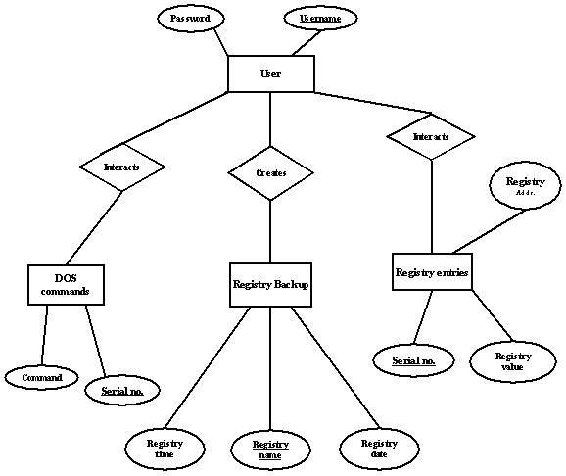

- Sequence Diagram:

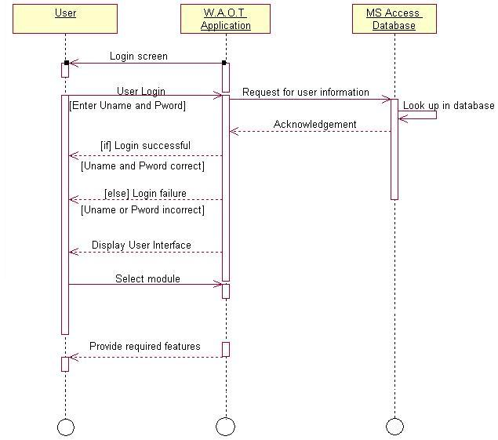

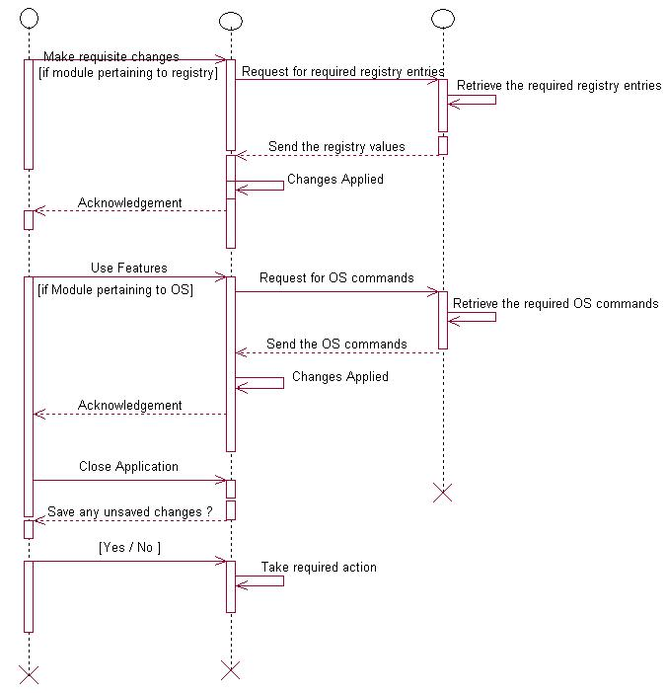

- Graphical User Interfaces (GUI):

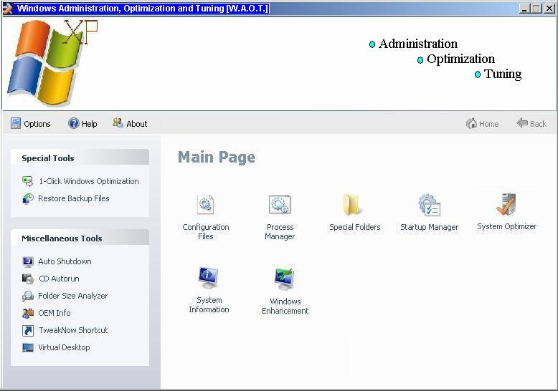

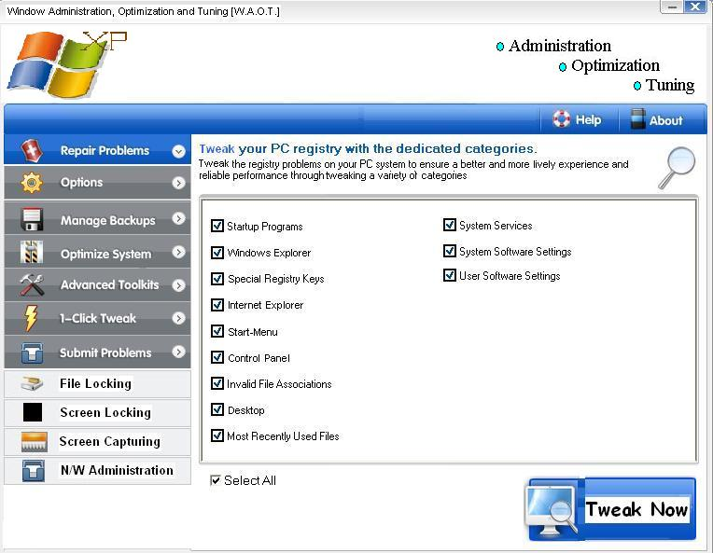

5. INTRODUCTION TO PROGRAMMING TECHNOLOGIES:

  - JAVA:

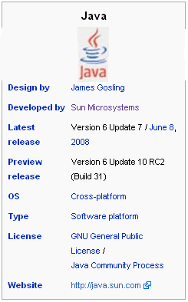
Java refers to a number of computer software products and specifications from Sun Microsystems that together provide a system for developing application software and deploying it in a cross-platform environment. Java is used in a wide variety of computing platforms spanning from embedded devices and mobile phones on the low end to enterprise servers and supercomputers on the high end. Java is nearly ubiquitous in mobile phones, Web servers and enterprise applications, and while less common on desktop computers, Java applets are often used to provide improved functionality while browsing the World Wide Web.

Writing in the Java programming language is the primary way to produce code that will be deployed as Java bytecode, though there are compilers available for other languages such as JavaScript, Python and Ruby, and a native Java scripting language called Groovy. Java syntax borrows heavily from C and C++ but it eliminates certain low-level constructs such as pointers and has a very simple memory model where every object is allocated on the heap and all variables of object types are references. Memory management is handled through integrated automatic garbage collection performed by the Java Virtual Machine (JVM).

Different "editions" of the Java platform are available, including:
- Java Card: refers to a technology that allows small Java-based applications (applets) to be run securely on smart cards and similar small memory footprint devices.
- Java ME (Micro Edition): Specifies several different sets of libraries (known as profiles) for devices which are sufficiently limited that supplying the full set of Java libraries would take up unacceptably large amounts of storage.
- Java SE (Standard Edition): For general purpose use on desktop PCs, servers and similar devices.
- Java EE (Enterprise Edition): Java SE plus various APIs useful for multi-tier client-server enterprise applications.

  - MS-Access:

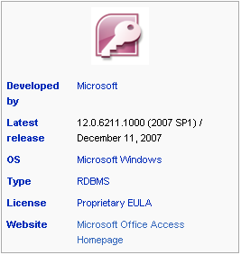
Microsoft Office Access, previously known as Microsoft Access, is a relational database management system from Microsoft that combines the relational Microsoft Jet Database Engine with a graphical user interface and software development tools. It is a member of the 2007 Microsoft Office system.
Access can use data stored in Access/Jet, Microsoft SQL Server, Oracle, or any ODBC-compliant data container (including MySQL and PostgreSQL). Skilled software developers and data architects use it to develop application software. Relatively unskilled programmers and non-programmer "power users" can use it to build simple applications. It supports some object-oriented techniques but falls short of being a fully object-oriented development tool.

  - History of MS-Access:

Access version 1.0 was released in November 1992, followed in May of 1993 by an Access 1.1 release to improve compatibility with other Microsoft products.
Microsoft specified the minimum operating system for Version 2.0 as Microsoft Windows v3.0 with 4 MB of RAM. 6 MB RAM was recommended along with a minimum of 8 MB of available hard disk space (14 MB hard disk space recommended). The product was shipped on seven 1.44 MB diskettes. The manual shows a 1993 copyright date.
The software worked well with small recordsets but testing showed some circumstances caused data corruption. For example, file sizes over 10 MB were problematic (note that most hard disks were smaller than 500 MB at the time this was in wide use). The Getting Started manual warns about a number of circumstances where obsolete device drivers or incorrect configurations can cause data loss.

  - Windows Registry Editor:

The Windows registry is a directory which stores settings and options for the operating system for Microsoft Windows 32-bit versions, 64-bit versions, and Windows Mobile. It contains information and settings for all the hardware, operating system software, most non-operating system software, users, preferences of the PC, etc. Whenever a user makes changes to Control Panel settings, file associations, system policies, or most installed software, the changes are reflected and stored in the registry. The registry also provides a window into the operation of the kernel, exposing runtime information such as performance counters and currently active hardware. This use of registry mechanism is conceptually similar to the way that Sysfs and procfs expose runtime information through the file system (traditionally viewed as a place for permanent storage), though the information made available by each of them differs tremendously.

The different hives in the registry editor are:
1] HKEY_CLASSES_ROOT (HKCR)
2] HKEY_CURRENT_USER (HKCU)
3] HKEY_LOCAL_MACHINE (HKLM)
4] HKEY_USERS (HKU)
5] HKEY_CURRENT_CONFIG
6] HKEY_PERFORMANCE_DATA
7] HKEY_DYN_DATA

.REG files :

.REG files (also known as Registration entries) are text-based human-readable files for storing portions of the registry. On Windows 2000 and later NT-based operating systems, they contain the string Windows Registry Editor Version 5.00 at the beginning and are Unicode-based. On Windows 9x and NT 4.0 systems, they contain the string REGEDIT4 and are ANSI-based. [11] Windows 9x format .REG files are compatible with Windows 2000 and later NT-based systems. The Registry Editor on Windows on these systems also supports exporting .REG files in Windows 9x/NT format

6. LIMITATIONS AND FUTURE SCOPE:

- Future Scope:

  - The current version of Windows Administration, Optimizing and Tuning (W.A.O.T.) is being planned and designed only for the Windows XP operating system. Future versions can also be designed to operate on upcoming operating systems of Windows such as Windows Vista.
  - Also, they can incorporate new modules to modify a greater number of registry values.
  - Since one of W.A.O.T.’s functions is to deal with registry values and their modifications, it can also be used as an efficient anti-virus package since the primary attack of a virus is the registry.
  - W.A.O.T. can also be used to monitor background process and alert the user if any service is using excessive resources.

- Limitations:

  - Windows Administration, Optimizing and Tuning (W.A.O.T.) is only compatible with computers using the Windows XP operation system.
  - Furthermore, W.A.O.T. assumes that the indented user using the application is an Administrator with administrative privileges. If the user lacks the sufficient privileges then the application might be rendered handicapped or completely futile.
  - If the stipulated drive is FAT32 the file locking feature will be rendered useless since this feature is only available over NTFS file system.
  - If the system under deployment is affected by a virus, spyware or malware which inhibits the use of task-manager, registry editor or command prompt then the W.A.O.T. application might be rendered handicapped or completely futile.

7. BIBLIOGRAPHY AND REFERENCES:

Books:

- Tata McGraw Hill – Java 2 The Complete Reference (J2CR)

- Ethical Hacking using Batch File Programming – Ankit Fadia

- Ethical Hacking using Windows Registry Editor – Ankit Fadia

Websites:

- http://www.wikipedia.org

- http://www.advancedpctweaker.com

- http://www.google.com

- http://www.tweaknow.com

