|  |  |
| --- | --- |
| Name: | Loukik Sainath Tayshete |
| Branch: | SY Data Science |
| Batch: | D4 |
| UID: | 2021700065 |
| Subject: | Design and Analysis of Algorithm |
| Experiment No. | 0 |
| Date: | 03-02-2023 |

|  |  |
| --- | --- |
| Aim: | To implement the various functions e.g. linear, non-linear, quadratic, exponential etc. |

|  |
| --- |
| Code for implementing the functions: |
|  |

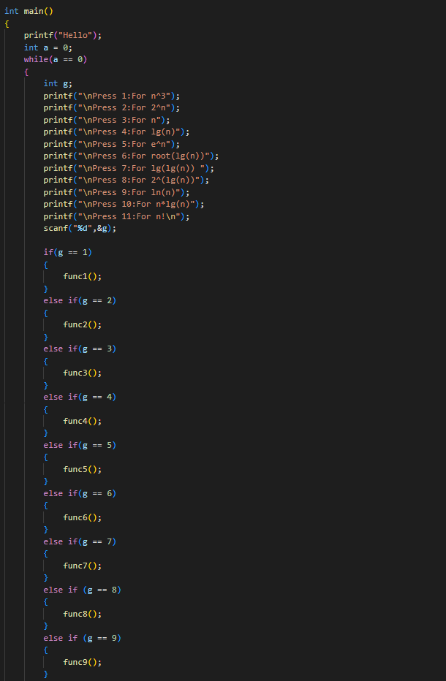

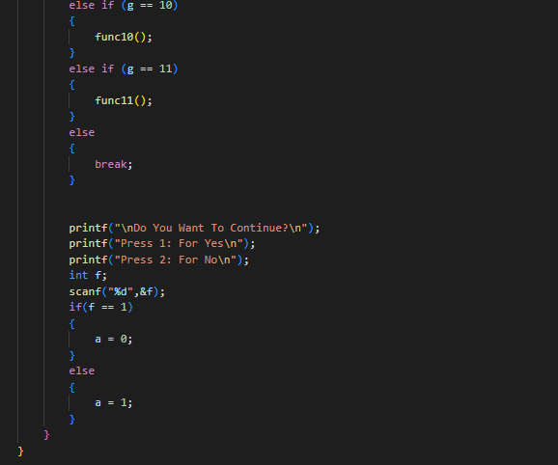

1. Output for n^3:

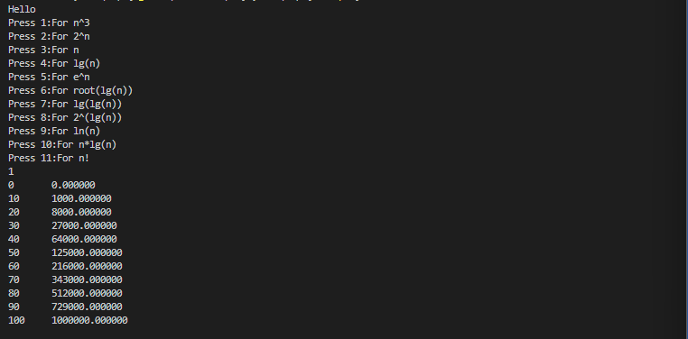

1. Output for 2^n:

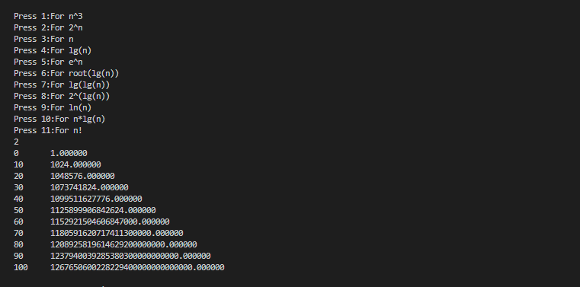

1. Output for n:

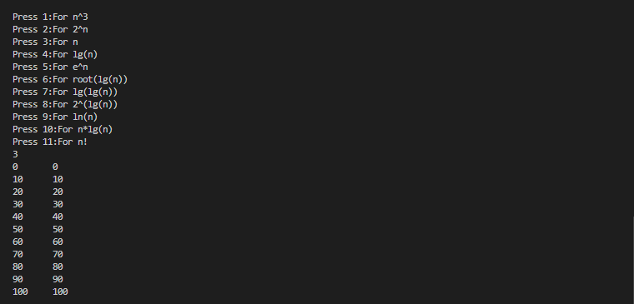

1. Output for lg(n):

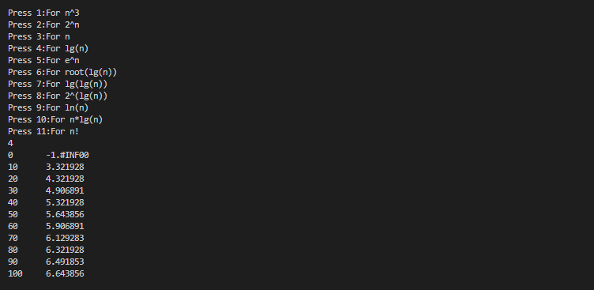

1. Output for e^n:

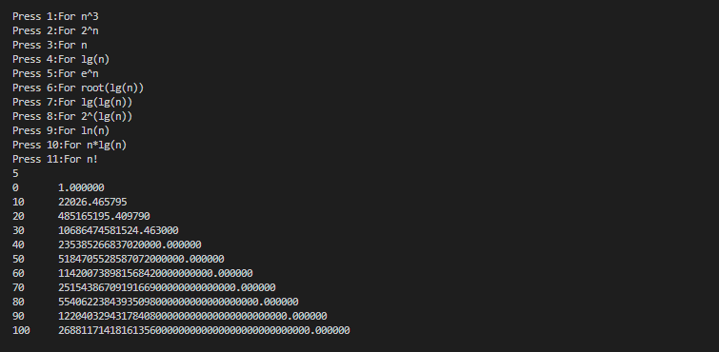

1. Output for root(lg(n)):

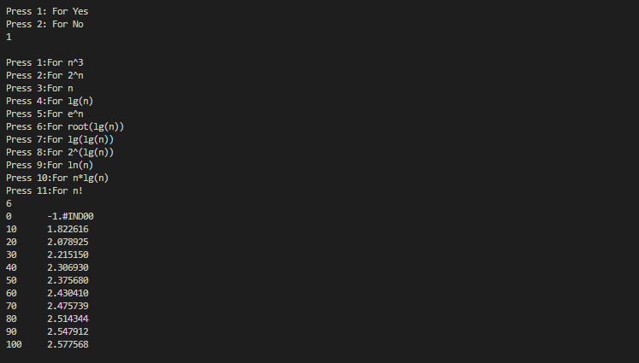

1. Output for lg(lg(n)):

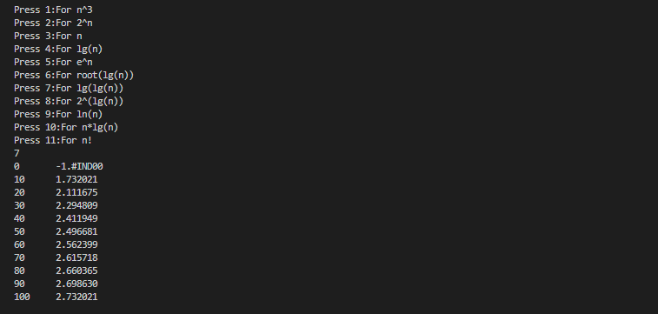

1. 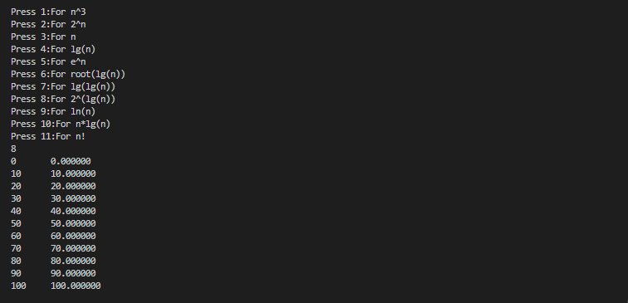Output for 2^(lg(n)):
2. Output for ln(n):

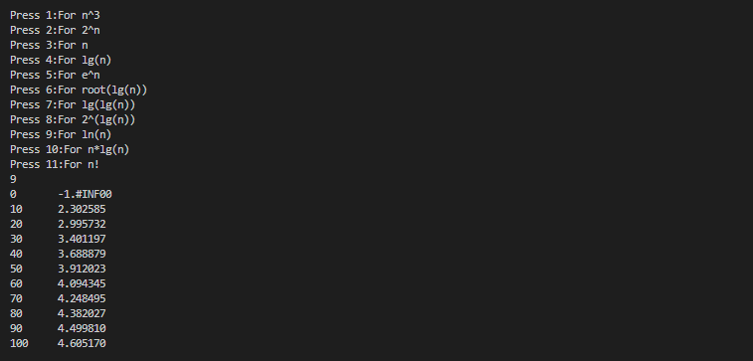

1. Output for n*lg(n):

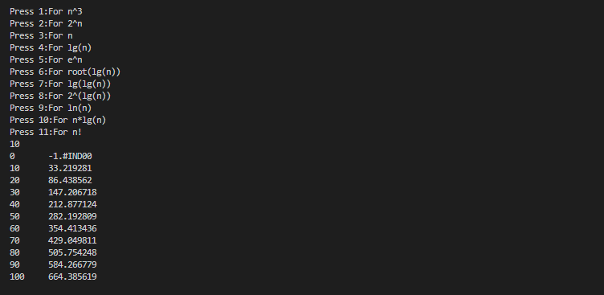

1. Output for n!:

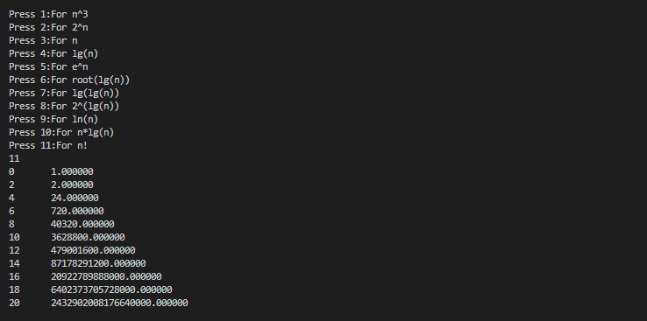

Graph Plotting For The First Five Function:

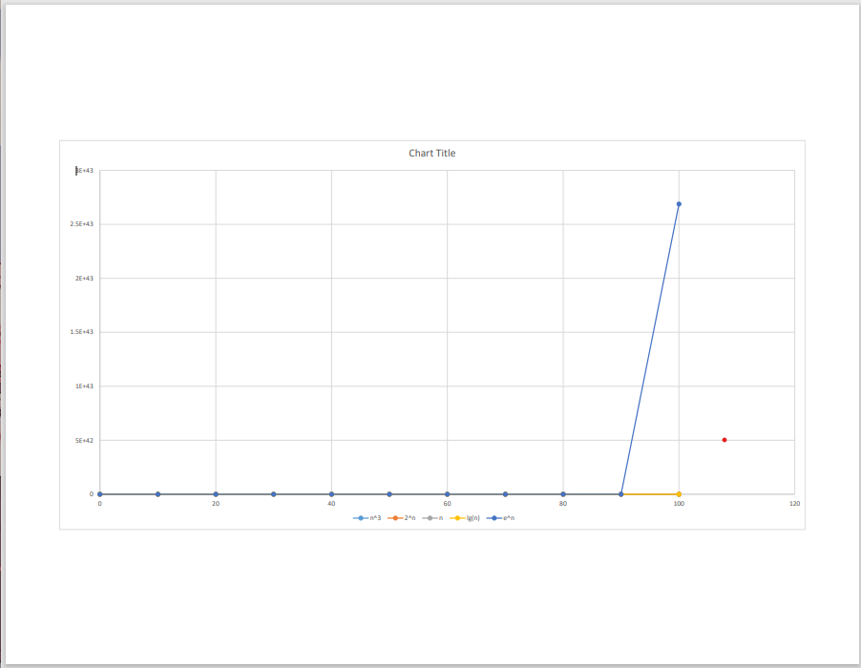

Observation:

The graph of function co-insides with each other only the function n^3 gets increased with increase in value of n.

Graph Plotting For The Last 5 Function:

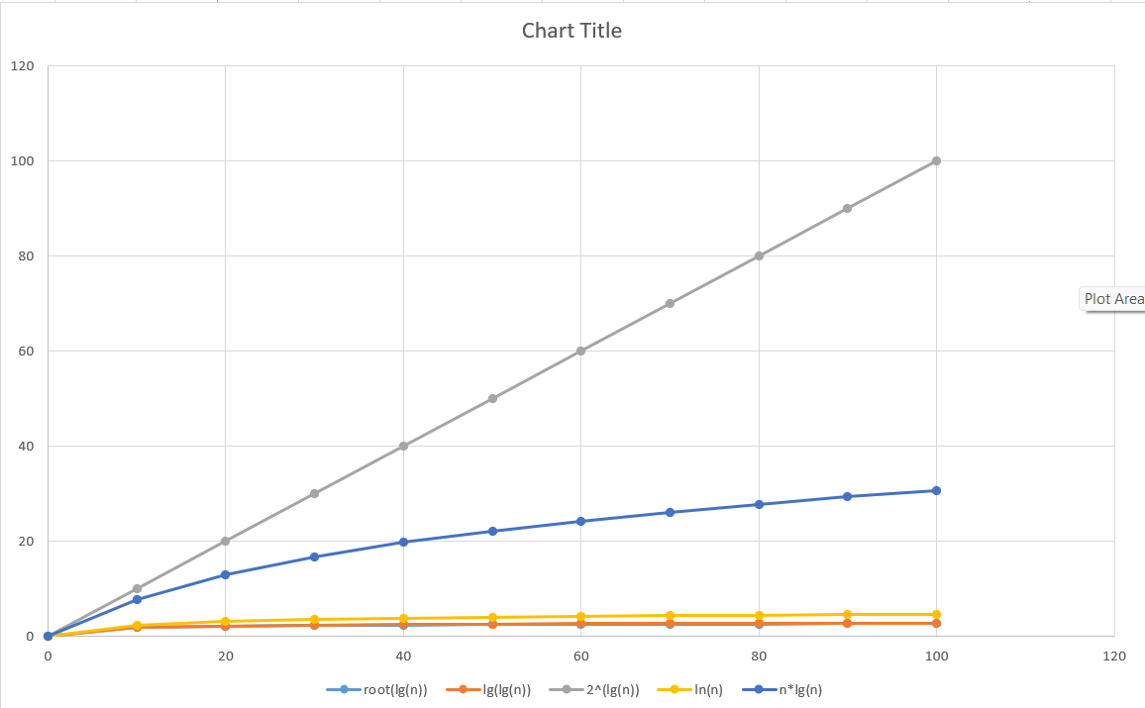

Observation:

The graph is gradually increasing with increase in value of n.

The function 2^lg(n) is increasing constantly.

Graph For n!:

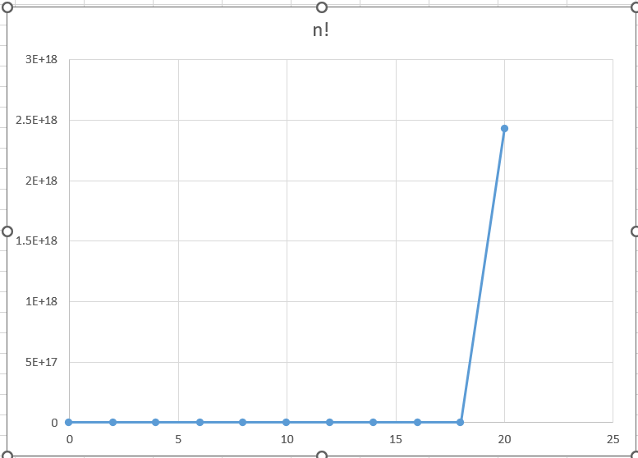

Observation:

The graph for n! is increasing after a certain value of n .

|  |  |
| --- | --- |
| Conclusion : | Successfully implemented various function in C and plotted the graph for the same. |