Name | Loukik Tayshete
UID no. | 2021700065
Experiment No. | 3

AIM: | To implement and compare the Normal and Strassen’s matrix multiplication
Program 1
PROBLEM STATEMENT : | Normal Matrix Multiplication
ALGORITHM/  THEORY: | Matrix multiplication in C: We can add, subtract, multiply and divide 2 matrices. To do so, we are taking input from the user for row number, column number, first matrix elements and second matrix elements. Then we are performing multiplication on the matrices entered by the user.  void multiply(int A[][N], int B[][N], int C[][N])  {  for (int i = 0; i < N; i++)  {  for (int j = 0; j < N; j++)  {  C[i][j] = 0;  for (int k = 0; k < N; k++)  {  C[i][j] += A[i][k]*B[k][j];  }  }  }  }  Time Complexity is : O(n^3)
PROGRAM: | #include <stdio.h>  #include <stdlib.h>  #include <time.h>  int main()  {  int a[2][2], b[2][2], mul[2][2], i, j, k;  system("cls");  printf("enter the first matrix element=\n");  for (i = 0; i < 2; i++)  {  for (j = 0; j < 2; j++)  {  scanf("%d", &a[i][j]);  }  }  printf("enter the second matrix element=\n");  for (i = 0; i < 2; i++)  {  for (j = 0; j < 2; j++)  {  scanf("%d", &b[i][j]);  }  }  clock_t start, end;  double cpu_time_used;  start = clock();  printf("multiply of the matrix=\n");  for (i = 0; i < 2; i++)  {  for (j = 0; j < 2; j++)  {  mul[i][j] = 0;  for (k = 0; k < 2; k++)  {  mul[i][j] += a[i][k] * b[k][j];  }  }  }  // for printing result  for (i = 0; i < 2; i++)  {  for (j = 0; j < 2; j++)  {  printf("%d\t", mul[i][j]);  }  printf("\n");  }  end = clock();  cpu_time_used = ((double)(end - start)) / CLOCKS_PER_SEC;  printf("\nNormal mult time : %d\n", cpu_time_used);  return 0;  }
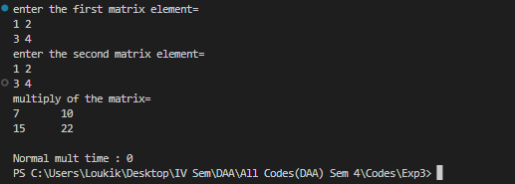
RESULT:

Program 2
PROBLEM STATEMENT : | Strassen’s Matrix Multiplication
ALGORITHM/  THEORY: | Strassen algorithm is a recursive method for matrix multiplication where we divide the matrix into 4 sub-matrices of dimensions n/2 x n/2 in each recursive step.  - Given two matrices A and B, divide them into four sub-matrices each of size n/2, where n is the size of the original matrices.  - Compute seven products recursively using these sub-matrices:  M1 = (A11 + A22) x (B11 + B22)  M2 = (A21 + A22) x B11  M3 = A11 x (B12 - B22)  M4 = A22 x (B21 - B11)  M5 = (A11 + A12) x B22  M6 = (A21 - A11) x (B11 + B12)  M7 = (A12 - A22) x (B21 + B22)  - Compute the four sub-matrices of the result matrix C using these products:  C11 = M1 + M4 - M5 + M7  C12 = M3 + M5  C21 = M2 + M4  C22 = M1 - M2 + M3 + M6  - Combine these sub-matrices to form the final result matrix C.
PROGRAM: | #include <stdio.h>  #include <time.h>  int main()  {  int a[100][100], b[100][100], c[100][100], i, j;  int m1, m2, m3, m4, m5, m6, m7;  printf("Enter the 4 elements of first matrix: ");  for (i = 0; i < 2; i++)  for (j = 0; j < 2; j++)  scanf("%d", &a[i][j]);  printf("Enter the 4 elements of second matrix: ");  for (i = 0; i < 2; i++)  for (j = 0; j < 2; j++)  scanf("%d", &b[i][j]);  printf("\nThe first matrix is\n");  for (i = 0; i < 2; i++)  {  printf("\n");  for (j = 0; j < 2; j++)  printf("%d\t", a[i][j]);  }  printf("\nThe second matrix is\n");  for (i = 0; i < 2; i++)  {  printf("\n");  for (j = 0; j < 2; j++)  printf("%d\t", b[i][j]);  }  clock_t start, end;  double cpu_time_used;  start = clock();  m1 = (a[0][0] + a[1][1]) * (b[0][0] + b[1][1]);  m2 = (a[1][0] + a[1][1]) * b[0][0];  m3 = a[0][0] * (b[0][1] - b[1][1]);  m4 = a[1][1] * (b[1][0] - b[0][0]);  m5 = (a[0][0] + a[0][1]) * b[1][1];  m6 = (a[1][0] - a[0][0]) * (b[0][0] + b[0][1]);  m7 = (a[0][1] - a[1][1]) * (b[1][0] + b[1][1]);  c[0][0] = m1 + m4 - m5 + m7;  c[0][1] = m3 + m5;  c[1][0] = m2 + m4;  c[1][1] = m1 - m2 + m3 + m6;  printf("\nAfter multiplication using \n");  for (i = 0; i < 2; i++)  {  printf("\n");  for (j = 0; j < 2; j++)  printf("%d\t", c[i][j]);  }  end = clock();  cpu_time_used = ((double)(end - start)) / CLOCKS_PER_SEC;  printf("\nStressen's time : %d\n", cpu_time_used);  return 0;  }
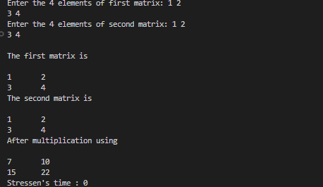
RESULT:

CONCLUSION: | We can say that the time required for Strassen’s Algo is slight less than that of normal method as the time complexity for strassen’s is O(n^2.807) and for normal it is O(n^3).

