Name | Loukik Tayshete
UID no. | 2021700065
Experiment No. | 2

AIM: | Implementing Merge and Quick Sort with C programing
Program 1
PROBLEM STATEMENT : | Merge Sort , for 1,00,000 random number in C
ALGORITHM/  THEORY: | Merge Sort:  Merge sort is a sorting algorithm that works by dividing an array into smaller subarrays, sorting each subarray, and then merging the sorted subarrays back together to form the final sorted array.  Algorithm:  step 1: start  step 2: declare array and left, right, mid variable  step 3: perform merge function.  if left > right  return  mid= (left+right)/2  mergesort(array, left, mid)  mergesort(array, mid+1, right)  merge(array, left, mid, right)  step 4: Stop
PROGRAM: | #include<stdio.h>  #include<stdlib.h>  #include<time.h>  void PrintArray(int *A , int n) //Pointer of 1st element and size  {  FILE * ptr = NULL;  ptr = fopen("merges2.csv","a");  for (int i = 0; i < n; i++)  {  fprintf(ptr,"%d\n",A[i]);  }  fprintf(ptr,"\n");  fclose(ptr);  }  void Merge(int a[],int low,int mid ,int high)  {  int i,j,k, b[100000];  i = low ;  j = mid+1;  k = low;  while(i<= mid && j<= high)  {  if (a[i]<a[j])  {  b[k]=a[i];  i++;  k++;  }  else  {  b[k]=a[j];  j++;  k++;  }  }  while (i <= mid)  {  b[k]=a[i];  i++;  k++;  }  while (j <= high)  {  b[k] = a[j];  k++;  j++;  }  for (int i = low ; i <= high; i++)  {  a[i] = b[i];  }  }  void mergeSort(int a[],int low, int high)  {  int mid;  if(low < high)  {  mid = (low + high)/2;  mergeSort(a,low,mid); //one part //recursive  mergeSort(a,mid+1,high); //second part  Merge(a,low,mid,high);  }  }  double mergeCalc(int a[], int n) {  FILE *fp = fopen("./mergeSort1.csv", "w+");  double totalTime = 0;  if(!fp) {  printf("Error opening file\n");  return -1;  }  fprintf(fp, "n, time\n");  for (int i = 99; i <= n; i+=100)  {  clock_t start, end;  double cpu_time_used;  start = clock();  mergeSort(a, 0, i);  end = clock();  cpu_time_used = ((double) (end - start)) / CLOCKS_PER_SEC;  totalTime += cpu_time_used;  fprintf(fp, "%d, %f\n", i+1, cpu_time_used);  printf("Sorted from 0 to %d in %.2fs\n", i, cpu_time_used);  }  fclose(fp);  fp = fopen("./mergeSort.csv", "w+");  for(int i = 0; i < n; i++) {  fprintf(fp, "%d\n", a[i]);  }  fclose(fp);  return totalTime;  }  void main()  {  int n = 100000;  int a[n];  double mergeT = mergeCalc(a, n);  printf("Time taken by Merge Sort: %f\n", mergeT);  }
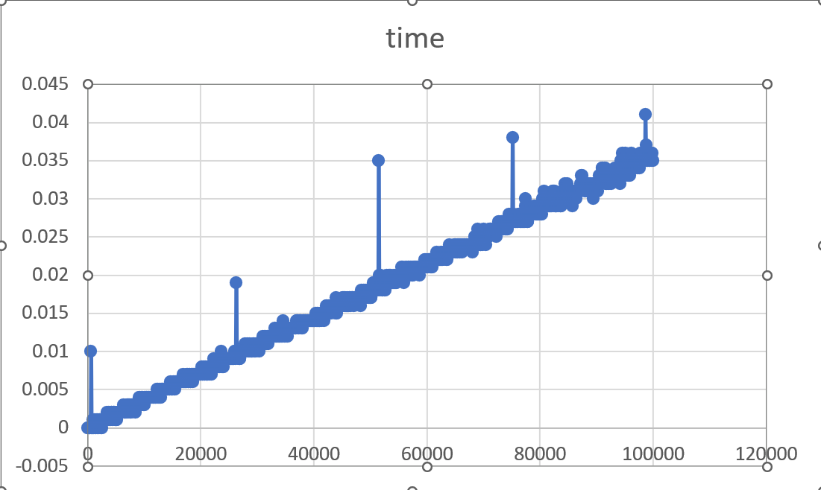
RESULT:
Program 2
PROBLEM STATEMENT : | Quick Sort , for 1,00,000 random number in C
ALGORITHM/  THEORY: | Algorithm:  - QUICKSORT (array A, start, end)  - {  - 1 if (start < end)  - 2 {  - 3 p = partition(A, start, end)  - 4 QUICKSORT (A, start, p - 1)  - 5 QUICKSORT (A, p + 1, end)  - 6 }  - }  Partition Algorithm:  - PARTITION (array A, start, end)  - {  - 1 pivot ? A[end]  - 2 i ? start-1  - 3 for j ? start to end -1 {  - 4 do if (A[j] < pivot) {  - 5 then i ? i + 1  - 6 swap A[i] with A[j]  - 7 }}  - 8 swap A[i+1] with A[end]  - 9 return i+1  - }
PROGRAM: | #include <stdio.h>  #include <stdlib.h>  #include <time.h>  void PrintArray(int *A , int n) //Pointer of 1st element and size  {  FILE * ptr = NULL;  ptr = fopen("selection1.csv","a");  for (int i = 0; i < n; i++)  {  fprintf(ptr,"%d\n",A[i]);  }  fprintf(ptr,"\n");  fclose(ptr);  }  int partition(int a[], int low, int high)  {  int pivot = a[low];  int i = low + 1;  int j = high;  int temp;  do  {  while (a[i] <= pivot)  {  i++;  }  while (a[j] > pivot)  {  j--;  }  if (i < j)  {  temp = a[i];  a[i] = a[j];  a[j] = temp;  }  } while (i < j);  temp = a[low];  a[low] = a[j];  a[j] = temp;  return j;  }  void quickSort(int a[], int low, int high)  {  int partitonindex;  if (low < high)  {  partitonindex = partition(a, low, high);  quickSort(a, low, partitonindex - 1); // left  quickSort(a, partitonindex + 1, high); // right  }  }  double qCort(int a[], int n) {  FILE *fp = fopen("./quickSort.csv", "w+");  double totalTime = 0;  if(!fp) {  printf("Error opening file\n");  return -1;  }  fprintf(fp, "n, time\n");  for (int i = 99; i <= n; i+=100)  {  clock_t start, end;  double cpu_time_used;  start = clock();  quickSort(a, 0, i);  end = clock();  cpu_time_used = ((double) (end - start)) / CLOCKS_PER_SEC;  totalTime += cpu_time_used;  fprintf(fp, "%d, %f\n", i+1, cpu_time_used);  printf("Sorted from 0 to %d in %.2fs\n", i, cpu_time_used);  }  fclose(fp);  fp = fopen("./quickSort1.csv", "w+");  for(int i = 0; i < n; i++) {  fprintf(fp, "%d\n", a[i]);  }  fclose(fp);  return totalTime;  }  void main()  {  int n = 100000;  int b[n];  double quickT = qCort(b, n);  printf("Time taken by Merge Sort: %f\n", quickT);  }
RESULT:

Conclusion: | Implemented merge-sort and quick sort algorithm for 1,00,000 and found out that merge sort is faster than quick sort.

