**Assignment Name:** Design and develop a distributed Hotel booking application using Java RMI. A distributed hotel booking system consists of the hotel server and the client machines. The server manages hotel rooms booking information. A customer can invoke the following operations at his machine i) Book the room for the specific guest ii) Cancel the booking of a guest.

**Software Required: BlueJ IDE**

**Step 1:** Create Project and provide suitable name

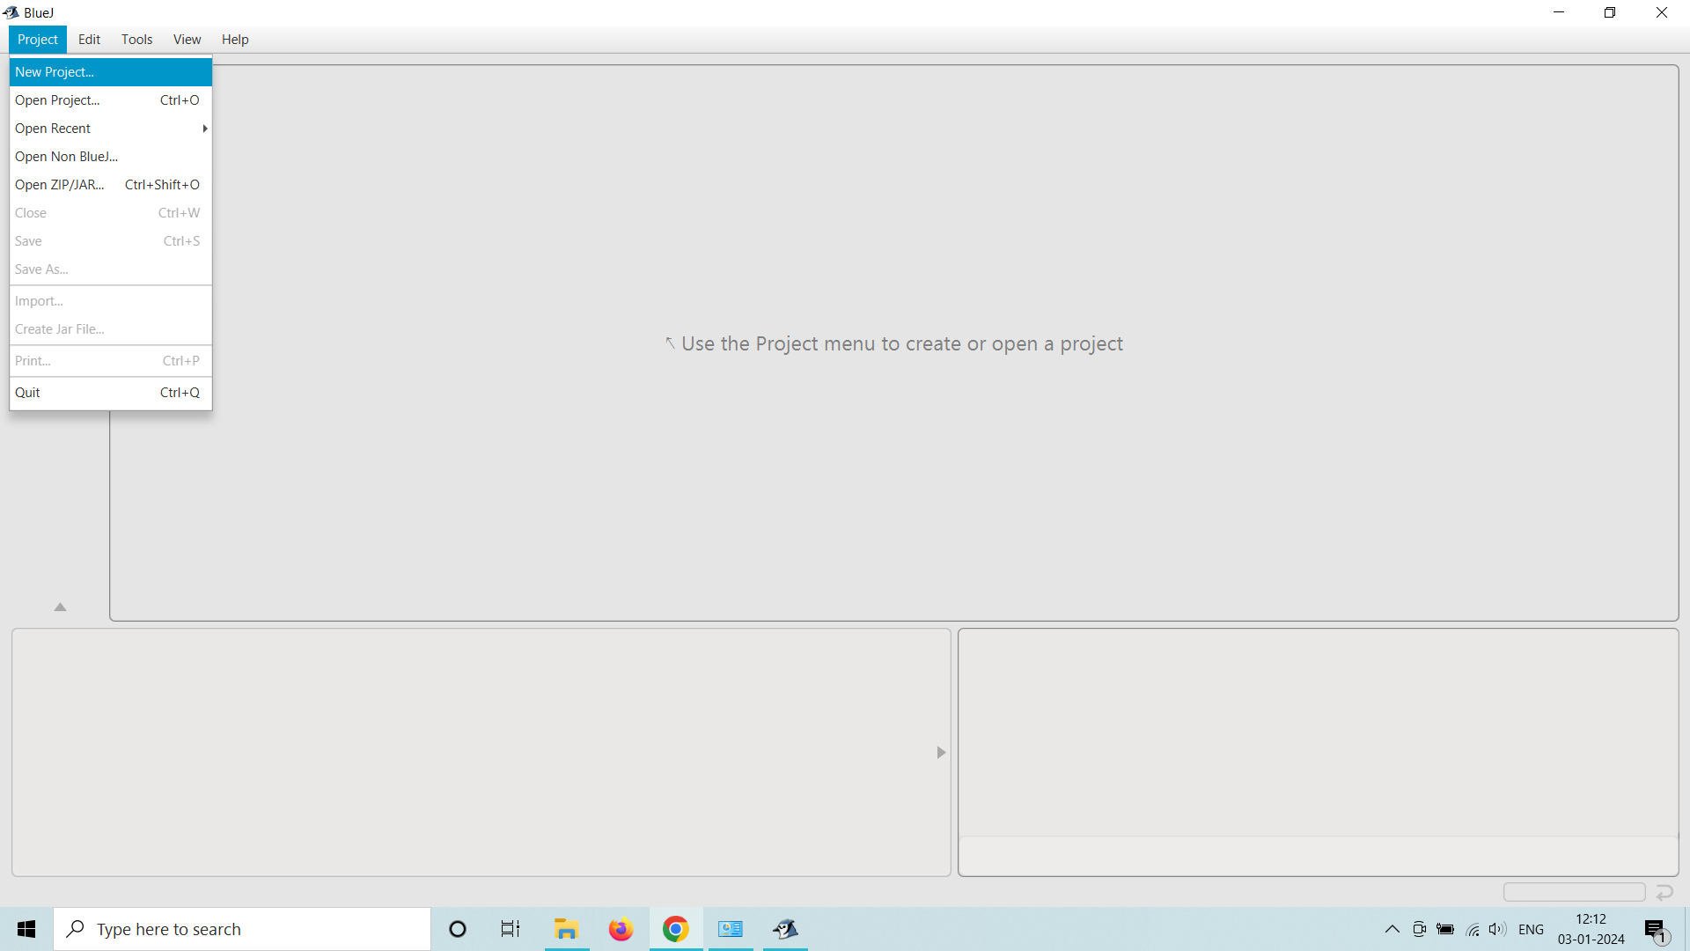

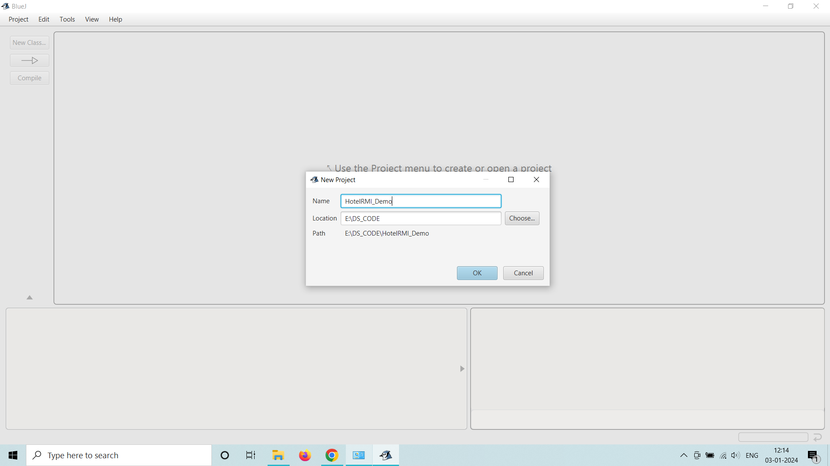

**Step 2:** Create Interface

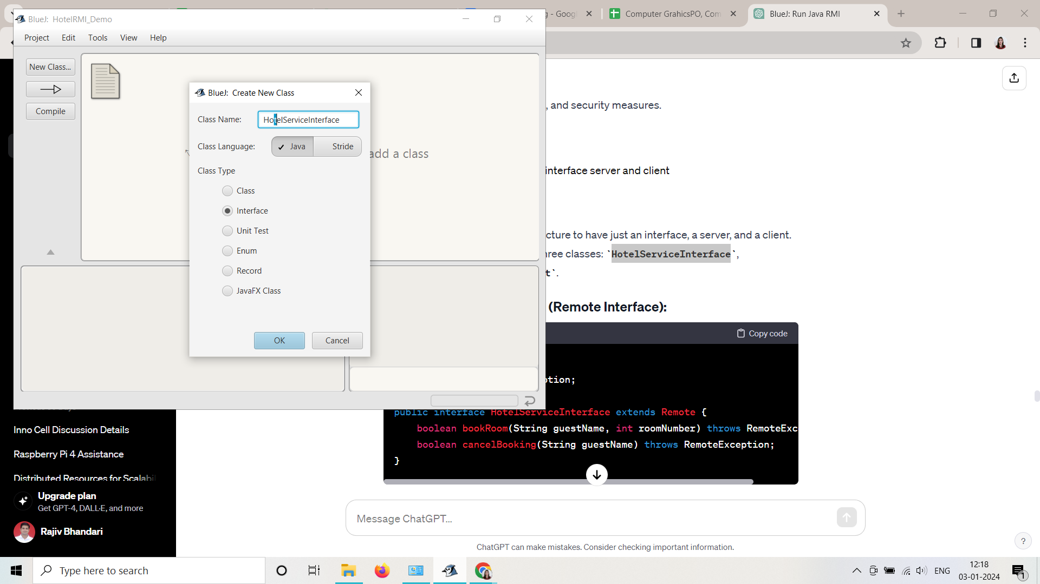

**Step 3:** Interface has been Created . Right click on Block of Interface.

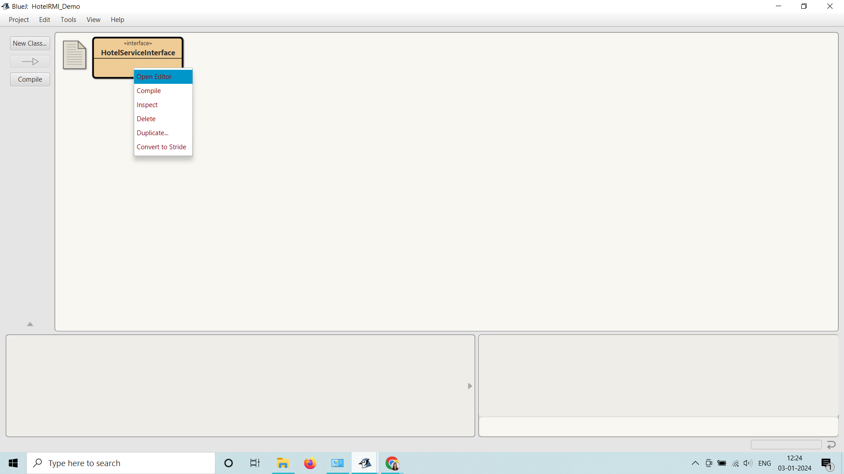

**Step 4 :** Click on Open Editor. Write the code of Interface here and Compile it.

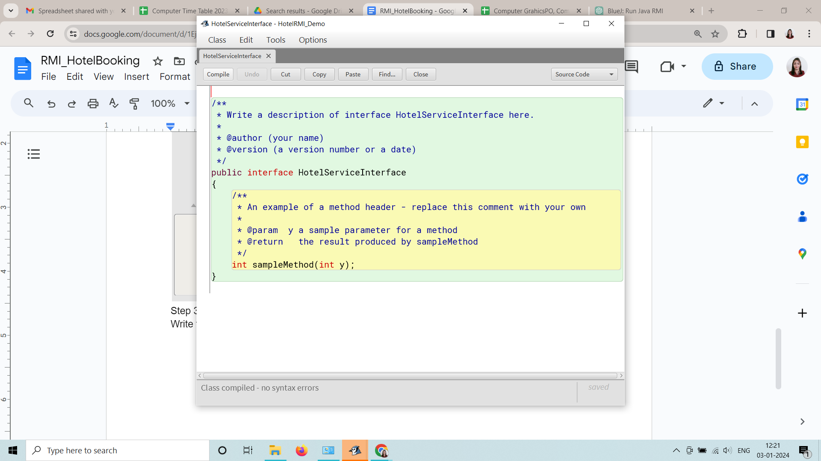

**Step 5:** In the similar way create two more classes HotelServer, and HotelClient. Open the editor and write the code and compile the both classes. On successfully completed the above procedure the diagram will be.

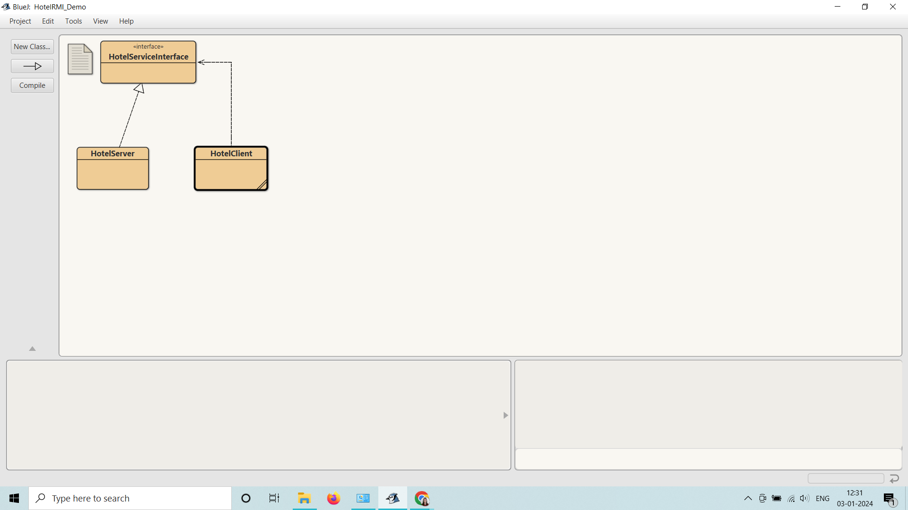

**Step 6:** Write Click on the block of HotelServer Class and select the main method call.

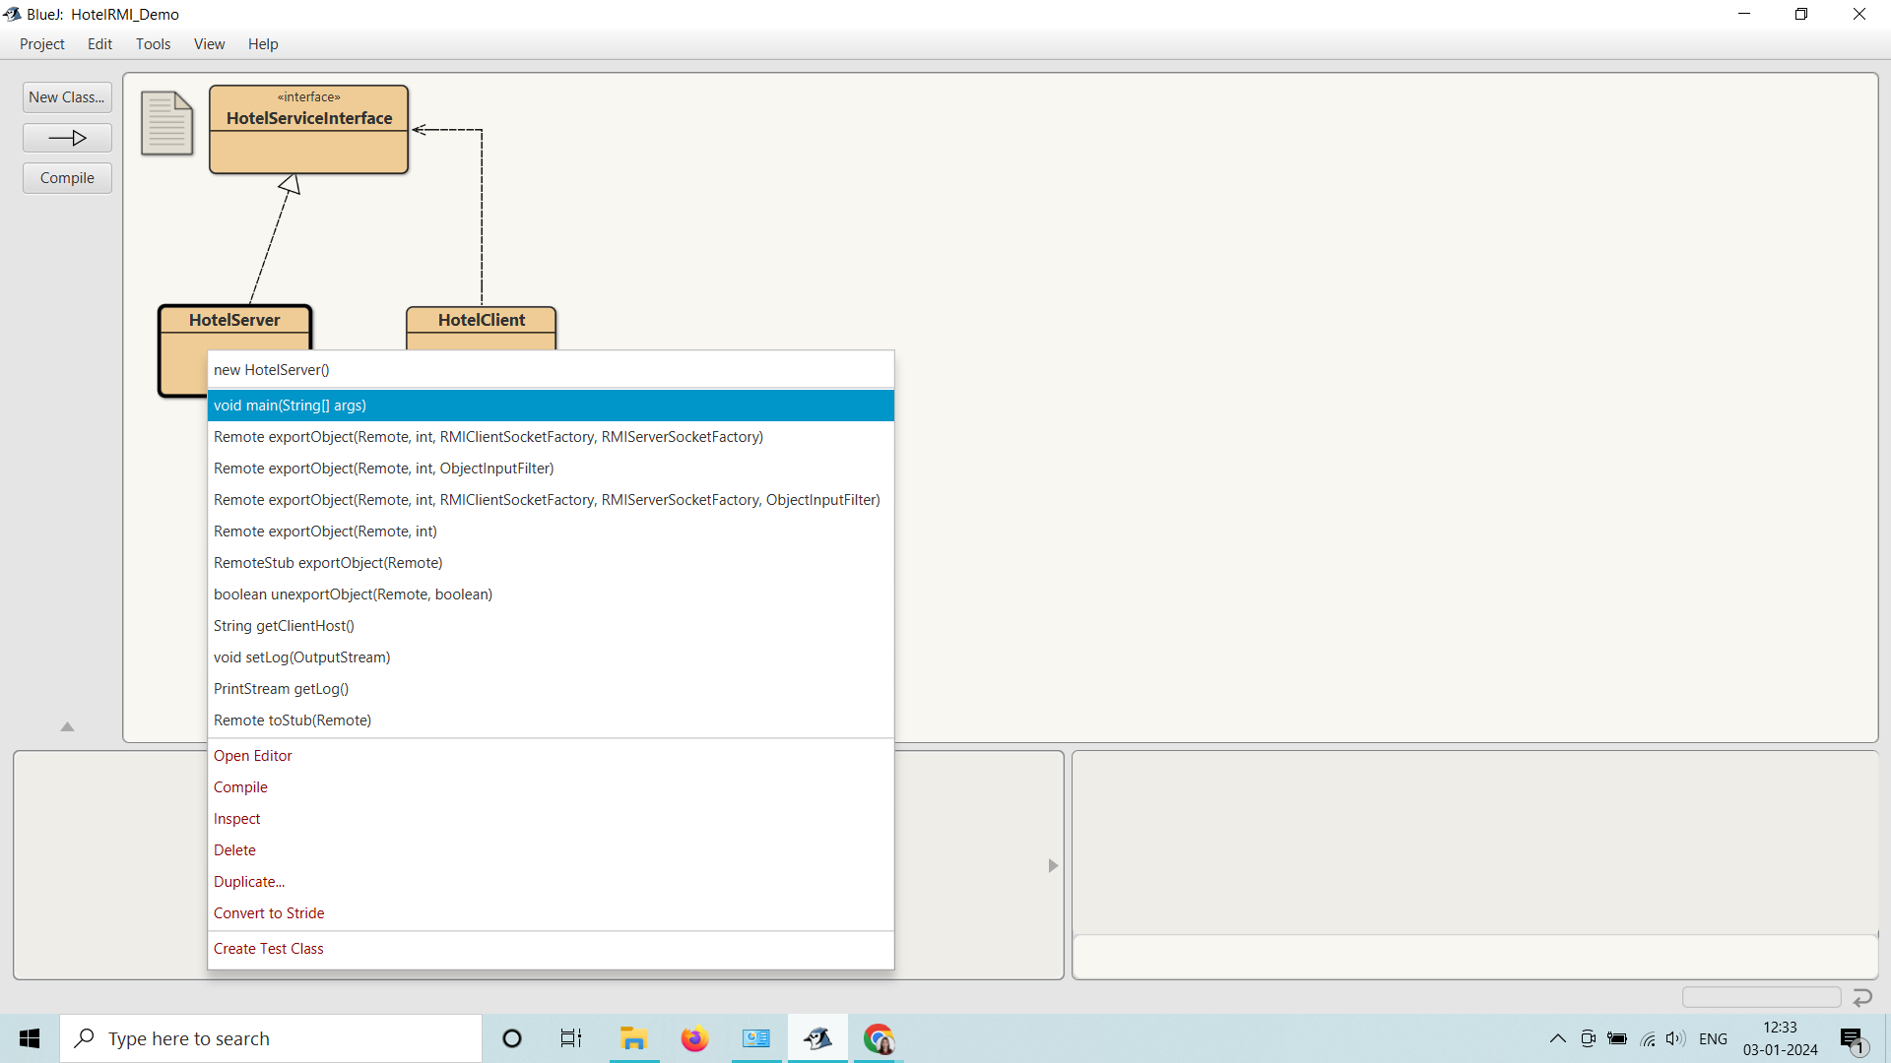

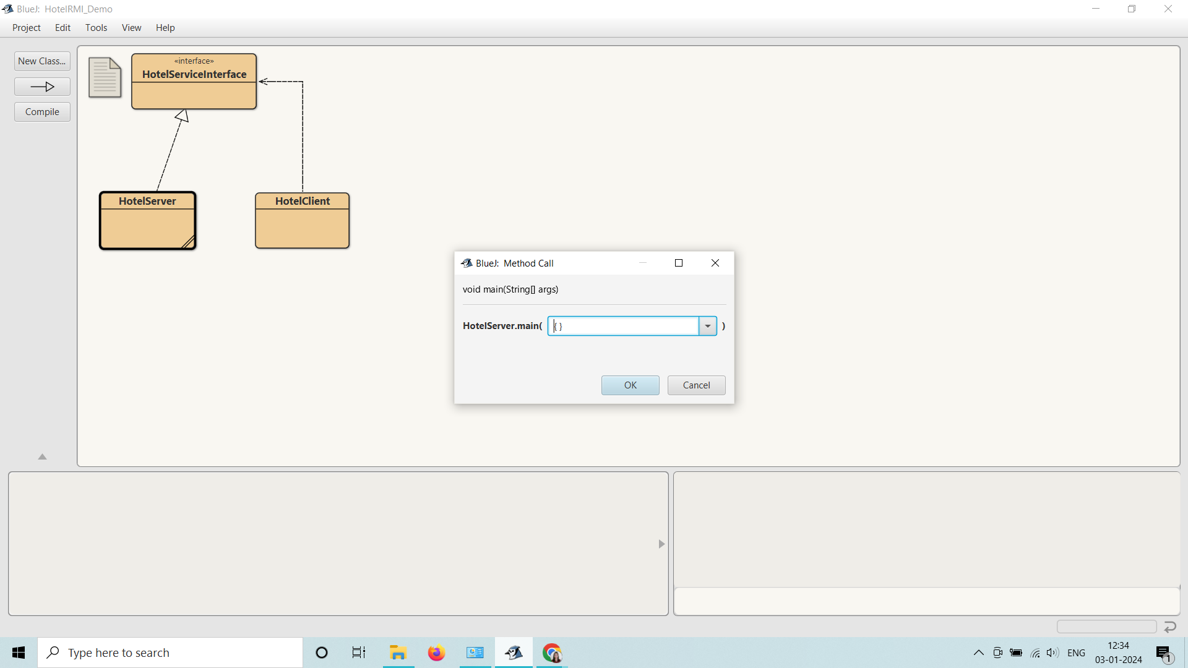



**Step 7:** Observe the HotelServer is running on Terminal Window.

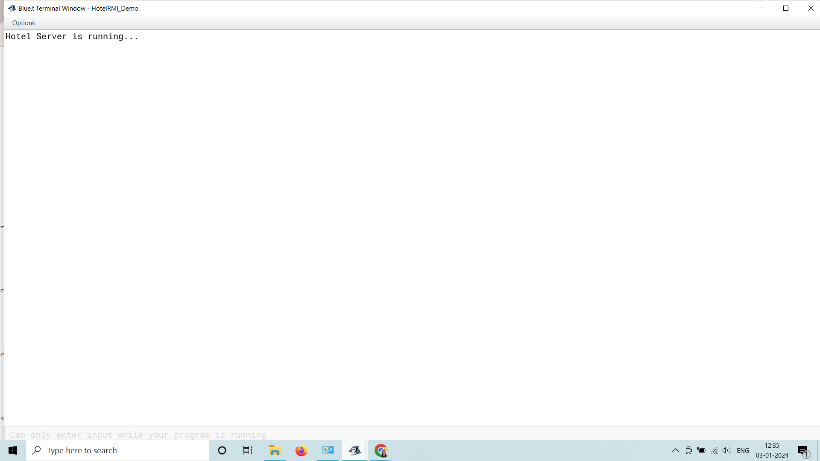

**Step 8:** In the similar way Right click on the block of HotelClient Class and select the main method call. Observe the HotelClient is running on Terminal Window.

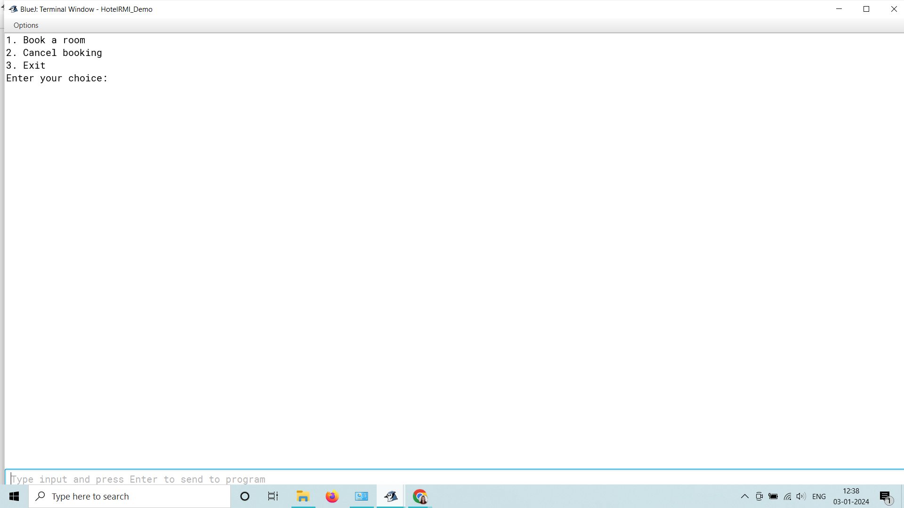

**Step 9**

Give the appropriate choice in the Terminal window and Run the code successfully.