Game documentation and HowTo guide.
CAVE RUN 3D

This document contains:

- Package description and contents.
- A description of the game's library items.
- Cheat Sheet: All the components with quick descriptions

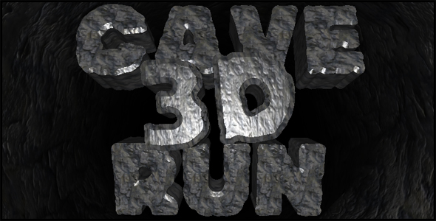

Package Description and contents
This is a UNITY3D file. To use it, download the free Unity tool from here.

Top of Form

Bottom of Form

Top of Form

Bottom of Form

This is a 3D version of my Cave Run Flash Game. Run like crazy, jumping on platforms and avoiding obstacles. Collect as many gems as you can and don't fall!
CONTROLS:
Move with the mouse, and Hold the mouse button to jump. Hold longer to jump higher, and click twice to double jump.

Have Fun!


• Easily publish your game for mobiles, web, PC/Mac, and consoles.
• Add any number of obstacle types with varying effects on player speed, rotation, and jump power. Make obstacles that stick to the player, or others that knock him up in the air.
• Control the shape and size of platforms by setting various attributes like length, width, height, rotation, and shift, rate of obstacles and gems.
• Customizable horizontal menu for easier button setup
• Customizable player attributes, Speed, rotation, jump power, animation sets and sounds.
• Many customization options for tweaking the level of challenge the game provides.

CREDITS:
The font used in this game is JFRock by Jester Font Studio
The sounds are courtesy of the free sound project.
Credits go to these authors for their great sound samples: Prozaciswack, RHumphries, pushtobreak, HerbertBoland, hello_flowers, rutgermuller, CGEffex
Please rate my file, I’d appreciate it

A Description of the Game's Library Items
Open the game project to look at the library folders:

- FBXModels: Contains the 3d models used in the game. These were created in 3DSMax and then exported to FBX. If you need the original Max files, send me a message.

- Materials: Contains the materials (not textures) used within Unity.

- Prefabs: These are the objects you actually play with in-game, comprised from several elements put together in a single object (3d model, script, sound, etc). For example, the Player is made up of a 3d model, along with a script to make it interactive, and a sound.

- Scenes: The start, game, and end, scenes which you play.

- Scripts: Many small pieces of code you add to your prefabs to make them interactive. You'll find a script for the camera, the player controls, obstacles etc.

- Sounds: All the sounds for the game, courtesy of the Free Sound Project.

- Textures: Textures for the Platforms, the obstacles, and the effects.

- GUI: Textures for the HUD, the menu, and the fonts

Cheat Sheet: All components, with a quick description

To start editing the file, open Unity3, then choose File>Open Scene then go to the directory of the game, and open Assets > CaveRun3D Assets > Scenes > game.unity. This will open the main game scene. Notice there are 2 other scenes in the directory, start, and end.

I gathered all the components in one Cheat Sheet. Here you can read about every customizable feature in the game:
Excel sheet
Open Doc Sheet

It is highly advised, whether you are a designer or a developer to look further into the code and customize it to your pleasing. See what can be improved upon or changed to make this file work better and faster. Don't hesitate to send me suggestions and feedback through my profile page at majd_abdul on the activeden.net
Good luck with your modifications!

