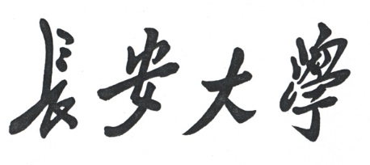

**毕业设计外文翻译**

**学 院: 信息工程学院**

**专 业: 软件工程**

**姓 名: 穆蕾**

**学 号: 201424060231**

**指导教师: 王夏黎**

**完成时间: 2018年 4 月 21 日**

**英**

**文**

**文**

**献**

A ROBUST ROAD SIGN RECOGNITION METHOD

USED BY IN-VEHICLE CAMERA SYSTEMS

**Xiaohui XIE[1], Weijie LIU[2], Gang WU[1], Qiang WEI[1]**

**Panasonic Research and Development Center, China [1]**

**Panasonic AV Core Technology Center, Japan [2]**

**Email: xiexiaohui@cmrd.panasonic.com.cn**

ABSTRACT

A robust road sign recognition method is proposed in this paper. Templates of road sign images are represented as a hierarchical structure of some component blocks. In the paper approaches for block selection and for hierarchical structure construction are our contributions. Existing block based methods require that template images having sufficient texture, but which is not the situation for road signs. In our method, blocks used as basic matching units (BMU) are selected based on calculations of their penetration numbers. And the hierarchical structure is formed by comparing the cover areas of different subsets of all BMUs. Experiments on actual video clips taken by in-vehicle cameras proved the robustness and efficiency performance of our method.

INTRODUCTION

The main objective of road signs is to regulate traffic. Road signs supply information to help drivers operate their cars in such a way as to enhance traffic safety. However, they may not be noticed sometimes when, for example, a driver gets tired or drunken. A stable road sign recognition system is thus desirable to alert the driver or give a signal to an ACC system at that time. Other applications of road sign recognition include navigation to unmanned driving.

Many techniques have been developed to detect road signs. Piccioli et al [1] retrieved triangular and square contours in an edge image by selecting the edge segments with proper slopes and checking whether their endpoints are close enough and form certain angles. Their approach usually suffers difficulties when retrieving broken edges. Escaleera et al [2] localized triangular signs by seeking the coexistence of three types of corners that form a triangle; and the similar principle were applied to square and circle detection. However, their method strongly relies on corner detection and classification, which are not easy in clutter scenes. Jimenez et al [3] developed a sign shape classification algorithm based on the FFT of the contour signature of a segmented blob. But their classification requires completely-filling blobs; thus an intractable preprocessing of enclosing blob gaps is necessary. Loy and Barnes [4] applied a radial symmetry algorithm to detect regular polygons. They took advantage of the radial symmetry nature of a regular polygon to locate its center. Moreover, they used a rotation-invariant measure, named n-angle gradient, to distinguish polygons with different numbers of side *n*. But their method can only be used for detecting regular polygons.

In our research, we have developed a rapid algorithm to detect both regular and non-regular shape road signs, which is reported in another paper [10].

In the paper, we concentrate on recognition, which verifies detected road sign candidates of a particular bound shape with depicted road sign templates. Compared to detection, it seems few techniques have been proposed for road sign recognition. Normalized cross correlation [11], neural networks [9] and template matching [8] methods are most used in literatures. But all consider seriously the classification of lots of road signs, rather than recognition of one road sign under complex environments. Indeed under a particular bound shape there still exist many road signs, that is, recognition have to deal with more objects than detection, but road signs that should be targeted by an in-vehicle camera system in order to alert a driver are limited. So for our system it is more important to be accurate and robust rather than to be applicable to most road signs.

In fact, many variations occurring to road signs have to be taken into account for an in-vehicle camera system. Such as (some are shown in Fig.9): (1) Colors may fade after long exposure to the sun. Moreover, paint may even flake or peel off, and signs may get damaged. (2) Air pollution and weather conditions may decrease the visibility of road signs. (3) Outdoor lighting conditions vary from day to night and may affect the appearance colors of road signs. (4) Obstacles, such as trees, poles, buildings, and even vehicles and pedestrians, may occlude or partially occlude road signs. (5) Video images of road signs often suffer from blurring in case that the camera is mounted on a moving vehicle. (6) Size of road sign images usually increases when the vehicle moves close to them, as shown in Fig.1.

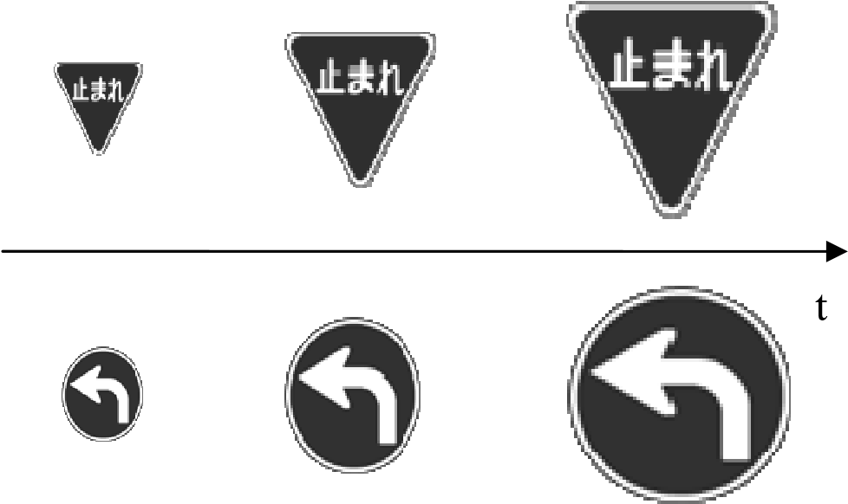

Fig.1 Road sign samples at different distances

To be efficient and robust under difficult conditions, object recognition methods based on local features have been proposed. One approach uses feature points. Under the approach, the SIFT method [6] is well known for its invariance property of the generated features to image scaling, translation, rotation, and partially to illumination changes and affine projection. But the first step in SIFT, that is, to determinate the points of interest by constructing a Gaussian pyramid, limits greatly its adoption to road sign recognition, because images captured at present usually are of small size and are blurred. Another approach uses feature blocks. A recent proposal under the approach suggested using feature hierarchies [7], where image blocks of locally maximal mutual information are extracted hierarchically to represent objects. But the method is not effective to pick up suitable blocks from road sign templates because the templates have not sufficient texture, with their only two or three colors, i.e. gray-levels, and definite patterns. Simple measures for block selection and a flexible structure for grouping blocks are necessary.

A novel recognition method based on a block hierarchy is presented in this paper. The blocks are selected based on a simple measure suitable for road signs. Rather than as usual tree hierarchies, the selected blocks are organized as a different multi-layer structure in our method. The block hierarchy generated takes into consideration that road signs are of few grey levels and simple patterns. One block hierarchy is generated by searching one template of a kind of road signs and is scaled and overlaid onto candidates detected. Matching between a template and a candidate is calculated based both block features and their hierarchy relations. Experiment results show that the proposed method has good robustness and calculation efficiency performance.

The rest of the paper is organized as follows. Firstly, the approaches to block selection and hierarchy construction are described respectively in the following sections. Then the matching process is shown. Finally, experimental results and conclusions are given.

BLOCK SELECTION

As a prerequisite, candidate road signs of a particular bound shape are assumed to be detected from the input images. As every candidate may have different size and varying color i.e. grey level, appearance, it is necessary to use some primary features of a candidate in order to ensure robust and real time recognition. It is noticed that road signs are usually painted with few colors, that is, they should show few gray levels with respect to their grayscale templates. So we can normalize and binarize the detected candidates, and to implement matching using binary images.

We definite a concept named penetration number for each image block to measure its information. According to the penetration number of blocks we search basic matching units (BMU) of an image, which are defined as the blocks with local maximum information. Details are described as below.

**Penetration Number**

Penetration number of an image block is generally defined as the intensity change frequency between foreground and background. For grey and color images, it could be obtained by counting edge points. As binary images are sufficient in our case, we give only a detailed description to binary images.

Suppose *A* is an *lm* * *ln* rectangle block area in a binary image *I*, its penetration number is calculated by

1 1

*F* = *lm* ∑*i p x*( )*i* + *ln* ∑*j p y*( *j* ) (1)

where, *p*(*xi*) means value change times from 0 to1 and 1 to 0 at line *x* = *xi*, while *p*(*yj*) value change times from 0 to1 and 1 to 0 at line *y* = *yj*. As shown in Fig. 2, line *x* = *x0* has a penetration number of two while line *y* = y*0* four. From the definition we could say that a block with a bigger penetration number contains more information. So block *A* with penetration number *FA* is said to be an informative block with *FA*.

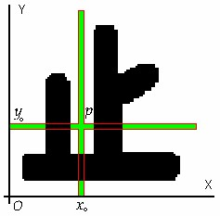

Fig.2 Penetration number

**Basic Matching Unit (BMU)**

A basic matching unit (BMU) is defined as such an image block which has a bigger penetration number than that of all its surrounding image blocks. Distribution of all BMUs with different scales in an image depends on contents of the image. Based on the penetration number, two BMU areas may be separate, overlapping and containing each other.

BMUs are searched only from templates of road signs. For candidates to be detected, the corresponding BMUs are extracted by scaling and overlaying one template onto it. In another words, BMUs are found at training phase. So we can use an exhaustive search.

For a template road sign, blocks of different sizes, say from 10% up to 100% of image size, are considered and all their penetration numbers are calculated. Then with a particular block, we investigate its surrounding blocks to determine if it is a BMU. In detail, suppose *A* is a block with a penetration number *FA*, we can translating *A* by [Δ*x*, Δ*y*] or scaling *A* by [1-*k*, 1+*k*] to obtain a block A’, where Δx and Δy are small constants and 0<*k*<1. Assume *A*’ with a penetration number *F*’*A*, if condition

*FA* > *FA*' (Δ Δ*x*, *y k*, ) (2)

is satisfied, *A* is determined to be a BMU.

As penetration number is an information measure, from the definition of formula (2) we know that a BMU points to an area of a road sign where a local maximum with respect to the information measure occurs. If compared to [7], a BMU corresponds to a variant of the informative blocks which is specifically applicable to images of simple texture. Fig. 3 gives an example for extracting a BMU for a turn-left road sign. When moving a block up, down, to left and to right, the corresponding penetration numbers are calculated. In the figure, (i) and (j) show the results for shrunk and magnified blocks respectively.

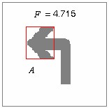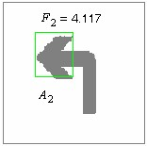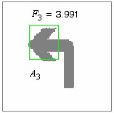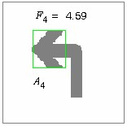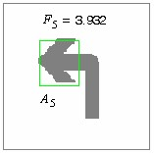

(a) BMU (b)up shift (c)right-up shift (d)left shift (e)right-shift

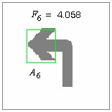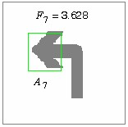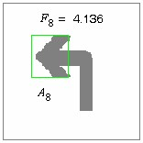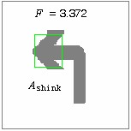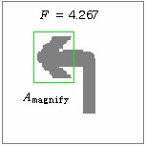

(f) left-down shift (g) down shift (h)right-down shift (i) shrink (j) magnify Fig.3 A sample of BMU

**HIERARCHY CONSTRUCTION**

After all BMUs of an image are searched, a flexible hierarchy structure that organizes those BMUs is necessary. Two reasons exist for needing such a hierarchy. One is that road sign candidates detected from an input image are usually noise, so not all details can be extracted always. A coarse-to-fine multi-layer feature structure is then effective. Another one is for speed-up. As road signs are observed from small size to big size (see Fig. 1), a coarse-to-fine matching process may give a decision at an early stage.

But unlike the tree structure of [7], where sub-blocks are further extracted from a parent layer block, we develop a different structure here. In our case, a tree structure is helpless because our BMUs with different scales usually overlap to each other. Thus a tree structure can not organize all BMUs necessary.

We give a brief description about a relationship between BMUs and the image. Then propose our method for hierarchy construction.

**Maximal Cover of Images**

A subset of BMUs give a cover to the foreground of an image. Let *ZA* is the foreground of image *I,* and A*i* (*i*=*1,…,N)* are a subset of BMUs, if *Ai* satisfies the condition that *Ai* covers

the largest area of *ZA* than any other subsets, and *A Ai*1 ⊄ *i*2 (∀*i i*1, 2, *i1≠i2, i1=1,…,N, i2=1,…,N)*, A*i* (*i=1,…,N)* is defined as the maximal cover of the image *I*. Similarly, the maximal cover can be defined for blocks too.

**Construct Hierarchical Structure**

Firstly, we find all maximal covers from all subsets of BMUs. Then we decide the one with the smallest number of BMUs as the top-layer of the hierarchical structure. And its BMUs are called top-layer BMUs. In our experiment, the top-layer is formed with only one BMU, which corresponds to the rectangular circumscribing the foreground of an image. Next, for each top-layer BMU we find all its maximal covers, but the covers are required not containing any top-layer BMUs. Likely, we find the cover with the smallest number of BMUs for each top-layer BMU and form the second-layer of the hierarchy. The procedure can be repeated until no more cover exists, and thus a complete multi-layer hierarchical structure is built. It should be noted that BMUs at a child layer may cover a larger area than its parent.

Two examples are shown in Fig. 4, where (a) depicts a stop, and (b) a turn-left road sign in Japan BMU *A* is a parent-layer BMU, and *B1, B2* are two child-layer BMUs.

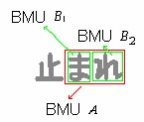 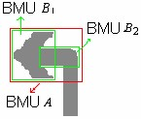

(a) Stop road sign (b) Turn-left road sign Fig.4 BMU hierarchy samples

**HIERARCHICAL STRUCTURE MATCHING**

**Recognition Flowchart**

BMUs and their hierarchical structure are built offline at a training step, where templates of target road signs are used as inputs. Otherwise, an online matching process is enforced between detected road sign candidates and depicted templates. BMUs of the candidates are marked by scaling and overlaying corresponding templates onto them. A primary flowchart of our recognition process is shown in Fig. 5.

Input Templates

Binarization

Extract BMUs

Construct Hierarchy

Compute Features

Input Candidates

Binarization

Mark BMUs

Set Hierarchy

Compute Features

Match

Get Results

Save Template

(

a) Offline training (b) Online matching

Fig. 5 Flowchart of recognition

**Examples of Hierarchical Structure**

Fig. 6 shows two examples of hierarchical structure with two Japanese road signs. Both are constructed with three layers. The left one gives a direct result in coincidence with our intuition, where the text area is suitably divided at different levels.

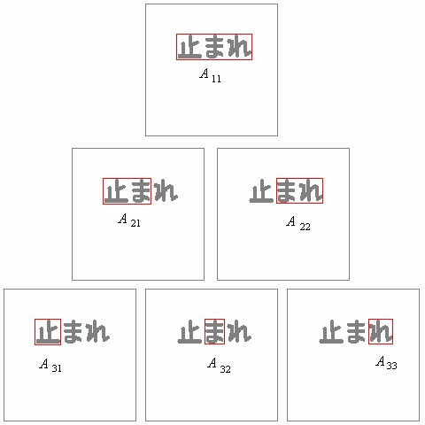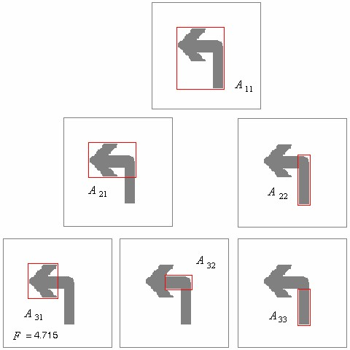

Fig.6 Examples of hierarchical structure

**Features and Similarity Measure**

Matching between two hierarchical structures of BMUs are implemented based on features of BMUs and their similarity measures. At present, several primary features are used in our development. Among them, one is the gravity center positions of BMUs within an image, which represents the space distribution of all BMUs. Other features include vertical and horizontal histograms of BMUs, which are thought suitable block features especially for low resolution images. Examples are shown in Fig. 7.

Similarity measure is implemented both with features and with hierarchical layers. For example, gravity center positions are compared with their relative coordinates within the bound shape of road signs, and histograms are compared through calculating the correlation of their outline curves. Other features, e.g. errors occurring when overlay templates onto detected candidates, can also be considered, but we indicate that simple features work well for our systems.

As BMUs are organized as a multi-layer structure, similarity measure for hierarchies is a fusion of that for individual layers. And the similarity measure for a layer is also a fusion of that for its BMUs. Simply, suppose the similarity of a BMU pair *j* at level *i* is *Sij*, and the similarity of layer *i* is *Si*, 1≤*i*≤*M*, 1≤*j*≤*N*, the fusions can be implemented by weighted sums as follows

|  |  |
| --- | --- |
| *Si* = ∑β*j* ⋅ *Sij*  *j* | (3) |
| *S* = ∑α*i* ⋅*Si* = ∑ ∑α β*i* ⋅( *j* ⋅*Sij* ) . | (4) |

*i i j*

where, αi and βj are suitable weights.

One important note is that we calculate the similarity from the top-layer BMUs. This is the situation for an in-vehicle camera system. And we can know if the similarity is low enough or high enough. If too low we can decide that the candidates are not real road signs at an early time when the in-vehicle camera is still far from the road sign and can not supply more details. If high enough we also decide a success for the recognition, according to how many BMUs have been considered. Either gives a speed up for the matching.

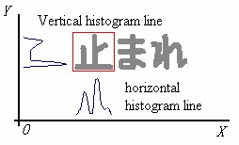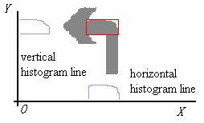

(a) Stop road sign (b) Turn-left road sign

Fig. 7 Feature selection for BMUs

**EXPERIMENTAL RESULTS**

Experiments on real videos captured with in-vehicle cameras are conducted to evaluate the proposed method. All our test data includes 12 video clips taken under different weather conditions, including in the morning, daylight and nightfall. Road signs include the Stop and the Turn-left road signs in Japan. Some videos also include blurred and occluded road signs.

Table 1 gives the total experimental results and Fig.8 shows the corresponding ROC curves.

|  |  |  |  |  |  |
| --- | --- | --- | --- | --- | --- |
| Video Clip  Number | Frame Number | Candidates  Number | False  Positive  Rate | False  Negative  Rate | Correct  Rate |
| 12 | 1429 | 1615 | 0.74% | 0.43% | 98.83% |

Table 1 Experiment results on 12 video clips

Table 1 shows that the proposed method achieves a recognition rate of 98.83% with 1615 detected candidates. It is better than that of using other methods, such as template matching with about 70%, and neural network with about 80%. At present our method recognizes candidates stably if the candidates have a size larger than 28x28, which corresponds to about 50 meters of distance with respect to our camera parameters.

Efficiency is also tested at the experiment. By using a PC with a Pentium CPU 1.8GHz and 256M memory, our method costs 4.5ms to match one candidate, that is, 222 matches can be done in one second. Figure 9 gives some variations of the Stop road sign. It is obvious that the proposed method gives a satisfied robustness performance besides its better accuracy and efficient real-time performance.

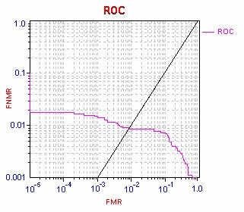

Fig.8 ROC curves of the experiment results

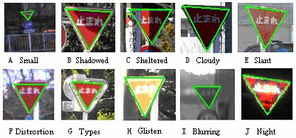

Fig.9 Samples of recognition objects

**CONCLUSION**

In this paper, we proposed a novel road sign recognition method. The method represents a road sign templates using a hierarchical structure of image blocks, which we have named as basic matching units (BMU). The blocks are selected based on penetration numbers and their hierarchical structure is constructed based on calculating maximal covers of BMU subsets. Rather than existing approaches, the hierarchical BMU structure is especially suitable for recognizing road signs. Experiment results show that our method has a satisfied robustness and efficiency performance.

**REFERENCES**

[1]. G. Piccioli, E. De Micheli, P. Parodi and M. Campani, “Robust Method for Road Sign Detection and Recognition”, Image and Vision Computing, Vol. 14, 1996.

[2]. Arturo de la Escalera, Luis E. Moreno, Miguel Angel Salichs and Jose Maria Armingol, “Road Traffic Sign Detection and Classification”, IEEE Transactions on Industrial Electronics, Vol. 44, No. 6, 1997.

[3]. P. Gil Jimenez, S. Lafuente Arroyo, H. Gomez Moreno, F. Lopez Ferreras and S. Maldonado Bascon, “Traffic Sign Shape Classification Evaluation II: FFT Applied to the Signature of Blobs”, IEEE Intelligent Vehicles Symposium, 2005.

[4]. Gareth Loy and Nick Barnes, “Fast Shape-based Road Sign Detection for a Driver Assistance System”, IEEE/RSJ International Conference on Intelligent Robots and Systems, 2004.

[5]. Milan Sonka, Valclav Hlavac and Roger Boyle, “Image Processing, Analysis, and Machine Vision”, Second edition, Brooks/Cole press, 2001.

[6]. D.G.Lowe. Distinctive Image Features from Scale-Invariant Keypoints. IJCV, 2004.

[7]. B.Epshtein, S.Ullman, Feature Hierarchies for object Classification, ICCV 2005, Beijing, China

[8]. Y.B.Lauziere, D.Gingras, F.P.Ferrie. A model-based road sign identification system. IEEE International Conference on Computer Vision and Pattern Recognition, 2001.

[9]. H.Ohara, I.N.S. Miki, N.Yabuki. Detection and recognition of road signs using simple layered neural networks. International Conference on Neural Information, 2002.

[10]. G. Wu, W. J. Liu, X. H. Xie, and Q. Wei, A shape-based method for traffic sign detection, submitted to ITS World Congress 2007, Beijing.

[11]. N. Barnes, G. Loy, D. Shaw, and A. Robles-Kelly, Regular polygon detection, ICCV 2005.

**中**

**文**

**翻**

**译**

**一种鲁棒性的的路标识别方法**

**用于车载摄像系统。**

谢晓惠[1]，刘伟杰[2]，吴刚[1]，[1]松下研发中心，中国[1]

松下AV核心技术中心，日本[2]

**文摘**

这篇论文提出了一种鲁棒的路标识别方法。路标图像的模板被表示为一些构件块的层次结构。本文提出了分段选择和分层结构施工的方法。现有的基于块的方法要求模板图像具有足够的纹理，但这不是路标的情况。在我们的方法中，根据计算它们的穿透数来选择基本匹配单元(BMU)。并通过对所有BMUs各子集的覆盖面积进行比较，形成层次结构。对车载摄像机拍摄的实际视频片段的实验证明了它的鲁棒性。

**介绍**

道路标志的主要目的是管制交通。道路标志提供信息，以帮助司机驾驶他们的汽车，以提高交通安全。然而，有时他们可能不会注意到，例如，司机会疲劳或喝醉。因此，需要一个稳定的路标识别系统，以提醒司机或向ACC系统发出信号。其它道路标志识别的其他应用包括导航到无人驾驶。

已经开发了许多探测路标的技术，Piccioli等人通过选取合适的边坡的边缘段，并检查其端点是否足够近，并形成一定的角度，在边缘图像中检索三角形和正方形轮廓。他们的方法通常在检索破损边缘时遇到困难。Escaleera等人利用局部三角形标记，寻求形成三角形的三种角的共存曲线;并将相似原理应用于方形和圆形检测。然而，他们的方法却非常依赖于角落的检测和分类，这在杂乱的场景中是不容易的。Jimenez等人开发了一种基于分段blob轮廓签名FFT的符号形状分类算法。但它们的分类需要完全填充的斑点;因此，必须要有一个难以处理的封闭斑点的预处理。Loy和Barnes采用径向对称算法检测规则多边形。他们利用正多边形的径向对称性质，以确定其中心位置。而且，他们使用旋转不变测度，命名为n角梯度，用来区分不同数量的边n的多边形，但它们的方法只能用于检测普通的多边形。在我们的研究中，我们开发了一种快速的算法来检测正规化和非规律性的路标。

在本文中，我们将重点放在识别上，通过描述路标模板来验证所检测到的道路标号。相对于检测，似乎很少有技术被提出用于路标识别。归一化交叉相关，神经网络和模板匹配方法在文献中最常用。但是，所有人都认真考虑了许多路标的分类，而不是在复杂的环境下识别一个路标。事实上，在一个特定的约束形状下，仍然存在许多路标，即识别必须处理更多的物体而不是检测，但是道路标志应该被车载摄像机系统作为目标，以提醒司机是有限的。因此，对于我们的系统来说，准确和稳健更重要，而不是更重要。适用于大多数路标。

事实上，在车载摄像机系统中，必须考虑到许多发生在路标上的变化。例如(有些如图9所示):(1)长时间暴露在阳光下，颜色可能会褪色。此外，油漆甚至可能剥落或剥落，而且迹象可能会损坏。(2)空气污染和天气状况可能会降低道路标志的能见度。(3)户外照明条件日以继夜，可能影响道路标志的外观颜色。(4)树木、杆子、建筑物、甚至车辆、行人等障碍物，可遮挡或部分遮挡道路标志。(5)当摄像机安装在移动车辆上时，道路标志的视频图像经常会出现模糊。(6)道路标志图像的大小。

当车辆靠近时增加，如图1所示。

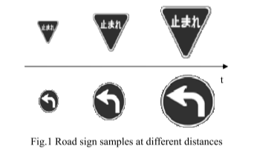

图 1 不同距离下的道路标线

为了在困难的条件下实现高效和鲁棒性，提出了基于局部特征的目标识别方法。一种方法使用特征点。在这种方法如下下,SIFT方法以其所生成的特征的不变性而闻名于图像的缩放、平移、旋转，以及部分的光照变化和仿射投影。但是，SIFT的第一步，即通过构造高斯金字塔来确定兴趣点，极大地限制了对路标识别的采用，因为目前捕捉到的图像通常都是小尺寸的，而且是模糊的。另一种方法使用特征块。最近的一项建议是使用特征层次结构，在这里，从层次上提取局部最大互信息的图像块来表示对象。

但该方法不能有效地从路标模板中提取合适的块，因为。模板没有足够的纹理，只有两到三种颜色，即灰度和确定的图案。简单的块选择方法和灵活的结构。组块是必要的。提出了一种基于块层次结构的识别方法。ocks是基于一种适合于路标的简单测量方法来选择的。与通常的树层次结构不同，选择的块在我们的方法中被组织成一个不同的多层结构。生成的块层次结构考虑到道路标志的灰度和模式都很简单。一个块层次结构是通过搜索一种路标的模板来生成的，并且被缩放并覆盖到被检测到的候选对象上。模板和候选对象之间的匹配是基于块特征和它们的层次关系计算的。实验结果表明，该方法具有较好的鲁棒性和计算能力。

效率性能。

本文的其余部分分别在以下章节中分别进行了描述。然后显示匹配过程。最后给出了实验结果和结论。

块选择

作为先决条件，假定特定约束形状的候选路标是从输入图像中得到。由于每个候选路标都有不同的大小和不同的颜色，比如灰度、外观，所以有必要使用候选人的一些主要特征，以确保其具有鲁棒性和实时性。人们注意到，路标通常是用很少的颜色来画的，也就是说，它们应该在灰度模板上显示很少的灰度。因此，我们可以使被检测到的候选对象规范化和标准化，并实现。使用二进制图像匹配。我们确定了每个图像块的概念名称d穿透数来测量它。根据块的穿透数，我们搜索一个图像的基本匹配单元(BMU)，它被定义为具有局部最大信息的块。

详细描述如下。

针入度

图像块的穿透次数通常定义为前景和背景之间的强度变化。对于灰度和彩色图像，可以通过计算边缘点得到。由于二元图像在我们的例子中是充分的，我们只给出一个。对二进制图像的详细描述。

假设A是一个lm * ln矩形，ck区在二值图像I中，其穿透数为计算为

  
 其中，p(xi)表示从0到1和1到0的值变化，在x = xi时，p(yj)值在y = yj时从0到1和1到0的变化。如图2所示，直线x = x0的穿透数为2，直线y = y0 4。从定义上我们可以说，一个具有较大渗透率的块包含了更多的息。所以阻止block a总被认为是一个信息丰富的组织。

公式 1

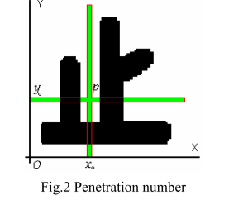

图 2 渗透数字

基础比对单元

一个基本的匹配单元(BMU)被定义为一个比所有周围的图像块更大的穿透数的图像块。在图像中不同尺度的BMUs的分布取决于图像的内容。基于渗透数字，两个BMU区域可能是分开的，重叠的和包含彼此。BMUs只在路标的模板上搜索。对于被检测到的候选者，相应的BMUs是通过缩放和覆盖一个模板来提取的。在另一个单词，BMUs是在训练阶段发现的。所以我们可以用穷举搜索。对于一个模板路标，不同大小的块，比如从10%到100%的图像大小，都被考虑，并且所有的穿透数值都是计算出来的。然后用一个特定的块，我们研究它周围的块，以确定它是否是一个BMU。详细,假设是一块渗透足总数量,我们可以翻译由[Δx,Δy]或缩放(1 k,1 + k)获得一块“,ΔxΔy小常量和0 < k < 1。假设一个如果条件允许的话。

由于渗透率是一种信息度量，从公式(2)的定义可知，BMU指向一个路标的区域，在该区域内，信息测量的最大值发生在某一区域。如果与[7]相比，BMU对应的是信息块的一个变体，它特别适用于简单纹理的图像。图3给出了一个为左转路标提取BMU的例子。当移动一个块向上，向下，向左和向右，相应的穿透数计算。在图中，(i)和(j)

分别显示缩小和放大块的结果。

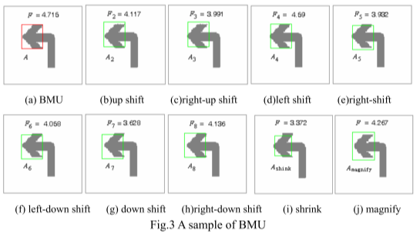

图 3 BMU样本

层次结构

在搜索图像的所有BMUs之后，需要一个灵活的层次结构来组织这些BMUs。需要这样一个层次结构的原因有两个。一个是，从输入图像中检测到的路标通常是噪音，所以不是所有的细节都可以提取。一个粗到细的多层特征结构是有效的。另一个是加速。当路标从小到大的时候(见图1)，一个粗到细的。匹配过程可以在早期阶段作出决定。但是，与[7]的树结构不同，子块是从父层块中进一步提取的，因此我们在这里开发了一个不同的结构。在我们的例子中，树状结构是无助的，因为我们的BMUs具有不同的鳞片通常是重叠的。因此一个树形结构不能组织所有必要的BMUs。我们简要描述了BMUs与图像之间的关系。然后提出了层次结构的方法。

最大的封面图片

BMUs的一个子集为图像的前景提供了一个封面。让咱是我的前景图像,人工智能(I = 1…N)是BMUs的一个子集,如果Ai满足你覆盖我的条件我咱比其他任何子集,最大的区域和⊄(∀i1,2我i1 Ai2,i1≠i2 i1 = 1,…,N,i2 = 1,…,N)、人工智能(i = 1…N)被定义为图像的最大覆盖。同样的,最大覆盖也可以定义为块。首先，我们从BMUs的所有子集合中找到所有最大的覆盖。然后我们选择最小数量的BMUs作为层次结构的顶层。它的BMUs被称为顶级BMUs。在我们的实验中，顶层是由一个BMU组成的，它对应于一个图像的前景的矩形。接下来，对于每一个顶级的BMU，我们发现它的最大的覆盖，但是封面是不需要包含任何顶级的BMUs。很有可能，我们找到了每个顶层BMU中最小数量的BMUs，并形成了层次结构的第二层。该过程可以重复，直到不再存在覆盖层，从而构建一个完整的多层层次结构。它应该注意到，在儿童层的BMUs可能覆盖比其母体更大的区域。

构建层次结构

首先，我们从BMU的所有子集中找到所有的最大覆盖。然后，我们以最小数量的BMU作为分层结构的顶层。它的BMU被称为顶层BMUs。在我们的实验中，顶层只形成一个BMU，它对应于图像前景的矩形边界。接下来，对于每个顶层BMU，我们发现所有的最大覆盖，但是覆盖不需要包含任何顶层BMUs。很可能，我们发现覆盖最小的BMU用于每个顶层BMU，并形成层次结构的第二层。该过程可以重复进行，直到不再存在覆盖，从而建立完整的多层递阶结构。应该注意的是，在子层上的BMUs可以覆盖比父层更大的区域。

在图4中示出了两个例子，其中（a）描绘了停止，并且（b）在日本BMU A中的左转路标是父层BMU，而B1、B2是两个子层BMUs。

 

(a) 停止路标 (b) 左转路标

结论

在本文中，我们提出了一种新的道路标志识别方法。该方法表示道路标志模板，使用图像块的层次结构，我们称之为基本匹配单元（BMU）。基于渗透数选择块，并基于BMU子集的最大覆盖来构造它们的层次结构。而不是现有的方法，分层BMU结构特别适合于识别道路标志。实验结果表明，该方法具有较好的鲁棒性和效率。

参考文献

[1]. G. Piccioli, E. De Micheli, P. Parodi and M. Campani, “Robust Method for Road Sign Detection and Recognition”, Image and Vision Computing, Vol. 14, 1996.

[2]. Arturo de la Escalera, Luis E. Moreno, Miguel Angel Salichs and Jose Maria Armingol, “Road Traffic Sign Detection and Classification”, IEEE Transactions on Industrial Electronics, Vol. 44, No. 6, 1997.

[3]. P. Gil Jimenez, S. Lafuente Arroyo, H. Gomez Moreno, F. Lopez Ferreras and S. Maldonado Bascon, “Traffic Sign Shape Classification Evaluation II: FFT Applied to the Signature of Blobs”, IEEE Intelligent Vehicles Symposium, 2005.

[4]. Gareth Loy and Nick Barnes, “Fast Shape-based Road Sign Detection for a Driver Assistance System”, IEEE/RSJ International Conference on Intelligent Robots and Systems, 2004.

[5]. Milan Sonka, Valclav Hlavac and Roger Boyle, “Image Processing, Analysis, and Machine Vision”, Second edition, Brooks/Cole press, 2001.

[6]. D.G.Lowe. Distinctive Image Features from Scale-Invariant Keypoints. IJCV, 2004.

[7]. B.Epshtein, S.Ullman, Feature Hierarchies for object Classification, ICCV 2005, Beijing, China

[8]. Y.B.Lauziere, D.Gingras, F.P.Ferrie. A model-based road sign identification system. IEEE International Conference on Computer Vision and Pattern Recognition, 2001.

[9]. H.Ohara, I.N.S. Miki, N.Yabuki. Detection and recognition of road signs using simple layered neural networks. International Conference on Neural Information, 2002.

[10]. G. Wu, W. J. Liu, X. H. Xie, and Q. Wei, A shape-based method for traffic sign detection, submitted to ITS World Congress 2007, Beijing.

[11]. N. Barnes, G. Loy, D. Shaw, and A. Robles-Kelly, Regular polygon detection, ICCV 2005.