class 05 R graphics intro

Hong bo Che

Jan 24th, 2019

# class 05 R graphics intro  
  
# my first box plot   
  
x <- rnorm(1000,0)   
  
boxplot(x)

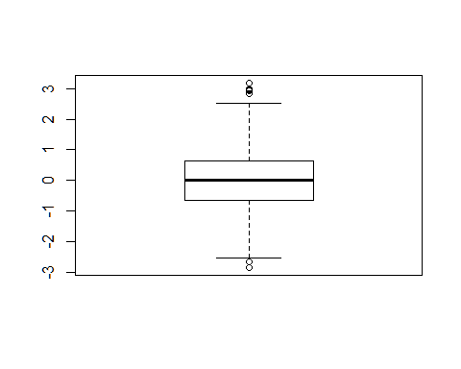

foo <- rnorm(10000, 0)  
boxplot(foo)

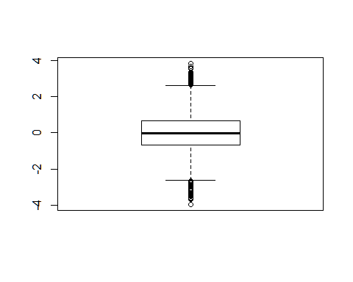

summary(x)

## Min. 1st Qu. Median Mean 3rd Qu. Max.   
## -2.853495 -0.649193 -0.003277 -0.015892 0.625513 3.184718

hist(x)

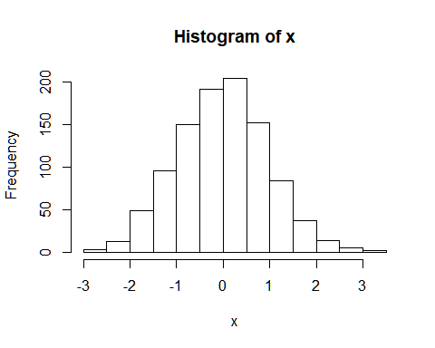

boxplot(x, horizontal = TRUE)

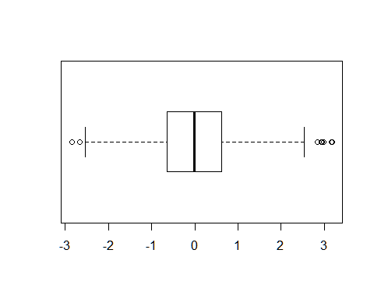

A script comment that includes **markdown** formatting.

#trouble summary statistics   
  
#the visual display of quantitative information   
 #good book!   
weight <- read.table("bimm143_05_rstats/weight_chart.txt", sep = '\t',header = TRUE)  
weight

## Age Weight  
## 1 0 3.6  
## 2 1 4.4  
## 3 2 5.2  
## 4 3 6.0  
## 5 4 6.6  
## 6 5 7.2  
## 7 6 7.8  
## 8 7 8.4  
## 9 8 8.8  
## 10 9 9.2

plot(weight$Age, weight$Weight, typ = "o",pch=15,cex =1.5, lwd = 2,ylim = c(2,10),xlab="Age(months)",  
 ylab="Weight(kg)", main = 'Maine lab')

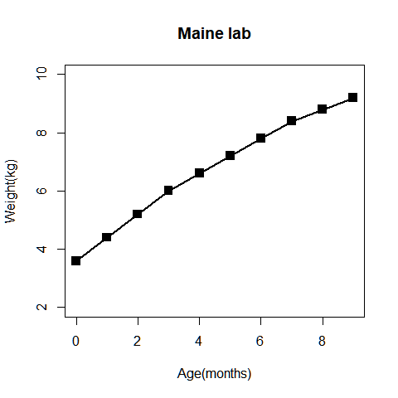

plot(weight$Age, weight$Weight, typ="o",   
 pch=15, cex=1.5:5.5, lwd=2, ylim=c(2,10),   
 xlab="Age (months)", ylab="Weight (kg)",   
 main="Baby weight with age", col = c('red','pink','yellow'))

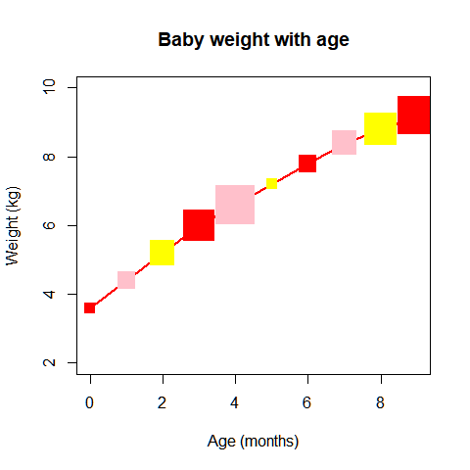

#ces recycles size without annotation, gimmicky  
mouse <- read.table("bimm143_05_rstats/feature_counts.txt", sep = "\t" ,header = TRUE)  
mouse

## Feature Count  
## 1 Messenger RNA 79049  
## 2 Coding Sequences 50770  
## 3 Genes 32029  
## 4 Transfer RNAs 26248  
## 5 CpG islands 13840  
## 6 Pseudogenes 5195  
## 7 Micro-RNAs 1638  
## 8 Small nucleolar RNAs 1602  
## 9 Small nuclear RNAs 1431  
## 10 Miscellaneous RNA 491  
## 11 Immunoglobulin Segments 474  
## 12 Ribosomal RNAs 341

par(mar=c(3.1, 2.1, 4.1, 2)) # for margins , bott, left, top, right( 4 directions)  
barplot(mouse$Count, ylab = "a", horiz = TRUE, names.arg = mouse$Feature, main="feature Count", las = 1)

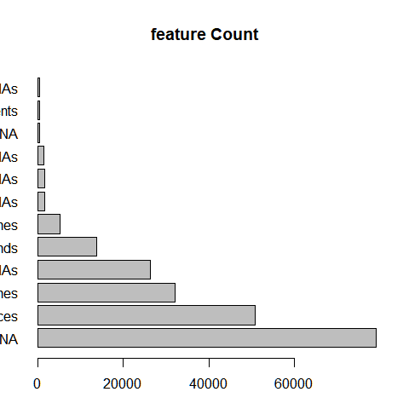

par()$mar # ck

## [1] 3.1 2.1 4.1 2.0

out <- c(rnorm(10000),rnorm(10000)+4)  
hist(out, breaks = 100)

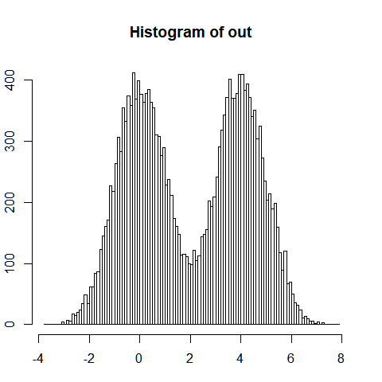

# color plots  
  
maleFemale <- read.table("bimm143_05_rstats/male_female_counts.txt", sep = "\t", header = TRUE)  
maleFemale

## Sample Count  
## 1 D1 Male 2  
## 2 D1 Female 1  
## 3 D2 Male 2  
## 4 D2 Female 3  
## 5 D3 Male 3  
## 6 D3 Female 6  
## 7 D4 Male 5  
## 8 D4 Female 10  
## 9 D5 Male 9  
## 10 D5 Female 18

barplot(maleFemale$Count, names.arg= maleFemale$Sample, ylab = 'count', col=rainbow(nrow(maleFemale)), las = 2)

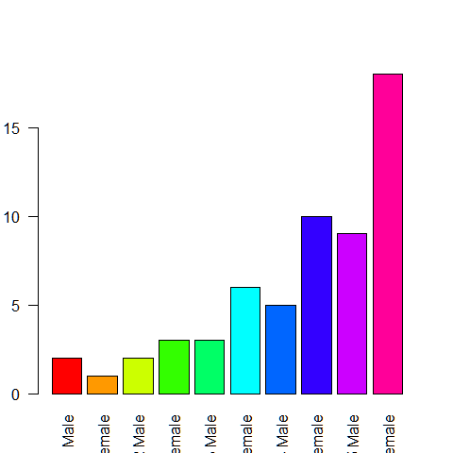

barplot(maleFemale$Count, names.arg= maleFemale$Sample, ylab = 'count', col = c("purple2","pink2"), las = 2)

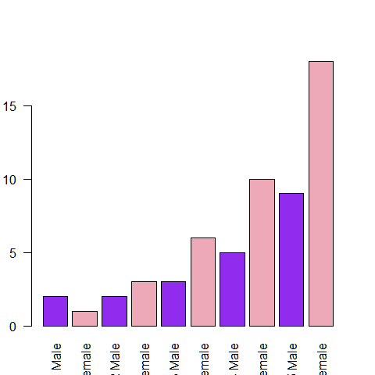

# color by value  
  
genes <- read.table("bimm143_05_rstats/up_down_expression.txt", sep = "\t", header = TRUE)  
table(genes$State)

##   
## down unchanging up   
## 72 4997 127

palette(c("blue", "gray","red"))  
plot(genes$Condition1, genes$Condition2, col = genes$State, xlab = "con 1", ylab = "cond 2" )

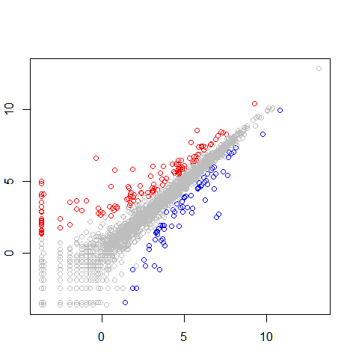

#dynamic use coloring  
meth <- read.table("bimm143_05_rstats/expression_methylation.txt", sep = "\t", header = TRUE)  
dcols<- densCols( meth$gene.meth,meth$expression)   
plot (meth$gene.meth, meth$expression, ylab = "expression", xlab = "meth", col = dcols, pch = 20)

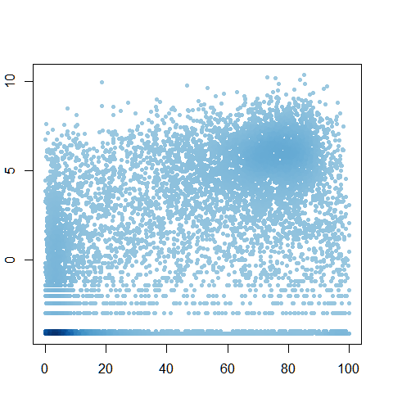

gZeroExp <- meth$expression > 0  
dcolsGZero <- densCols( meth$gene.meth[gZeroExp], meth$expression[gZeroExp])  
plot (meth$gene.meth[gZeroExp],meth$expression[gZeroExp] , col = dcolsGZero, pch=20, ylab = "expression", xlab = "meth")

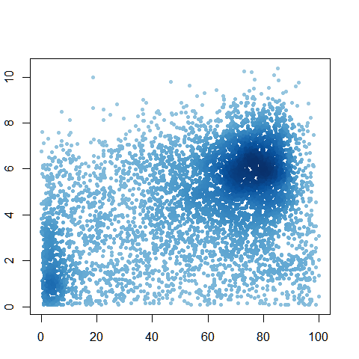

#ck ans  
gZeroExp <- meth$expression > 0  
dcols <- densCols(meth$gene.meth[gZeroExp], meth$expression[gZeroExp])  
plot(meth$gene.meth[gZeroExp], meth$expression[gZeroExp], col = dcols, pch = 20)



#colramp  
gZeroExp <- meth$expression > 0  
dcols.custom <- densCols(meth$gene.meth[gZeroExp], meth$expression[gZeroExp],  
 colramp = colorRampPalette(c("blue2",  
 "green2",  
 "red2",  
 "yellow")) )  
plot(meth$gene.meth[gZeroExp], meth$expression[gZeroExp],   
 col = dcols.custom, pch = 20)

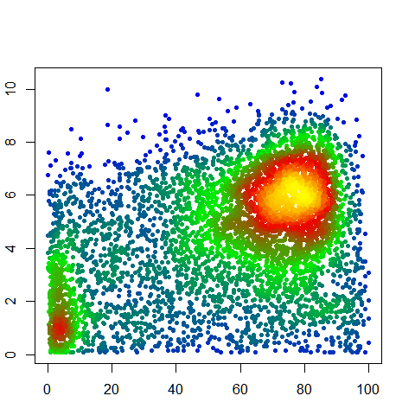

#color extension promotoer meth, gene meth  
par(mar=c(3.1, 3.1, 4.1, 2))  
plot(meth$promoter.meth, meth$gene.meth, xlab = "gene methylation", ylab = "promoter methylation")

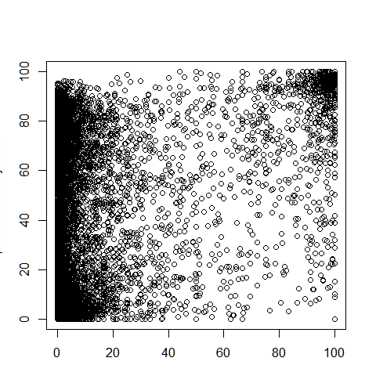

plot(meth$promoter.meth, meth$gene.meth, ylab="Gene Methylation", xlab="Promoter Methylation")

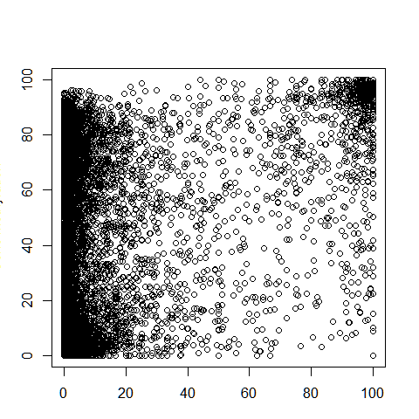

# methylation stuff  
source("bimm143_05_rstats/color_to_value_map.r")  
  
mycols=map.colors(meth$expression,   
 c(max(meth$expression), min(meth$expression)),   
 colorRampPalette(c("blue","red"))(100))  
  
plot(meth$promoter.meth, meth$gene.meth,   
 ylab="Gene Methylation",   
 xlab="Promoter Methylation",   
 col=mycols)

