## Meteorological Subsystem

The meteorological subsystem is represented by meteorological processing software connected to external data source

### Meteo Data representation

For representation of Meteo Data received from Meteo sensor, Wartsila SW used in 2 components: Server SW and Client SW.

#### Hydrometeorological Server (HMServer)

Hydrometeorological Server SW is windows bases application that receives data from RS/IP converter by TCP/IP protocol, processing and sends to Operator Display Units.

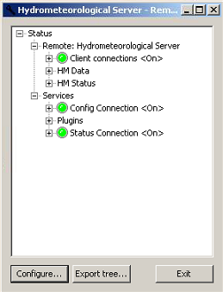

Figure 3‑13 - Hydrometeorological Server

#### Meteo Display Software Wartsila Remote Terminal

Is a part of Navi Harbour software.

The program interface includes the following components:

• Menu which contains a full list of program functions

• Information panels which show numeric data

• Status bar which contains information on the operation of connected equipment, name of the operator on watch, current date and time

Choose the **Sensor > Weather station** menu item. The **Weather Data** window opens up:



Figure 3‑14 – Weather Data menu

To view parameter details, expand the plus button at the right of the parameter name:



Figure 3‑15 –Expanded Weather Data menu