# VTS Processing Core

VTS Processing Core proposed by Wartsila consist of different kind of software.

### VTS Server

Navi Harbour software installed on VTS servers is described in chapter 6.

### Network Monitoring Server Software

Network Monitoring System (NMS) server located in Server Room of Control Tower and has PRTG Software.

PRTG performs the following functions:

* Centralized monitoring/diagnostic of software and hardware components;
* Monitoring equipment room/rack temperature and humidity;
* Watch out an unauthorized access to equipment rack and/or room;
* Monitor system usage (CPU loads, free memory, free disk space etc.);
* Graphical presentation of current component’s status;
* Monitor and account bandwidth and network device usage;
* System events and alarms presentation in tabular form;
* Data log of all system events and alarms in the database with search capability;
* Report generator to create reports in HTML or Portable Document Format (PDF).

PRTG Server component is responsible for monitoring of all components, generation of events and alarms, storing of them in internal SQLite SQL database. PRTG supports two thousand of sensors. Built-in web server with HTTP and HTTPS support is used for client connections.

Sensors are the basic building blocks of PRTG and are organized in an [Object Hierarchy](https://www.paessler.com/manuals/prtg/object_hierarchy). A sensor can tell you about one or more aspects (referred to as [channels](https://www.paessler.com/manuals/prtg/object_hierarchy.htm#channel)) of a device or node. For example:

* Uptime;
* Load;
* Interface throughput;
* Bandwidth usage (for example, flows);
* Loading times;
* Speed;
* Hardware status;
* Temperature;
* Quality;
* Resource consumption;
* User counts;
* Record counts;
* Log events;

The information boxes show how many alarms. Need to click the respective box to view the list of Alarms.



*Figure 5‑1 PRTG Information Box*

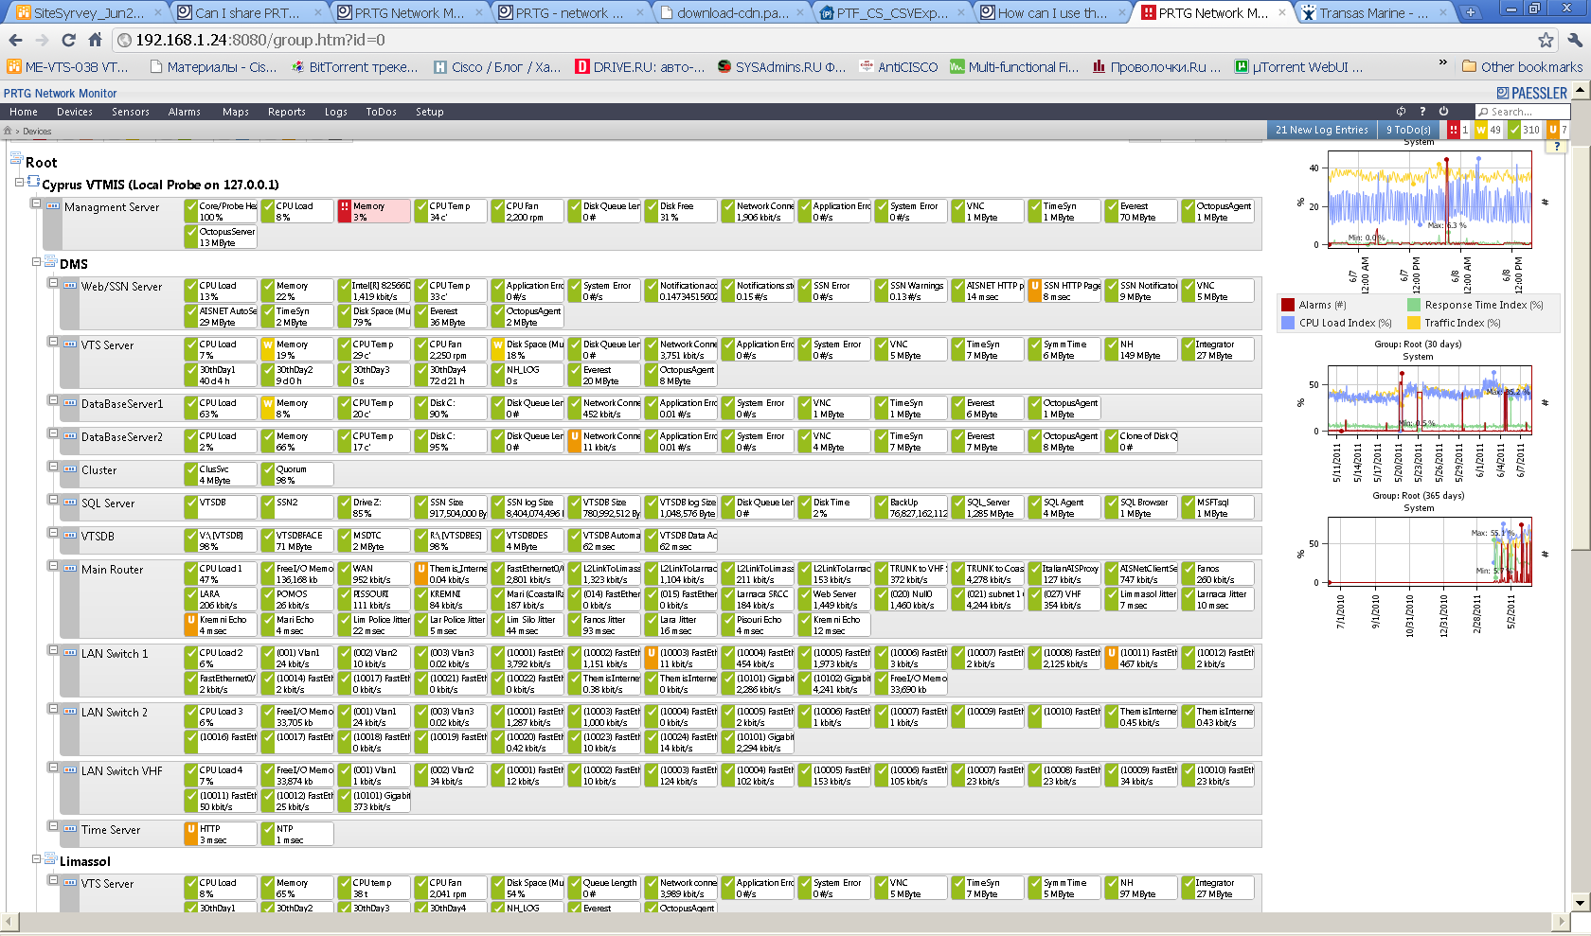

*Figure 5‑2 PRTG sensors list*

All servers, Industrial PCs and Operator PCs have Windows operating system. SNMP and WMI interface are used for monitoring of all PCs and application.

### Milestone Xprotect Product

XProtect Express is manageable, affordable IP video management software (VMS) for companies requiring a security solution with functionality beyond typical video surveillance capabilities. It is built with innovative technology designed to save you money and boost the overall performance of your hardware. With full alarm management capabilities and multi-layered map XProtect Express is suited for business with light live monitoring needs. It can manage up to 48 surveillance cameras and supports simple ways of incorporating video into existing business operations, such as linking access control to live video feeds.



Figure 5‑3 Distributed System Setup

### Milestone Xprotect Smart Client

Designed for Milestone XProtect® IP video management software, the XProtect Smart Client is an easy-to-use client application that provides intuitive control over security installations. Manage security installations with XProtect Smart Client which gives users access to live and recorded video, instant control of cameras and connected security devices, and an overview of recordings. Available in multiple local languages, XProtect Smart Client has an adaptable user interface that can be optimized for individual operators’ tasks and adjusted according to specific skills and authority levels.

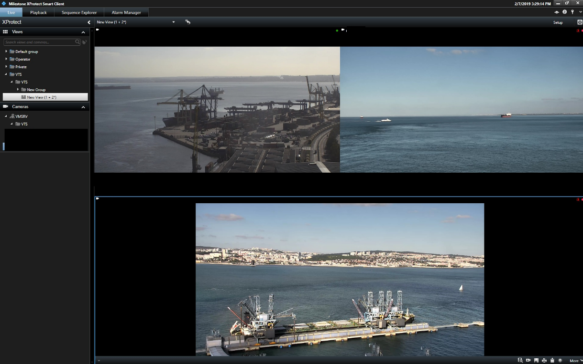

Figure 5‑4 Xprotect Smart Client Interface

### Database server

VTS Database SW provides extensive capabilities for managing and storing different types of data related to ships, ship visits and port activities in the tabular form:

* Input, storage and editing of data on new VTS information objects;
* Automatic input of information on AIS equipped vessels in the database;
* Automatic recording of ship visits data;
* Automatic recording of ship position in the VTS area;
* Referencing to scheduled visits;
* Use of database information for identifying acquired radar targets;
* Generation of Vessel Positioning report for a certain moment of time;
* Processing of information and display of data selected according to the parameters set by the operator;
* Easy-to-use and intuitive interface.

### Configuration

VTS Database SW consists of VTS Database Service components installed on VTS Database Server and several VTS Database Client Terminal. VTS Database Client Terminals are installed on Operator Workstations to provide access to VTS Database.

VTS Database consists of reference books. Reference book is a table in Database which contains data logically related to each other. The table row is called a Record of the reference book. Each table column called field has a name unique for this table. All the values in the columns are of the same type.

Database consists of several mutually related reference books. Contents of one reference book are used for filling in other reference books.

The VTS database has following base reference books:

* Vessels
* Visits
* Operations
* Log book
* Positioning
* Incidents
* Weather log

As these reference books are filled in, auxiliary reference books whose contents are displayed in the drop-down lists of fields with the same name are used:

* Companies
* Personnel
* Positions
* Meteo stations
* Regions
* Ports
* Flags
* Cargoes
* Vessel types
* Target Classes
* Company types
* Occupations
* Vessels in Incidents.

The names and field types of auxiliary reference books of VTS Database may be different for each particular database because database is created individually for the customer’s requirements **(including classification societies, ship owners and agents)**.

Example of Database window is presented on the figure below.

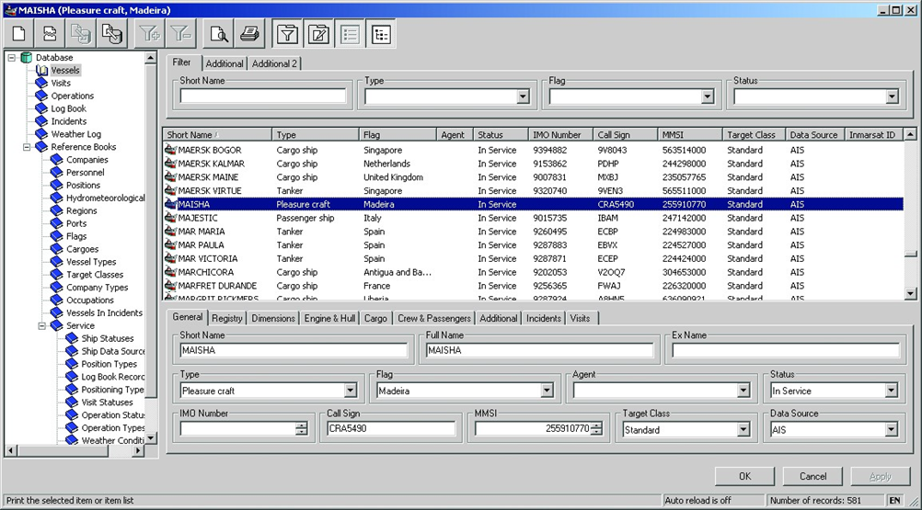

Figure 5‑5 Database Window

### Database Filling

After a new AIS target has been acquired, a search for the ship with the same MMSI number is made in the database:

* if the ship is found, this ship data is associated with the target;
* if the ship is not found, an entry can be added to the database and associated with the target. The following fields are filled in:
* Name and short name;
* MMSI;
* Call sign;
* INO number;
* Length, width, draught;
* Authenticity – “No”.

### Import Utility

There is a way to import data from any source having full information about imported data (format, Data Type, date, time etc). Example of VTS DB Exchange Service Utility is presented below.

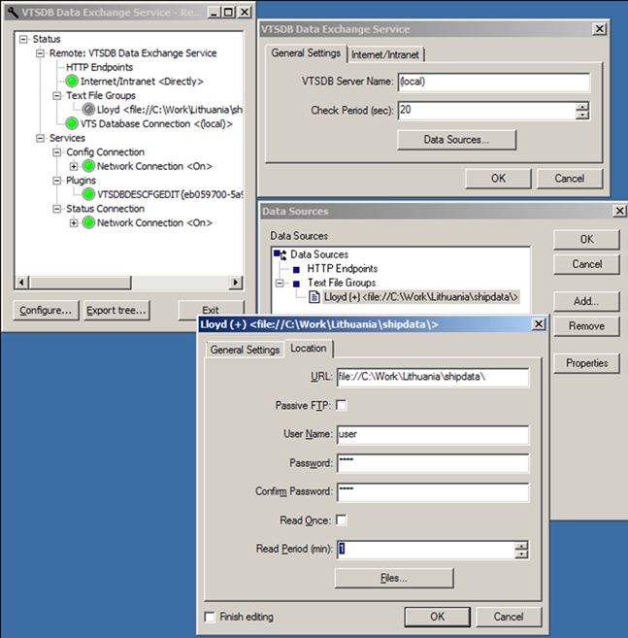

Figure 5‑6 Database Exchange Service Utility

### Handling Database Data

In the work with databases, the following operations are available to the operator:

* Adding, editing and deleting records
* Selecting information by criteria
* Sorting records
* Viewing and printing out reference books in the form of a table
* Creating ship position report.

Special tool allows operator to get vessel information from database. The tool allows opening the database window with information on the target selected with the cursor in the Chart window. The screen will display the database window with information on the selected target.

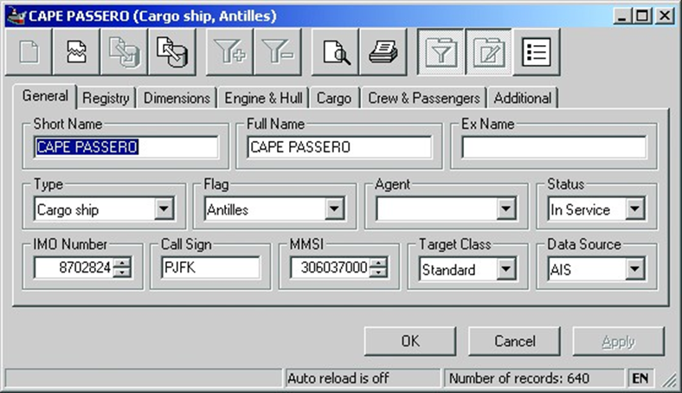

Figure 5‑7 Database window