### Base Station Controller AND BASE Station configurator software

Base Station Controller - Software component for configuration and management of AIS base stations, as well as the organization of traffic between base stations and other subsystems of the AIS software.

Base Station Configuration - a software component that is specifically designed to configure the AIS Base Station and software Base Station Controller by the service engineer and / or operator.

Base Station Controller and Base Station Configurator performs the following functions:

* Management AIS Base Station (powered transmitters, digital I / O etc)
* Manage the duplicated AIS Base Station (status monitoring, and control switching to reserve)
* Provide service diagnostics AIS Base Station (temperature, error messages and statistics reception state radio)
* Providing the client as much as possible to get traffic from the AIS Base Station, the possibility of sending traffic through the AIS Base Station, as well as providing management service AIS Base Station supporting system of differentiation of access rights to the functions of Base Station Controller
* Maintain a local database of incoming traffic AIS Base Station and providing its client software on request.

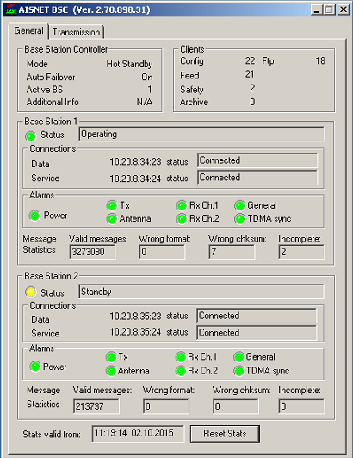

Figure 3‑4 Base Station Controller

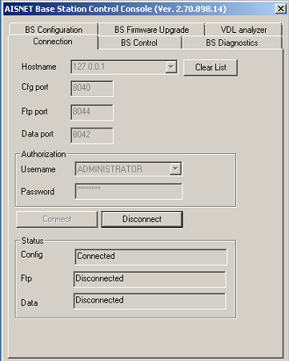

Figure 3‑5 Base Station Configurator