## Radar Subsystem

The radar subsystem is represented by radar processing unit connected to existing radar and radar processing software.

### Radar processing unit

The extremely versatile ScanStreamer unit can connect to virtually any radar transceiver on the market without any converters. It is designed to directly interpret the proprietary protocols used by the different manufacturers. It is currently offered with two protocols, dspnor proprietary and Asterix CAT-240 (UDP Unicast).

The efficient Ethernet design enables the board to transmit up to 98MB/s.

Several customers are using their own proprietary LAN protocol.

The ScanStreamer currently serves as a processor for applications used for Oil Spill Detection, C2 Systems, OEM Radar Processor, Ice Navigation, Wave Estimation, Small Target Trackers, Coastal Surveillance, WECDIS/ ECDIS Radar Overlay, Situational Awareness Systems and Generic Radar Processing.

The ScanStreamer can fully control a number of transceivers and more may be added. The unit supports RS232, RS485, RS422 and CAN bus.

The unit has two optically isolated inputs and one spare input for NMEA/AIS signals that may be distributed over LAN using the embedded multicast server.

There are no moving parts, no operating system, no harddrives and no risk of computer virus. It is a truly install and forget product. As of 2018 the MTBF of the MK I version was more than 23M hours!

The Radar Processor is useful should the resulting radar video be fed into systems with few or no processing capabilities such as chart systems and command & control systems. It contains the following components:

* Interference Reject Filter
* Rain Clutter Filter (FTC)
* Sea Clutter Filter (STC)
* Clutter Map Filter
* Modified Ordered Statistics CFAR
* Custom filtering packages
* Lossless ZLIB Compression (TBA)

The ScanStreamer can be supplied with a Synchro/Resolver snap-in card which accepts the most common Synchro/Resolver formats. This  useful feature enables quick and reliable LAN connectivity of  legacy radars. The latency between the trigger and the azimuth position is reduced to a minimum while the reliability is unsurpassed. The default video protocol is Asterix CAT-240..

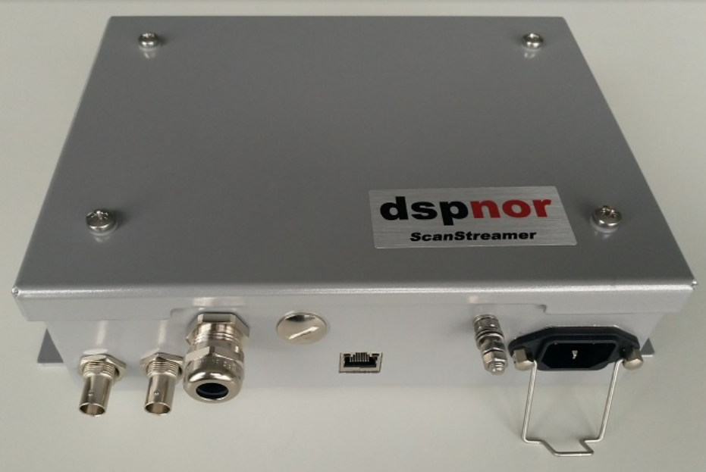

Figure 3‑6 Radar processing unit.