### Band Pass Filter, Amphenol Procom DPF2/6H-4/6

* The housing is made of extruded aluminium, the chassis of steel, and teflon insulation has been used in the coaxial cables and in the connectors.
* DPF2/6H-4/6 is coated with black vinyl to prevent corrosion.
* Selected cavities:
  + Ch1: 162MHz for AIS features;
  + Ch2:156.525MHZ for VHF DSC features;

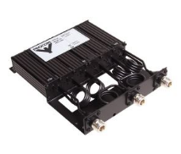

Figure 3‑2 DPF2/6H-4/6 Band-Pass Filter