GROWTH INTERNSHIP ASSIGNMENT

MySivi – Growth & Performance Marketing
Facebook Ad Library Scraping & Creative Intelligence Report
Automated competitive ad intelligence using n8n, Apify and Google Gemini
Prepared for
Growth Marketing Manager, MySivi
Prepared by
[Candidate name]
Date
November 2026

Contents
1. Project Overview 3
2. Executive Summary 4
3. Business Context and Problem Statement 5
4. Technology Stack and System Architecture 6
4.1 Technology stack 6
4.2 Component roles 6
4.3 End-to-end architecture 6
5. Facebook Ad Library Data Extraction 8
5.1 About the Ad Library and why it is useful 8
5.2 How data reaches the workflow 8
5.3 Data fields and handling of missing values 8
6. AI-Powered Creative Decomposition 9
6.1 The Hook–Body–CTA framework 9
6.2 How Gemini returns structured results 9
7. Ad Creative Analysis 10
7.1 Comparison of the five creatives 11
8. Conversion Resonance Scoring Framework 12
8.1 Calculation and ranking 12
9. Winner Selection and Deep Creative Teardown 14
9.1 Creative quality versus verified performance 14
10. Customer Persona Analysis 15
11. Growth Strategy and Business Recommendations 17
11.A Creative iteration 17
11.B Funnel optimisation: 60-second AI voice assessment 17
11.C Creative fatigue monitoring 18
11.D Scaling roadmap 18
12. Automation Workflow in n8n 19
12.1 Example input and output 22
12.2 Implemented nodes versus recommended enhancements 22
13. Results and Key Findings 23
13.1 Key findings 23
14. Limitations and Future Improvements 24
14.1 Limitations 24
14.2 Future improvements 24
15. Conclusion 25
Appendix A. Verification Checklist Before Submission 26

1. Project Overview
This report documents an automated competitive advertising intelligence pipeline built for MySivi’s growth and performance marketing function. The pipeline collects active Facebook and Instagram ads from the Meta Ad Library, breaks each creative into its Hook, Body and Call-To-Action, scores it against a weighted framework, ranks the results and turns the findings into growth recommendations.
Project title | Facebook Ad Library Scraping & Creative Intelligence Using AI Automation
Company | MySivi
Objective | Build an automated pipeline that converts raw Ad Library data into ranked, explainable creative insights for faster marketing decisions.
Core tools | n8n (orchestration), Apify Facebook Ad Library scraper (data collection), Google Gemini (AI analysis), JavaScript Code node (scoring)
Sample analysed | Five representative ad variations (AD-01 to AD-05)

The system is designed to perform eight functions
- Collect active Facebook and Instagram advertisements.
- Extract advertising creatives and ad text.
- Identify the Hook, Body and Call-To-Action (CTA) of each ad.
- Analyse psychological triggers and customer pain points.
- Evaluate creative quality with a weighted scoring framework.
- Rank the advertisements.
- Identify the strongest creative.
- Generate actionable growth and performance marketing recommendations.

How to read this report
Reported – taken from the original assignment (for example, the five ads and their scores).
Proposed – a design recommendation or hypothesis that has not been tested.
To verify – an implementation detail that should be confirmed against the exported n8n workflow, execution logs or source data before submission (see Appendix A).
No impression, spend, CTR, conversion or ROAS figure in this report is presented as verified Ad Library data.

2. Executive Summary
The business problem. MySivi’s ambition is to grow from ₹175 Cr ARR towards ₹500 Cr ARR. In paid acquisition, growth at that scale depends on finding messages that earn attention efficiently, replacing them before they tire, and keeping customer acquisition cost (CAC) under control. Today, learning what competitors and the category are saying means manually browsing the Ad Library, which is slow and hard to repeat.
Why competitor ad intelligence matters. The Ad Library shows which ads are live, how long they have been running and what creative angles are being used. A long-running ad is not proof of success, but it is a useful signal about what an advertiser keeps funding. Systematic observation of the category helps a team generate better hypotheses for its own creative tests.
Creative fatigue. Audiences see the same creative repeatedly and respond less over time. Teams therefore need a steady supply of fresh, differentiated variations. Spotting which hooks, pain points and CTAs recur across the market shortens the path to the next test.
What automation and AI add. An n8n workflow triggers an Apify scraper, cleans the returned data, and sends each ad’s text to Google Gemini, which returns a structured breakdown (Hook, Body, CTA, pain point, psychological trigger and five dimension ratings). A JavaScript step applies fixed weights to calculate a repeatable score and rank the ads. This replaces hours of manual reading with a consistent, auditable process, while leaving final judgement to the marketing team.
Result in the supplied sample. Of five representative ads, AD-01 (workplace meeting anxiety) ranked first at 9.4/10, followed by AD-04 (Hinglish customer story) at 9.1/10. These are AI-generated creative assessments and not conversion metrics.
Business targets versus verified achievements
Item | Status | Notes
₹175 Cr ARR (current) | Company context | Stated in the assignment brief; not verified or influenced by this project.
₹500 Cr ARR (ambition) | Business target | A company-level goal. This project can contribute insight to it, but cannot achieve it alone.
Five ads analysed | Reported | Representative sample, not a statistically representative market study.
AD-01 ranked first (9.4/10) | Reported, AI-assessed | A creative-quality score, not a measured conversion result.
60+ active days; 850k–1M impressions (AD-01) | Supplied observation | Requires independent verification before being used as evidence of ROAS or conversions.
25–35% conversion uplift from a voice-assessment funnel | Hypothesis | Must be validated by an A/B test; not a guaranteed outcome.

3. Business Context and Problem Statement
Six recurring challenges limit how quickly a performance marketing team can learn from the market. The table below sets each challenge against the way the proposed system responds.
Challenge | Why it matters | How the system helps
1. Manual competitor ad research is slow | Browsing the Ad Library ad by ad does not scale and results are inconsistent between reviewers. | Scraping and analysis run on a schedule or on demand, with the same steps every time.
2. High-performing hooks are hard to identify | The first line decides whether the ad is noticed; patterns are easy to miss by eye. | Gemini isolates each hook and rates its stopping power so hooks can be compared side by side.
3. Creative fatigue | Repeated exposure lowers response, so stale creative raises costs. | A steady stream of categorised ideas, plus a proposed fatigue-monitoring workflow (Section 11.C).
4. CAC needs continuous optimisation | Weak creative raises CAC; strong creative can lower it. | Prioritises which messages to test first, so budget goes to stronger hypotheses.
5. Different personas respond to different messages | A single message rarely fits an IT professional, a fresher and a Hinglish-speaking user equally. | Each ad is tagged with pain point and persona, enabling persona-level iteration (Sections 10–11).
6. Teams need faster creative testing | Slow briefing and analysis cycles delay experiments. | Structured JSON output can feed briefs and test plans directly.

4. Technology Stack and System Architecture

4.1 Technology stack
Component | Technology | Purpose | Status
Workflow automation | n8n | Orchestrates every step of the pipeline from trigger to output. | Core
Data extraction | Apify (Facebook Ad Library scraper) | Collects active ad data from the Meta Ad Library and returns it as a dataset. | Core
AI analysis | Google Gemini 1.5 Flash (as originally specified) | Reads ad copy and returns structured Hook/Body/CTA analysis and dimension ratings. | Core; model ID to verify (see note)
AI integration | LangChain (n8n AI nodes) | Connects the model to the workflow. List only if the Gemini step used n8n’s LangChain-based AI nodes. | To verify
Processing | JavaScript Code node | Validates ratings, calculates weighted scores and ranks ads. | Core
Trigger | Manual / Cron | Starts the workflow on demand or on a schedule. | Manual core; Cron proposed
Output | Structured JSON | Stores the ranked analysis for review or downstream tools. | Core

Model availability note
Google’s model lifecycle documentation lists the Gemini 1.5 Flash versions as retired, so calls to that model ID can no longer be expected to work. If the workflow is re-run, select a currently supported Gemini Flash model in the model node and record the exact model ID used. Confirm which model produced the original scores.

4.2 Component roles
- n8n is the orchestration layer. It sequences the steps, passes data between them and provides retry and error-handling options.
- Apify runs the scraper in the cloud, handles browsing and pagination of the Ad Library, and exposes results through a dataset that n8n can read.
- Google Gemini performs the language analysis. It is prompted to return JSON only so downstream code can parse it reliably.
- JavaScript Code node holds the deterministic logic: weights, validation, rounding and ranking. Keeping scoring in code, not in the prompt, makes results reproducible.

4.3 End-to-end architecture
Data flows through eight stages: Trigger → Apify Scraper → Data Extraction → Data Cleaning → Gemini AI Analysis (Hook/Body/CTA extraction) → JavaScript Scoring → Ad Ranking → Final Report.
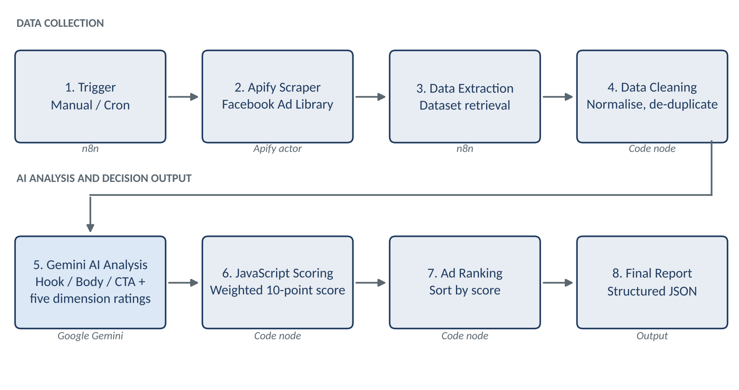
Figure 1. End-to-end system architecture
This report describes only the integrations listed in Section 4.1. Features that are proposals rather than built components are marked as such wherever they appear.

5. Facebook Ad Library Data Extraction

5.1 About the Ad Library and why it is useful
The Meta Ad Library is a public transparency tool that lists ads currently running across Meta technologies such as Facebook and Instagram. For competitor research it shows the creative text and media, the platforms an ad is running on, whether it is active, and when it started. Reading these over time reveals which angles, formats and offers an advertiser keeps in market.

5.2 How data reaches the workflow
Apify runs a Facebook Ad Library scraper (actor to be confirmed against the workflow) with search parameters such as advertiser page or keyword, country and active status. Results are stored in an Apify dataset. The n8n workflow starts the actor run, waits for completion and then retrieves the dataset items for processing.

5.3 Data fields and handling of missing values
Field | Description | Handling when missing
Ad ID | Unique identifier of the ad. | Required. Records without it are logged and skipped.
Advertiser name | Page that runs the ad. | Fall back to page ID; flag for review.
Ad creative text | Primary text of the ad. | Required for analysis. If empty, mark as “media-only” and skip text scoring.
Headline | Headline shown with the creative. | Set to null; Gemini analyses the primary text only.
Description | Secondary text under the headline. | Set to null.
CTA button | Button label such as Install Now or Learn More. | Set to “unspecified”; CTA effectiveness is rated from copy only.
Platform | Facebook, Instagram or others. | Set to “unknown”.
Active status | Whether the ad is currently running. | Treat as unknown; do not assume active.
Start date | Date the ad began running. | Set to null; active duration cannot be calculated.
Active duration | Derived: days from start date to run date. | Calculated in the Code node; null if start date is missing.
Creative variations | Number or list of variants sharing the same ad copy. | Default to 1; mark as “not reported”.

Data cleaning covers trimming whitespace, removing duplicate Ad IDs, normalising date formats to ISO 8601, stripping emoji-only or tracking text from the analysis input, and recording a data-quality flag for any record with missing required fields.
Metrics that the Ad Library does not provide for these ads
Impressions, spend, CTR, conversion rate and ROAS must not be presented as verified Ad Library data. For commercial ads the Ad Library does not generally expose these figures. Where such numbers appear in this report they are labelled as supplied observations that need independent verification, for example from Meta Ads Manager.

6. AI-Powered Creative Decomposition

6.1 The Hook–Body–CTA framework
Part | Definition | What is analysed
Hook | The opening statement designed to capture attention. | Hook type (question, statistic, story, offer), specificity, relevance to the audience, stopping power.
Body | The main message that follows the hook. | Customer pain point  Product value proposition and benefits  Emotional triggers  Social proof  Objection handling
CTA | The action requested from the audience. | Clarity, urgency and friction of the request. Examples: Install Now, Download, Try Free Demo, Learn More, Get Offer.

6.2 How Gemini returns structured results
Each ad is sent to Gemini individually with an instruction to act as a performance-marketing analyst and respond with JSON only, following a fixed schema. Recommended prompt settings are a low temperature for consistency, an explicit rating rubric for each dimension (1–10) with brief anchors, and a single-sentence rationale per rating. The Code node then parses and validates the JSON before scoring; malformed responses are retried or flagged.
Sample JSON output (illustrative format)
{
"ad_id": "AD-01",
"hook": "Stuck while speaking English in office meetings?",
"body": {
"pain_point": "Hesitation speaking English with managers and clients",
"value_proposition": "AI voice roleplay, 15 minutes a day, judgment-free",
"emotional_trigger": "Fear of judgment at work",
"social_proof": "250,000+ Indian users (as stated in the ad)",
"objection_handling": "Judgment-free practice; low daily time commitment"
},
"cta": "Install Now - 7-Day Fluency Trial",
"target_persona": "Working professional in client-facing roles",
"ratings": { "hook": 9.5, "emotion": 9.5, "value": 9.5, "cta": 9.0, "friction": 9.0 },
"rationale": "Specific workplace situation; low-commitment trial CTA"
}

Note: the field names are the proposed schema. The five rating values are an illustrative reconstruction that is consistent with the reported 9.4/10; the original per-dimension ratings were not supplied and should be taken from the execution output (see Appendix A).

7. Ad Creative Analysis
The five representative ad variations below are preserved from the original assignment. Scores are AI-generated analytical assessments of creative quality; they are not verified campaign conversion metrics.

AD-01: Workplace Meeting Anxiety
Hook | “Stuck while speaking English in office meetings?”
Body | Addresses professional hesitation during meetings with managers and clients. Promotes MySivi’s AI voice roleplay, 15-minute daily practice, a judgment-free experience, and the stated social proof of 250,000+ Indian users.
CTA | Install Now – 7-Day Fluency Trial
Original score | 9.4/10 (AI-assessed)

AD-02: Interview Confidence
Hook | “Cracking job interviews requires more than technical skills. You need fluent English!”
Body | Addresses difficulties with spoken English during job interviews. Promotes AI-based HR, technical and behavioural interview practice.
CTA | Download – Career English
Original score | 8.8/10 (AI-assessed)

AD-03: Coaching Cost Comparison
Hook | “English coaching classes take 3 months and cost ₹15,000+.”
Body | Compares traditional English coaching with MySivi’s stated ₹499/month AI tutor and 24/7 smartphone accessibility.
CTA | Try Free Demo
Original score | 8.5/10 (AI-assessed)

AD-04: Hinglish Customer Story
Hook | “Maine socha tha English seekhna bohot tough hai... par MySivi ne 21 dino me meri hesitation khatam kar di!”
Body | A Hinglish-style testimonial describing improved confidence in professional client meetings.
CTA | Learn More – Story
Original score | 9.1/10 (AI-assessed)

AD-05: Discount-Based Promotion
Hook | “Limited Time Offer! Get 50% OFF on MySivi Annual Fluency Pass.”
Body | Highlights unlimited voice drills, accent scoring and limited-time promotional urgency.
CTA | Get Offer
Original score | 7.2/10 (AI-assessed)

7.1 Comparison of the five creatives
The two tables below hold the full comparison. Persona, pain point, trigger and observation columns are analyst annotations derived from the ad text and should be reviewed by the marketing team.
Table 7.1 – Targeting and message
Ad ID | Target persona | Hook | Pain point | Value proposition
AD-01 | Working professionals in client-facing roles | Stuck while speaking English in office meetings? | Hesitation in meetings | AI voice roleplay, 15 min/day, judgment-free, 250,000+ users
AD-02 | Job seekers and fresh graduates | Cracking job interviews requires more than technical skills… | Spoken English in interviews | AI HR, technical and behavioural interview practice
AD-03 | Cost-conscious learners comparing options | English coaching classes take 3 months and cost ₹15,000+. | High cost and long duration of coaching | ₹499/month AI tutor, available 24/7 on a smartphone
AD-04 | Hinglish-comfortable professionals | Maine socha tha English seekhna bohot tough hai… | Belief that learning English is too hard | Confidence gained in 21 days (customer story)
AD-05 | Deal-sensitive prospects already considering | Limited Time Offer! Get 50% OFF… | Price barrier | Unlimited voice drills, accent scoring, annual pass discount
Table 7.2 – Trigger, CTA, score and observation
Ad ID | Psychological trigger | CTA | Original score | Key observation
AD-01 | Fear of judgment; social proof | Install Now – 7-Day Fluency Trial | 9.4 | Names a specific, relatable situation and lowers perceived effort and risk.
AD-02 | Career aspiration; fear of falling behind | Download – Career English | 8.8 | Strong outcome focus, but the hook is broader and less situational.
AD-03 | Loss aversion; price anchoring | Try Free Demo | 8.5 | Clear value contrast, but leads with cost rather than a felt problem.
AD-04 | Relatability; transformation story | Learn More – Story | 9.1 | Native-language voice builds trust; “Learn More” is a softer CTA.
AD-05 | Scarcity; urgency; discount | Get Offer | 7.2 | Promotional hook with little emotional resonance; likely better suited to retargeting.

8. Conversion Resonance Scoring Framework
The Conversion Resonance framework is a proposed analytical model for comparing creatives on a common 10-point scale. It combines five dimension ratings produced by Gemini with fixed weights applied in code.
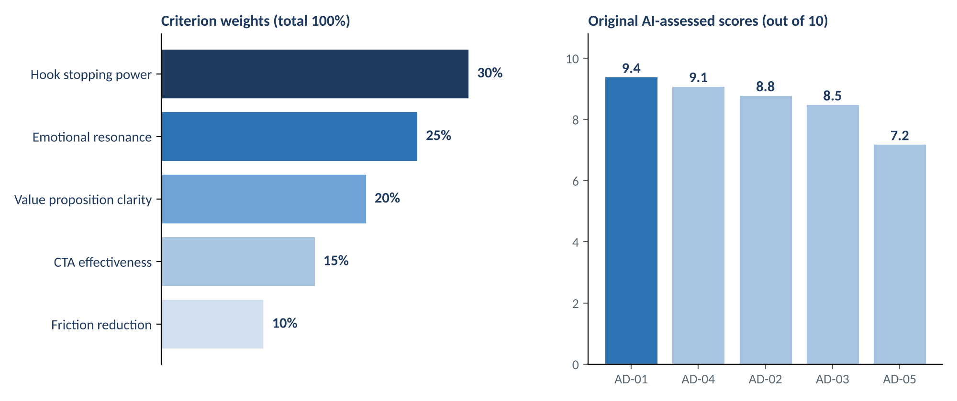
Figure 2. Scoring weights (left) and original AI-assessed scores (right)
Dimension | Weight | Why it matters | What Gemini rates
Hook stopping power | 30% | If the hook does not earn attention, nothing else is seen. | Specificity, relevance, curiosity or tension in the opening line.
Emotional resonance | 25% | Messages that connect to a felt problem are more memorable. | Clarity and intensity of the emotional trigger and pain point.
Value proposition clarity | 20% | People act when they quickly understand what they get. | How clearly the benefit, price or outcome is stated.
CTA effectiveness | 15% | The CTA turns interest into action. | Clarity, relevance and urgency of the requested action.
Friction reduction | 10% | Perceived effort and risk reduce response. | Trial offers, short time commitments, reassurance and objection handling.

8.1 Calculation and ranking
Gemini rates each dimension from 0 to 10 with a one-line rationale. The Code node validates each rating, multiplies it by its weight and sums the results:
Final score = 0.30 × Hook + 0.25 × Emotion + 0.20 × Value + 0.15 × CTA + 0.10 × Friction
Ads are sorted by final score in descending order. Ties are broken by hook rating, then emotional resonance. The top-ranked ad is flagged as the winner.
JavaScript example (n8n Code node, “Run Once for All Items”)
const WEIGHTS = { hook: 0.30, emotion: 0.25, value: 0.20, cta: 0.15, friction: 0.10 };

function weightedScore(r) {
let total = 0;
for (const [key, w] of Object.entries(WEIGHTS)) {
const v = Number(r[key]);
if (!Number.isFinite(v) || v < 0 || v > 10)
throw new Error(`Invalid rating for ${key}: ${r[key]}`);
total += v * w;
}
return Math.round(total * 100) / 100;
}

const scored = $input.all().map(item => {
const ad = item.json;
return { json: { ...ad, final_score: weightedScore(ad.ratings) } };
});

scored.sort((a, b) =>
b.json.final_score - a.json.final_score ||
b.json.ratings.hook - a.json.ratings.hook ||
b.json.ratings.emotion - a.json.ratings.emotion);

return scored.map((s, i) => ({ json: { ...s.json, rank: i + 1 } }));

Worked example (illustrative ratings). Hook 9.5, Emotion 9.5, Value 9.5, CTA 9.0, Friction 9.0 gives 2.85 + 2.375 + 1.90 + 1.35 + 0.90 = 9.375, shown as 9.38 and reported as 9.4/10. The calculation was checked by running the function above in Node.js.
Interpretation
This is an analytical creative-evaluation framework. It is not a conversion-performance prediction model: the weights are proposed rather than empirically fitted, and the ratings are produced by a language model. Scores should guide which ideas to test first, not replace testing.

9. Winner Selection and Deep Creative Teardown
Based on the supplied scores, AD-01 (Workplace Meeting Anxiety) is the highest-scoring creative at 9.4/10. From a creative-strategy perspective it performs well for seven reasons.
Factor | Why it works
1. Relatable professional pain point | “Stuck while speaking English in office meetings?” names a specific, familiar moment, so the right audience self-selects immediately.
2. Emotional connection | The hook describes a feeling of being stuck rather than listing product features.
3. Fear-of-judgment reduction | The “judgment-free” promise addresses the main barrier to practising speaking: embarrassment.
4. Clear value proposition | AI voice roleplay for real workplace conversations is concrete and easy to picture.
5. Low perceived time commitment | “15 minutes a day” makes the habit feel manageable.
6. Social proof | The stated 250,000+ Indian users reduces perceived risk (the figure is the ad’s own claim).
7. Direct CTA | “Install Now – 7-Day Fluency Trial” gives one clear action with a time-boxed, low-risk offer.

9.1 Creative quality versus verified performance
A high creative-quality score says an ad is well constructed according to the framework. It does not say the ad converts. Verified performance means measured outcomes such as CTR, cost per install, trial starts, CAC and ROAS, taken from a reliable source and read alongside spend and audience.
The sample reports that AD-01 has been active for 60+ days with 850k–1M impressions. These are supplied observations and need independent verification before being used as evidence of ROAS or conversion success. Long run time suggests an advertiser keeps funding an ad, but it is a weak signal on its own.
- If the ads are run by MySivi: confirm impressions, CTR, cost per install and downstream conversion in Meta Ads Manager.
- If the ads are run by a third party: these outcomes cannot be verified externally; treat the findings as directional hypotheses for MySivi’s own tests.

10. Customer Persona Analysis
The four personas below are working hypotheses based on the ad sample and the product proposition. They are not research findings and should be refined with MySivi’s first-party user data.

Persona 1: IT professionals who struggle with English during client meetings
Pain points | Hesitates to speak up in client calls; worries about being misunderstood or judged; strong technical skills but low spoken confidence.
Motivation | Visibility, credibility with clients and managers, career progression.
Barriers | Limited free time; embarrassment about practising with colleagues; scepticism about apps.
Suitable hook | “Great at the code, stuck on the client call?”
Recommended message | Practise real meeting scenarios with an AI partner for 15 minutes a day, without anyone judging you.
CTA | Install Now – 7-Day Fluency Trial

Persona 2: Fresh graduates preparing for job interviews
Pain points | Freezing during HR and technical rounds; unsure how to structure answers aloud.
Motivation | Landing the first job; standing out among similar candidates.
Barriers | Budget limits; no access to realistic mock interviews; fear of failure.
Suitable hook | “Your degree got you the interview. Can your English get you the offer?”
Recommended message | Rehearse HR, technical and behavioural interview questions out loud and get feedback each time.
CTA | Download – Career English

Persona 3: Entrepreneurs and founders who need communication confidence
Pain points | Pitching to investors, customers and partners in English; worry that hesitation weakens credibility.
Motivation | Winning trust and deals; representing the business well.
Barriers | Very little time; reluctance to take formal classes; high expectations for quality.
Suitable hook | “Your idea is ready for the pitch. Is your English?”
Recommended message | Rehearse pitches and client conversations with an AI roleplay partner that fits around a busy day.
CTA | Try Free Demo

Persona 4: Hinglish-speaking users who fear grammatical mistakes
Pain points | Avoids speaking English for fear of errors; thinks in Hindi and translates mentally.
Motivation | Speaking naturally and without embarrassment, at work and socially.
Barriers | Fear of being corrected in public; belief that English is “too tough”; mistrust of formal-sounding courses.
Suitable hook | “Galti hone ka darr? Roz 15 minute AI se bolo – bina judge hue.”
Recommended message | Use everyday Hinglish tone and real user stories to show that confidence can be built in small daily steps.
CTA | Learn More – Story

11. Growth Strategy and Business Recommendations

11.A Creative iteration
Four variations of AD-01 keep the core solution (AI voice roleplay, 15 minutes a day, judgment-free practice, social proof and trial CTA) and change only the hook for each persona. Changing a single element makes test results easier to interpret.
Variation / persona | Hook | Retained core
AD-01a – IT professionals | Great at the code, stuck on the client call? | Body and CTA as AD-01
AD-01b – Fresh graduates | Your degree got you the interview. Can your English get you the offer? | Body and CTA as AD-01
AD-01c – Founders | Your idea is ready for the pitch. Is your English? | Body and CTA as AD-01
AD-01d – Hinglish speakers | Galti hone ka darr? Roz 15 minute AI se bolo – bina judge hue. | Body and CTA as AD-01

Proposed test design: run the control (AD-01) and four variants with equal budgets and matched audiences, define the primary metric (for example cost per trial start) and sample size before launch, and read results only after the planned run length.

11.B Funnel optimisation: 60-second AI voice assessment
Proposed: send ad traffic to a landing page that offers a 60-second AI voice assessment instead of sending users straight to the app store.
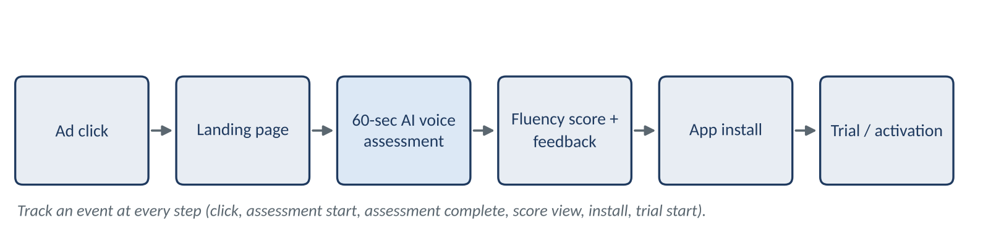
Figure 3. Proposed assessment-led funnel
Stage | Description
User journey | Ad click, then a landing page that explains the 60-second assessment, then consent and microphone permission.
Voice assessment | The user answers one or two short spoken prompts relevant to their persona (for example a meeting update or an interview question).
Feedback | Immediate, encouraging feedback on clarity and confidence, framed as a starting point.
Fluency scoring | A simple fluency score and two or three focus areas, so the app’s value is visible before installation.
App installation | A personalised CTA such as “Start your 15-minute plan” leads to the install.
Conversion tracking | Events at each step (assessment start, completion, score view, install, trial start) tied to the ad variant through UTM parameters.

Hypothesis, not a result
An estimated 25–35% conversion improvement is a hypothesis that requires an A/B test against the current funnel. It is not a guaranteed outcome.
Suggested test: 50/50 split; primary metric install-to-trial conversion and CAC; guardrails on drop-off and early retention. Voice recording requires clear consent and compliance with applicable Indian data-protection requirements.

11.C Creative fatigue monitoring
A proposed second n8n workflow would combine two kinds of data, kept strictly separate:
Source | Provides | Does not provide
Meta Ad Library (via Apify) | Active status, start date, active duration, number of creative variations, ad text. | CTR, conversions, spend, ROAS.
Meta Ads Manager / Marketing API (own campaigns) | CTR, frequency, CPI, CPA, conversions, spend by creative and period. | Competitor performance.

Example fatigue rules (thresholds to be calibrated)
- Monitor active duration of each creative against an internal benchmark.
- Track CTR changes using actual campaign performance data from Ads Manager, for example a sustained decline versus the creative’s first-week baseline.
- Compare creative performance over time, including frequency and cost per result.
- Alert the marketing team (Slack or email) when a rule is triggered.
- Generate new creative variations with AI, using the Hook–Body–CTA schema, for human review before launch.
Thresholds are deliberately left to be set from MySivi’s own historical data.

11.D Scaling roadmap
The roadmap below outlines how the intelligence pipeline could support, but not alone deliver, MySivi’s ₹500 Cr ARR ambition. ARR also depends on product, pricing, distribution, retention and execution across the company.
Workstream | Phase | Key actions | Measurement
Creative testing | Phase 1 (first 30 days) | Run AD-01 persona variants; build a creative library tagged by hook, pain point and CTA. | CTR, cost per install by variant
Funnel optimisation | Phase 1–2 | Launch the 60-second assessment page as an A/B test. | Install-to-trial rate
Audience segmentation | Phase 2 | Map personas to channels, languages and creative; add regional language tests. | CAC by segment
CAC monitoring | Phase 2 | Weekly CAC by creative, persona and channel. | CAC, payback period
Conversion measurement | Phase 2–3 | Connect Ads Manager, app analytics and subscription data. | Trial-to-paid, ROAS
Retention | Phase 3 | Feed learnings into onboarding and early-habit design. | D7/D30 retention, LTV
Experimentation | Ongoing | Maintain a test backlog and a clear decision rule for each test. | Tests run, win rate, learning logged

12. Automation Workflow in n8n
The workflow has ten steps. Each is described by purpose, input, processing, output, configuration and error handling. Node names and settings should be confirmed against the exported workflow JSON (Appendix A); nothing here claims that proposed enhancements have been built.
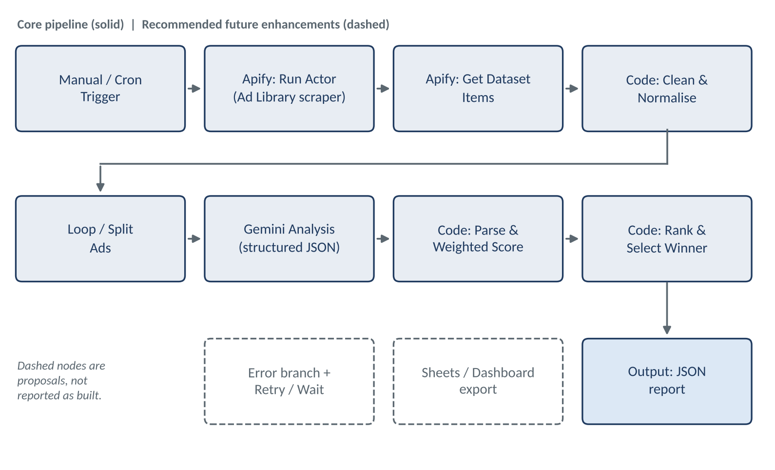
Figure 4. Workflow diagram: core pipeline and proposed enhancements

Node 1 – Manual / Cron Trigger
Purpose | Starts the workflow on demand or on a schedule.
Input | None (manual click) or a timer.
Processing | Emits one item that carries run parameters such as search term or page ID, country and run date.
Output | A single JSON item with run parameters.
Configuration | Manual Trigger for runs; Schedule Trigger (Cron, e.g. weekly) is proposed for automation.
Error handling | n8n execution log; a failure notification is proposed.

Node 2 – Apify: Run Actor (or HTTP Request)
Purpose | Executes the Facebook Ad Library scraper on Apify.
Input | Run parameters from Node 1.
Processing | Calls the Apify actor-run API with the search configuration and waits until the run finishes.
Output | Run object with run ID and default dataset ID.
Configuration | Apify credential (API token); actor ID to confirm; input: query or page URL, country, active ads only, result limit. Alternative: HTTP Request node POST to the Apify actor-runs endpoint.
Error handling | Fail the run on non-success status; set a timeout; proposed retry with backoff for transient errors and rate limits.

Node 3 – Apify: Get Dataset Items
Purpose | Retrieves the scraped ads.
Input | Dataset ID from Node 2.
Processing | Reads dataset items, paginating if needed.
Output | One n8n item per ad with raw fields.
Configuration | Apify credential; dataset ID taken from the previous node’s output; format JSON.
Error handling | If the dataset is empty, stop and log “no ads returned”.

Node 4 – Code: Clean & Normalise
Purpose | Standardises the data and derives active duration.
Input | Raw ad items.
Processing | Select fields in Section 5.3; trim text; remove duplicate Ad IDs; parse dates; calculate active days; set data-quality flags.
Output | Clean ad records.
Configuration | JavaScript, Run Once for All Items.
Error handling | Skip records without Ad ID or text and write them to a rejected list.

Node 5 – Loop Over Items
Purpose | Sends ads to Gemini in small batches.
Input | Clean ad records.
Processing | Splits items into batches (for example one to five at a time).
Output | Batches of ads.
Configuration | Batch size chosen to respect model rate limits.
Error handling | Proposed Wait node between batches to avoid rate-limit errors.

Node 6 – Google Gemini Chat Model
Purpose | Provides the language model used for analysis.
Input | Prompt text from Node 7.
Processing | Generates the analysis with the configured model.
Output | Model response text.
Configuration | Google Gemini credential; model ID to confirm (see Section 4.1 note); low temperature; JSON-only instruction.
Error handling | Retry On Fail enabled; model-not-found and quota errors surfaced in the execution log.

Node 7 – Structured Creative Analysis
Purpose | Turns each ad into Hook, Body, CTA, pain point, trigger and five ratings.
Input | One ad record per call.
Processing | Prompt with the schema in Section 6.2 and the rating rubric; response parsed as JSON (for example via a structured output parser).
Output | Analysis JSON joined to the ad record.
Configuration | System prompt, schema and rubric stored in the node; whether n8n’s LangChain-based AI nodes were used is to be verified.
Error handling | If parsing fails, retry once, then flag the ad as “analysis failed” for human review.

Node 8 – Code: Weighted Scoring
Purpose | Calculates the Conversion Resonance score.
Input | Analysis JSON with five ratings.
Processing | Validates ratings (0–10) and applies the weights in Section 8.
Output | Ad records with final_score.
Configuration | Code from Section 8, Run Once for All Items.
Error handling | Throws on invalid ratings; the affected ad is routed to the review list.

Node 9 – Code / Sort: Rank & Select Winner
Purpose | Orders ads and identifies the top creative.
Input | Scored ad records.
Processing | Sort by score, then hook rating, then emotional resonance; assign rank; flag rank 1.
Output | Ranked list with winner flag.
Configuration | Sort logic as in the Section 8 code.
Error handling | Empty input stops the run with a clear message.

Node 10 – Output: Final Report JSON
Purpose | Delivers the structured report.
Input | Ranked list.
Processing | Assembles run metadata, ranked ads, winner and data-quality summary into one JSON object.
Output | Structured JSON (execution output or a saved file).
Configuration | Set node and, if saving, a Convert to File node.
Error handling | Confirm that required keys are present before output.

12.1 Example input and output
Input to the Gemini step (cleaned ad record)
{
"ad_id": "<ad id>",
"advertiser": "MySivi",
"text": "Stuck while speaking English in office meetings? ...",
"headline": null,
"cta_button": "Install Now",
"platform": "facebook",
"is_active": true,
"start_date": "YYYY-MM-DD",
"active_days": null,
"variations": 1
}

Output of the ranking step (one item, abridged)
{
"rank": 1,
"ad_id": "AD-01",
"final_score": 9.38,
"ratings": { "hook": 9.5, "emotion": 9.5, "value": 9.5, "cta": 9.0, "friction": 9.0 },
"winner": true
}

Values shown are placeholders or illustrative. Replace them with real execution output before submission.

12.2 Implemented nodes versus recommended enhancements
Core pipeline (per original scope; verify against workflow JSON) | Recommended future enhancements (not reported as built)
Manual trigger  Apify actor run and dataset retrieval  Data cleaning in a Code node  Gemini analysis returning structured JSON  JavaScript weighted scoring and ranking  Structured JSON output | Cron schedule trigger  Error Trigger workflow with Slack or email alerts  Retry with backoff and Wait between batches  Export to Google Sheets or a dashboard  Meta Ads Manager integration for fatigue monitoring  Historical comparison store

13. Results and Key Findings
Measure | Result
Representative ads analysed | 5
Highest-scoring creative | AD-01 – Workplace Meeting Anxiety
Highest original score | 9.4/10
Second-highest creative | AD-04 – Hinglish Customer Story (9.1/10)
Lowest-scoring creative | AD-05 – Discount-Based Promotion (7.2/10)

13.1 Key findings
- Main insight: professional communication anxiety is a strong creative messaging angle in the supplied sample.
- Both of the top two ads (AD-01 and AD-04) centre on confidence in professional settings, while the discount-led ad scored lowest.
- Ads that name a specific situation and reduce perceived risk (trial, judgment-free practice, a real story) scored above ads that lead with price or a generic benefit.
- The hook of AD-04 is in Hinglish, suggesting language-native creative deserves its own test.
Limitations and verification requirements
The sample is five ads, so findings are directional, not statistically conclusive.
Scores are AI-generated and subjective, and no conversion or ROAS data was verified.
The 60+ days and 850k–1M impressions for AD-01 need independent verification.
Execution evidence (workflow JSON, run logs, dataset sample) should be attached to confirm the implementation.

14. Limitations and Future Improvements

14.1 Limitations
Limitation | Implication and mitigation
Incomplete Ad Library data | Some fields (headline, variations, dates) may be missing. Handle with null values and quality flags; do not infer.
Scraper reliability | Page-layout or access changes can break scraping. Monitor runs and keep a fallback or manual export.
Rate limits | Apify and the Gemini API both limit usage. Use batching, waits and retries.
AI interpretation errors | The model may misread tone, slang or Hinglish. Sample outputs for human spot checks.
Subjective scoring | Ratings may vary between runs. Use a fixed rubric, low temperature and consistent prompts.
No verified conversion metrics | Scores reflect creative quality only. Validate with experiments.
Missing campaign-level data | The Ad Library lacks spend, CTR and ROAS. Combine with Ads Manager data for owned campaigns.
Need for human review | A marketing lead should review rankings and recommendations before acting on them.

14.2 Future improvements
- Automated reporting dashboard (for example Google Sheets or Looker Studio).
- Meta Ads Manager integration for owned-campaign performance.
- Historical creative comparison to track how competitor messaging changes over time.
- More sophisticated fatigue detection using frequency, CTR trend and cost per result.
- Automated creative generation from the Hook–Body–CTA schema, with human approval.
- A/B testing integration to link scores to test outcomes and calibrate the weights.
- CAC and ROAS monitoring by creative and persona.

15. Conclusion
This project combines three capabilities in one workflow: advertising intelligence from the Meta Ad Library, orchestration with n8n and Apify, and AI-based creative evaluation with Google Gemini. Together they turn a slow, manual research task into a repeatable process that produces structured, ranked and explainable insights.
In the supplied sample, AD-01 emerged as the strongest creative at 9.4/10, with professional communication anxiety standing out as a promising messaging angle. The recommendations that follow from it (persona-specific hooks, a 60-second voice-assessment funnel and fatigue monitoring) are hypotheses to be tested, not results already achieved.
Used with human judgement and validated against real campaign data, the pipeline can help the marketing team generate better creative hypotheses, test them faster and monitor CAC more closely. These are inputs that contribute to MySivi’s growth objectives; they are not a guarantee of the ₹500 Cr ARR ambition.

Appendix A. Verification Checklist Before Submission
The items below should be confirmed or attached so that every implementation statement in this report is backed by evidence.
# | Item | Why it is needed
1 | Exported n8n workflow JSON | Confirms node names, order and configuration in Section 12.
2 | Execution screenshots or logs | Shows that the workflow ran end to end.
3 | Apify actor name and a dataset sample | Confirms the data fields listed in Section 5.3.
4 | Gemini model ID and prompt used | Confirms the model and the analysis schema; the 1.5 Flash model is retired.
5 | Original per-dimension ratings for each ad | Replaces the illustrative ratings in Sections 6 and 12.
6 | Whether LangChain/AI nodes were used | Decides whether LangChain stays in the technology table.
7 | Source of the 60+ days and 850k–1M impressions | Needed before these figures are used as evidence.
8 | Whether the ads are MySivi’s own or competitors’ | Determines how performance can be verified.
9 | Candidate name on the cover page | Placeholder currently shown.

