ZETECH UNIVERSITY

School of Computing & Information Technology

LOST AND FOUND ITEM MANAGEMENT SYSTEM

SYSTEM DOCUMENTATION

SUBMITTED BY:

Johnson Ndile
DSE-02-8698/2024

A SYSTEM DOCUMENTATION SUBMITTED IN PARTIAL FULFILMENT FOR THE AWARD OF
DIPLOMA IN SOFTWARE ENGINEERING
BY ZETECH UNIVERSITY

APRIL 2025

DECLARATION
I, Johnson Ndile, declare that this project has been carried out by me and has not been outsourced or copied from any other source. This documentation has also been prepared by me in its entirety, in accordance with the requirements of Zetech University for the award of the Diploma in Software Engineering.

Student Name: Johnson Ndile

Signature: ______________________________

Date: 27 March 2026

Supervisor Name: ______________________________

Signature: ______________________________

Date: ______________________________

DEDICATION
This project is dedicated to my family, whose unwavering support and encouragement throughout my studies have made this achievement possible. I also dedicate this work to my lecturers at Zetech University, who guided and challenged me to grow as a developer, and to every student who has ever lost something valuable and had no easy way to recover it — this system was built for you.

ABSTRACT
This project involved the design and development of a web-based Lost and Found Item Management System over a period of six weeks. The technologies used include HTML, CSS, and JavaScript for the front-end, PHP for the back-end logic, and MySQL as the relational database management system, all running on a local XAMPP server environment. The system was built to address the inefficiencies of manual lost-and-found management in institutions, providing a centralized digital platform for reporting, tracking, and claiming lost and found items.
The system achieved a fully functional implementation covering user registration and authentication, role-based access control for regular users and administrators, item reporting with photo uploads, a token-based matching algorithm that surfaces potential item matches, a multi-step claims workflow with admin approval and photo proof, in-app notifications, a direct messaging channel between users and administrators, and a physical handover recording module. The project demonstrated that modern web technologies can significantly improve the transparency and efficiency of institutional lost-and-found processes.

DEFINITION OF KEY TERMS
Administrator:
A privileged user account with elevated access rights within the system, responsible for managing found item reports, reviewing claims, approving or rejecting ownership requests, and issuing items to verified claimants.
Claim:
A formal request submitted by a user asserting ownership of a found item, accompanied by proof of ownership such as photographs, serial numbers, or descriptive evidence.
Database:
A structured collection of data stored electronically and managed by a Database Management System (DBMS). In this system, MySQL is used to store all users, items, claims, notifications, and messages.
Front-end:
The part of the web application that the user interacts with directly in their browser, built using HTML, CSS, and JavaScript.
Back-end:
The server-side logic of the web application, responsible for processing requests, querying the database, and returning responses. Built using PHP in this project.
Handover:
The physical act of an administrator issuing a found item to a verified claimant, recorded in the system with the claimant's legal name, ID/passport number, and a photographic record.
Match Score:
A numerical score computed by the system to indicate how closely a found item corresponds to a user's lost report, based on category, item name tokens, description tokens, and image filename similarity.
Notification:
An in-app alert sent to a user to inform them of an event relevant to their account, such as a claim being approved or a potential item match being found.
Session:
A server-side mechanism used to maintain a user's authenticated state across multiple HTTP requests during a single visit to the web application.
XAMPP:
A free, open-source software package that bundles the Apache web server, MySQL database, PHP, and Perl, enabling local development and testing of web applications.

ABBREVIATIONS AND ACRONYMS
CSS — Cascading Style Sheets
DB — Database
DBMS — Database Management System
HTML — Hyper Text Markup Language
HTTP — Hyper Text Transfer Protocol
ID — Identity Document
IMEI — International Mobile Equipment Identity
JS — JavaScript
JSON — JavaScript Object Notation
MySQL — My Structured Query Language
PHP — Hypertext Preprocessor (recursive acronym)
SQL — Structured Query Language
UI — User Interface
XAMPP — Cross-Platform Apache, MySQL, PHP, and Perl

LIST OF FIGURES
Fig 3.2.1 — Landing / Home Page
Fig 3.2.2 — Login Page
Fig 3.2.3 — Registration Page
Fig 3.2.4 — User Dashboard
Fig 3.2.5 — Report Lost Item Form
Fig 3.2.6 — My Items Page (Lost Tab)
Fig 3.2.7 — Found for You Tab (Matched Items)
Fig 3.2.8 — Submit Claim Form
Fig 3.2.9 — Claim Status Page
Fig 3.2.10 — Admin Panel — Reported Items Tab
Fig 3.2.11 — Admin Panel — Claims Tab
Fig 3.2.12 — Admin Panel — Users Tab
Fig 3.2.13 — Admin Panel — Issued Items Tab
Fig 3.2.14 — Notifications Panel
Fig 3.2.15 — Messaging Interface
Fig 3.3.1 — Database Schema (MySQL)
Fig 3.3.2 — Login Validation Code (login.php)
Fig 3.3.3 — Match Scoring Algorithm (fetch_items.php)
Fig 3.3.4 — Claim Submission Logic (submit_claim.php)
Fig 3.3.5 — Approve Claim Endpoint (approve_claim.php)
Fig 3.3.6 — Issue Handover Endpoint (issue_handover.php)
Fig 3.3.7 — Notification Helper (helpers.php)

LIST OF TABLES
Table 1.4 — Functional Requirements
Table 1.5 — Tools and Resources
Table 1.6 — Project Schedule Breakdown
Table 3.4.1 — Test Cases and Results

TABLE OF CONTENTS
DECLARATION ............................................................... 2
DEDICATION ................................................................ 3
ABSTRACT .................................................................. 4
DEFINITION OF KEY TERMS ................................................... 5
ABBREVIATIONS AND ACRONYMS ................................................ 6
LIST OF FIGURES ........................................................... 7
LIST OF TABLES ............................................................ 8
TABLE OF CONTENTS ......................................................... 9

CHAPTER ONE: PROJECT PLANNING AND ANALYSIS ...............................10
1.1 Statement of Problem ............................................... 10
1.2 Study Justification ................................................ 10
1.3 System Objectives .................................................. 11
1.4 Functional Requirements ............................................ 11
1.5 Breakdown of Tools & Resources ..................................... 12
1.6 Project Schedule Breakdown ......................................... 13

CHAPTER TWO: DESIGN AND MODELING ........................................ 14
2.1 Introduction to Modelling .......................................... 14
2.2 User Interface Models .............................................. 14
2.3 Logic Models ....................................................... 15

CHAPTER THREE: SYSTEM IMPLEMENTATION .................................... 18
3.1 Introduction ....................................................... 18
3.2 User Interface Development ......................................... 18
3.3 Logic Development .................................................. 27
3.4 Testing ............................................................ 36
3.5 Deployment ......................................................... 38

CHAPTER FOUR: CONCLUSION AND RECOMMENDATION ............................. 39
4.1 Conclusion ......................................................... 39
4.2 Recommendation ..................................................... 40

REFERENCES ............................................................... 41

CHAPTER ONE: PROJECT PLANNING AND ANALYSIS

1.1 Statement of Problem

Public bodies such as schools, universities, government offices, parks, and other public spaces produce a large number of cases in the lost and found every day. For many of these organizations, the traditional way of managing lost and found cases is through the use of physical bulletin boards where lost and found items are posted, through the use of handwritten logs or registries, or through verbal communication between employees of the organization. As a result of the manual nature of this process, the efficiency of managing such cases is greatly reduced. Typically, there are long periods when items remain without an owner, and staff can spend a significant amount of time trying to track cases manually. The people who have lost belongings do not have a clear way to get status updates on their belongings.

In addition, without a centralized computer-based record-keeping system, there are often many duplicate records, incomplete records, and misplaced records. As a result, claimants must visit the office multiple times to make claims on lost items, and there is no accountability for how staff handles the items. Therefore, items are rarely recovered, and students and employees have decreased confidence in the institution’s ability to provide lost-and-found services. As a result, students and employees who have lost personal items experience a great deal of frustration.

1.2 Study Justification.

The Lost and Found Item Management System directly solves this problem by providing a digital, web-based system instead of a manual process, which can be accessed by all users within an institution without having to install software on individual computers. It creates a centralized system where users can report lost items, administrators can report found items, and they can be compared using an algorithm.

This digital approach solves the problem of transparency because it allows all users to have real-time visibility at all times regarding the status of their reported items. The claims process involves a structured process for verifying claims based on photographic evidence and descriptive proof, thus reducing fraudulent claims. It also solves the problem of accountability because it can track who among the administrators handles each reported item and creates an immutable audit trail for all actions, including physical transfer of items to verified owners.

1.3 System Objectives

1.3.1 General Objective
To design and develop a web-based Lost and Found Item Management System that provides institutions with a centralized, efficient, and transparent platform for reporting, tracking, matching, and managing lost and found items.

1.3.2 Specific Objectives
- To implement a secure user registration and role-based authentication system that distinguishes between regular users and administrators.
- To develop a digital item reporting workflow that enables users to submit lost item reports and administrators to log found items with supporting photographs and metadata.
- To implement an automatic item-matching algorithm that surfaces found items likely to correspond to a user's lost report, based on category, name, and description similarity.
- To build a structured claims and handover workflow that allows users to submit proof-of-ownership claims, administrators to approve or reject them, and the physical handover to be recorded with identity verification.

1.4 Functional Requirements

User | User Activities | Features
Regular User | Register & log in | Email/password registration with profile photo; session-based login with role detection
Regular User | Report a lost item | Form capturing item name, category, description, location, date lost, and optional photos with rename capability
Regular User | Browse matched found items | Filtered view of found items in the same category as the user's open lost reports, with match score indicators
Regular User | Submit a claim | Upload up to 5 proof photos, provide description, serial number, box/receipt notes, and device unlock info
Regular User | Track claim status | Real-time status page showing pending/approved/rejected state, rejection reasons, and next steps
Regular User | Receive notifications | In-app bell with unread badge; notifications for matches, claim decisions, and item issuance
Regular User | Message administrator | Direct messaging thread with the admin for queries about reports or claims
Administrator | Log found items | Found item form with category, location, date, description, and multi-photo upload with custom naming
Administrator | Manage all reports | View all lost and found items with match scores; filter by category or search term; delete items
Administrator | Review & decide claims | View proof photos and descriptions; approve or reject with mandatory reason; auto-reject competing claims on approval
Administrator | Record physical handover | Enter claimant's legal name and ID/passport number; upload handover photo; system marks item as collected
Administrator | Manage users | View all registered users with registration date; delete user accounts (cascade-deletes all related data)

Table 1.4 — Functional Requirements

1.5 Breakdown of Tools & Resources to Be Used

Category | Tool / Technology | Purpose
Front-end | HTML5 | Page structure and semantic markup for all user-facing pages
Front-end | CSS3 | Styling, responsive layout, notification panel, and card-based UI components
Front-end | JavaScript (Vanilla) | Dynamic UI interactions, AJAX fetch calls to the backend, DOM manipulation
Back-end | PHP 8 | Server-side logic: authentication, file uploads, database queries, session management
Database | MySQL (MariaDB) | Relational storage for users, items, claims, photos, notifications, and messages
Dev Environment | XAMPP | Bundled Apache web server and MySQL database for local development and testing
Code Editor | Visual Studio Code | Primary development environment with PHP and JavaScript extensions
Version Control | Git / GitHub | Source code tracking and backup during development

Table 1.5 — Tools and Resources

1.6 Project Schedule Breakdown

Weeks | Planning & Analysis (Ch.1) | Design & Modeling (Ch.2) | Development & Testing (Ch.3) | Deployment (Ch.3) | Final Docs (Ch.4 & Refs) | Presentation
5–9 May | ✓
12–16 May | ✓ | ✓
19–23 May |  | ✓
26–30 May |  |  | ✓
2–6 June |  |  | ✓
9–13 June |  |  | ✓
16–20 June |  |  | ✓ | ✓
23–27 June |  |  |  | ✓
30–4 July |  |  |  |  | ✓
7–11 July |  |  |  |  | ✓
14–18 July |  |  |  |  | ✓
21–25 July |  |  |  |  |  | ✓
11 Aug |  |  |  |  |  | ✓

Table 1.6 — Project Schedule Breakdown

CHAPTER TWO: DESIGN AND MODELING

2.1 Introduction to Modelling
This chapter presents the design and modeling work undertaken before development began on the Lost and Found Item Management System. System modeling is a critical step in the software development lifecycle because it allows a developer to visualize how the system will look, behave, and process data before writing a single line of code. By sketching user interfaces and drawing process-flow diagrams in advance, potential design flaws can be identified and corrected at minimal cost, compared to discovering them during or after development.
The models in this chapter are organized into two categories: User Interface Models, which show how the system's screens and forms were planned, and Logic Models, which show how data flows through the system and how different processes were designed to work. Together, these models served as the blueprint for the implementation described in Chapter Three.

2.2 User Interface Models

2.2.1 Landing Page Design
The landing page was designed as a public-facing page requiring no login. It features a full-viewport hero image with a navigation bar, a 'How it Works' section with three action cards (Report Lost, Report Found, Browse Items), a Recent Items section, and a call-to-action block directing visitors to register. The hero was planned with a dark image overlay to ensure the white headline text remains legible regardless of the background photograph used.

2.2.2 Login & Registration Forms Design
Both forms were designed as centered card components on a neutral background. The login form captures email and password; the registration form adds full name, password confirmation with a strength indicator bar, and an optional profile photo upload with live preview. Both forms include an inline error/success message area below the heading.

2.2.3 User Dashboard Design
The user dashboard was designed as a welcome screen with two large action cards: Report Lost Item and View My Items. An administrator session redirects automatically to the admin panel. The navigation bar includes links to Dashboard, Report Lost, View Items, and Logout, plus a notification bell with an unread badge.

2.2.4 Item Reporting Forms Design
Both the lost and found item reporting forms were designed using a two-column grid layout to make efficient use of horizontal space. Fields planned include item name, category (dropdown), date, location, a full-width description text area, and a multi-photo uploader with rename inputs and thumbnail previews. Required fields are marked with a red asterisk.

2.2.5 Admin Panel Design
The admin panel was designed as a tabbed single-page interface with the following tabs: Reported Items, Claims, Users, Inbox (messaging), and Issued Items. The Reported Items tab shows all lost and found items with match scores; the Claims tab shows pending/approved/rejected claims with a detail modal for reviewing proof photos; the Users tab lists all registered accounts with delete functionality; and the Issued Items tab records completed physical handovers.

2.3 Logic Models

2.3.1 User Registration and Login Flowchart
The registration process starts when a visitor submits the registration form. The system validates all fields (full name, email format, password length, confirmation match) and checks whether the email is already in use. If all checks pass, the password is hashed using PHP's password_hash () function and a new user record is inserted. The user is then redirected to the login page with a success message. On login, the entered password is verified against the stored hash using password_verify (); on success the session is populated and the user is directed to their role-appropriate destination (admin panel or dashboard).

2.3.2 Lost Item Report Submission Flowchart
When a logged-in user submits a lost item report, the system validates the item name and category, processes any uploaded photos (validating type and moving to the uploads directory), inserts the record into the lost items table, saves photo paths to lost_item_photos, and sends a notification to all admins. The user is redirected to the My Items page upon success.

2.3.3 Item Matching Algorithm Diagram
The matching algorithm is implemented in fetch_items.php. For each lost item, a match score (0–100) is computed against each found item using four weighted components: category match (30 points), image filename token similarity (up to 30 points), item name token similarity (up to 30 points), and description token similarity (up to 30 points), capped at 100. Only scores above 10 are surfaced to the user. The algorithm normalizes text by lowercasing, removing special characters, and filtering common stopwords before tokenizing.

2.3.4 Claim Submission and Approval Flowchart
A user navigates to the claim form for a specific found item, selects their matching lost report (filtered by category), uploads proof photos, and submits the form. The backend validates the lost item belongs to the user, confirms the found item is still active, checks that categories match, and blocks duplicate pending claims. On success a claim record and photo records are inserted, and all admins are notified. The admin then reviews the claim in the admin panel and either approves or rejects it. On approval, other pending claims for the same found item are automatically rejected, and the item is put on approval hold. The user receives a notification in either case.

2.3.5 Physical Handover Data Flow Diagram
After a claim is approved, the item appears in the admin's 'Ready to Issue' list. The admin fills in the claimant's legal name, ID or passport number, and uploads a photo of the claimant holding the item. The issue_handover.php endpoint validates the claim status, guards against double-issuing, saves the photo, and within a single database transaction inserts the issued_items record, deactivates the found item, marks the lost report as resolved, and notifies the user. This produces a complete audit trail from report to physical collection.

CHAPTER THREE: SYSTEM IMPLEMENTATION

3.1 Introduction
This chapter documents the full development journey of the Lost and Found Item Management System, from the initial setup of the development environment and database through to the completed, tested, and deployed application. The chapter is organized into three main sections: User Interface Development, which covers all the front-end pages built with HTML, CSS, and JavaScript; Logic Development, which covers all the back-end PHP scripts and SQL schema; and Testing, which records the test cases executed and the results obtained.

3.2 User Interface Development

3.2.1 Landing Page (index.html)
The landing page serves as the public entry point to the system. It features a full-viewport hero section with a background image overlaid with a dark tint to ensure the headline text remains legible. The navigation bar contains Login and Register buttons styled distinctly. Below the hero are a 'How it Works' section with three card links (Report Lost, Report Found, Browse Items), a Recent Items showcase with badge labels, and a call-to-action block encouraging visitors to create a free account. The footer carries the institutional branding. No authentication is required to view this page.
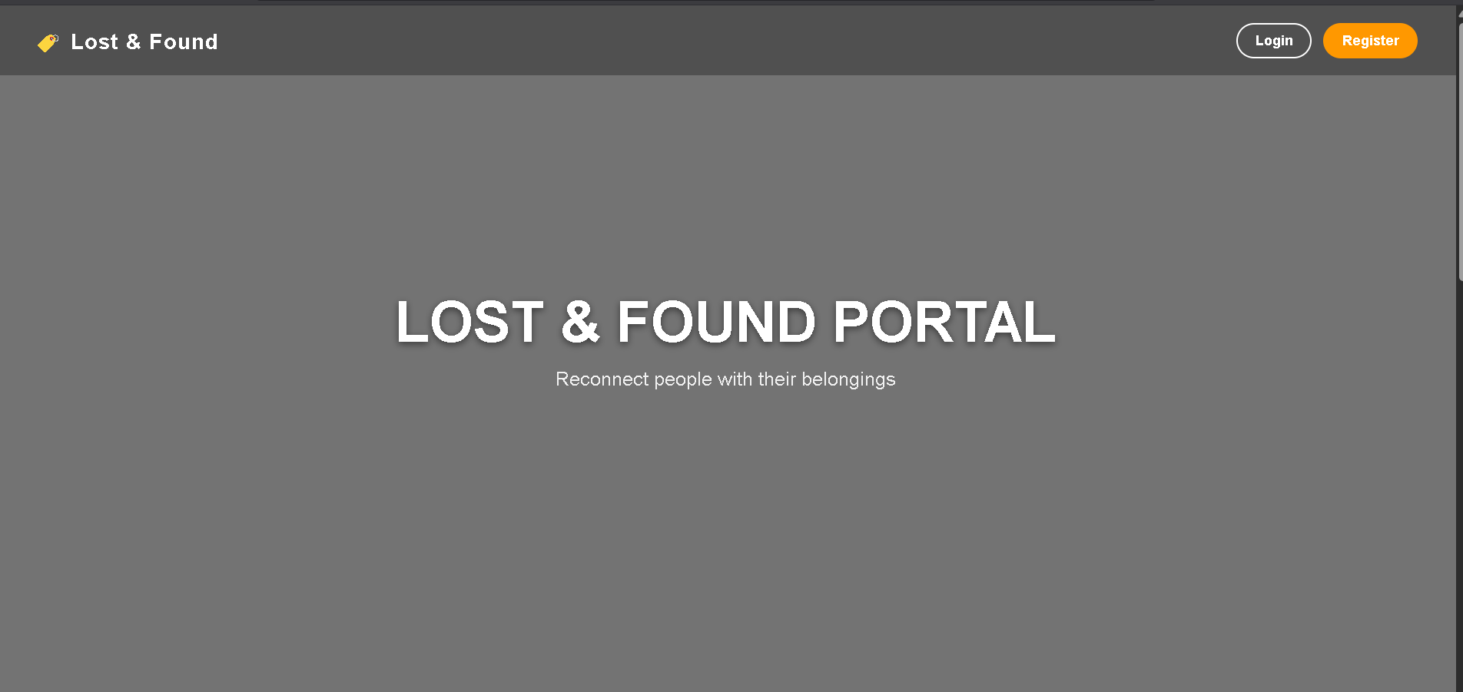
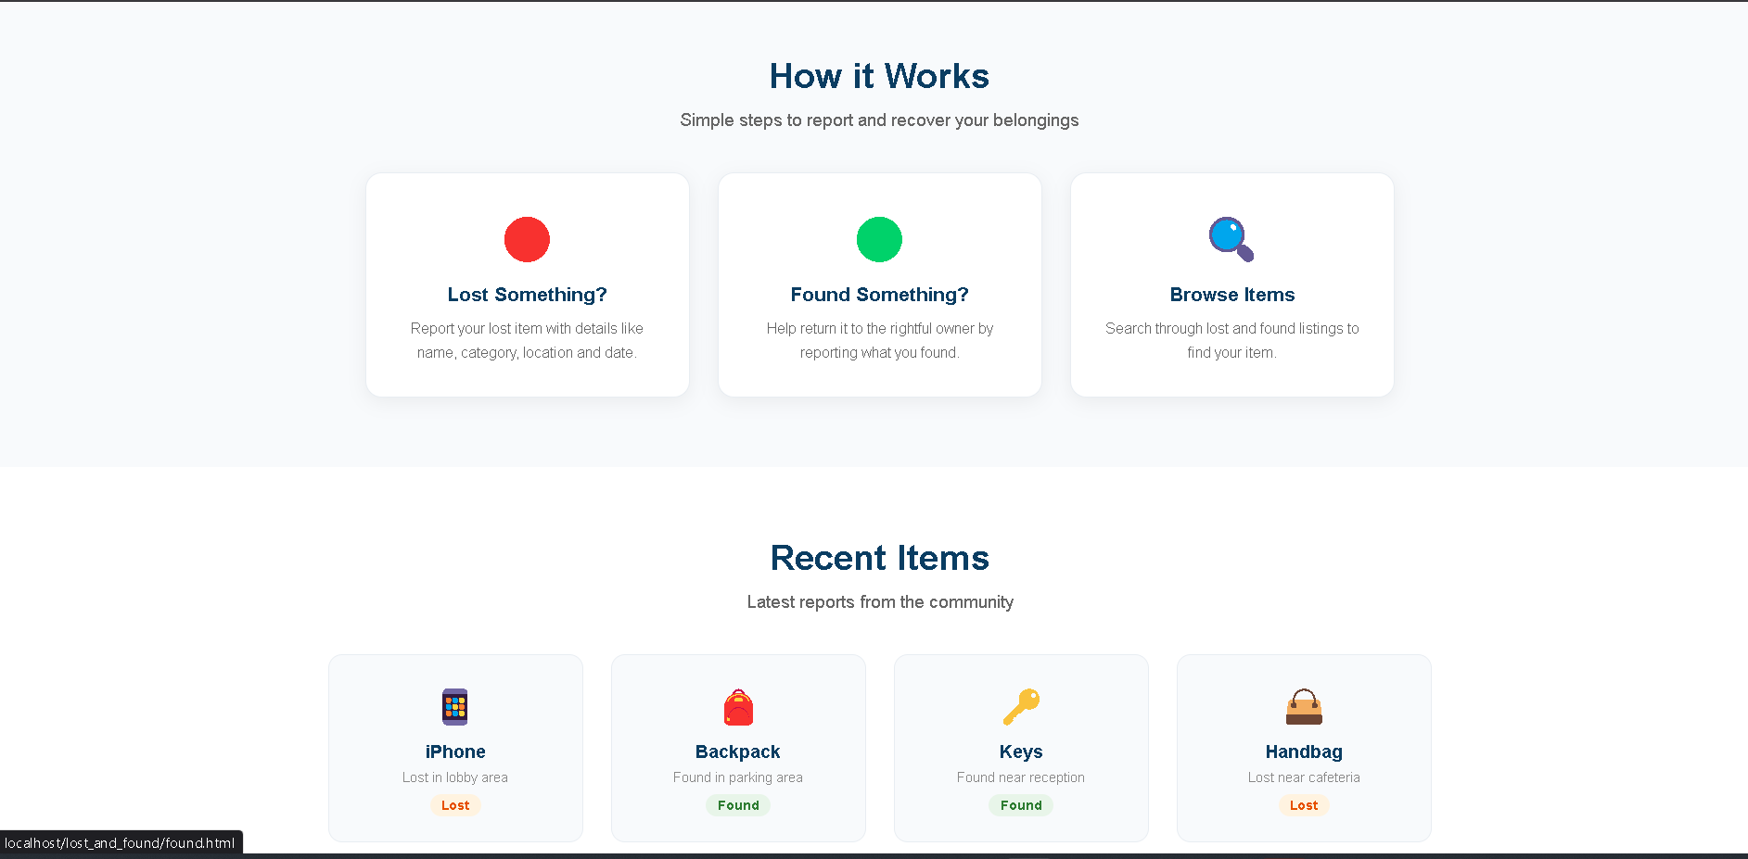

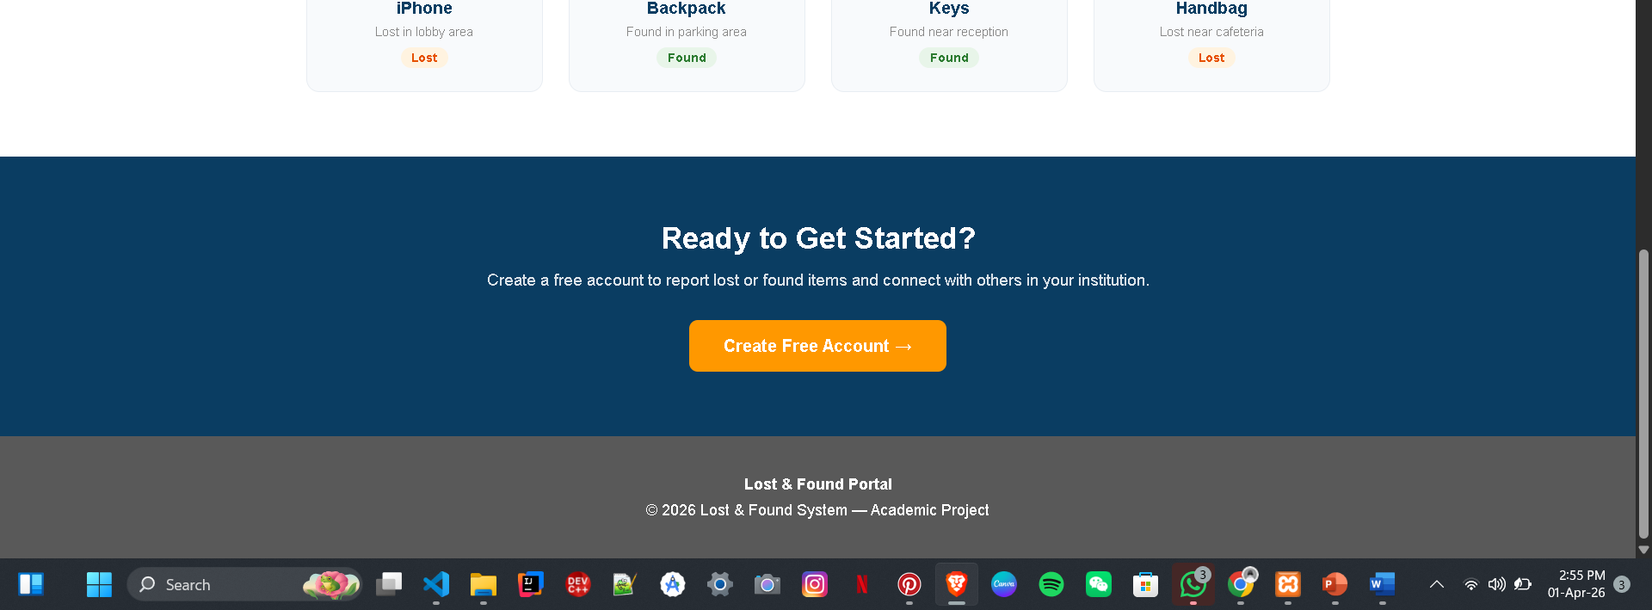

3.2.2 Login Page (login.html)
The login form is a centered card rendered on a light grey background. It captures the user's email and password, performs client-side validation to ensure both fields are filled before submission, and displays success or error messages from URL query parameters (used when redirected from the backend). The form posts to backend/login.php which handles server-side authentication, session creation, and role-based redirection.
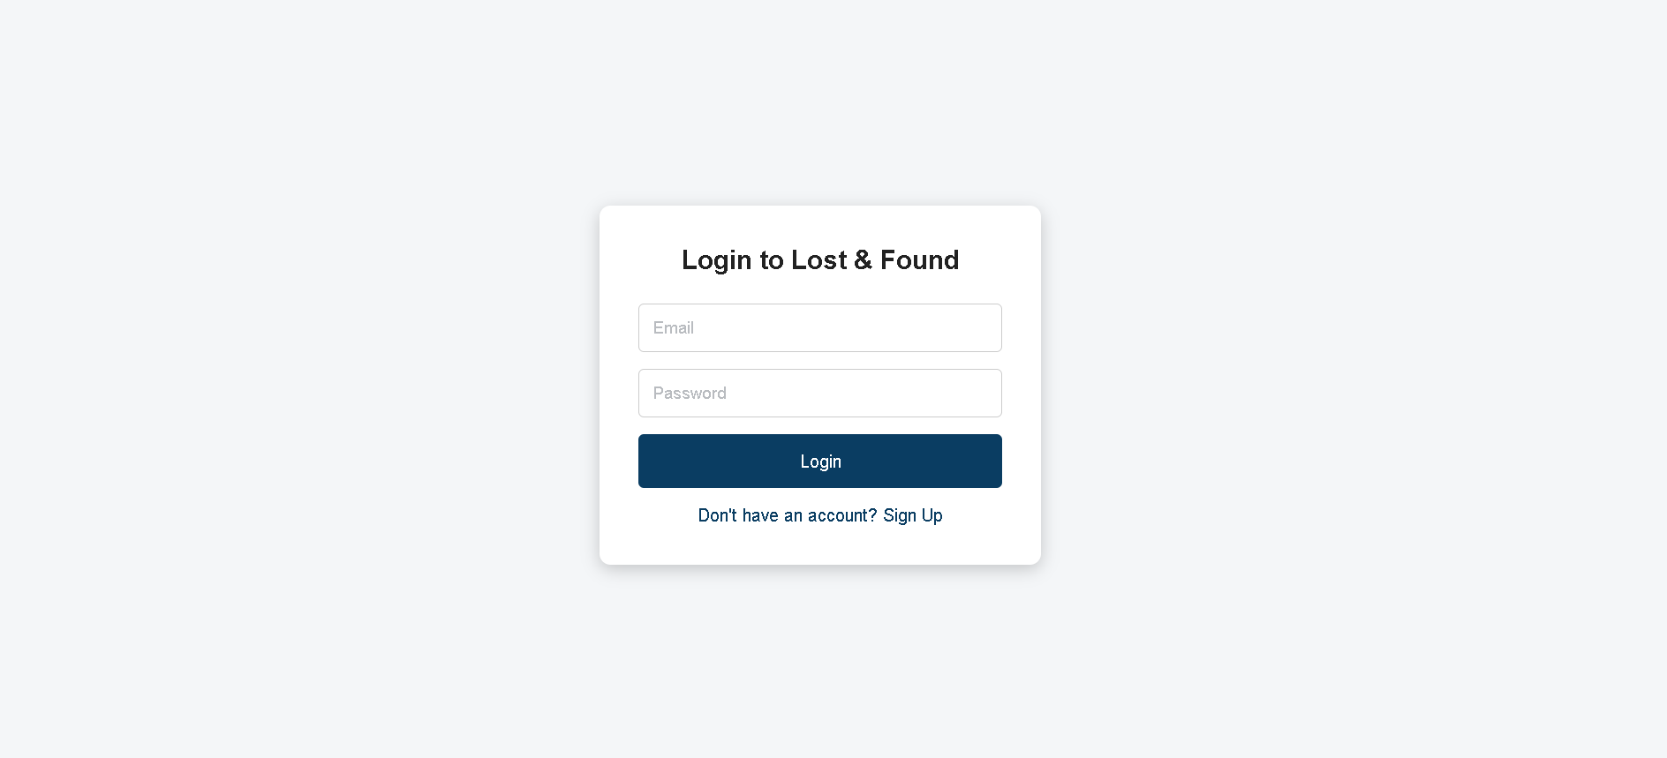

3.2.3 Registration Page (register.html)
The registration form captures full name, email address, password, password confirmation, and an optional profile photo. A real-time password strength indicator bar changes color and label (Weak / Medium / Strong) as the user types. An image preview is displayed when a profile photo is selected. Client-side validation checks password length and confirmation match before submission.
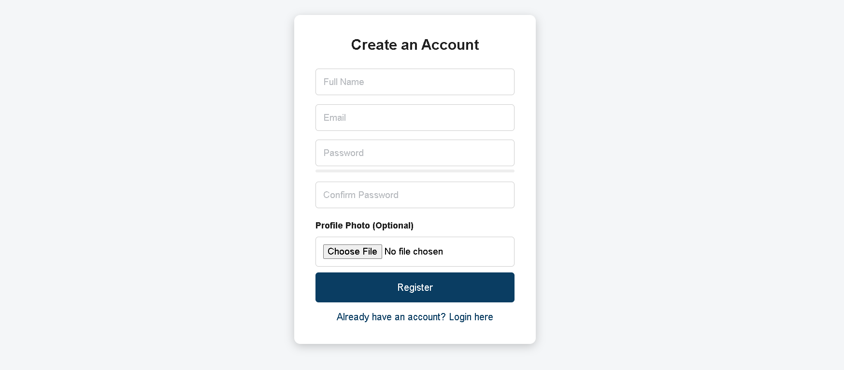

3.2.4 User Dashboard (dashboard.html)
After a successful login, a regular user lands on the dashboard. A fetch call to backend/session_info.php reads the session and populates the welcome name. Admins are automatically redirected to admin.php. The dashboard presents two large action cards: Report Lost Item and View My Items. The navigation bar includes a notification bell that loads the user's unread notification count on page load.
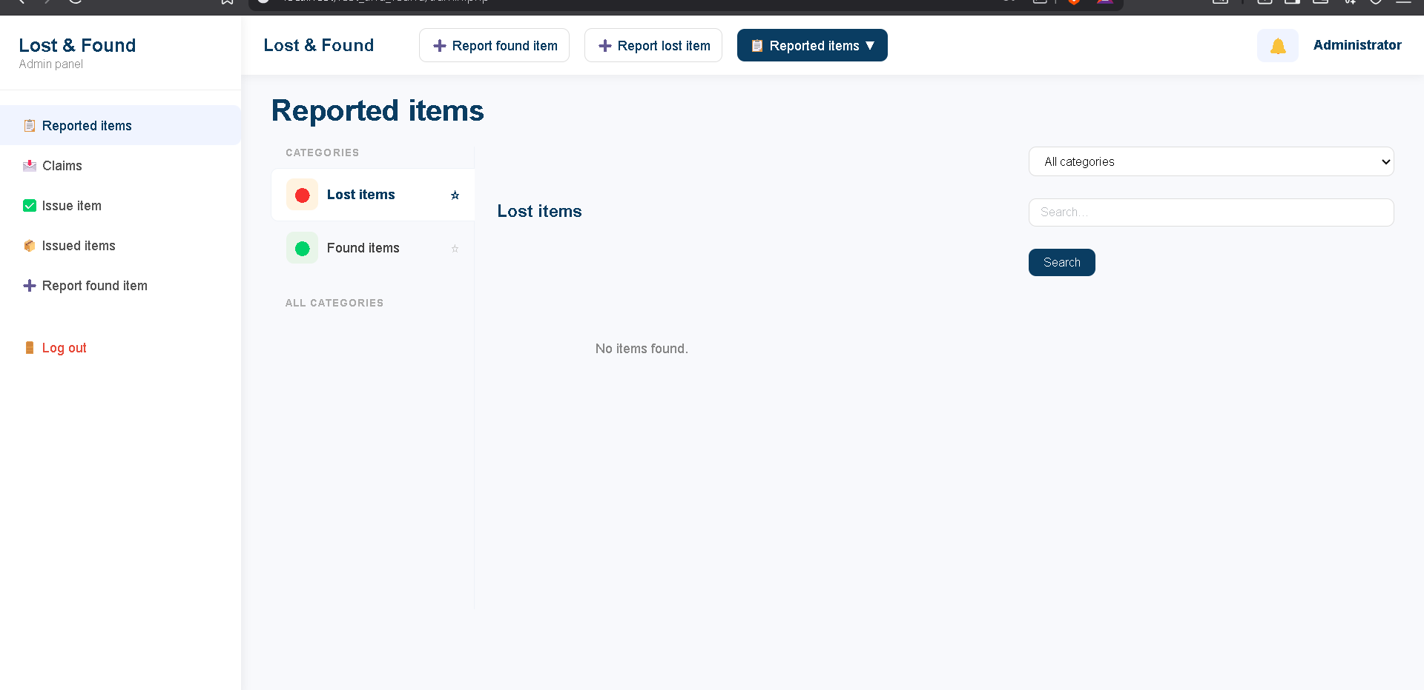

3.2.5 Report Lost Item Form (lost.html)
This form allows logged-in regular users to report a lost item. It uses a two-column grid layout with fields for item name, category (dropdown), date lost (capped at today's date), location, description, and a multi-photo uploader. When photos are selected, a preview list appears with an editable name field for each file. On form submission, the JavaScript uses the Data Transfer API to apply the custom filenames before the form posts to backend/submit_lost.php.
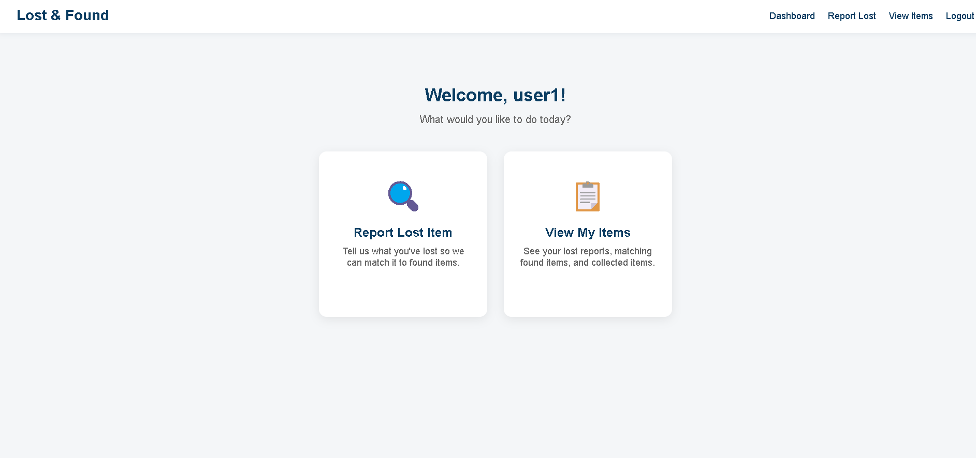

3.2.6 My Items Page — Lost Tab (items.html)
The My Items page is a tabbed interface built in JavaScript. The Lost tab fetches the user's own lost reports from backend/fetch_items.php? Mine=1 and renders them as item cards. Cards that have a matching found item show a green 'Item Found — view matches' overlay. Users can delete their own reports. The Found for You tab fetches found items matching the user's lost report categories from backend/fetch_matched_found.php.
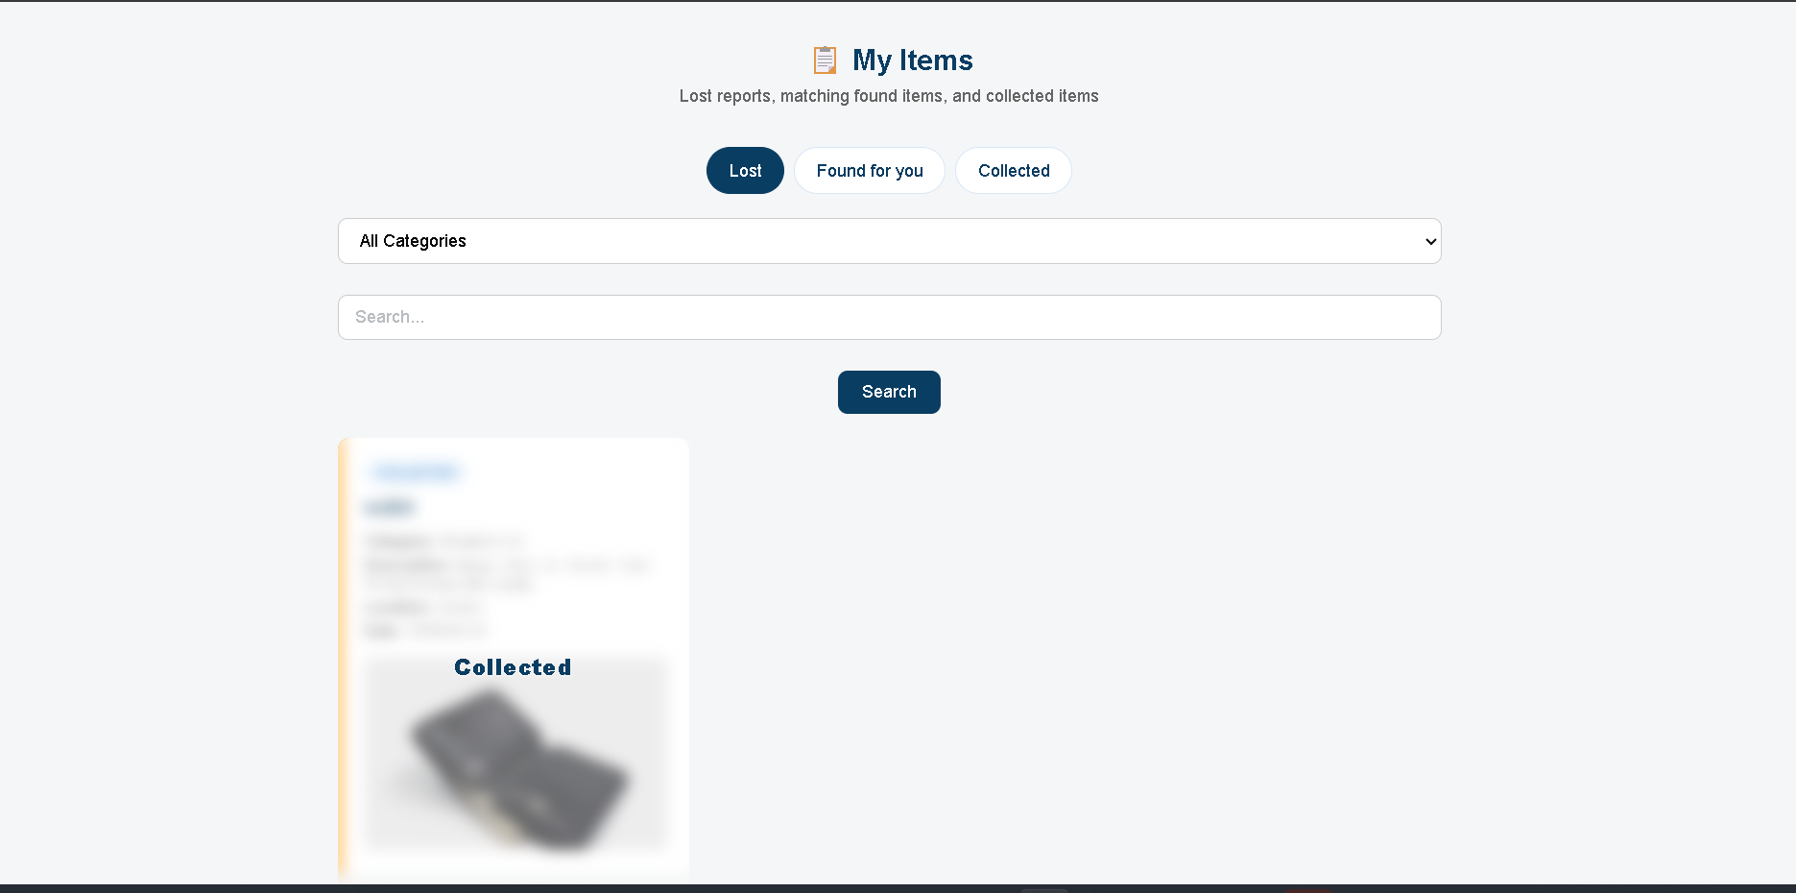

3.2.7 Found for You Tab — Matched Items
This tab surfaces found items whose category matches at least one of the user's opens lost reports. Each card shows the item name, category, location, date found, and an optional thumbnail. If a user has already submitted a claim for an item, the claim status (Pending / Approved / Rejected) is shown. If another claim has been approved, the item is shown as 'No longer accepting claims'. Users can click 'Claim This Item' to proceed to the claim form.
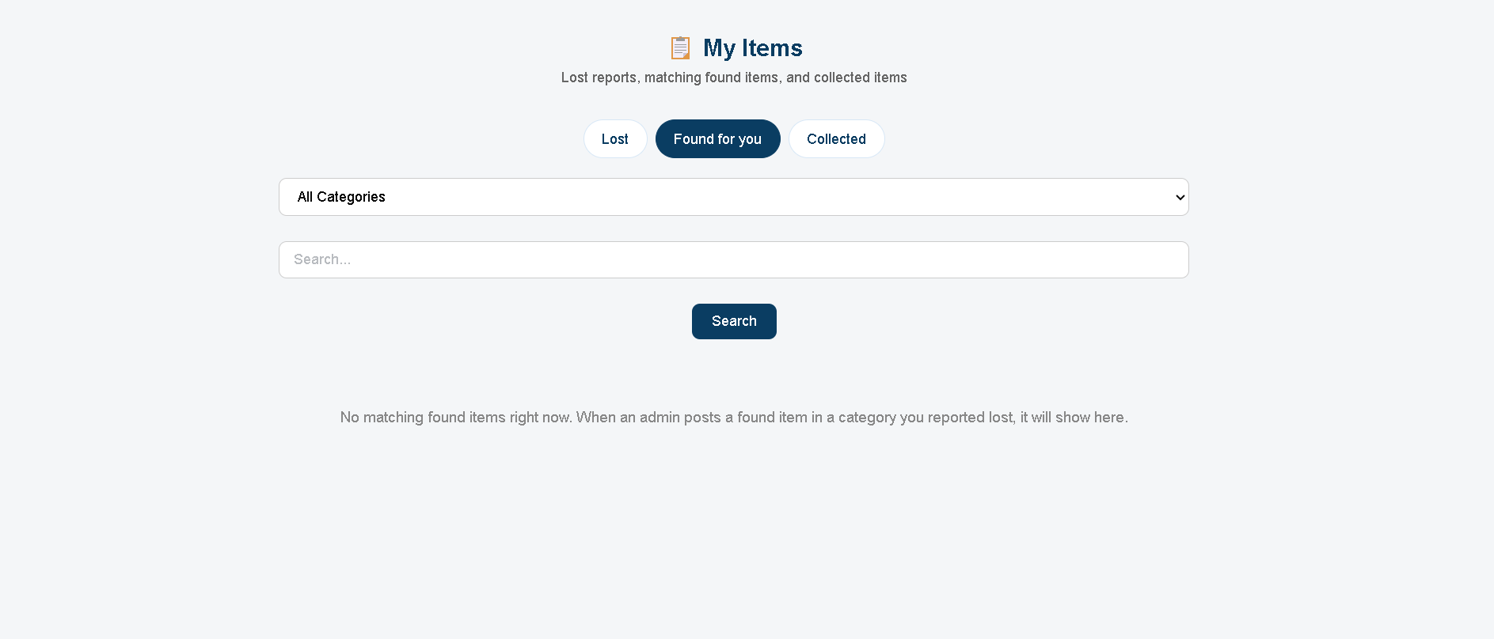

3.2.8 Submit Claim Form (claim.html)
The claim form is pre-populated with the found_id from the URL query parameter. It fetches the user's eligible lost reports (same category, unresolved) from backend/fetch_eligible_lost.php and populates a dropdown. The user provides a proof description, serial/product number (optional), box/receipt notes (optional), a device unlock password if applicable, and up to five proof photos. Proof photos are mandatory for submission.
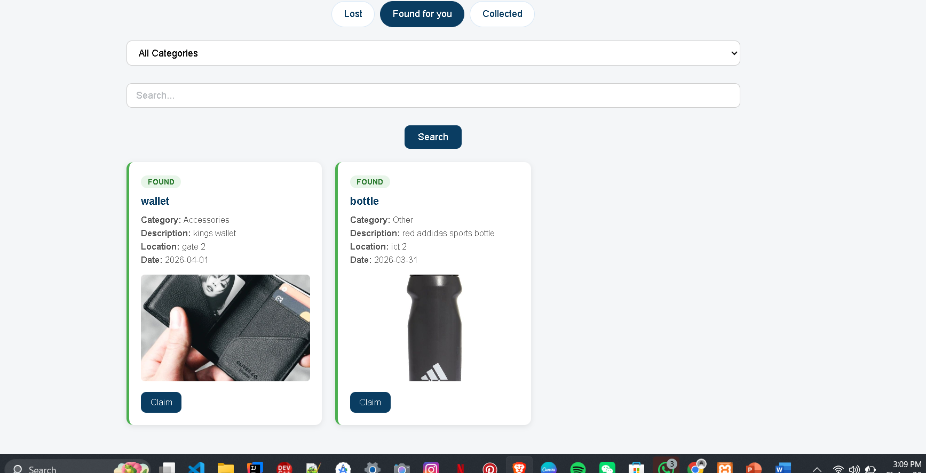

3.2.9 Claim Status Page (claim_status.html)
After submitting a claim, the user is redirected to the claim status page, which fetches the claim's current state from backend/get_claim.php. A colored status pill (orange for pending, green for approved, red for rejected) indicates the outcome. For approved claims, next steps for collecting the item are displayed. For rejected claims, the administrator's rejection reason is shown, along with guidance on resubmitting with stronger proof. Proof photos are shown in a scrollable gallery with a larger hero image.
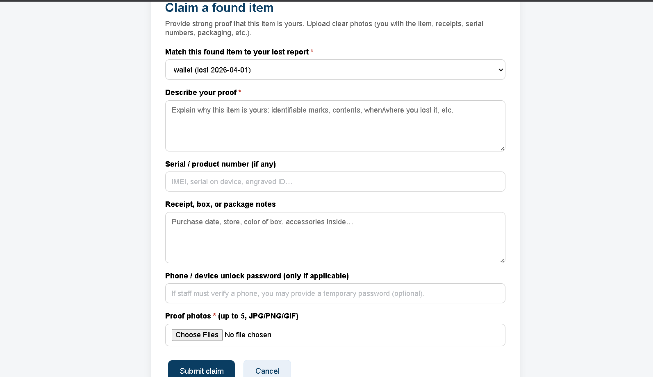

3.2.10 Admin Panel — Reported Items Tab (admin.php)
The admin panel is a tabbed single-page PHP file that requires an admin session. The Reported Items tab fetches all items from backend/fetch_items.php? Admin=1 and displays them with match scores. Admins can filter by type (Lost / Found / All) and search by keyword. Each item card shows the reporter's name, category, match score if any, and action buttons (View, Delete, Mark Resolved, Assign to Me). Found items have an additional 'Report Found' button to add new found items.
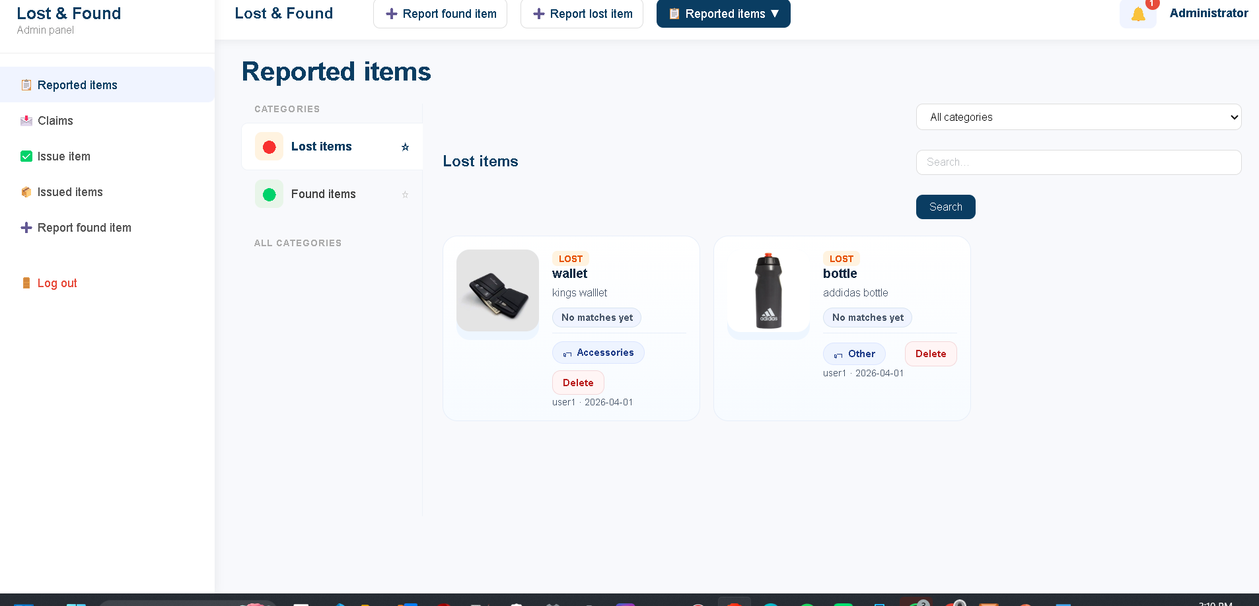

3.2.11 Admin Panel — Claims Tab
The Claims tab fetches all claims with a status filter (All / Pending / Approved / Rejected). Each row shows a thumbnail of the first proof photo, the claimant's name, the found item name, the matched lost report name, and the submission date. Clicking a claim opens a modal with the full proof description, serial number, box notes, all proof photos in a gallery, and Approve / Reject buttons. Rejecting requires a mandatory reason to be entered before the decision is submitted.

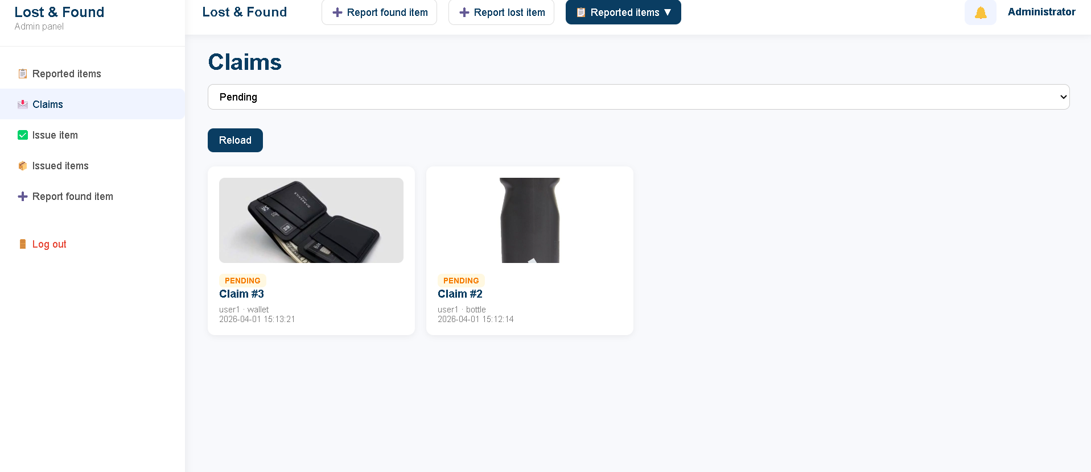

3.2.12 Admin Panel — Users Tab
The Users tab fetches all registered user accounts from backend/fetch_users.php and displays them in a table with columns for name, email, role, and registration date. Administrators can delete any non-admin account using the Delete button, which triggers a confirmation prompt before posting to backend/delete_user.php. Deletion cascades to all related records through the database foreign key constraints.

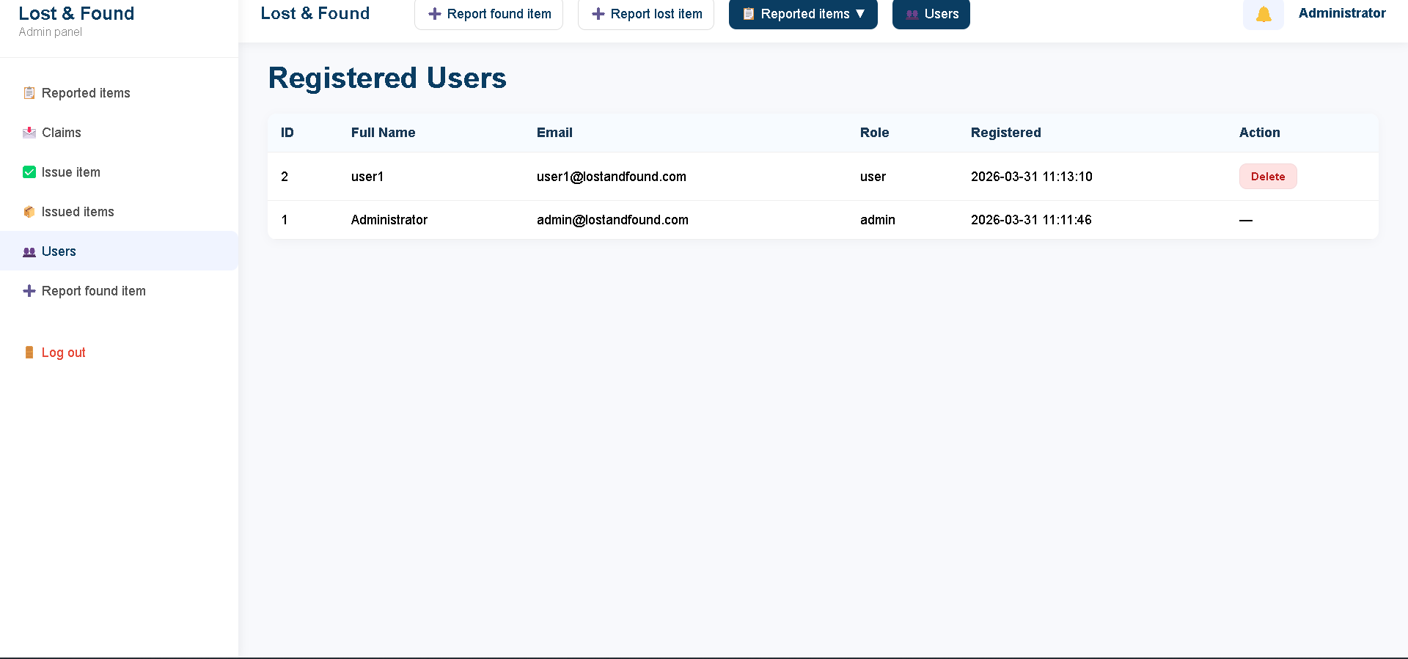

3.2.13 Admin Panel — Issued Items Tab
This tab displays the complete handover history fetched from backend/fetch_issued_admin.php. Each record shows the claimant's legal name, ID/passport number, the found item details, and the date of issue. For approved claims that have not yet been issued, a 'Ready to Issue' section at the top lists them with an Issue button that opens a handover form requiring the claimant's legal name, ID number, and a handover photograph.
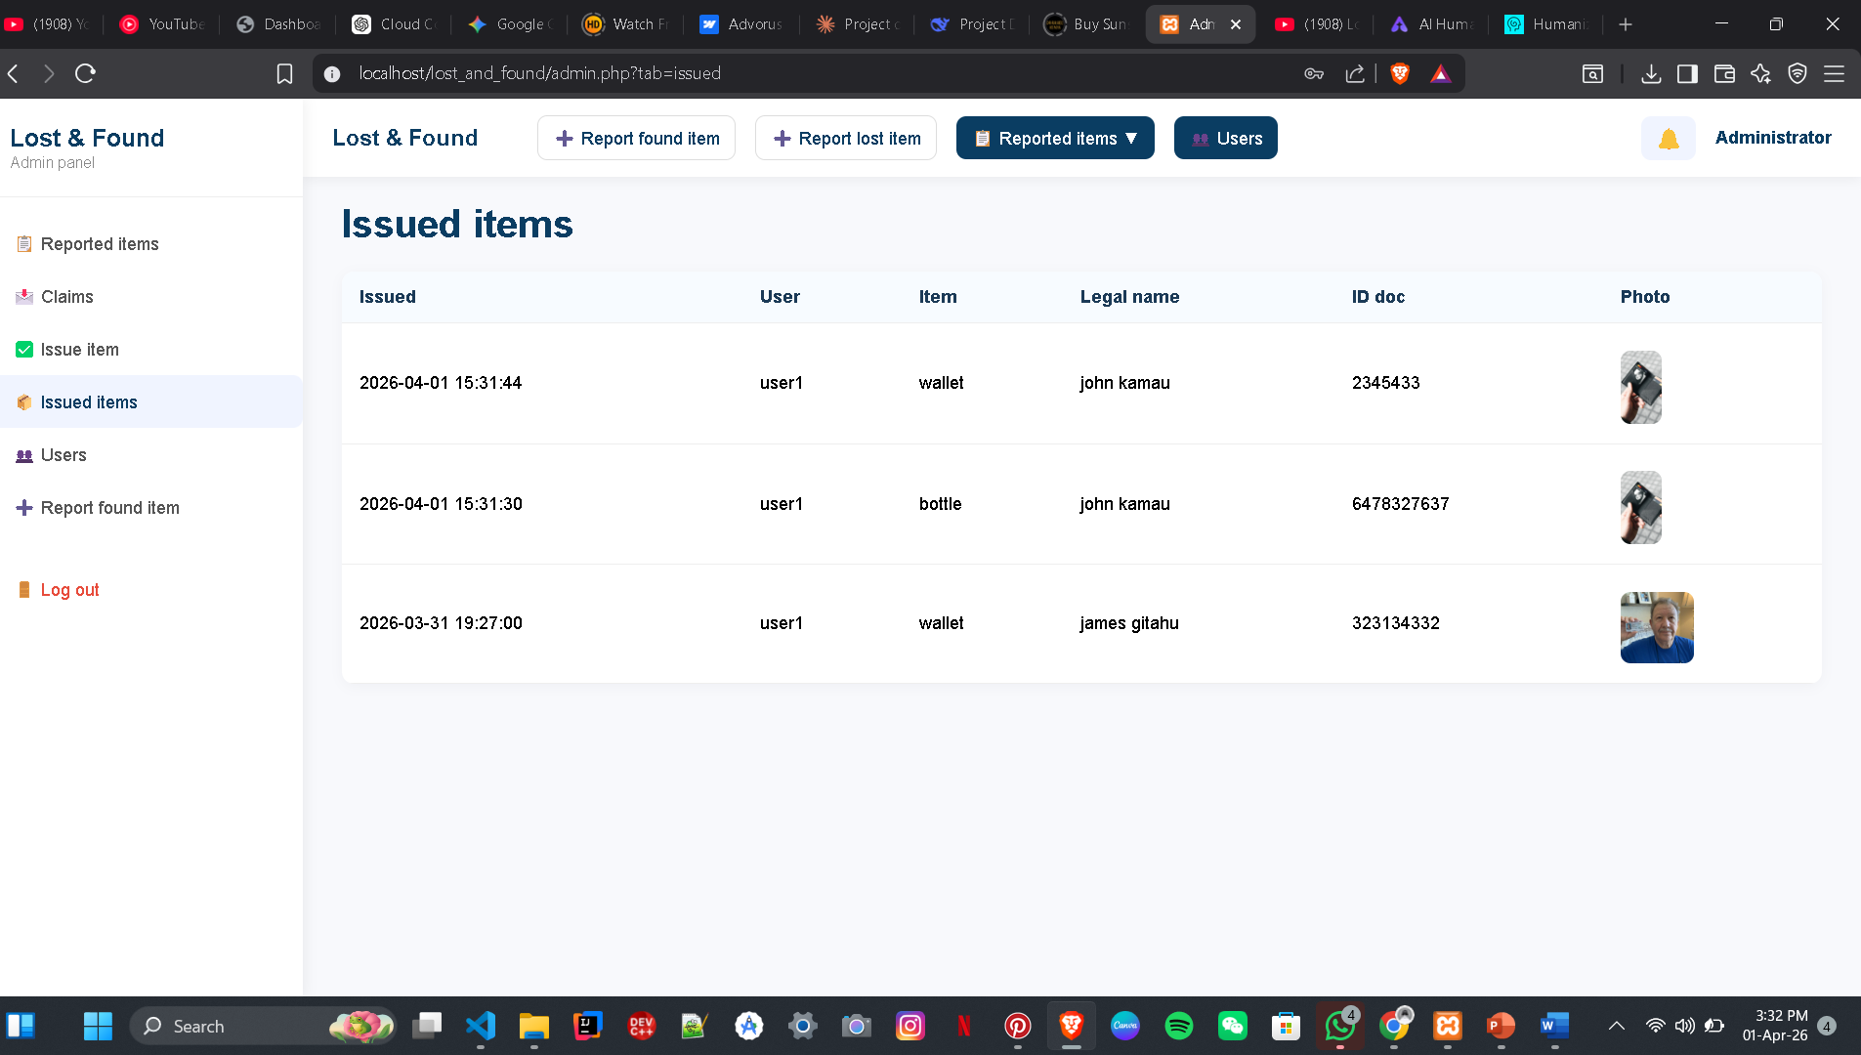

3.2.14 Notifications Panel
The notification system is implemented in notifications.js and is mounted into any page's navigation bar via a bell icon button. Clicking the bell toggles a dropdown panel listing the most recent 100 notifications. Unread notifications are highlighted in light blue. Clicking a notification marks it as read and navigates to its associated link. A 'Mark all as read' button is available at the top of the panel. The badge on the bell icon shows the unread count and hides itself when the count reaches zero.

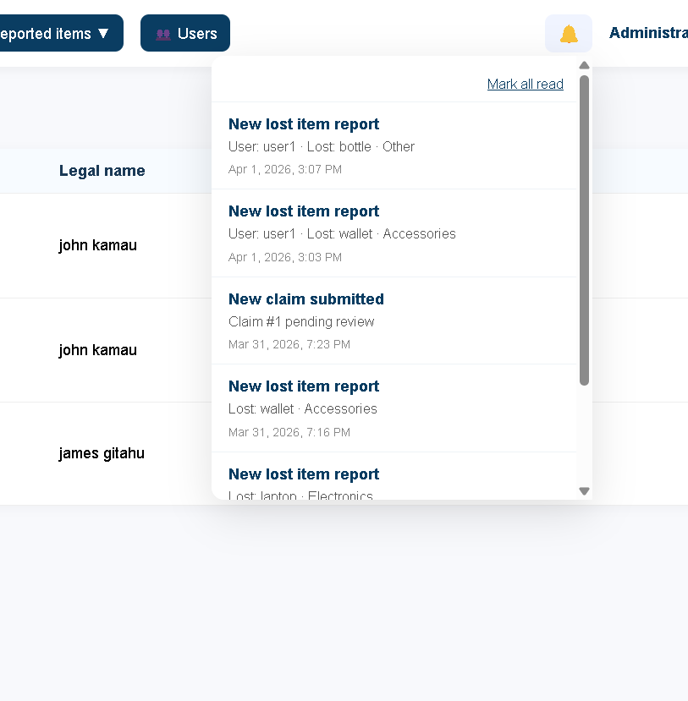

3.2.15 Messaging Interface
The messaging system allows users to contact the administrator directly from within the My Items page. Messages are sent to backend/send_message.php and fetched from backend/fetch_messages.php. The admin views all conversations in the Inbox tab of the admin panel, where conversations are listed by user with unread counts. Both sides see messages in chronological order in a scrollable chat-style panel.
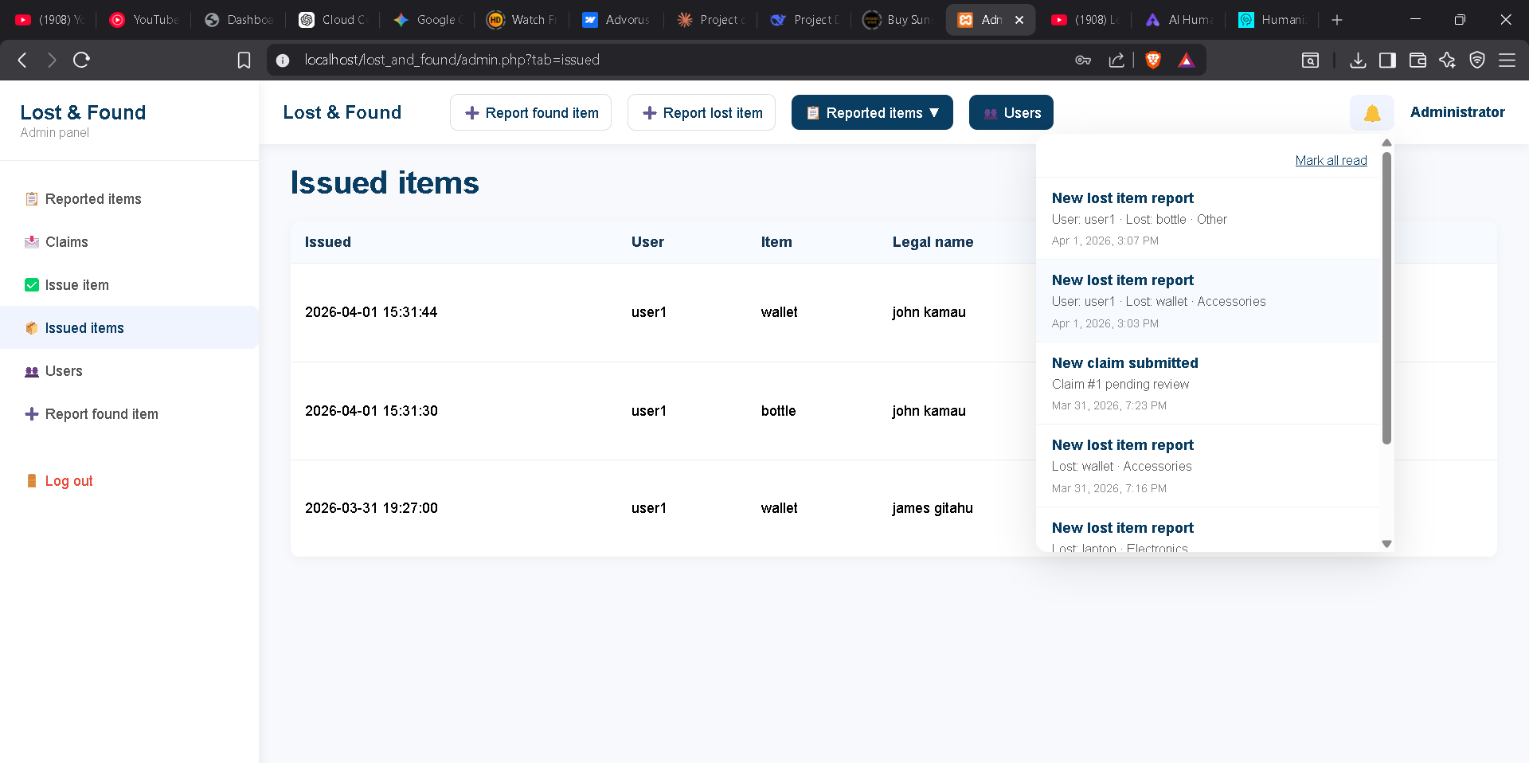

3.3 Logic Development

3.3.1 Database Schema
The database is named lost_and_found and uses the utf8mb4 character set. It contains the following eight tables:
- users — Stores registered user accounts with id, full name, email, hashed password, role (user/admin), and created at timestamp.
- lost items — Stores lost item reports with item name, category, description, location, date, image path, status (lost/found), and a resolved flag.
- found items — Stores found item reports with similar fields plus is_active and approval hold flags that control visibility and claim eligibility.
- lost_item_photos / found_item_photos — Support multiple photos per item with a sort order column.
- claims — The central claims table linking a user, a found_item, and a lost_item with proof fields and a status Enum (pending/approved/rejected).
- claim_photos — Stores up to five proof photos per claim with sort_order.
- issued_items — Records completed physical handovers with the claimant's legal name, ID/passport number, handover photo path, and the admin who issued the item.
- notifications — Stores per-user in-app notifications with title, message, preview, link, ref_type, ref_id, and an is_read flag.
- messages — Stores direct messages between users with sender_id, receiver_id, message text, and is_read flag.
- admin_assignments — Records which admin has taken responsibility for handling a specific item.
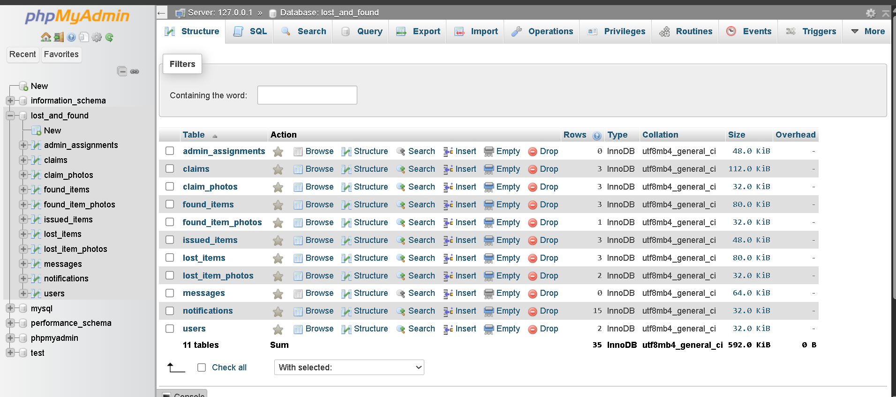

3.3.2 Configuration and Error Handling (config.php)
The config.php file is the foundation of all backend scripts. It enables strict MySQL error reporting so that database errors throw exceptions instead of failing silently, establishes the database connection, sets the time zone to Africa/Nairobi, and defines three global utility functions: log Error () which appends timestamped error entries to a file; Json Error () which outputs a JSON error response and exits; and Json Success () which outputs a JSON success response. A global exception handler is registered using set_exception_handler() so that any uncaught exception returns a safe JSON error rather than leaking a PHP stack trace.

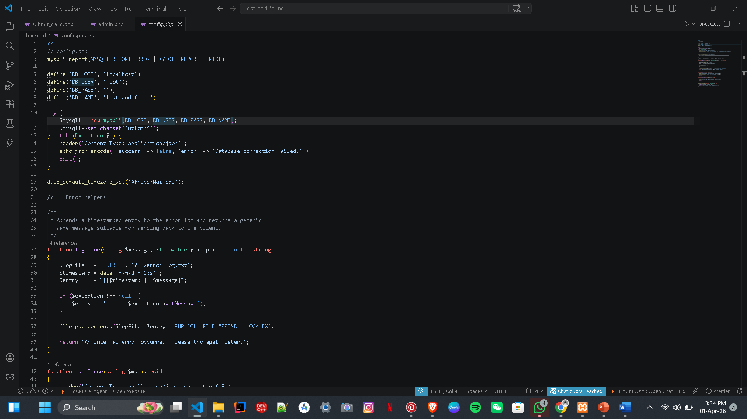

3.3.3 User Authentication (login.php / register.php / logout.php)
The login.php script authenticates users by fetching the account by email and calling password_verify() against the stored bcrypt hash. On success, session_regenerate_id(true) is called to prevent session fixation, the session variables are populated (user_id, email, username, logged_in, is_admin), and the user is redirected to the appropriate destination. The same generic error message is returned for both 'email not found' and 'wrong password' cases to avoid leaking registration data.
The register.php script validates all fields server-side (duplication of client-side checks), verifies the uploaded profile photo using finfo for MIME type detection, hashes the password with password_hash(PASSWORD_DEFAULT), and inserts the user. The logout.php script clears the session array, invalidates the session cookie, destroys the session, and redirects to the login page.

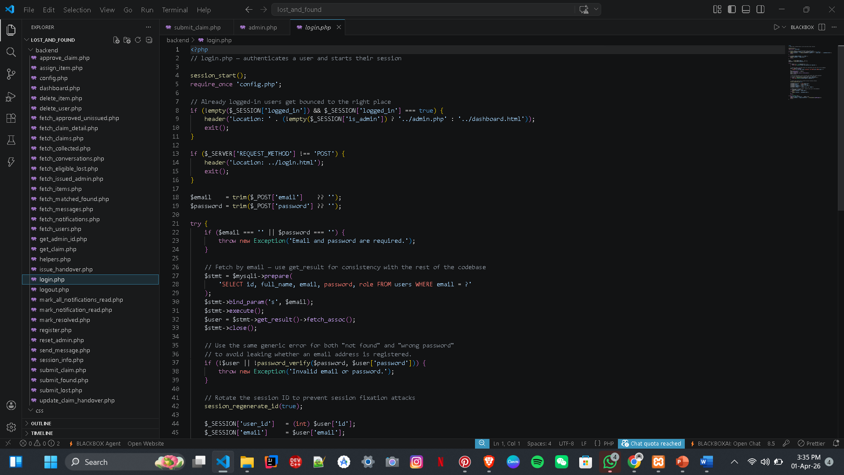

3.3.4 Item Matching Algorithm (fetch_items.php)
The matching algorithm uses a token-based text similarity approach. The normalize_text() function lowercases the input, removes all non-alphanumeric characters using a Unicode-aware regex, and trims whitespace. The tokens_from_text() function tokenizes the normalized string, deduplicates tokens, and filters out a set of common English stopwords (the, and, for, item, lost, found, etc.). The compute_match_score() function then computes four sub-scores for two items being compared:
- Category score (30 points): awarded if both items share the same category string (case-insensitive).
- Image score (up to 30 points): awarded if the tokenized filenames of both items' images share overlapping tokens.
- Name score (up to 30 points): proportional to the Jaccard-like intersection-over-max of the name token sets.
- Description score (up to 30 points): same formula applied to description tokens.
Any score of 10 or below is treated as noise and returned as null. Scores above 10 are capped at 100 and displayed on the item card in the admin panel as a percentage indicator.

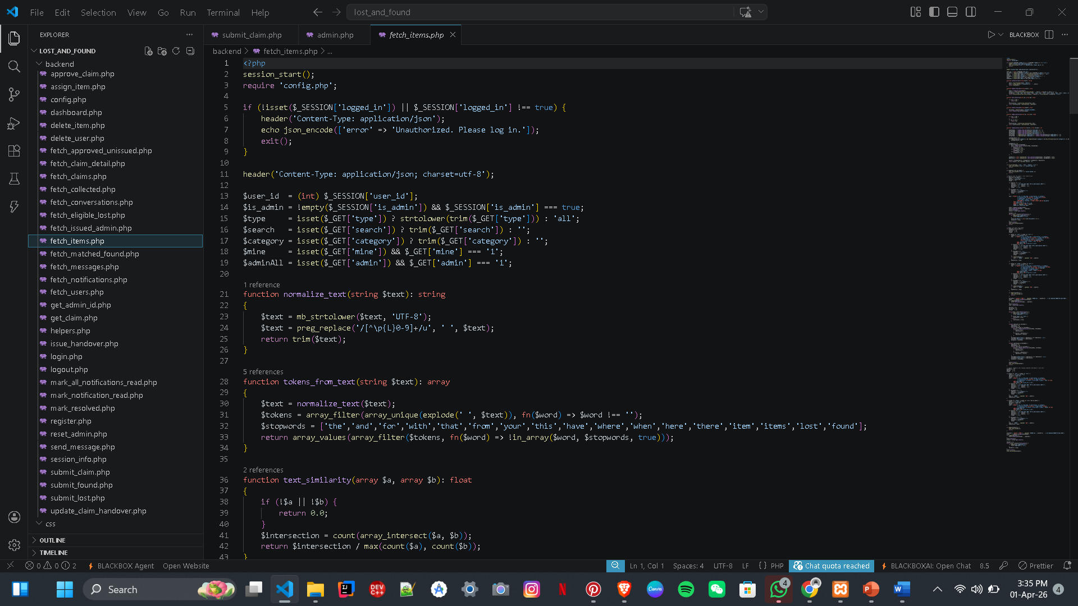

3.3.5 Claim Submission (submit_claim.php)
The claim submission endpoint processes multipart form data. It first validates all uploaded photos outside the database transaction (saving them to the uploads directory) to ensure a disk error cannot corrupt an open transaction. It then verifies that the lost item belongs to the submitting user, that the found item is still active, and that the item categories match. It checks for duplicate claims on the same lost/found pair and rejects the submission if another claimant's claim has already been approved. If a previous claim by the same user was rejected, it re-opens that claim with fresh proof instead of inserting a new row. All photo paths are saved to the claim_photos table within the same transaction. On completion, all admins are notified via the notify_all_admins() helper.

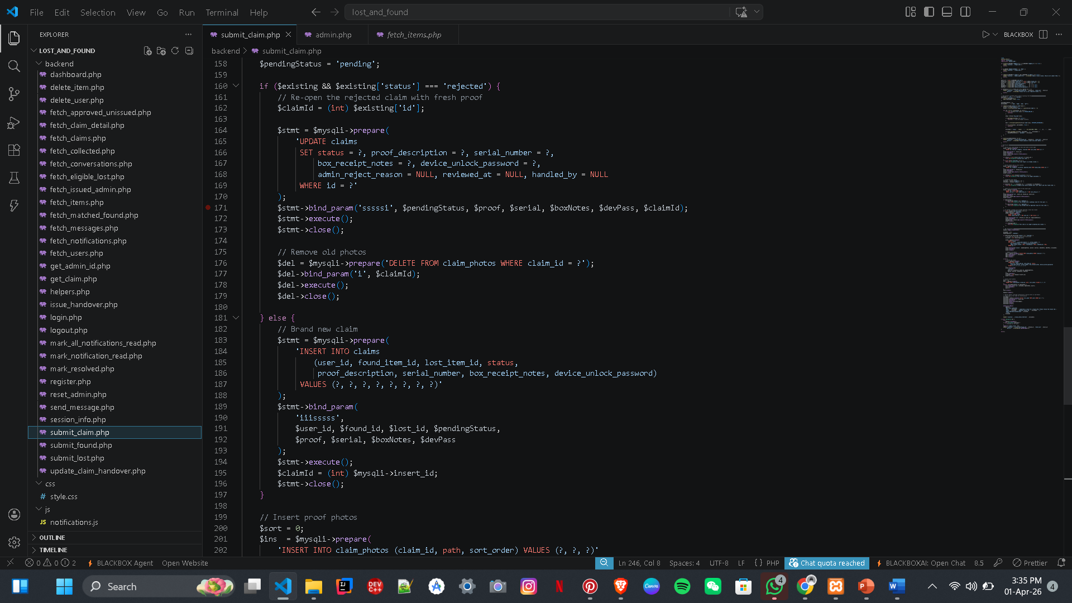

3.3.6 Claim Approval (backend/approve_claim.php)
This admin-only endpoint accepts a JSON POST body containing the claim id, the desired status (approved or rejected), and an optional reject_reason. On approval, the claim status is set to approved, the associated found item receives the approval_hold flag (preventing new claims), and all other pending claims for the same found item are automatically rejected with a standard reason. A notification is sent to the claimant. On rejection, a notification is sent containing the reason provided by the admin. All database updates are wrapped in a single transaction that is rolled back on any failure.
[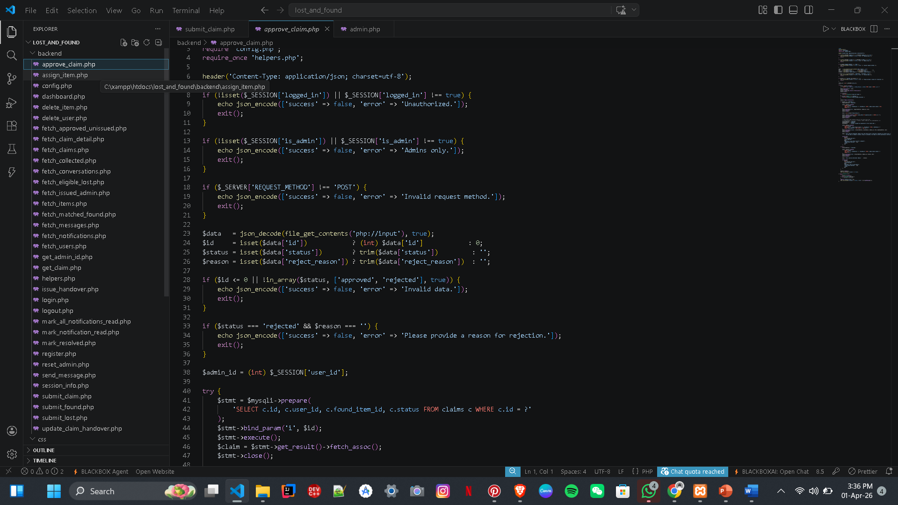

3.3.7 Physical Handover Recording (issue_handover.php)
The handover endpoint accepts a multipart form POST from the admin panel. It validates that the claim is in approved status and that it has not already been issued (guarding against double-issuing). The uploaded handover photo is verified as a genuine image using getimagesize() before the file is moved to the uploads directory. Within a single database transaction, the endpoint inserts the issued_items record, sets found_items.is_active to 0, and sets lost_items.resolved to 1 and status to found. A notification is sent to the claimant outside the transaction so that a notification failure cannot roll back the completed handover.
[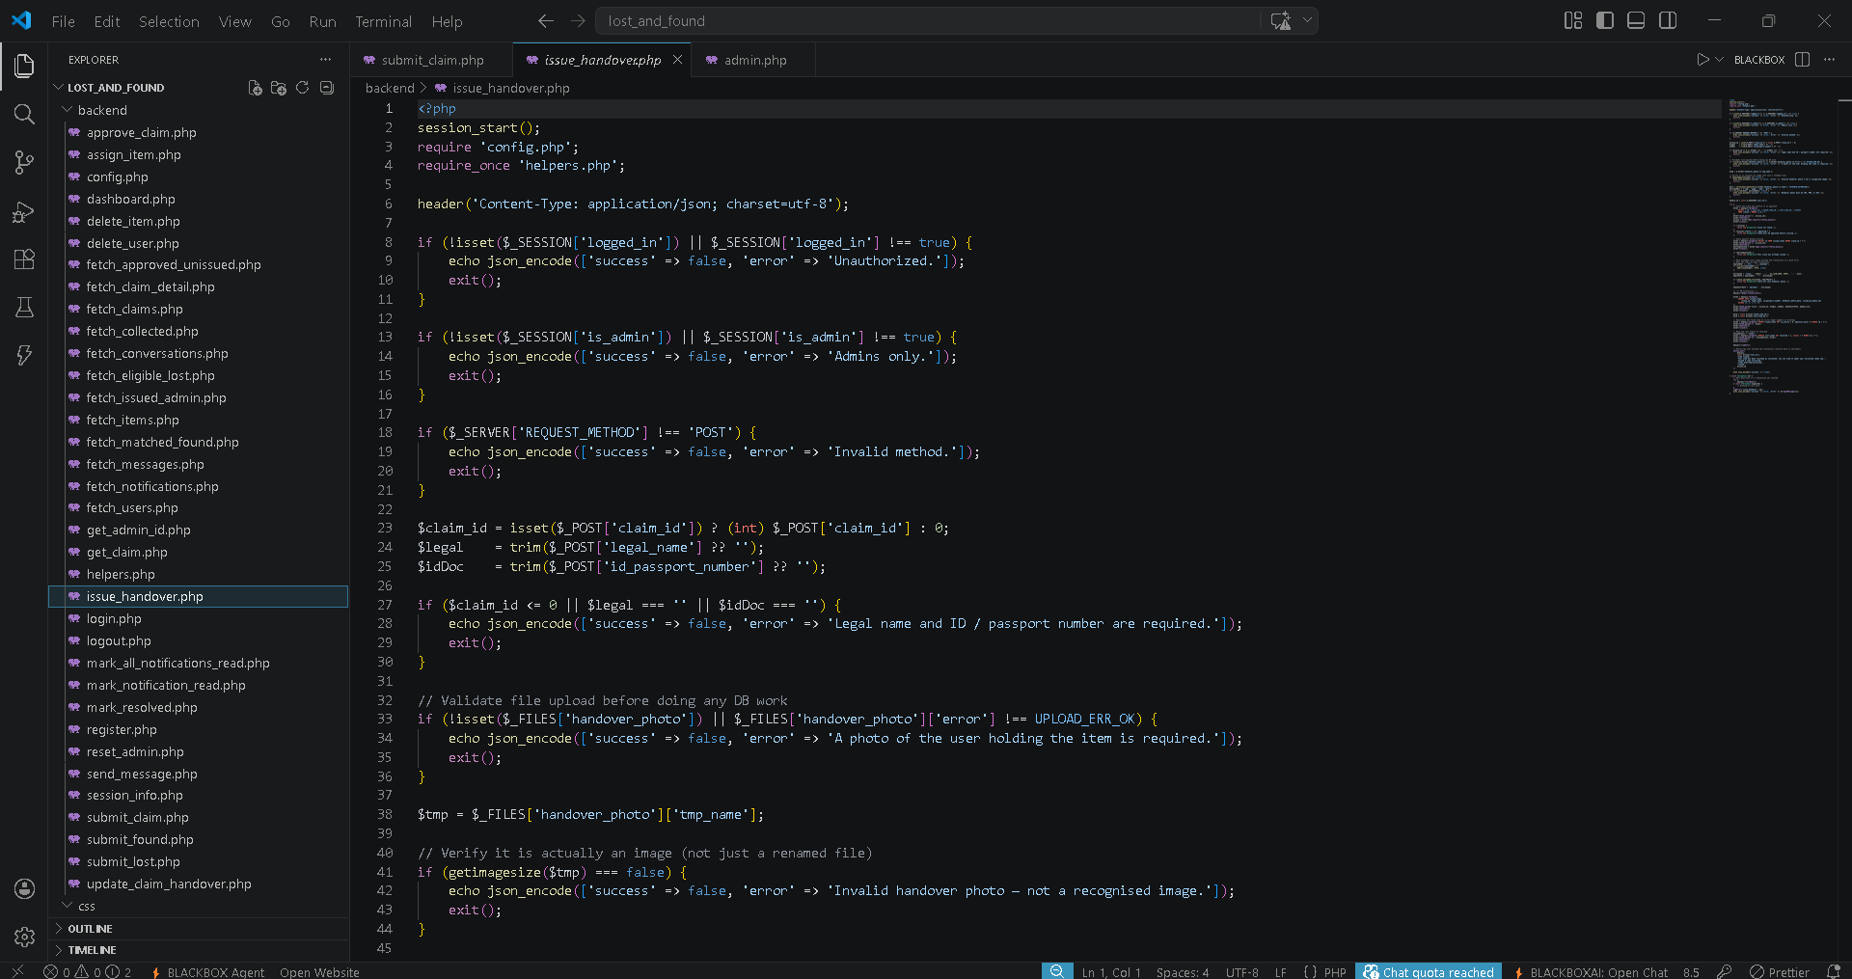

3.3.8 Notification System (helpers.php / notifications.js)
The helpers.php file defines three server-side notification functions. notify_user() inserts a single notification row for a specified user ID. notify_all_admins() fetches all users with role='admin' and calls notify_user() for each. notify_users_with_matching_lost_category() fetches all users who have an unresolved lost report in a given category and notifies each of them — this is called when a new found item is logged, alerting all potentially affected users immediately.
The notifications.js client-side module defines window.loadNotifications() which fetches from backend/fetch_notifications.php, renders the notification list into a specified mount element, and updates the badge count. Clicking a notification calls backend/mark_notification_read.php before navigating to the notification's link.
[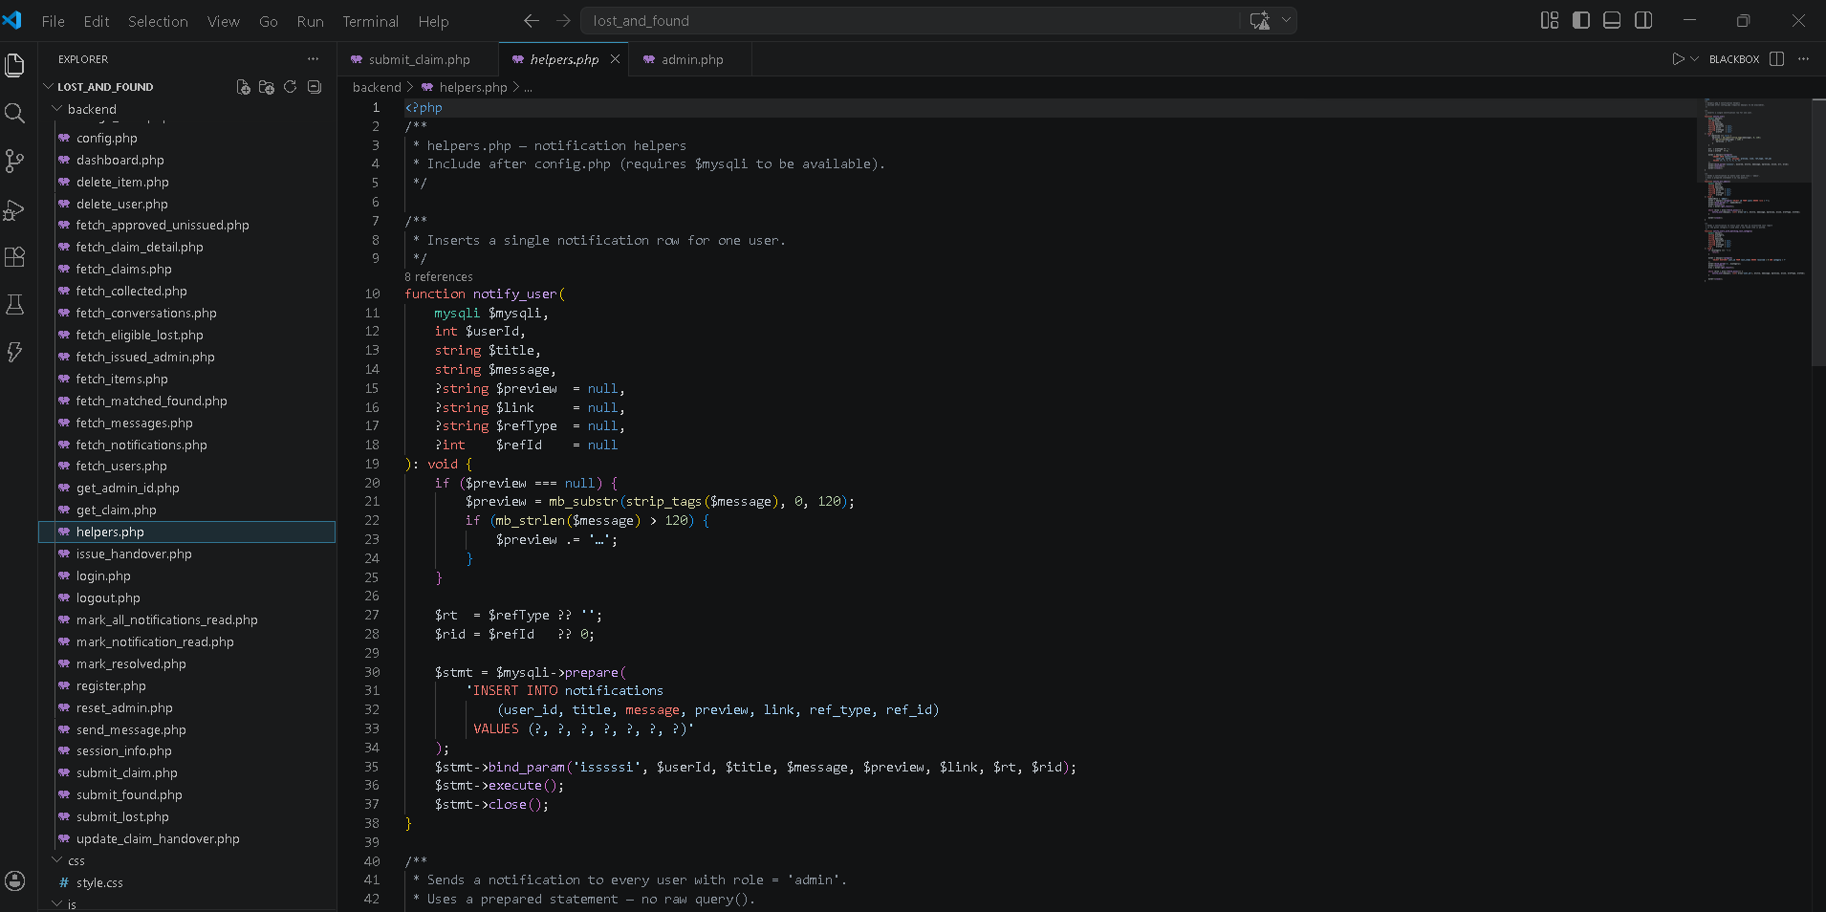

3.4 Testing
Testing was carried out manually by simulating the actions of both regular users and administrators using XAMPP running locally. The test cases below record the feature tested, the input used, the expected outcome, and the actual result.

# | Feature | Input / Action | Expected Outcome | Actual Outcome | Result
1 | User Registration | Valid name, email, password (6+ chars) | Account created; redirect to login with success message | Account created; success message displayed | PASS
2 | Duplicate Email Check | Register with existing email | Error: 'An account with that email already exists' | Correct error message shown | PASS
3 | Login — valid credentials | Correct email and password | Session created; redirect to dashboard or admin panel | Correct redirect by role | PASS
4 | Login — wrong password | Valid email, wrong password | Generic error message (no leaking of reason) | Generic error displayed | PASS
5 | Lost item report | Fill form, select category, submit | Record saved; redirect to items.html with success | Record saved; success shown | PASS
6 | Category required on report | Submit form without selecting category | Error: category required | Error displayed | PASS
7 | Item matching | Report lost 'iPhone' (Electronics); admin logs found 'iPhone' (Electronics) | Found item appears in user's 'Found for You' tab with non-zero score | Item appeared with match score 60 | PASS
8 | Claim submission | Select found item, select lost report, upload 2 photos, submit description | Claim created; redirect to claim_status.html | Claim created; status page shown as pending | PASS
9 | Claim — no photos uploaded | Submit claim form without uploading photos | Error: at least one proof photo required | Error redirected back to form with message | PASS
10 | Claim — category mismatch | Try to match Electronics lost with Clothing found (by URL manipulation) | Error: category must match | Server-side check caught mismatch | PASS
11 | Admin approves claim | Admin opens claim modal, clicks Approve | Claim status set to approved; user notified; other pending claims auto-rejected; item put on approval hold | All outcomes observed correctly | PASS
12 | Admin rejects claim | Admin clicks Reject without entering reason | Error: reason required | Error displayed in modal | PASS
13 | Issue handover | Admin fills legal name, ID number, uploads handover photo | issued items record created; found item deactivated; lost report resolved; user notified | All outcomes observed; item disappeared from active listings | PASS
14 | Double-issue prevention | Admin attempts to issue same approved claim twice | Error: claim already issued | Error returned; no duplicate record inserted | PASS
15 | Notification delivery | Admin approves a claim | Claimant receives in-app notification with correct status and link | Notification appeared; badge updated; link navigated correctly | PASS
16 | Delete user (cascade) | Admin deletes a registered user | User record and all related lost items, claims, and messages deleted | Cascade delete confirmed via phpMyAdmin | PASS
17 | Session guard | Access dashboard.html without logging in | Redirect to login.html | Redirect occurred correctly | PASS
18 | Admin guard | Regular user attempts to access admin.php | Redirect to dashboard.html | Redirect occurred correctly | PASS
19 | Search functionality | Search 'wallet' in search.php | Results filtered to items matching 'wallet' in name | Correct results returned | PASS
20 | MySQL bind Param fix | Run approve_claim on any pending claim (after fix) | No bind Param reference errors in error_log.txt | Errors resolved after assigning literals to variables | PASS

Table 3.4.1 — Test Cases and Results

3.5 Deployment
The Lost and Found Item Management System was deployed as a local web application running on XAMPP on the development machine. XAMPP bundles the Apache HTTP server and MariaDB (MySQL-compatible) database engine, making it suitable for institutional deployment on a local area network or a private server.
The deployment steps were as follows: XAMPP was installed and the Apache and MySQL modules were started from the XAMPP Control Panel. The project directory (lost_and_found/) was placed inside the htdocs folder of the XAMPP installation. The database was created by importing schema. SQL via phpMyAdmin, followed by migration_v2.sql to update the schema to the current version, and migration_add_item_photos.sql to add multi-photo support. The default administrator account (admin@lostandfound.com / admin123) was created by the seed INSERT in schema. SQL. The system was then accessible at http://localhost/lost_and_found/ from any browser on the same machine or local network.
The reset_admin.php utility script was used during development to reset the admin password and was deleted from the production directory after use as a security precaution. The uploads/ directory was created automatically by the PHP file upload handlers and given write permissions by the web server process.

CHAPTER FOUR: CONCLUSION AND RECOMMENDATION

4.1 Conclusion
This project set out to solve the problem of inefficient and non-transparent lost-and-found management in institutional settings. Over six weeks, a fully functional web-based Lost and Found Item Management System was designed, developed, tested, and deployed using HTML, CSS, JavaScript, PHP, and MySQL on a XAMPP local server environment.
The system achieved all four specific objectives stated in Chapter One. A secure, role-based authentication system was implemented that correctly distinguishes between regular users and administrators and guards all sensitive endpoints with server-side session checks. A comprehensive item reporting workflow was built allowing users to submit lost reports and admins to log found items, both with multi-photo upload support and custom file renaming. A token-based matching algorithm was implemented in PHP that automatically scores found items against lost reports based on category, item name, description, and image filename similarity, surfacing the most likely matches to users in the 'Found for You' tab. Finally, a complete claims and handover pipeline was built covering claim submission with photographic proof, admin review and approval or rejection, automatic rejection of competing claims, and physical handover recording with legal identity verification.
During development, the most significant technical challenge encountered was a PHP MySQL bind Param () error caused by passing string literals directly as referenced parameters, which appeared repeatedly in the error log. This was resolved by assigning all literal values to intermediate variables before binding. Another challenge was designing the matching algorithm to be meaningful without requiring identical item descriptions — the token normalization and stop word filtering approach produced scores that correctly identified related items across different phrasings.
The project reinforced several important software engineering principles in practice: the importance of parameterized queries for SQL injection prevention, the use of database transactions to keep multi-step operations atomic, the value of a centralized error-handling configuration, and the need for server-side validation to mirror and enforce client-side validation rules.

4.2 Recommendation
To any developer who picks up this system and wishes to enhance it further, the following improvements are recommended:
- Email notifications: The current system delivers notifications only within the application. Integrating an email delivery service such as SendGrid or PHPMailer would allow the system to send email alerts to users when a match is found or a claim is decided, reaching users who are not actively logged in.
- Cloud storage for uploads: Currently all uploaded photos are stored on the local server filesystem. For a production deployment with multiple users, integrating cloud object storage such as Amazon S3 or Cloudflare R2 would provide scalable, redundant photo storage and eliminate the risk of losing files if the server is rebuilt.
- Machine learning image matching: The current matching algorithm is text-based. Integrating a computer vision API (such as Google Cloud Vision or a locally hosted model) to compare actual image content would dramatically improve match accuracy, especially for items described differently by different users but photographed from similar angles.
- Mobile application: The system currently runs as a responsive website. Developing a companion mobile application for Android and iOS using a framework such as React Native would improve accessibility and allow users to receive push notifications, which are more immediate than in-app bell notifications.
- MPESA integration for item insurance: For high-value items, an optional MPESA payment integration could allow users to pay a small refundable deposit when submitting a claim, reducing fraudulent claims while providing a refund to the verified owner upon successful collection.
- Two-factor authentication: Adding OTP-based two-factor authentication (via SMS or an authenticator app) would significantly strengthen account security for administrator accounts, which have elevated privileges including the ability to approve claims and record handovers.
- Reporting and analytics dashboard: Adding a statistics dashboard for administrators showing item recovery rates, average claim resolution times, and items by category over time would provide institutional management with useful data for resource planning and policy decisions.

REFERENCES
Anthropic. (2024). Claude AI assistant [Conversation logs]. Anthropic. https://claude.ai

Mozilla Developer Network. (2024). Fetch API. MDN Web Docs. https://developer.mozilla.org/en-US/docs/Web/API/Fetch_API

MySQL. (2024). MySQL 8.0 reference manual. Oracle Corporation. https://dev.mysql.com/doc/refman/8.0/en/

PHP Group. (2024). PHP manual. The PHP Group. https://www.php.net/manual/en/

Stack Overflow Community. (2023–2024). Various Q&A threads on PHP MySQL prepared statements, session management, and file upload handling. Stack Overflow. https://stackoverflow.com

W3Schools. (2024). PHP tutorial. W3Schools. https://www.w3schools.com/php/

W3Schools. (2024). SQL tutorial. W3Schools. https://www.w3schools.com/sql/

XAMPP. (2024). XAMPP documentation. Apache Friends. https://www.apachefriends.org/

